

|  |  |
| --- | --- |
| **Exchange Program Details for Rhodes College Academic Year 24-25** | |
| **Name of Institution** | Rhodes College |
| **Exchange Contact** | Dr. Elin Ovrebo, DSO  Associate Director of International Programs and Exchange Coordinator  Buckman Center for International Education at Rhodes College  [ovreboe@rhodes.edu](mailto:ovreboe@rhodes.edu)  +001 (901) 843-3403 |
| **Institution Address** | 2000 North Parkway  Memphis, TN 38112  USA |
| **Websites** | [www.rhodes.edu](http://www.rhodes.edu)  [International Student Services at Rhodes](http://sites.rhodes.edu/iss/)  [Rhodes Internationals Instagram](https://www.instagram.com/rhodesinternationals?utm_source=ig_web_button_share_sheet&igsh=ZDNlZDc0MzIxNw==)  [View the beauty of Rhodes College](https://www.google.com/search?q=rhodes+college+beautiful&client=firefox-b-1-ab&source=lnms&tbm=isch&sa=X&ved=0ahUKEwjwobHOiNXfAhVQnq0KHXTcDqMQ_AUIDygC) |
| **The Exchange Program** | |
| **Eligibility** | GPA requirement: 3.0 out of a 4.0 scale  Good academic and social standing  Required English Proficiency: TOEFL: 95 or higher IBT or IELTS: 7.0 or higher |
| **Deadlines** | March 15 for Fall Term (August - December) and Academic Year (August - May).  Students who apply by March 15 will be granted registration privileges and may sign up for classes alongside of our own Juniors (rather than wait to sign up after all other students have had a chance to do so). This would mean fewer classes would already be full. |
| **How to Apply** | 1. The Home Institution Exchange Coordinator will supply a nomination email containing: student name, student email, student major field of study, the term of exchange, and a statement concerning the student’s seriousness of academic purpose and personal maturity. This statement may come from an international programs advisor or from a faculty member. One paragraph is sufficient! 2. The exchange student will complete the [Exchange Application](https://internationalprograms.rhodes.edu/index.cfm?FuseAction=Programs.ViewProgram&Program_ID=19137).   Please instruct the students to create a profile and log in or they will not be able to save their progress. The application will require the students to upload a transcript. |
| **Immigration and Visa Information** | After exchange students are accepted to study at Rhodes, they will receive an admission letter and an immigration document “Form I-20” from the Rhodes Exchange Advisor, Rachel Gasser. Immediately after receiving these items, students should make an appointment with the nearest United States Consulate to apply for an **F-1 Student Visa to enter the United States.** Information about this visa application process may be found on the [US International Student site](https://studyinthestates.dhs.gov/students). |
| **Arrival and Orientation** | Exchange students are expected to arrive **on the exact date requested by Rhodes** in the acceptance letter. Rhodes staff will meet all exchange students at the airport for transportation to Rhodes on the specified date. Students arriving outside our requested arrival dates place significant strain on our office.  Students arriving earlier will bear the cost of hotel and transportation to Rhodes campus on their own. *Please note: public transportation is unreliable and difficult to navigate in Memphis; it is not recommended.  International Student Orientation begins the day after arrival and lasts 3 days. Orientation is planned with jet lag and transition stress in mind; it is a relaxed and a fun period to learn about Rhodes, finalize course registration, meet other new international students, become acquainted with the International Student Services staff, and explore various attractions and restaurants in the city of Memphis itself. |
| **Academic Information** | |
| **Academic Calendar for Exchange Students**  **Fall Term (Aug-Dec 2024)** | Aug 19 : Mandatory Arrival for Exchange Students  Aug 20-21: Mandatory International Student Orientation  Aug 22-27: International students join Welcome Week for all new students  Aug 28: Classes Begin  Dec 11: Classes End  Dec 13-18: Final Examinations Period  Dec 18: Last day of Exchange Student Housing, 10:00am  *Academic Year Exchange Students, with pre-approval, may remain on campus over the semester break. However, there is an extra fee involved and students may need to switch dorms to do so.* |
| **Academic Calendar for Exchange Students**  **Spring Term (Jan-May 2025)** | Jan 12: Student who left campus may move back in  Jan 15: Classes Begin  May 2: Classes End  May 5-10: Final Examination Period  May 10: Last day of Exchange Student Housing, 10:00am |
| **Course Load** | 16 credit hours (usually four 4-credit courses) across several departments |
| **Min. Course Load** | 12 credit hours |
| **Max. Course Load** | 20 credit hours (not recommended) |
| **Course Restrictions** | Exchange students will take courses in multiple departments/faculties (there is no scenario when a student may take all courses from the same department/faculty). Students must have flexibility in course requirements.  Students have access to most departments and courses, however, exchange students should know that certain departments, like those below, and some upper-level courses are extremely difficult to enter, due to space limitations.  Exchange students may attempt to register for two course from the following, with the understanding that they may be denied due to space limitations.   * Commerce/Business * Economics * Biology/Chemistry * Neuroscience   Some courses in studio art, sciences with labs, and music practice lessons will carry additional fees borne by the exchange student. |
| **Tips for Finding Courses** | Students should carefully review our class schedule with their home institution academic advisor to see which courses will be available and may suit degree requirements at the home institution.  Exchange students will review courses from the online class schedule prior to application. Course selections are not guaranteed, though effort is made to accommodate specific course requests. Students will meet with an Academic Advisor during the Orientation prior to the beginning of classes. Exchange Students must provide a minimum of 6 (six) courses of interest on their application. Here are some examples of available courses for incoming exchange students: [Fall 2023 Course Offerings](https://view.officeapps.live.com/op/view.aspx?src=https%3A%2F%2Finternationalprograms.rhodes.edu%2F_customtags%2Fct_DocumentRetrieve.cfm%3Ftoken%3DeyJ0eXAiOiJKV1QiLCJhbGciOiJIUzI1NiJ9.eyJwYXlsb2FkIjp7InRpbWVzdGFtcCI6IjIwMjQtMDItMDJUMTY6NDc6MjAiLCJleHBpcmVMaW5rIjp0cnVlLCJmaWxlSWQiOjU1NDExMX19.ZlETAWDSAtC9akFVpp1OvrNtdidsbLJGEXsrpVbPn-8&wdOrigin=BROWSELINK) & [Spring 2024 Course Offerings](https://view.officeapps.live.com/op/view.aspx?src=https%3A%2F%2Finternationalprograms.rhodes.edu%2F_customtags%2Fct_DocumentRetrieve.cfm%3Ftoken%3DeyJ0eXAiOiJKV1QiLCJhbGciOiJIUzI1NiJ9.eyJwYXlsb2FkIjp7InRpbWVzdGFtcCI6IjIwMjQtMDItMDJUMTY6NDc6MzgiLCJleHBpcmVMaW5rIjp0cnVlLCJmaWxlSWQiOjU1NDExMn19.4dcewns6cJwvTbx3Xp6Z8_a0Eg03ZNYAy8Yu__3wAYc&wdOrigin=BROWSELINK)  **Course Offerings will be updated once they are available.** |
| **Academic Transcripts** | Students will request an academic transcript to be mailed to their home institution following the completion of the work at Rhodes. Payment for all fees must be made prior to Rhodes releasing the academic transcript to the home institution. |
| **Living and Money Matters** | |
| **Housing and Meals** | Exchange Students live in our on-campus Residence Halls in shared bedrooms. Shared bedrooms typically contain two students and may share bathrooms with multiple other bedrooms on the hall. [Residence Life website](https://www.rhodes.edu/student-life/living-rhodes/residence-life).  Meal plans are part of the housing bill charges. There are two dining halls on campus. [Dining at Rhodes website](https://www.rhodes.edu/content/dining-rhodes).  This site lists the [fees for Room and Board](https://www.rhodes.edu/admission-aid/cost-and-affordability/tuition-and-fees) for an academic year at Rhodes. (Semester students may just divide this number in half). |
| **Cost of Living:** | In addition to housing, meals, and insurance, exchange students should be prepared to spend up to $2000 per semester on text books, cell phone, dining out, miscellaneous shopping, etc. This figure is an approximate and students should consider their usual spending habits to best prepare themselves. |
| **International Student Health Insurance Policy** | Rhodes requires health insurance throughout the enrollment period and has a standardized, comprehensive policy for international students. Rhodes will enroll exchange students each semester in the health insurance policy and will charge their Rhodes student account. This insurance generally costs approximately $795/semester. There is no exception to this policy. |

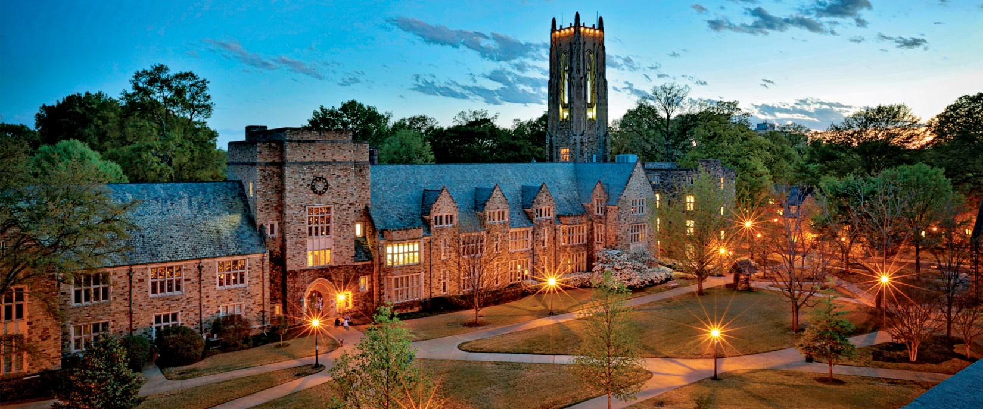



*Updated 27/02/2024 EO*