

University of Aberdeen

School of Education

2024-2025

PGDE PRIMARY

INDUCTION BOOKLET

**PGDE (Professional Graduate Diploma in Education) Primary**

**Induction Booklet**

Contents

Welcome 3

Initial contacts 4

PGDE Primary programme timeline 5

Timetable 7

Catholic Teacher’s Certificate in Religious Education (CTC) 8

Library/ICT 9

IT services 9

Quick links 9

MyAberdeen 10

Student email 10

IT Help 10

Student advice and support 11

Optional pre-course reading 12

Recommended course reading 13

# Welcome

Dear PGDE students,

We are delighted to welcome you to the University of Aberdeen as you take up your place on the PGDE Primary Programme. Some of you will know Aberdeen, and others will be exploring it for the first time. Whatever the case, on behalf of the Programme Team, can we wish you an exciting, challenging, and fulfilling year, as you journey towards your teaching qualification and provisional registration with the General Teaching Council for Scotland.

We very much look forward to sharing this year with you.



Alyson Young

PGDE Primary Programme Director

[alyson.young@abdn.ac.uk](mailto:alyson.young@abdn.ac.uk)

Rhea Marnoch

PGDE Programme Administrator

[pgde@abdn.ac.uk](mailto:pgde@abdn.ac.uk)

# Initial contacts

The following are your first points of contact throughout the course. By addressing any questions and passing on any information to the correct person, this will help us to best support your needs.

Further contact information is contained in the Programme Handbook, found on MyAberdeen.

| **Curriculum** | Curricular tutors as detailed in MyAberdeen |
| --- | --- |
| **Professional Studies** | Your LinC Tutor |
| **School Placements or Disclosure (PVG’s)** | Partnership Unit: [partnershipunit@abdn.ac.uk](mailto:partnershipunit@abdn.ac.uk) |
| **School Experience support**  **(once you are in school)** | School Experience Tutors (in the first instance)  You will be allocated a school experience tutor who will support/visit you during placement. |
| **Programme admin issues**  **e.g. absence, enquiries about courses, timetables, MyAberdeen, etc.** | Programme administrator: Rhea Marnoch  [pgde@abdn.ac.uk](mailto:pgde@abdn.ac.uk) |
| **General advice or guidance for personal issues** | Your LinC Tutor |
| **University Disability support contact** | [student.disability@abdn.ac.uk](mailto:student.disability@abdn.ac.uk)  [www.abdn.ac.uk/disabilities](http://www.abdn.ac.uk/disabilities) |
| **Disability Officer** | Ingrid Stanyer: [ingrid.stanyer@abdn.ac.uk](mailto:ingrid.stanyer@abdn.ac.uk) |
| **Student Learning Services** | The Student Learning Service can help you with a range of requirements for your course: e.g. writing essays and assignments, managing your time, thinking critically, etc.  Visit [www.abdn.ac.uk/sls/](http://www.abdn.ac.uk/sls/) for further information. |
| **Aberdeen University Students’**  **Association (AUSA)** | Visit [www.ausa.org.uk](http://www.ausa.org.uk) to find out about the range of services provided by the Students’ Association. |
| **Library Services** | Claire Molloy: [c.a.l.molloy@abdn.ac.uk](mailto:c.a.l.molloy@abdn.ac.uk) |
| **e-reg issues** | Rhea Marnoch: [pgde@abdn.ac.uk](mailto:pgde@abdn.ac.uk) |
| **ICT problems** | Service desk: [servicedesk@abdn.ac.uk](mailto:servicedesk@abdn.ac.uk) |
| **Registry** | [educationregistryofficer@abdn.ac.uk](mailto:educationregistryofficer@abdn.ac.uk) |
| **Finance (including fees)** | [tuitionfees@abdn.ac.uk](mailto:tuitionfees@abdn.ac.uk) |
| **Student Info Hub** | [www.abdn.ac.uk/infohub](http://www.abdn.ac.uk/infohub) |

# PGDE Primary programme timeline

**SEMESTER 1**

| **Uni Week** | **Week**  **Beg** | **ED402J – Education in Context**  **ED402K – Exploring the Curriculum** | | **Additional Information** |
| --- | --- | --- | --- | --- |
| 3 | 12 Aug | Online Registration | | |
| 4 | 19 Aug | Block A – week 1 (on campus) | |  |
| 5 | 26 Aug | Block A – week 2 (on campus) | |  |
| 6 | 2 Sept | Block A – week 3 (on campus) | |  |
| 7 | 9 Sept | Block A – week 4 (on campus) | |  |
| 8 | 16 Sept | Reading week | | |
| 9 | 23 Sept | Block B – week 6 (on campus) | |  |
| 10 | 30 Sept | Block B – week 7 (on campus) | |  |
| 11 | 7 Oct | Block B – week 8 (on campus) | |  |
| 12 | 14 Oct | Block B – week 9 (on campus) | |  |
| 13 | 21 Oct | Reading week | | Assessment 1A due  10am Friday 25th October |
| 14 | 28 Oct | School Experience 1A  Upper stages (P4-7)  7 weeks | SE week 1 |  |
| 15 | 4 Nov | SE week 2 |  |
| 16 | 11 Nov | SE week 3 |  |
| 17 | 18 Nov | SE week 4 |  |
| 18 | 25 Nov | SE week 5 | SE Tutor Visits |
| 19 | 2 Dec | SE week 6 | SE Tutor Visits |
| 20 | 9 Dec | SE Week 7 | SE Tutor Visits |
| 21 | 16 Dec | Online Learning | | Assessment 1B due  10am Friday 20th December |
| 22 | 23 Dec | University Holidays | | |
| 23 | 30 Dec |

**SEMESTER 2**

| **Uni Week** | **Week**  **Beg** | **ED452M – Informing Professional Practice**  **ED452N – Connecting the Curriculum** | | **Additional Information** |
| --- | --- | --- | --- | --- |
| 24 | 6 Jan | School Experience 1A  Upper stages (P4-7)  3 weeks | SE week 8 |  |
| 25 | 13 Jan | SE week 9 |  |
| 26 | 20 Jan | SE week 10 | SE Tutor Visits (Return) |
| 27 | 27 Jan | Block C – week 1 (on campus) | |  |
| 28 | 3 Feb | Block C – week 2 (on campus) | |  |
| 29 | 10 Feb | Block C – week 3 (on campus) | |  |
| 30 | 17 Feb | Online learning | | Assessment 2A due  10am Friday 21st February |
| 31 | 24 Feb | SE2A  Early stages (P1-3)  5 weeks | SE week 1 |  |
| 32 | 3 Mar | SE week 2 |  |
| 33 | 10 Mar | SE week 3 |  |
| 34 | 17 Mar | SE week 4 | SE Tutor Visits |
| 35 | 24 Mar | SE week 5 | SE Tutor Visits |
| 36 | 31 Mar | University Holidays | | |
| 37 | 7 Apr |
| 38 | 14 Apr | Assessment week  Assessment 2B due 10am Monday 14th April  Presentations 17th or 18th April | | |
| 39 | 21 Apr | SE2B  Early stages (P1-3) 4 weeks | SE week 6 |  |
| 40 | 28 Apr | SE week 7 |  |
| 41 | 5 May | SE week 8 |  |
| 42 | 12 May | SE week 9 | SE Tutor Visit (Return) |
| 43 | 19 May | Block D – Tuesday & Wednesday only (on campus) | | |

# Timetable

Below is the timetable for the first 4 weeks of the course, although this may be subject to small changes. The timetable for the whole year, with rooms, can be found on MyAberdeen.

Tutorial groups will be issued during your first lecture on Tuesday 20th August 2024.

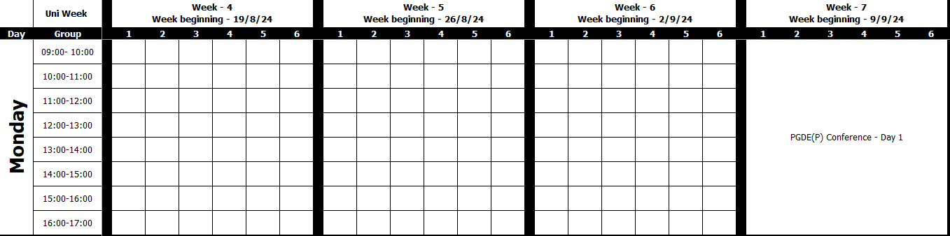

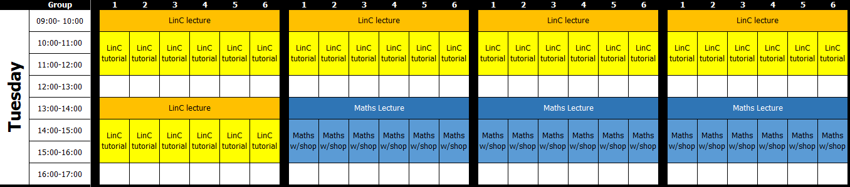

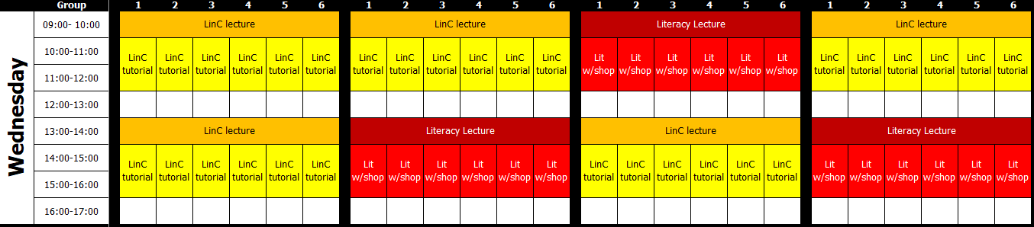

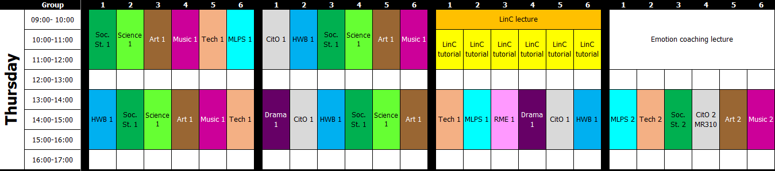

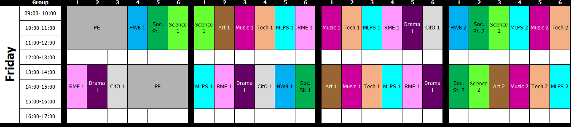

# Catholic Teacher’s Certificate in Religious Education (CTC)

The Catholic Teacher’s Certificate in Religious Education (CTC) is the qualification required for those eligible* and wishing to teach Religious Education in Catholic primary schools or in Catholic secondary schools as a ‘generalist’ RE teacher. Working in partnership with the Scottish Government and the Bishops’ Conference of Scotland, the University of Glasgow is responsible for this award, and it is delighted to offer the qualification in 2024-25 to PGDE students at the University of Aberdeen.

The blended learning course will be taught by University of Glasgow staff over two semesters and will involve face to face teaching on the University of Aberdeen campus and online coursework. It will fit with your PGDE timetable and is at no extra cost.

To find out more about the course and to apply please use the following link:

<https://www.gla.ac.uk/schools/education/study/undergraduate/informationforapplicants/catholicteachercertificate/>. NB: From the ‘PROGRAMME’ drop down box, please select the university where you will be completing your programme of study.

*More information on eligibility can be found here: <https://sces.org.uk/download/instrument/>.

If you are interested in applying for this course please do so as soon as possible and, at the latest, by Monday 19th August 2024.

# Library/ICT

A wide range of online information can be accessed to support you with any ICT issues and essential Library skills. All information is available on MyAberdeen.

# IT services

Having gone through the process of E-registration and MyCurriculum, you can then access:

* + Computing facilities and MyAberdeen

|  |
| --- |
| Log in using Computer Username  e.g. **t01abp24** |

* + Student Email

|  |
| --- |
| Log in using your email address  e.g. **any.b.person.24@abdn.ac.uk** |

Use the same password for both, which you chose as part of e-registration.

# Quick links

On the university website: [www.abdn.ac.uk](http://www.abdn.ac.uk) Go to Quick Links.

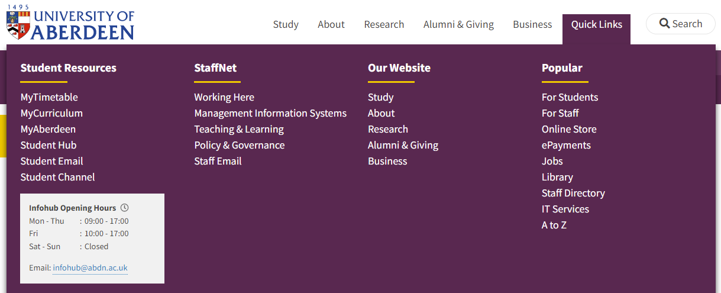

Here you will find shortcuts to:

* + MyAberdeen
  + Student Email
  + IT Services

# MyAberdeen

MyAberdeen is the Virtual Learning Environment used by the University of Aberdeen. This is where you will find all your course information, materials, resources, messages, announcements and assessment. Once you have access, you will find the **PGDE Programme Handbook** here.

1. From **Quick links**, select *MyAberdeen*.

At the login page, use your University computer username which you were allocated during e-registration. This is of the form **t01abc24** where the abc are your initials.

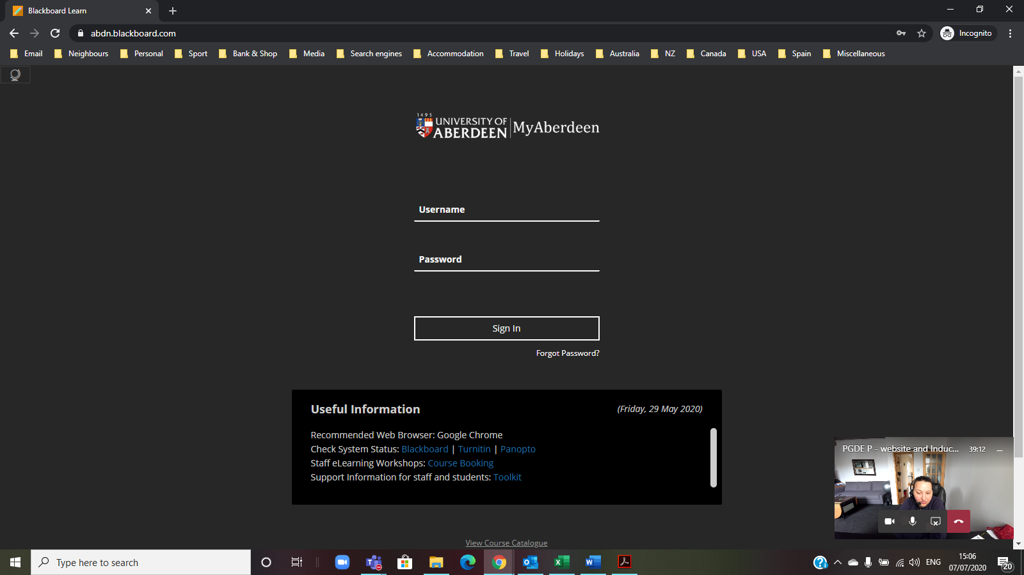

Use the **password** that you set up during e-registration.

1. Once logged in you will see your **courses** listed.

# Student email

You **must** use and check your University email account regularly as all communication from tutors, course, MyAberdeen and the University is sent to that account.

1. Login to this from the same **Quick Links** section.
2. Use the email address you chose during the e-registration process and your password.

The email address will be of a form similar to [any.b.person.24@abdn.ac.uk](mailto:any.b.person.24@abdn.ac.uk). If you do not know your email address, you will find a note of it in your Student Portal.

The first time you log into student email from the website, you will be required to enter authentication details that can be used should you need to re-set your password at any time.

# IT Help

When you need help, visit the Service Desk. This is your first point of contact for IT support.

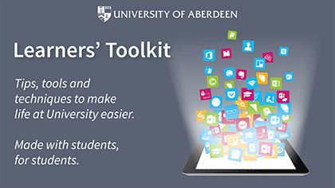

* + Login to MyIT Portal at <https://myit.abdn.ac.uk/>
  + Email: [servicedesk@abdn.ac.uk](mailto:servicedesk@abdn.ac.uk)

IT Services for Students - [www.abdn.ac.uk/it/student](http://www.abdn.ac.uk/it/student)

Learners’ Toolkit - [www.abdn.ac.uk/toolkit/](http://www.abdn.ac.uk/toolkit/)

# Student advice and support

The Student Advice and Support team offer a wide range of impartial and confidential advice and support to students on any issue or matter of concern which they might face throughout their time at University, including those of a personal, emotional or financial nature.

The Student Support Advisers also administer the University’s discretionary funds, including the childcare fund.

The team can provide specific information and support for students with disabilities, students with mental health issues, and students who require advice on visas and immigration.

Telephone: 01224 273935

Email: Student Support: [student.support@abdn.ac.uk](mailto:student.support@abdn.ac.uk)

Disability Team: [student.disability@abdn.ac.uk](mailto:student.disability@abdn.ac.uk)

International Student Support: [student.international@abdn.ac.uk](mailto:student.international@abdn.ac.uk)

The website has lots of great information which is updated regularly with support service updates, and resources for students to access online: [www.abdn.ac.uk/students/support](http://www.abdn.ac.uk/students/support).

Launched in December 2021, the Student Helpline is available 24/7 and specifical designed for periods normal support services are not. This is open to ALL students regardless of their location.

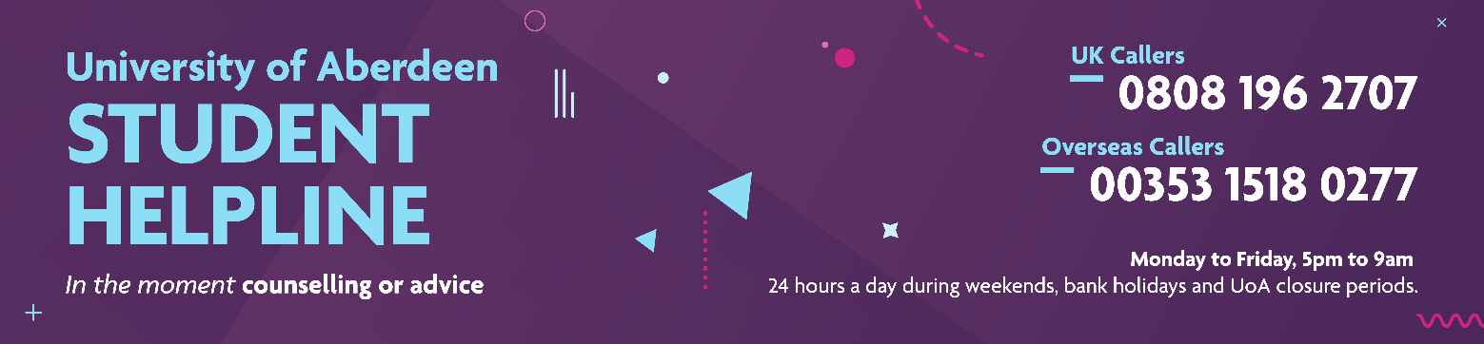

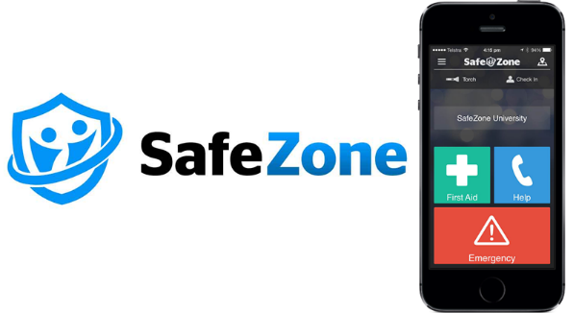The University also uses an app which connects you to the University campus security team in an emergency.

The University can send you important campus information.

You can download the app on Android or iOS and register with your University email.

# Optional pre-course reading

If you would like to engage with some pre-programme reading, you can choose from some of the links below or take a look at some of the books on the recommended reading list. Remember to read broadly and think critically – you don’t have to understand everything or agree with everything!

GTCS Professional Standards for Teachers 2021

<https://www.gtcs.org.uk/knowledge-base/articles/a-guide-to-the-professional-standards>

The Curriculum for Excellence, especially the Principles and Practice Sections

<https://education.gov.scot/media/wpsnskgv/all-experiencesoutcomes18.pdf>

Realising the Ambition

<https://education.gov.scot/media/3bjpr3wa/realisingtheambition.pdf>

Learning for Sustainability

<https://education.gov.scot/media/ulodcmfl/res1-vision-2030.pdf>

Reflective Practices

<https://apiar.org.au/wp-content/uploads/2017/02/13_APJCECT_Feb_BRR798_EDU-126-131.pdf>

# Recommended course reading

Below is a list of books you will find useful during this year of study and beyond. Some of these books will be referred to by your tutors during the course. Your tutors will also provide links to additional sources, which they will ask you to access to support your thinking.

The books have been organised by theme to support you in identifying the readings you might find most useful at different points in the course. Please note that there is **no expectation** for you to have read each of them in their entirety before joining the course. Initially, choose the ones that interest you the most.

*Available on-line [for free] via the library, once you have your University login

*Learning, Teaching and Pedagogy*

BATES, B., (2019). *Learning theories simplified*. 2nd edition. London: SAGE Publications.

*CREMIN, T. & BURNETT, C., (2018). *Learning to teach in the primary school*. London: Routledge

<http://www.vlebooks.com/vleweb/product/openreader?id=Aberdeen&isbn=9780203854624>

GAUNT, A. & STOTT, A., (2019). *Transform teaching and learning through talk*. London: Rowman & Littlefield.

*HATTIE, J., (2012). *Visible learning for teachers: maximizing impact on learning*. Abingdon: Routledge.

<https://www.taylorfrancis.com/books/mono/10.4324/9780203181522/visible-learning-teachers-john-hattie>

PALMER, S., (2021). *Play is the way*. United Kingdom: CCWB Press.

*Social Justice, Inclusion and Diversity*

*ARSHAD, R., WRIGLEY, T. & PRATT, L., (2020). *Social Justice Re-Examined: Dilemmas and Solutions for the Classroom Teacher*. London: Institute of Education Press.

<https://ebookcentral.proquest.com/lib/abdn/detail.action?docID=6403353>.

*BLACK-HAWKINS, K., FLORIAN, L. & ROUSE, M., (2015). *Achievement and inclusion in schools*. 2nd edition. London: Routledge.

<https://www.vlebooks.com/Vleweb/Product/Index/864408?page=0>

*HART, S. et al., (2004). *Learning without Limits*. Maidenhead: Open University Press.

<https://ebookcentral.proquest.com/lib/abdn/reader.action?docID=290385>

THOM, J., (2020). *A quiet education challenging the extrovert ideal in our schools*. United Kingdom: John Catt Educational Limited.

*Assessment*

*CLARKE, S., (2014). *Outstanding Formative Assessment: Culture and Practice*. London: Hodder Education.

<https://www.vlebooks.com/Product/Index/416781?page=0&startBookmarkId=-1>

*Professional Enquiry*

*POULTNEY, V. & FOX, A., (2020). Professional Learning Communities and Teacher Enquiry. St Albans: Critical Publishing.

<https://ebookcentral.proquest.com/lib/abdn/reader.action?docID=6146802>

*Learning for Sustainability*

*BEAMES, S., HIGGINS, P. & NICOL, R., (2012). *Learning Outside the Classroom*. Abingdon: Routledge.

<https://ebookcentral.proquest.com/lib/abdn/detail.action?docID=957269>

*MURRAY, P., (2011). *The Sustainable Self: A Personal Approach to Sustainability Education*. London: Earthscan.

<https://ebookcentral.proquest.com/lib/abdn/detail.action?docID=981647&pq-origsite=primo>

*Classroom Climate/Ethos*

*DIX, P., (2017). *When the adults change everything changes: Seismic shifts in school behaviour*. Carmarthen: Crown House Publishing Limited.

<https://ebookcentral.proquest.com/lib/abdn/detail.action?pq-origsite=primo&docID=4871033>

*Academic Support*

REDMAN, P., (2017). *Good Essay Writing: A Social Sciences Guide*. 5th edition. London: SAGE.

*School Experience*

*MEDWELL, J. & SIMPSON, F., (2008). *Successful teaching placement in Scotland: Primary and Early Years*. Exeter: Learning Matters.

<https://ebookcentral.proquest.com/lib/abdn/reader.action?docID=820164>

**Book bundle purchasing option**

Blackwells books logoPGDE Primary staff have worked with the Blackwell’s campus bookshop to share this year’s reading list and create a book bundle of 5 key frequently used titles for the Primary PGDE course, **highlighted in yellow in the reading list**.

This exclusive bundle is specially made just for this course and is discounted to be cheaper than buying the books individually anywhere else online.

To take advantage of this offer, please contact the store directly. They can be contacted by either email - [aberdeen@blackwell.co.uk](mailto:aberdeen@blackwell.co.uk) or via telephone - 01224 486102. Alternatively, if you are based in Aberdeen, you can call into the shop which is located at 99 High Street, Old Aberdeen, Aberdeen, AB24 3EN.

If you have any questions at all, please contact the shop by email or phone.

Email - [aberdeen@blackwell.co.uk](mailto:aberdeen@blackwell.co.uk)

Telephone - 01224 486102

