**Briefing Paper**

**Professional Services – Future Directorate Structure**

This paper outlines a proposal for a reshaped directorate structure for Professional Services.

The proposals are intended to progress the University’s strategic objectives and improve service effectiveness and efficiency. Reduction in headcount is not an objective.

The need to invest in Research and Academic Commercialisation as well as in the development of Transnational Education (TNE) and philanthropic fundraising is recognised.

**High Level Directorate Structure**

The current high level structure of Professional Services Directorates is outlined in Chart 1.

There are currently 9 Directorates of which 7 report directly to the Chief Operating Officer. The Chief Financial Officer (Finance) and the Director of Advancement (DARO) report to the Principal.

The proposed new structure outlined in Chart 2, would **reduce** the number of Directorates to 8, of which 7 will report to the Chief Operating Officer. Finance, through the Chief Financial Officer, would continue to report directly to the Principal.

The key structural changes proposed are:

* The completion of the sub-division of External Relations to **create a specialist Global Engagement, Marketing and Recruitment** Directorate. This responds to the need for increased focus on student recruitment and TNE partnerships to support diversification of market and income generation and to improve the experience of the applicant journey.

The possible sub-division of External Relations was formally communicated to External Relations staff before the Winter break but then paused because of the wider financial recovery work. Subject to consultation, the directorate could also include the Online Education team currently located in Academic Services and Online. A priority would include the establishment of a Global Partnerships Team to support our increased engagement with TNE activities.

* **Creation of a new Directorate (name to be determined) combining our Engagement and Reputation functions** across External Relations and Development & Alumni Relations.

It is proposed that a single Directorate be established to build and strengthen relationships across our internal and external constituencies. The Directorate would bring together each of the following functional areas, Communications, Public Affairs and Events (both currently part of External Relations) and the Development and Alumni Relations Office (DARO, which currently reports to the Principal).

Realigning DARO within the Directorates will enable increased collaboration across existing externally facing teams as the University plans to launch a comprehensive fundraising campaign in the next 6-9 months.

* **Formal separation of the research support and academic commercialisation functions within the Research & Innovation Directorate**.

It is proposed to establish an Enterprise and Innovation Unit, focussed on an external sales function aimed at increasing contract research income, consultancy, commercialisation, and Intellectual Property Management and supporting regional economic development priorities. The Research Support Office will focus on policy, strategy and governance (Research Excellence Framework preparations), research income, impact and public engagement with research, along with support for Postgraduate Research Student, researcher development and culture. Export-license support and compliance with National Investment Act requirements is a key area of additional activity.

* **Creation of a “registration to graduation” taught student journey within a single directorate.**

This would bring the Academic Services and People directorates together, with student activities co-ordinated by an Associate Director/Registrar role. People directorate includes Student Services and Student Experience functions while Academic Services includes the Centre for Academic Development (CAD), and Registry functions. The Director of People co-ordinates operational (non-academic) delivery in our TNE partnerships while academic co-ordination is undertaken in Academic Services. The new structure will be co-created, addressing process hand-offs and opportunities to improve services for students.

**Chart 1:**

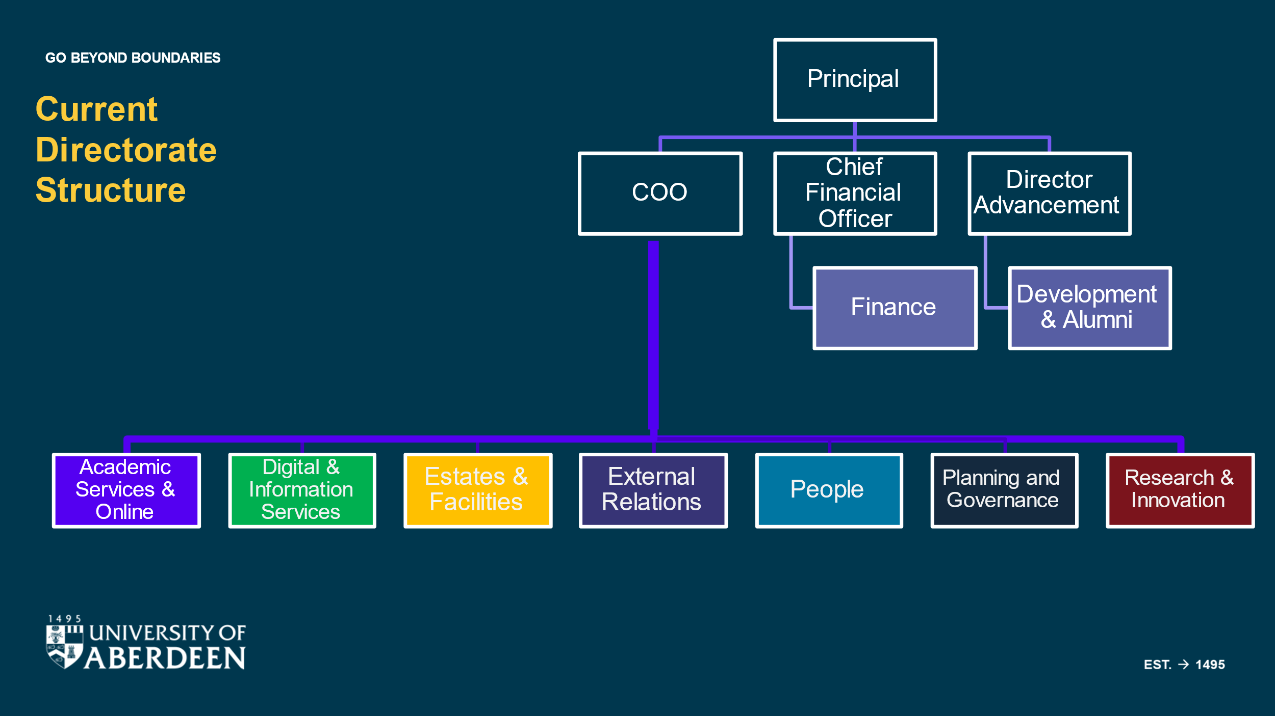

**Chart 2:**

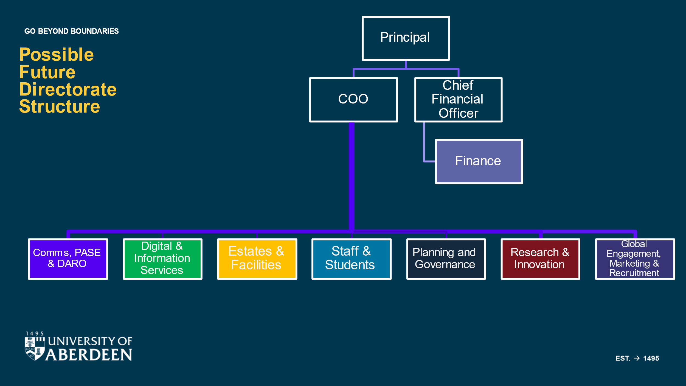

**Directorate Level Change processes**

Re-organisation is also expected within Directorates to address the gaps created by the VS/ER departures and to address strategic imperatives.

Change management exercises will be undertaken as appropriate, informed by the nature and scale of the change required. These will be undertaken in line with the policies, procedures and governance arrangements as set out in the [Change Management Toolkit.](https://www.abdn.ac.uk/staffnet/working-here/change-management-13516.php) This will include proposals being considered during a period of consultation with staff and the trade unions, prior to decisions being confirmed for implementation.

In doing so it is recognised that it is imperative to reduce workload for Professional Services colleagues by improving systems and processes; to change the ways in which we use spaces to support engagement; and, to improve the visibility of the University and our culture of enterprise and innovation, as well as the income generated by our non-academic services.  The combination of “student” functions into a single location will also underpin the process design work necessary for the vital (and substantial) investment required for an integrated Student Management System.

It is recognised that reallocation of responsibilities within several Directorate (DIS, Finance, People/Academic Services) management teams is needed and that interim appointments will be necessary in such circumstances. Interim arrangements will be subject to formal appointment processes in due course and any formal change management processes.

**Timeline**

Formal change management processes, where necessary, are expected to each run over a 3-5 month period. The overall process is expected to complete during 2024/25.

The initial priorities would be:

* + Restructuring of External Relations – supporting TNE.
  + Interim arrangements to address departures from key roles.
  + Commercialisation of campus services.