Department / Area |  | Assessment No.
Assessor(s) |  | Lab No.
Assessment Date |  | Review Due Date

Name of substance
Valid Safety Data Sheet attached | Yes / No | Date
Can a safer substance be used instead? | Yes / No | Details
Describe the activity / work process (how long & how often is this carried out and the quantity used)
Identify who is at risk | Employees / Students / Visitors / Contractors / Public / Other

Hazard Classification, tick all that apply:
Symbol | Hazard |  | Symbol | Hazard
 | No hazard |  |  | Less serious health risks
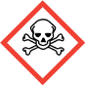 | Acute toxicity (category 1-3) |  | 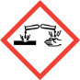 | Corrosive
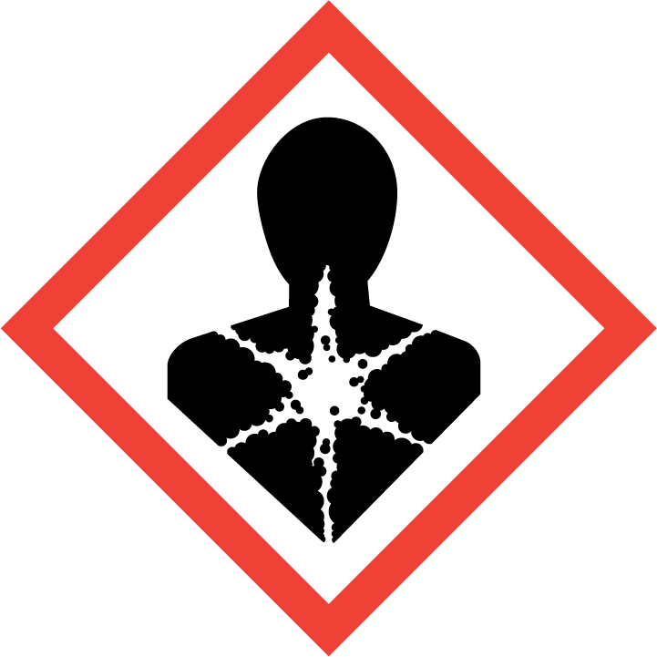 | Serious health hazard |  | 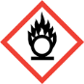 | Oxidising
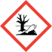 | Aquatic Environment |  |  | Gas under pressure
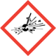 | Explosive |  | 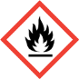 | Flammable

Hazard Type
​​☐​ | ​​☐​ |  | ​​☐​ | ​​☐​ |  | ​​☐​ | ​​☐​ |  | ​​☐​ | ​​☐​
Gas | Vapour |  | Mist | Fume |  | Dust | Liquid |  | Solid | Other | State:__________
Route of Exposure
​​☐​ |  | ​​☐​ |  |  | ​​☐​ |  |  | ​​☐​ |  | ​​☐​
Inhalation |  | Skin |  |  | Eyes |  |  | Ingestion |  | Other | State:__________

State the risks to health from identified hazards
Control measures (e.g. extraction, ventilation, training, supervision) include special measures for any vulnerable groups e.g. pregnant workers
Is health surveillance required? | Yes / No | Details

Personal Protective Equipment Required (state type and standard)
First Aid Measures
Fire Fighting Measures
Spill Release Measures
Storage and Handling
Disposal

Is exposure controlled? | Yes / No

Further Controls Needed? | Yes / No | Details

