



|  |
| --- |
| JOB TITLE  ***DIRECTORATE OF XXX*** |

|  |  |
| --- | --- |
| Closing date: | **Enter Closing Date** |
| Interview date: | **Enter Interview Date** |
| Reference number: | XXX000 |

## Introduction

Insert text regarding where the post will be based and background to relevant School or Directorate

## Job description

### MAIN PURPOSE OF THE ROLE:

Insert text

### KEY RESPONSIBILITIES:

Insert text

## Candidate background

Insert text

## Terms of Appointment

Salary will be at the appropriate point on the Choose Grade., Choose Salary and negotiable with placement according to qualifications and experience.

Any appointment will be made subject to satisfactory references and probation period.

For further information on various staff benefits and policies please visit <http://www.abdn.ac.uk/staffnet/working-here>

This role is based in the UK and as such the successful candidate will be required to live and work in the UK.

Select Appropriate Visa Paragraph

|  |
| --- |
| AT A GLANCE  SALARY:  Choose Grade  Salary banding  HOURS OF WORK:  XX  CONTRACT TYPE:  XXXXXXX  LOCATION:  Aberdeen |

Select Appropriate Homeworking Paragraph

## Person specification

|  | **ESSENTIAL** | **DESIRABLE** |
| --- | --- | --- |
| **Education/Qualifications**  Academic, technical and professional education and training |  |  |
| **Work and Other relevant experience (including training)**  e.g. Specialist knowledge, levels of experience, supervisory experience, research |  | • |
| **Personal qualities and abilities**  e.g. initiative, leadership, ability to work on own or with others, communication skills |  |  |
| **Other**  e.g. special circumstances (if any) appropriate to the role such as unsocial hours, travelling, Gaelic language requirements etc. |  |  |

(Delete if not required)

|  | **ESSENTIAL** | **DESIRABLE** |
| --- | --- | --- |
| **Education/Qualifications**  Academic, technical and professional education and training |  |  |
| **Work and Other relevant experience (including training)**  e.g. Specialist knowledge, levels of experience, supervisory experience, research |  | • |
| **Personal qualities and abilities**  e.g. initiative, leadership, ability to work on own or with others, communication skills |  |  |
| **Other**  e.g. special circumstances (if any) appropriate to the role such as unsocial hours, travelling, Gaelic language requirements etc. |  |  |

## University of Aberdeen

*Open to all and dedicated to the pursuit of truth in the service of others*

The University of Aberdeen is a broad based, research intensive University, and we put students at the centre of everything we do. Outstanding in a wide range of discipline areas, Aberdeen is credited for its international reach and commercialisation of research ideas into spin out companies. The University has over 16,000 matriculated students and 3,600 staff representing 130 nationalities. We encourage bold thinking, creativity and innovation, and we nurture ambition with many opportunities for professional and personal development in an inclusive learning environment which challenges and inspires.

### CURRENT CONTEXT

The University continues to uphold the principals of the foundational purpose. We remain committed to delivering positive change both locally and globally. We work together and with our partners in an interdisciplinary way, catalysing world-leading research in our areas of strength: Energy Transition; Social Inclusion and Cultural Diversity; Environment and Biodiversity; Data and Artificial Intelligence; and Health, Nutrition and Wellbeing. We are investing in our future and have committed £100m to upgrading our campus, including the new fully digitised Science Teaching Hub, the regeneration of the historic King’s Quarter and a new Business School building. Our commitment to our students, campus and community has led to us being named a Top 20 UK institution in two major league tables[1] and 4th in the UK for overall student satisfaction[2].

### ABERDEEN 2040

On our 525th anniversary as a University we launched [**Aberdeen 2040**](https://www.abdn.ac.uk/2040/), our strategic vision for the next 20 years. Four strategic themes will shape our learning and discovery, underlined by 20 commitments we have made against each theme:

* **Inclusive**

We welcome students, staff and partners from all backgrounds, organisations and communities. We value diversity.

* **Interdisciplinary**

We innovate in education and research by generating, sharing and applying new kinds of knowledge. We learn together.

* **International**

We connect with others and extend our networks and partnerships around the world. We think across borders.

* **Sustainable**

We understand and nurture our environment, and take care of our resources, including our people and finances.

We work responsibly.

### OUR EDUCATION

Recognised as the Scottish University of the Year in the Times and Sunday Times Good University Guide 2019, we remain true to our roots as an ancient Scottish university, combining breadth and depth in our degree programmes and drawing strength from the quality of our research. Our flexible curriculum encourages students to grow as independent learners and therefore to thrive as graduates in the diverse workplaces of the future. Our education is open to all and we are setting ambitious targets to further widen access.

### OUR RESEARCH

Researchers at the University of Aberdeen have been at the forefront of innovation and excellence throughout the centuries, generating insights in medicine, science, engineering, law, social sciences, arts and humanities. This research has contributed to five Nobel prizes as well as other awards such as the Queen’s Anniversary prize. Our research is intellectually rigorous working within our established areas of excellence as well as new methods of enquiry. We will continue to generate new knowledge addressing economic and societal issues with ambition and imagination, ensuring that it is globally excellent and locally relevant.

### INTERNATIONAL

Aberdeen is increasing its international presence, positioning the University as a global organisation and building on established global partnerships around the world, including Qatar, China, North America, Europe. We feature in the top 50 institutions worldwide for international students[3].

### IMPACT

In 2020 the University signed the United Nations Sustainable Development Goals accord, solidifying our commitment to developing the world in a sustainable way. In 2022 we were listed in the global Top 100 for 8 of these goals[4].

Our highly cited work in zero-carbon technology and global outlooks makes us Scotland’s best institution for environmental research[5].

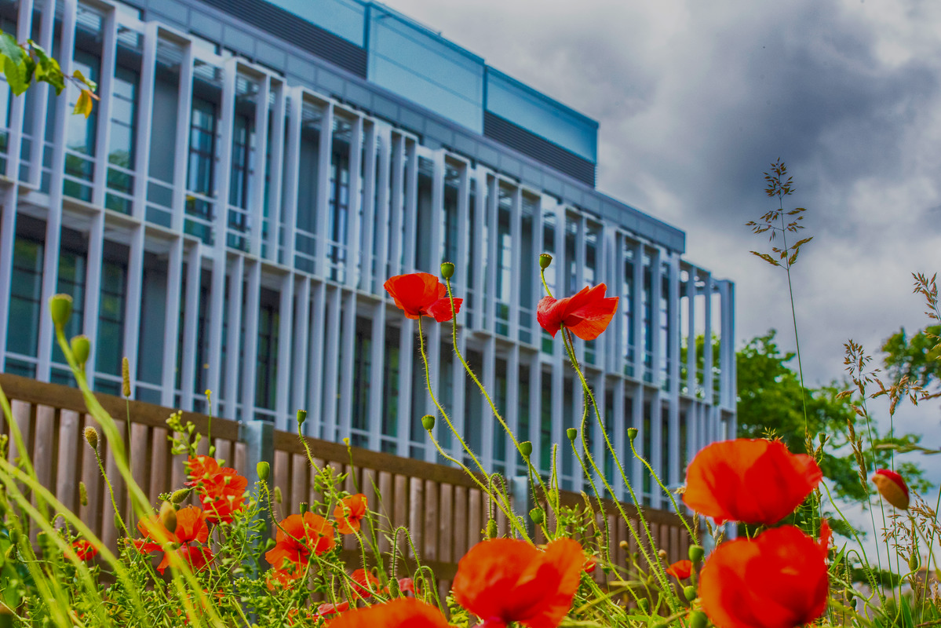

## The Directorate of XXX

The Directorate’s responsibilities include <insert text>

The School’s areas of expertise and interest include <insert text>

## Aberdeen and Aberdeenshire

Scotland’s third largest city, Aberdeen sits on the coast between the mountains of Aberdeenshire and the stunning North Sea coastline. The Aberdeen City region is a can-do place that is actively investing, at scale, in its future.

Renowned as a Global Energy Hub, Aberdeen is a vibrant, entrepreneurial region, home to a unique mix of business opportunities and specialist skills across various sectors including energy, technology, life sciences and food & drink. More than 20% of Scotland’s top businesses are located in this region which is taking great strides to ensure that it continues to compete on a world stage. Investments of more than £10 billion of public and private infrastructure is due to be delivered before 2030, marking an exciting time to be part of a genuine world-class location.

Built from sparkling local granite Aberdeen has earned the name of the Silver City. As the energy capital of Europe, Aberdeen nevertheless retains its old-fashioned charm and character making it an attractive place in which to live, work and study. Due to its global business and international energy industry credentials, Aberdeen is well served by local and national transport infrastructure with excellent rail networks that run both North and South of Scotland and the rest of the UK. It also acts as an international travel hub. Flying time to London is just over one hour with regular daily flights and serves international travel to European centres such as Amsterdam (Schiphol) and Paris (Charles de-Gaulle) as well as flights to other European destinations.

The City and the surrounding countryside provide a variety of urban, seaside and country attractions. Aberdeen has first class amenities including [His Majesty’s Theatre](https://www.aberdeenperformingarts.com/his-majestys-theatre/), [Music Hall](https://www.aberdeenperformingarts.com/music-hall/), [Art Gallery](https://www.aberdeencity.gov.uk/AAGM), [the P&J Arena](https://www.pandjlive.com/), [Museums](https://www.aberdeencity.gov.uk/AAGM), and [Beach Leisure Centre](https://www.sportaberdeen.co.uk/venues/get-active-beach-leisure-centre/). The City is framed by its accessible beach front which is within a short walk of the city centre and there are an array of activities available across the region such as hill walking; mountaineering; sailing; surfing; salmon, trout and sea fishing; golf; sailing; surfing and windsurfing. The surrounding countryside, known as Aberdeenshire, is also one of Scotland’s most appealing regions. Royal Deeside and the Cairngorms National Park are within easy access of the city, and there are a variety of towns and villages scattered along the coastline.

The city and the surrounding area have ranked consistently highly in nationally recognised quality of life surveys, coming out top 10 as one of the best places to live in Scotland in 2020 in the annual Bank of Scotland survey.

To find out more visit www.visitabdn.com



## Equality and Diversity

The University values and celebrates a diverse working and learning environment and recognises the richness this brings, both in terms of contributing to the success of the University and creating safe and inclusive cultures. We welcome applications from individuals with diverse lived experiences.

The University supports flexible working, including hybrid working arrangements, and has policies in place to facilitate this where it is appropriate. The policies can be found at <https://www.abdn.ac.uk/staffnet/working-here/flexible-working--5607.php>.

We are committed to progressing gender equality across all functions and a proud member of the Advance HE Athena Swan Charter, achieving an institutional Bronze award, Silver departmental award and departmental Bronze awards. LGBTQ+ equality is championed through the University’s membership of the Stonewall Diversity Champions Programme, where the University has achieved a Silver award in the Workplace Equality Index. The University is on a continual journey to respond to, and combat, GBV in our community and beyond. We are proud to have been awarded the EmilyTest Charter, in partnership with the charity, EmilyTest. We all have a role to play in knowing how to signpost colleagues and students to support for gender-based violence, and training and support is available to all staff on this topic.

The University affirms its commitment to the Charter’s aim of improving the representation, progression and success of staff and students who identify as belonging to a racialised group. Our Antiracism Strategy was launched in 2022, representing a bold framework for progress on race equality. Recognising the importance of addressing the under-representation of racialised groups in the senior team, the University’s new Recruitment and Selection Policy embeds specific positive action measures to address this.

The University is delighted to be accredited as a [Disability Confident](https://disabilityconfident.campaign.gov.uk/) employer and strives to ensure that disabled staff and students have the opportunity to work and study in an inclusive, accessible and supportive environment. The University’s Wellbeing Strategy commits to progressing work to tackle stigma related to mental health and action to promote and improve health and wellbeing for staff and students. Candidates who are British Sign Language (BSL) users can contact us directly by using [contact SCOTLAND-BSL](https://contactscotland-bsl.org/).

Our work on equality, diversity and inclusion is supported by a range of networks and engagement activities, designed to provide safe spaces and raise awareness of the support available and the steps everyone can take to create inclusive campuses. [www.abdn.ac.uk/staffnet/governance/equality-and-diversity-277](http://www.abdn.ac.uk/staffnet/governance/equality-and-diversity-277)

## How to Apply

Online application forms are available at [www.abdn.ac.uk/jobs](http://www.abdn.ac.uk/jobs)

The closing date for receipt of applications is Closing Date

Should you wish to make an informal enquiry please contact:

**Name, Job Title**

01224 27**xxxx**

**xxx**@abdn.ac.uk

Please do not send application forms or CVs to **Name**.

**Please quote reference number XXX on all correspondence**

1. The Times and Sunday Times Good University Guide 2023 and the Guardian University Guide 2023
2. National Student Survey (NSS) 2022
3. Times Higher Education World University Rankings 2021
4. Times Higher Education Impact Rankings 2022
5. QS World University Rankings 2022