Equality, Diversity and Inclusion Digest (May 2024)
Welcome to the Equality, Diversity and Inclusion (EDI) Digest where you will find a rundown of EDI activities over the last quarter including discussions at our latest University EDI Committee (in April 2024).
The information presented in this digest is organised with reference to the University of Aberdeen's Equality Outcomes and Aberdeen 2040's Inclusive commitments.
Please note: This EDI digest is in a new format. We have endeavoured to ensure accessibility, if you experience any accessibility challenges, please do let us know via edi@abdn.ac.uk.. The digest is also available in Word on our EDI committee web page.

Equality Diversity and Inclusion Governance
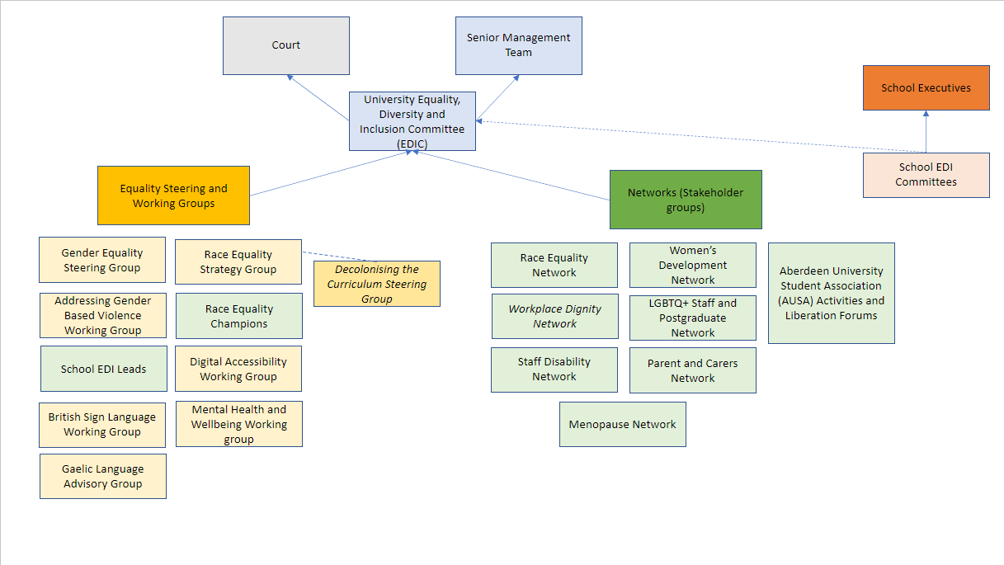
1 - Visual of the University's EDI Governance structure
The University's EDI Committee (EDIC) normally meets four times a year and is responsible for the strategic direction of Equality, Diversity and Inclusion activities as set out within the Inclusive strand of Aberdeen 2040 and the University's Equality Outcomes for the period up to 2025.
EDIC reports to Senior Management Team and University Court. The University's Equality Steering Groups and Working Groups, staff networks and student liberation forums report to EDIC. Equality Groups include the Gender Equality Steering Group, the Race Equality Strategy Group, Addressing Gender Based Violence Working Group, Digital Accessibility Working Group, British Sign Language Working Group, Mental Health and Wellbeing working group and Gaelic Language Advisory Group. School EDI committees report to School Executives and feed into the University EDIC.
Professor Jo-Anne Murray, Vice-Principal (Education), recently took over as chair to Equality, Diversity and Inclusion (EDI) Committee. Jo-Anne has also taken over as co-chair to our Race Equality Strategy Group.
2 - Professor Jo-Anne Murray, Vice-Principal (Education)

Equality Outcome Spotlight
At EDIC all our Equality Outcomes are considered, on a rotational basis. At the recent EDIC (held in April 2024), focus was on the following Equality Outcomes:
- Outcome 1: Achieve the highest recognition in equality and diversity through achievement of awards in accreditation initiatives such as Athena Swan, Race Equality Charter and Stonewall Workplace Equality Index
- Outcome 2: Tackle mental health stigma to improve outcomes and experiences for staff and students who have mental ill health.
- Outcome 5: Eliminate barriers to learning, progression, promotion and physical accessibility for disabled staff and students.

Eliminate barriers for disabled staff and students (Outcome 5)
The EDI committee considered the proposals for the Reimagining our Campuses project in relation to improving accessibility and inclusion. EDIC discussions included whether an Equality Impact Assessment had been initiated. Equality Impact Assessments developed from the outset of projects of this scale and scope can support in identifying both positive and negative equality impacts. EDIC also queries how stakeholders and stakeholder groups, who have specific lived experience in relation to inclusion and access to the campuses, have been engaged with the project. Subsequently, EDIC feedback was summarised and shared with the Reimagining our Campuses steering group.
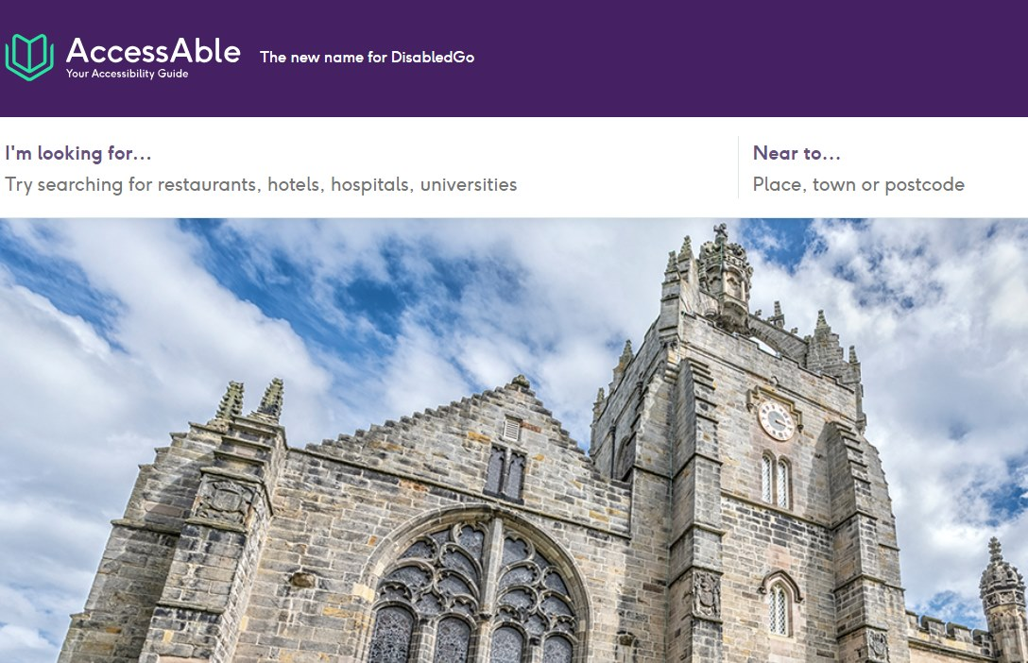
3 - Access Able
The University of Aberdeen works with AccessAble to provide online access guides for buildings across the campuses.
EDIC also received an update from the Digital Accessibility Working Group (DAWG), progress with the University's second British Sign Language plan and on the recent review of the study-related support provisions, which has considered exam provisions, terminology and the application of provisions or adjustments beyond health and / or disability.

Digital Accessibility Working Group
The Digital Accessibility Working Group (DAWG) oversees work to improve the accessibility and inclusivity of the University’s digital estate, ensuring institutional compliance with the Public Sector Bodies (Websites and Mobile Applications) (No. 2) Accessibility Regulations.
Want to find out how you can improve digital accessibility in your teaching?
The Inclusivity and Accessibility Framework details our obligations, provides tools and resources and signposts to support available.
All university staff can access the online introductory module and the Accessibility and Me: Lived Experience Mini Modules designed to equip colleagues with guidance on how to create accessible content for teaching and learning.
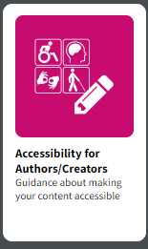
4 - Authors and Creators Accessibility Toolkit

British Sign Language
The University of Aberdeen has recently developing its second British Sign Language (BSL) Plan (2024-2030). Our commitment is to create inclusive working and studying environments where BSL culture is celebrated and accessibility is embedded in all our functions. Read more about the University's British Sign Language plan...
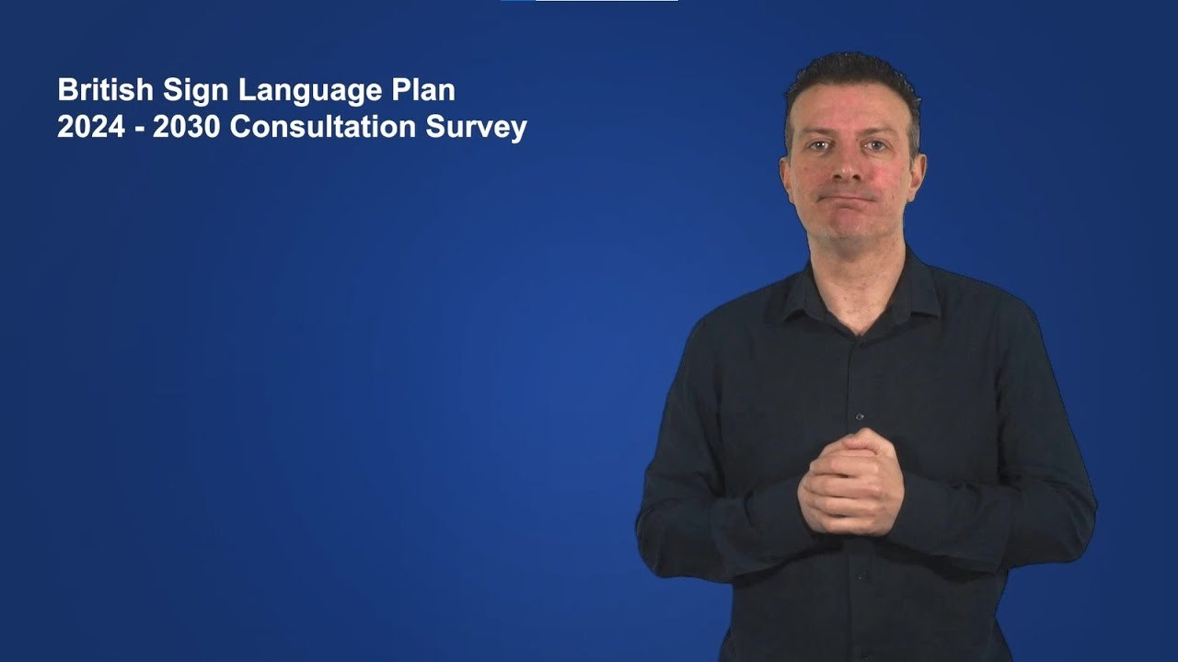
5 - British Sign Language plan consultation video explainer

Tackle mental health stigma (Outcome 2)
At the University's recent EDIC, an update was provided on progress for the University’s Wellbeing strategy (2021 – 2025), which sets out the approach to supporting our community to maintain positive wellbeing, support the prevention of mental and physical ill health. Priorities over the next quarter include the development and rollout of the Suicide Safer University strategy to minimise the risk and wide-reaching impact of suicide within our community. Find out more about wellbeing resources, training, events and activities...

Gender Equality / Athena Swan Charter Mark (Outcome 1)
The University's Gender Equality Steering Group (GESG), established in 2023, is responsible for supporting the implementation of the Aberdeen 2040 Inclusive commitments related to gender equality and acting as the Self-Assessment Team for the University's Silver-level Athena Swan Submission by 2026.
Since convening, GESG has focused on:
- reviewing of the Institutional Athena Swan action plan;
- developing the project plan and timeline in preparation for the University’s next Institutional submission in 2026;
- gathering insight on School management of Athena Swan (including workload allocations, administrative support and challenges experienced).

Dignity at Work and Study
The University does not tolerate any form of discrimination and will not condone any acts of harassment, bullying, violence and sexual misconduct.
This includes all forms of:
- gender based violence and harassment
- targeted abuse based on gender, gender identity or sexual orientation towards members of the LGBTQ+ community
- racism or attacks against someone based on their ethnicity
- all hate towards any protected characteristic (such as age, disability and religion).
Read more on how to access support or to make a Report to the University through our Online Reporting Tool.

Staff Equality Networks / Student Liberation Forums
We have a range of Staff and PGR Student Equality Networks at the University, including the LGBTQ+ Staff and Postgraduate Network, Women's Development Network, Parents & Carers Network, Menopause Network, Race Equality Network and Disability Network. There are also student Liberation Forums.
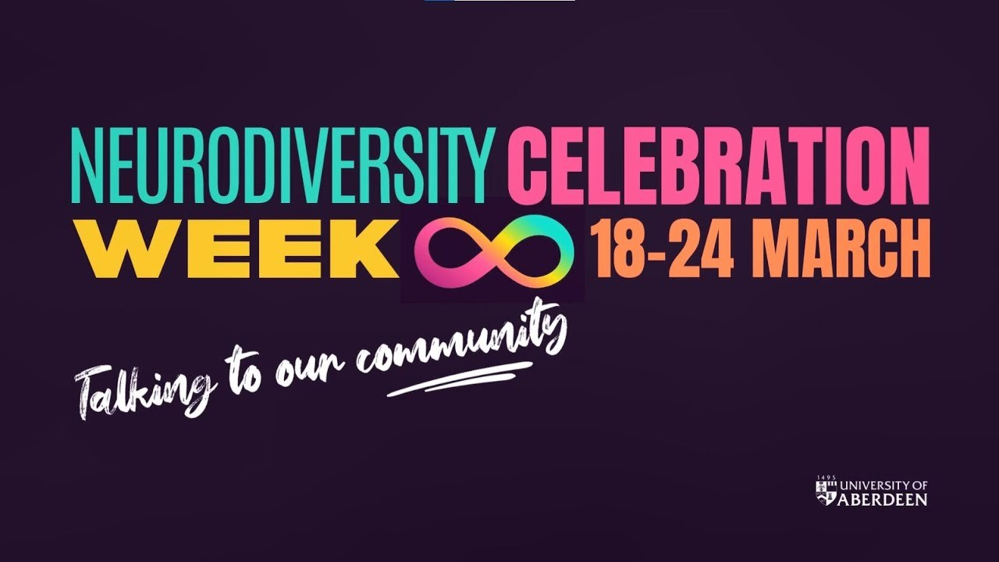
6 - Neurodiversity Celebration Week: Talking to our Community video
New Neurodiversity Network
The proposal for a new Neurodiversity Network was supported by EDI Committee initiated following the development and publication of the University’s Neurodiversity Equality policy in 2023. Watch out for further information in due course... In the meantime, you can read more on our recent Neurodiversity Celebration Week
The staff events and activities calendar details upcoming events.
This upcoming Pride Month, June 2024, the University has a packed schedule, hosting several events platforming the diversity of our large community. The LGBTQ+ Staff and Postgrad Network will also be walking in the Grampian Pride parade with an open invite to all Staff Equality Networks and Student Liberation Forums to walk with them.
Please see the Pride Month | What's On | The University of Aberdeen web page for all event details.
7 - Pride 2024 banner

Resources!
There are online EDI modules and many other resources available on the above topics. Thank you to Dr Aideen M. O'Leary and Barbara Barreiro, Race Equality Champions, School of Language, Literature, Music and Visual Culture for sharing their Equality Playlist! We have shared a few resources from their playlist.
8 - Be Well Podcast Series
The Be Well podcast series focuses on topical wellbeing issues from student pressure points to national wellbeing campaigns. The series is hosted by Wellbeing Adviser Bekah Walker who is joined each week by guest speakers from our staff and student community.
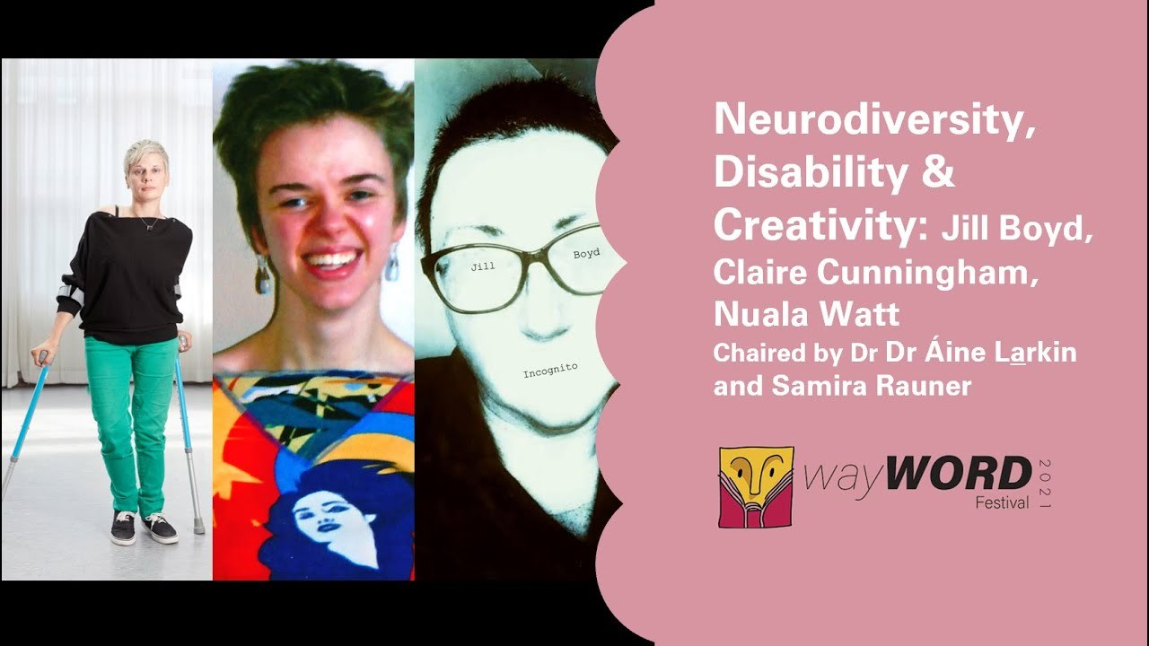
9 - Event recording
‘The Truth About Mental Health podcast series’, produced by BBC World Service radio series and includes globally-based discussions.
Contact us!
If you have any feedback or suggestions for the EDI digest, please let us know at edi@abdn.ac.uk

