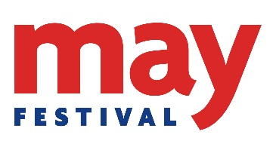 **May Festival Call for Ideas 2019**

**Want to be involved in the May Festival? Interested in hosting an event?**

**Please fill in one form for each event you would like to submit for consideration and send them to the Festivals and Events Team at** [**festival@abdn.ac.uk**](mailto:festival@abdn.ac.uk) **by Friday 7th December at the very latest.**

|  |
| --- |
| **Your Name:** |
| **Your School/Section/Dept:** |
| **Your Email address:** |
| **Your Mobile number:** |
| 1. **Are you filling this form out for yourself or on behalf of another person/party?** |
| 1. **Please list the full names and contact details (email & mobile) of all of the speakers/performers for the event if this is not you:** |
| 1. **Please provide us with a detailed description of your idea/event:** |
| 1. **Which of our Programmes do you think your event would come under? (tick all that apply)**   □ Main Programme (Friday 24 – Sunday 26 May - open to public)  □ Schools’ Programme (Tuesday 21 & Wednesday 22 May - activities for school class groups)  □ Children’s Programme (Saturday 25 & Sunday 26 May - activities for families, open to public)  □ Exhibitions (Friday 24 – Sunday 26 May - open to public)  □ Tours (Friday 24 – Sunday 26 May - open to public) |
| 1. **What type of audience is your event aimed at?** E.g. primary school, secondary school, adults, young people, children and families |
| 1. **Which of the main May Festival themes do you think your event aligns with?** E.g. music, science, environment, literature, sport, food and drink, history & heritage, film, current affairs, Gaelic etc. |
| 1. **Suggested a venue type and time of your event**. Consider capacity and room set-up e.g. is your event a lecture for 100 people or a workshop for 20. Do you need a flat performance space? Do you need desks and chairs? What date/time of day would be your preference? |
| 1. **Do you have a maximum number of people you would expect to attend or take part in your event?** |
| 1. **Please indicate if you have funding for your event.** E.g. research grant/school budget. |
| 1. **What do you hope to gain by being part of the Festival? (tick all that apply)**   □ Skills development  □ Personal enjoyment  □ Encourage use of research findings  □ Disseminate research findings  □ Develop links or test an idea with a non-academic audience  □ Enhance research impact  □ Other*  If other, please specify: |