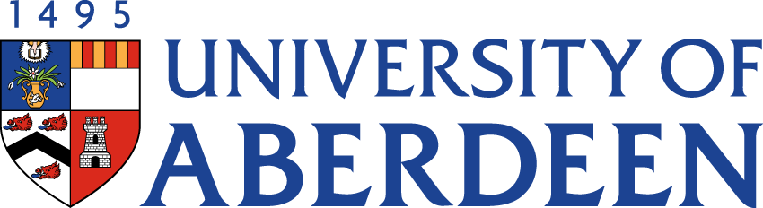

There will be a meeting of the SUSTAINABLE DEVELOPMENT COMMITTEE on WEDNESDAY 30 AUGUST 2023 at 9.05am – 10.55am via Microsoft Teams.
Heather Crabb
Senior Vice-Principal’s Office
Tel: 01224 272404
Email: h.crabb@abdn.ac.uk
BUSINESS
DECLARATION OF INTEREST:
Any member or individual in attendance (including officers) who has a clear interest in a matter on the agenda must declare that interest at the meeting. Items for information will not normally be considered.

FOR DISCUSSION

- MINUTES
Minutes of the Sustainable Development Committee meeting held on 30 May 2023

- MATTERS ARISING
  - Table of Actions

- ANNUAL REVIEW OF TERMS OF REFERENCE

- SUSTAINABILITY RISK REGISTER

- ABERDEEN 2040 IMPLEMENTATION PLAN UPDATE

- INTERNAL AUDIT REPORT

LIVING & WORKING SUSTAINABLY

- STRATEGIC DISCUSSION TOPIC – THE SUSTAINABLE CAMPUS

EDUCATION

- UPDATE FROM DEAN (EDUCATION)
  - Graduate Attributes & Skills Update (Oral)

- UPDATE FROM AUSA

NET ZERO

- NET ZERO UPDATE

RESEARCH

- UPDATE FROM INTERDISICPLINARY CENTRES

- DATE OF NEXT MEETING
The next meeting of the Sustainable Development Committee will be held on Monday 13 November 2023 at 2.05pm via Microsoft Teams.

