*SR3009- Applied Practice in Sports Science 1*

*Course Handbook 2023-2024*

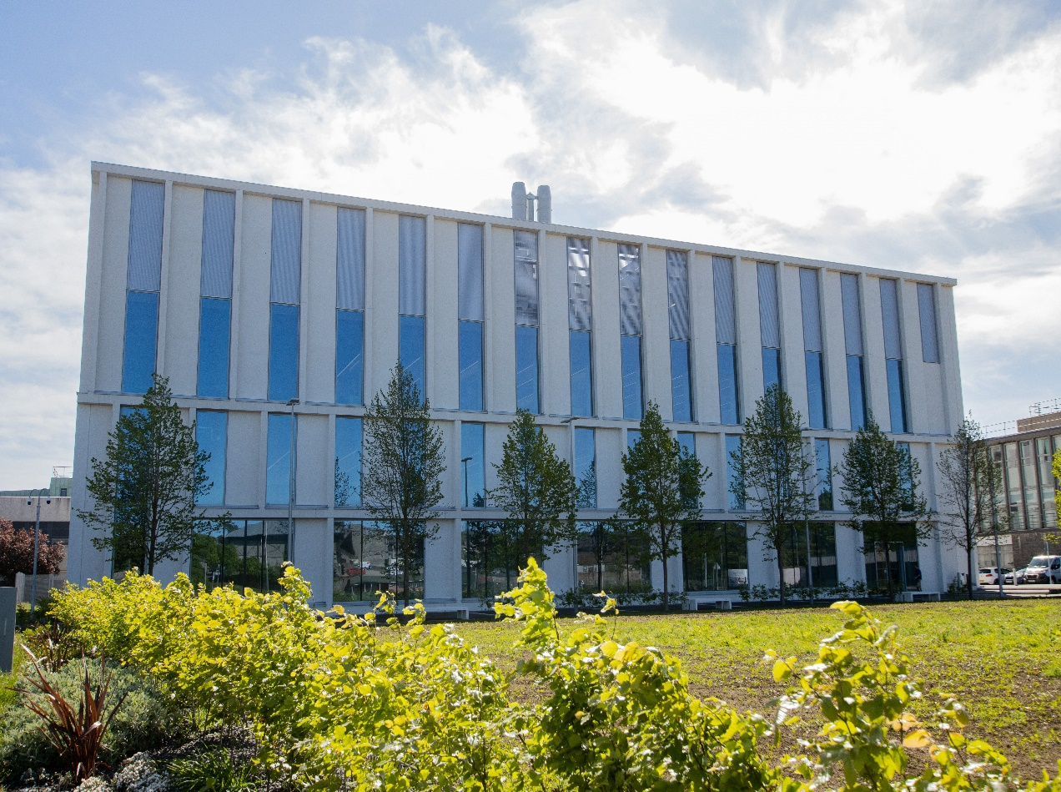

***Undergraduate Medical Sciences***

***School of Medicine, Medical Sciences & Nutrition***

**Contents**

* Course Summary (3)
* Course Aims & Learning Outcomes
* Course Teaching Staff
* Assessments & Examinations
* Class Representatives (4)
* Problems with Coursework (5)
* Course Reading List
* Lecture Synopsis
* Practical/Lab/Tutorial Work
* University Policies (6)
* Academic Language & Skills support (7)
* Medical Sciences Common Grading Scale (8)
* Course Timetable SR3009: 2023-2024 (9)
* Campus and Floor Maps

Course Summary

For the sports science practitioner experience of working with both coaches and athletes in an applied setting is a key skill to understanding the challenges and rewards that are gained from this exposure. The course described in the coursebook provides an overview of the practices employed when interacting with coach and athlete to meet their demands, which could range for an assessment of force/power production, the implementation of novel training practice through to dietary advice and education. The course describes the process of professional conduct and ethics and confidentiality agreements, conducting a needs analysis for athlete to assess sports performance, training practice and/or nutritional status. The course incorporates a significant practical element and is assessed in two elements.

Course Co-ordinator: Dr Derek Ball (ext. 7456) [derek.ball@abdn.ac.uk](mailto:derek.ball@abdn.ac.uk)

External links: Mr Patrick Miley, Mr Eddie McKenna,

Course Aims & Learning Outcomes

The learning outcomes of this course are:

* An understanding of the role of Sport Scientist in provision of Sport Science Support
* To recognize the principles of conducting a needs analysis for coaches and athletes
* Adopt the professional attributes of the Sport Scientist, in relation to attitude, confidentiality and ethics
* To conduct a needs analysis for an athlete/coach/team and construct a plan to provide sport science to support.
* To demonstrate a program of sport sciences support and reflective analysis.

Course Teaching Staff

**Course Coordinator(s):**

Dr Derek Ball (DB), Medical Sciences

**Other Staff:**

Ms Gillian Kerr (GK)

Mr Dan Sutton (DS)

Assessments & Examinations

Students are expected to attend all lectures, tutorials, and presentation sessions and to complete all class exercises by stated deadlines. It is imperative that any reasonable excuses for the late handing in of work are made to the course organiser (Dr Derek Ball) before the deadline date. Failure to do so will result in the work not being marked and the class certificate, which is required, may be withheld. The minimum performance acceptable for the granting of a class certificate is attendance at all practical sessions, and completion of all course assessments, both written and practical (OSPE).

The course is based on 100% continuous assessment (CA): 25% of the course assessment is based on student groups conducting a needs analysis assessment to be completed by week 12 of the course. Each group of students will complete an oral presentation and report of their project that counts for the 50% (25:25) of continuous assessment that describes the needs analysis, plan and outcome of their sport sciences support. Individually, each student will submit a written report of their reflective summary of the experience with their chosen sport (25% of the CA). The overall report may be co-assessed by the academic staff and the coach (where applicable).

Common grading scale (CGS) grade: The overall performance of the student is expressed as a grade awarded on the common spine marking scale (see attached sheet).

The resit assessment for this course will be through a written assessment.

# 

# Class Representatives

We value students’ opinions in regard to enhancing the quality of teaching and its delivery; therefore, in conjunction with the Students’ Association we support the Class Representative system.

In the School of Medicine, Medical Sciences & Nutrition we operate a system of course representatives, who are elected from within each course. Any student registered within a course that wishes to represent a given group of students can stand for election as a class representative. You will be informed when the elections for class representative will take place.

What will it involve?

It will involve speaking to your fellow students about the course you represent. This can include any comments that they may have. You will attend a Staff-Student Liaison Committee and you should represent the views and concerns of the students within this meeting. As a representative, you will also be able to contribute to the agenda. You will then feedback to the students after this meeting with any actions that are being taken.

Training

Training for class representatives will be run by the Students Association. Training will take place within each half-session. For more information about the Class representative system visit [www.ausa.org.uk](http://www.ausa.org.uk) or email the VP Education & Employability [vped@abdn.ac.uk](mailto:vped@abdn.ac.uk) . Class representatives are also eligible to undertake the STAR (Students Taking Active Roles) Award with further information about this co-curricular award being available at: [www.abdn.ac.uk/careers](http://www.abdn.ac.uk/careers).

Problems with Coursework

If students have difficulties with any part of the course that they cannot cope with, alone they should notify the course coordinator immediately. If the problem relates to the subject matter general, advice would be to contact the member of staff who is teaching that part of the course. Students with registered disabilities should contact the medical sciences office, ([medsci@abdn.ac.uk](mailto:medsci@abdn.ac.uk)) (based in the Polwarth Building, Foresterhill) to ensure that the appropriate facilities have been made available. Otherwise, you are strongly encouraged to contact any of the following as you see appropriate:

* Course student representatives
* Course co-ordinator
* Convenor of the Medical Sciences Staff/Student Liaison Committee (Dr Donna McCallum)
* Personal Tutor
* Medical Sciences Disabilities Co-ordinator (Dr Derryck Shewan)

All staff are based at Foresterhill and we strongly encourage the use of email or telephone the Medical Sciences Office. You may have a wasted journey travelling to Foresterhill only to find staff unavailable.

If a course has been completed and students are no longer on campus (i.e. work from second half session during the summer vacation), coursework will be kept until the end of Fresher’s Week, during the new academic year. After that point, unclaimed student work will be securely destroyed.

Lecture Synopsis

Teaching will take place at the King’s College site and Aberdeen Sports Village (Aberdeen University Sports Pavillion) and at the Foresterhill campus. The course starts with tutorials that will cover the role of the Sport Scientist and process of building a working relationship with coach/athlete or team. Additional tutorials will be conducted to further discuss the role of the sport scientist and the ethical and confidentiality requirements of the applied sport scientist and as progress reports as you complete your placement. Electronic copies of the course material will be posted on MyAberdeen.

Practical/Lab/Tutorial Work

**Practical/Lab Work**

It is likely that the practical elements of this course will be conducted at either the Aberdeen Sports Village (athletics track/indoor sports area/aquatic centre), King’s Pavilion or outdoor sports pitches.

**University Policies**

Students are asked to make themselves familiar with the information on key education policies, available here. These policies are relevant to all students and will be useful to you throughout your studies. They contain important information and address issues such as what to do if you are absent, how to raise an appeal or a complaint and how the University will calculate your degree outcome.

These University wide education policies should be read in conjunction with this programme and/or course handbook, in which School specific policies are detailed. These policies are effective immediately, for the 2023/24 academic year. Further information can be found on the University’s Infohub webpage or by visiting the Infohub.

The information included in the institutional area for 2023-24 includes the following:

• Assessment

• Feedback

• Academic Integrity

• Absence

• Student Monitoring/ Class Certificates

• Late Submission of Work

• Student Discipline

• The co-curriculum

• Student Learning Service (SLS)

• Professional and Academic Development

• Graduate Attributes

• Email Use

• MyAberdeen

• Appeals and Complaints

Where to Find the Following Information:

C6/C7- University of Aberdeen Homepage > Students > Academic Life > Monitoring and Progress > Student Monitoriung (C6 & C7)

https://www.abdn.ac.uk/students/academic-life/student-monitoring.php#panel5179

Absences- To report absences you should use the absence reporting system tool on Student Hub. Once you have successfully completed and sent the absence form you will get an email that your absence request has been accepted. The link below can be used to log onto the Student Hub Website and from there you can record any absences you may have.

[Log In - Student Hub (ahttps://www.abdn.ac.uk/studenthub/loginbdn.ac.uk)](https://www.abdn.ac.uk/studenthub/login)

Submitting an Appeal- University of Aberdeen Homepage > Students > Academic Life > Appeals and Complaints

https://www.abdn.ac.uk/students/academic-life/appeals-complaints-3380.php#panel2109

Academic Language & Skills support

For students whose first language is not English, the Language Centre offers support with Academic Writing and Communication Skills.

Academic Writing

* Responding to a writing task: Focusing on the question
* Organising your writing: within & between paragraphs
* Using sources to support your writing (including writing in your own words, and

citing & referencing conventions)

* Using academic language
* Critical Thinking
* Proofreading & Editing

Academic Communication Skills

* Developing skills for effective communication in an academic context
* Promoting critical thinking and evaluation
* Giving opportunities to develop confidence in communicating in English
* Developing interactive competence: contributing and responding to seminar discussions
* Useful vocabulary and expressions for taking part in discussions

More information and how to book a place can be found here

Medical Sciences Common Grading Scale

|  |  |  |  |  |  |
| --- | --- | --- | --- | --- | --- |
| **Grade** | **Grade Point** | **% Mark** | **Category** | **Honours Class** | **Description** |
| A1 | 22 | 90-100 | Excellent | First | • Outstanding ability and critical thought • Evidence of extensive reading • Superior understanding •The best performance that can be expected from a student at this level |
|  |
| A2 | 21 | 85-89 |  |
|  |
| A3 | 20 | 80-84 |  |
|  |
| A4 | 19 | 75-79 |  |
|  |
| A5 | 18 | 70-74 |  |
|  |
| B1 | 17 | 67-69 | Very Good | Upper Second | • Able to argue logically and organise answers well  • Shows a thorough grasp of concepts  • Good use of examples to illustrate points and justify arguments  • Evidence of reading and wide appreciation of subject |  |
|  |
| B2 | 16 | 64-66 |  |
|  |
| B3 | 15 | 60-63 |  |
|  |
| C1 | 14 | 57-59 | Good | Lower Second | • Repetition of lecture notes without evidence of further appreciation of subject • Lacking illustrative examples and originality • Basic level of understanding |  |
|  |
| C2 | 13 | 54-56 |  |
|  |
| C3 | 12 | 50-53 |  |
|  |
| D1 | 11 | 47-49 | Pass | Third | • Limited ability to argue logically and organise answers • Failure to develop or illustrate points • The minimum level of performance required for a student to be awarded a pass |  |
|  |
| D2 | 10 | 44-46 |  |
|  |
| D3 | 9 | 40-43 |  |
|  |
| E1 | 8 | 37-39 | Fail | Fail | • Weak presentation • Tendency to irrelevance • Some attempt at an answer but seriously lacking in content and/or ability to organise thoughts |  |
|  |
| E2 | 7 | 34-36 |  |
|  |
| E3 | 6 | 30-33 |  |
|  |
| F1 | 5 | 26-29 | Clear Fail | Not used for Honours | • Contains major errors or misconceptions • Poor presentation |  |
|  |
| F2 | 4 | 21-25 |  |
|  |
| F3 | 3 | 16-20 |  |
|  |
| G1 | 2 | 11-15 | Clear Fail/Abysmal |  | • Token or no submission |  |
|  |
| G2 | 1 | 1-10 |  |
|  |
| G3 | 0 | 0 |  |
|  |

Course Timetable SR3009: 2023-2024

|  |  |  |  |  |  |
| --- | --- | --- | --- | --- | --- |
| **Date** | **Time** | **Place** | **Subject** | **Session** | **Staff** |
|  |  |  | **Week 9** |  |  |
| Mon 25 Sep | 09:00-10:00 | G3 St Marys | Course introduction | Lecture | DB |
| Tue 26 Sep |  |  |  |  |  |
| Wed 27 Sep |  |  |  |  |  |
| Thu 28 Sep |  |  |  |  |  |
| Fri 29 Sep | 11:00-12:00 | Auris LT | The role of Sport Scientist | Lecture | DB |
|  |  |  | **Week 10** |  |  |
| Mon 02 Oct |  |  |  |  |  |
| Tue 03 Oct | 12:00-13:00 | Auris LT | Conducting a needs analysis | Lecture | DB |
| Wed 04 Oct |  |  |  |  |  |
| Thu 05 Oct | 10:00-11:00 | Auris LT | Strategies to meet the needs of the coach and athlete | Lecture | DB |
| Fri 06 Oct |  |  |  |  |  |
|  |  |  | **Week 11** |  |  |
| Mon 09 Oct | 10:00-11:00 | KQG7 | Introduction to bursar athlete | Tutorial | DB/CR/GK |
| Tue 10 Oct | 14:00-16:00 | STH 0.001 | Assessment of power production and aerobic capacity with Wattbike | Practical | DB/DS |
| Wed 11 Oct |  |  |  |  |  |
| Thu 12 Oct | 09:00-11:00 | STH 0.001 | Assessment of speed and power production, force plate and opto gates | Practical | DB/DS |
| Fri 13 Oct |  |  |  |  |  |
|  |  |  | **Week 12** |  |  |
| Mon 16 Oct | 10:00-11:00 | MT2 | The process of self-reflection | Lecture | DB |
| Tue 17 Oct | 10:00-12:00 | ASV | Assessing 1RM and 3RM loading | Practical | DS |
| Wed 18 Oct | Deadline 16:00 | MyAb | coach/athlete/team Needs analysis | Assessment | DB |
| Thu 19 Oct | 10:00-12:00 | ASV | Procedure for assessing fast bowler | Tutorial | DS |
| Fri 20 Oct |  |  |  |  |  |
|  |  |  | **Week 13** |  |  |
| Mon 23 Oct | 10:00-11:00 | MT2 | Progress report | Tutorial | DB |
| Mon 23 Oct |  |  |  |  |  |
| Tue 24 Oct |  |  |  |  |  |
| Wed 25 Oct |  |  |  |  |  |
| Thu 26 Oct |  |  |  |  |  |
| Fri 27 Oct |  |  |  |  |  |
|  |  |  | **Week 14** |  |  |
| Mon 30 Oct |  |  |  |  |  |
| Tue 31 Oct |  |  |  |  |  |
| Wed 01 Nov |  |  |  |  |  |
| Thu 02 Nov |  |  |  |  |  |
| Fri 03 Nov |  |  |  |  |  |
|  |  |  | **Week 15** |  |  |
| Mon 06 Nov |  |  |  |  |  |
| Tue 07 Nov |  |  |  |  |  |
| Wed 08 Nov |  |  |  |  |  |
| Thu 10 Nov |  |  |  |  |  |
| Fri 11 Nov |  |  |  |  |  |
|  |  |  | **Week 16** |  |  |
| Mon 13 Nov | 10:00-11:00 | KCG7 | Progress report | Tutorial | DB/CR/GK |
| Tue 14 Nov |  |  |  |  |  |
| Wed 15 Nov |  |  |  |  |  |
| Thu 16 Nov |  |  |  |  |  |
| Fri 17 Nov |  |  |  |  |  |
|  |  |  | **Week 17** |  |  |
| Mon 20 Nov | 10:00-11:00 | KCG7 | Progress report | Tutorial | DB/CR/GK |
| Tue 21 Nov |  |  |  |  |  |
| Wed 22 Nov |  |  |  |  |  |
| Thu 23 Nov |  |  |  |  |  |
| Fri 24 Nov |  |  |  |  |  |
|  |  |  | **Week 18** |  |  |
| Mon 27 Nov | 10:00-12:00 |  | Presentation of placement | Assessment | DB/CR/GK |
| Tue 28 Nov |  |  |  |  |  |
| Wed 29 Nov |  |  |  |  |  |
| Thu 30 Nov |  |  |  |  |  |
| Fri 01 Dec |  | MyAb | Final group report and self-reflection document | Assessment | DB |
|  |  | **Week 19** | |  |  |
| Mon 04 Dec |  |  |  |  |  |
| Tue 05 Dec |  |  |  |  |  |
| Wed 06 Dec |  |  |  |  |  |
| Thu 07 Dec |  |  |  |  |  |
| Fri 08  Dec |  |  |  |  |  |
|  |  | **Week 20** | |  |  |
| Mon 11 Dec |  |  |  |  |  |
| Tue 12 Dec |  |  |  |  |  |
| Wed 13 Dec |  |  |  |  |  |
| Thu 14 Dec |  |  |  |  |  |
| Fri 15 Dec |  |  |  |  |  |

Staff

|  |
| --- |
| Dr Derek Ball (DB), Medical Sciences (Course Coordinator) |
| Mr Dan Sutton (DS), Medical Sciences |
| Dr Christine Roberts (CR), Aberdeen Sports Village |
| Ms Gillian Kerr (GK), Aberdeen Sports Village |

Campus Maps - Foresterhill

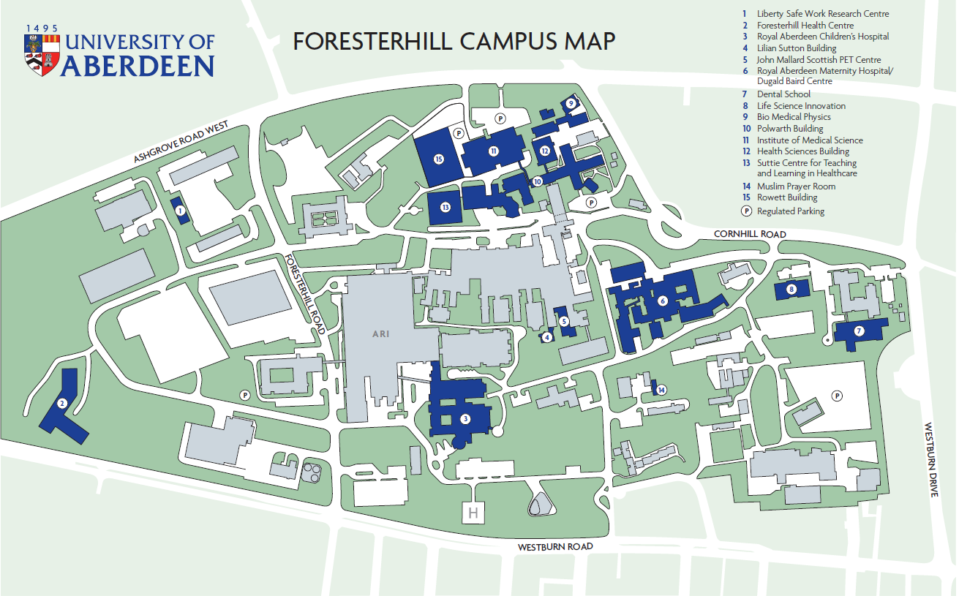

Polwarth Floor Plans

