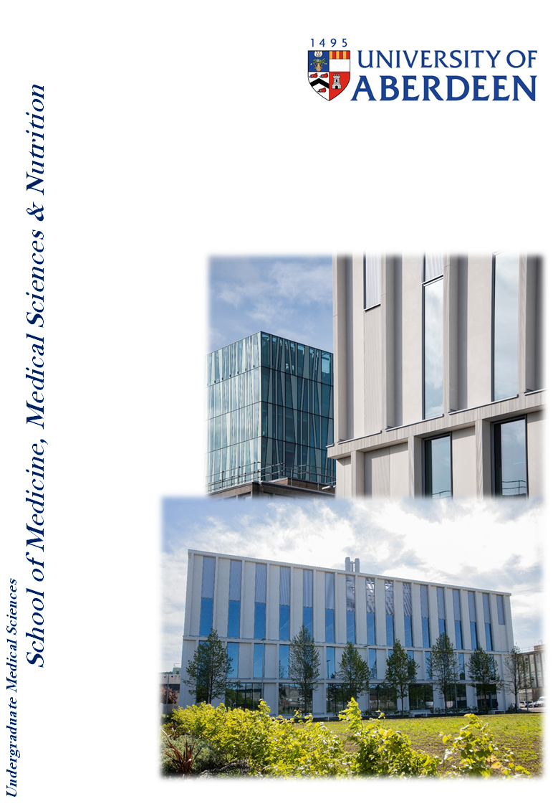

SR2003 Principles of Strength and conditioning

Course Handbook 2023-24

**Contents**

* Course Summary (3)
* **Course Aims & Learning Outcomes**
* **Course Teaching Staff**
* **Assessments & Examinations**(4)
* **Class Representatives**
* **Problems with Coursework**(5)
* **Course Reading List**(6)
* **Lecture Synopsis**
* **Practical/Lab/Tutorial Work**
* **University Policies**
* **Academic Language & Skills support**(7)
* **Medical Sciences Common Grading Scale**(8)
* **Course Timetable SR2003: 2023-2024**(9)
* Campus and Floor Maps

Course Summary

For the sports science practitioner an understanding of the principles of strength and conditioning is a pre-requisite to working with both coaches and athletes. The course described in the coursebook provides the fundamental principles related to muscle physiology, training load and volume and an assessment of neuromuscular performance. The course describes the physiology of the neuromuscular system to meet the demands of exercise and training, with a focus on the development of force and power to improve sports performance. The course includes practical elements and assessment of neuromuscular function, the design and application of a training programme to improve either strength or power and the safe practice of both functional assessment and training programmes.

Course Co-ordinator: Dr Derek Ball (ext. 7456) [derek.ball@abdn.ac.uk](mailto:derek.ball@abdn.ac.uk)

Mr Dan Sutton (ext ) [Daniel.Sutton@abdn.ac.uk](mailto:Daniel.Sutton@abdn.ac.uk)

Course Aims & Learning Outcomes

The learning outcomes of this course are:

* An understanding of the neuromuscular system related to the anatomy and physiology of muscles, nerves and their recruitment.
* The principles of assessing neuromuscular function, related to force and power production.
* To differentiate between training programmes to increase strength and power and to those designed to modulate overall fitness
* To understand the principles underlying training in terms of frequency, load and volume.
* To demonstrate safe working practice when conducting strength and conditioning with novice and elite practitioners.

Course Teaching Staff

Course Co-ordinator(s):

Dr Derek Ball (DB), Medical Sciences

Mr Dan Sutton (DS), Medical Sciences

Other Staff:

Dr Christine Roberts (CR)

Ms Gillian Kerr (GK)

Assessments & Examinations

Students are expected to attend all lectures, tutorials, and presentation sessions and to complete all class exercises by stated deadlines. It is imperative that any reasonable excuses for the late handing in of work are made to the course organiser (Dr Derek Ball) before the deadline date. Otherwise the work will not be marked and the class certificate, which is required to sit the examination, may be withheld. The minimum performance acceptable for the granting of a class certificate is attendance at all practical sessions, and completion of all course assessments, both written and practical (OSPE).

The course is based on 100% continuous assessment: 50% of the course assessment is based on two separate multiple-choice online assessments (25% each) to be completed in the first half of the course. Each student will complete an Objective Structured Practical Examination (OSPE) that counts for the remaining continuous assessment: each student will be required to demonstrate two resistance-based exercise that demonstrates the correct technique, students will be required to identify hazards associated with two different conditioning exercises.

Common grading scale (CGS) grade: The overall performance of the student is expressed as a grade awarded on the common spine marking scale (see attached sheet).

The resit assessment for this course will be through a written examination held in the July examination diet.

# Class Representatives

We value students’ opinions in regard to enhancing the quality of teaching and its delivery; therefore, in conjunction with the Students’ Association we support the Class Representative system.

In the School of Medicine, Medical Sciences & Nutrition we operate a system of course representatives, who are elected from within each course. Any student registered within a course that wishes to represent a given group of students can stand for election as a class representative. You will be informed when the elections for class representative will take place.

What will it involve?

It will involve speaking to your fellow students about the course you represent. This can include any comments that they may have. You will attend a Staff-Student Liaison Committee and you should represent the views and concerns of the students within this meeting. As a representative, you will also be able to contribute to the agenda. You will then feedback to the students after this meeting with any actions that are being taken.

Training

Training for class representatives will be run by the Students Association. Training will take place within each half-session. For more information about the Class representative system visit [www.ausa.org.uk](http://www.ausa.org.uk) or email the VP Education & Employability [vped@abdn.ac.uk](mailto:vped@abdn.ac.uk) . Class representatives are also eligible to undertake the STAR (Students Taking Active Roles) Award with further information about this co-curricular award being available at: [www.abdn.ac.uk/careers](http://www.abdn.ac.uk/careers).

Problems with Coursework

If students have difficulties with any part of the course that they cannot cope with, alone they should notify the course coordinator immediately. If the problem relates to the subject matter general, advice would be to contact the member of staff who is teaching that part of the course. Students with registered disabilities should contact the medical sciences office, ([medsci@abdn.ac.uk](mailto:medsci@abdn.ac.uk)) (based in the Polwarth Building, Foresterhill) to ensure that the appropriate facilities have been made available. Otherwise, you are strongly encouraged to contact any of the following as you see appropriate:

* Course student representatives
* Course co-ordinator
* Convenor of the Medical Sciences Staff/Student Liaison Committee (Professor Gordon McEwan)
* Personal Tutor
* Medical Sciences Disabilities Co-ordinator (Dr Derryck Shewan)

All staff are based at Foresterhill and we strongly encourage the use of email or telephone the Medical Sciences Office. You may have a wasted journey travelling to Foresterhill only to find staff unavailable.

If a course has been completed and students are no longer on campus (i.e. work from second half session during the summer vacation), coursework will be kept until the end of Fresher’s Week, during the new academic year. After that point, unclaimed student work will be securely destroyed.

Lecture Synopsis

All teaching will take place at the King’s College site and Aberdeen Sports Village (Aberdeen University Sports Pavillion). The course starts with lectures that will cover the anatomy and physiology of the neuromuscular system. The kinesiology of the neuromuscular system will be divided into anatomical location, functional capacity and neurological innervation and metabolic profile. The principles of training theory, safety and practice will also be delivered in preparation for practical elements of the course. Electronic copies of all course material will be posted on MyAberdeen.

Practical/Lab/Tutorial Work

Practical/Lab Work

1. The practical classes will be conducted in the free weights area in the Aberdeen Sports Village

1. Strength and Power Assessment

Practical classes will be assessed in Week 18 as an Objective Structured Practical Examination (OSPE)

University Policies

Students are asked to make themselves familiar with the information on key education policies, available [here](https://www.abdn.ac.uk/staffnet/teaching/key-education-policies-for-students-11809.php). These policies are relevant to all students and will be useful to you throughout your studies.  They contain important information and address issues such as what to do if you are absent, how to raise an appeal or a complaint and how the University will calculate your degree outcome.

These University wide education policies should be read in conjunction with this programme and/or course handbook, in which School specific policies are detailed. These policies are effective immediately, for the 2023/24 academic year. Further information can be found on the [University’s Infohub webpage](https://www.abdn.ac.uk/students/) or by visiting the Infohub.

The information included in the institutional area for 2023-24 includes the following:

* Assessment
* Feedback
* Academic Integrity
* Absence
* Student Monitoring/ Class Certificates
* Late Submission of Work
* Student Discipline
* The co-curriculum
* Student Learning Service (SLS)
* Professional and Academic Development
* Graduate Attributes
* Email Use
* MyAberdeen
* Appeals and Complaints

Where to Find the Following Information:

C6/C7- University of Aberdeen Homepage > Students > Academic Life > Monitoring and Progress > Student Monitoriung (C6 & C7)

https://www.abdn.ac.uk/students/academic-life/student-monitoring.php#panel5179

Absences- To report absences you should use the absence reporting system tool on Student Hub. Once you have successfully completed and sent the absence form you will get an email that your absence request has been accepted. The link below can be used to log onto the Student Hub Website and from there you can record any absences you may have.

[Log In - Student Hub (ahttps://www.abdn.ac.uk/studenthub/loginbdn.ac.uk)](https://www.abdn.ac.uk/studenthub/login)

Submitting an Appeal- University of Aberdeen Homepage > Students > Academic Life > Appeals and Complaints

https://www.abdn.ac.uk/students/academic-life/appeals-complaints-3380.php#panel2109

Academic Language & Skills support

For students whose first language is not English, the Language Centre offers support with Academic Writing and Communication Skills.

Academic Writing

* Responding to a writing task: Focusing on the question
* Organising your writing: within & between paragraphs
* Using sources to support your writing (including writing in your own words, and

citing & referencing conventions)

* Using academic language
* Critical Thinking
* Proofreading & Editing

Academic Communication Skills

* Developing skills for effective communication in an academic context
* Promoting critical thinking and evaluation
* Giving opportunities to develop confidence in communicating in English
* Developing interactive competence: contributing and responding to seminar discussions
* Useful vocabulary and expressions for taking part in discussions

More information and how to book a place can be found here

Medical Sciences Common Grading Scale

|  |  |  |  |  |  |
| --- | --- | --- | --- | --- | --- |
| Grade | Grade Point | % Mark | Category | Honours Class | Description |
| A1 | 22 | 90-100 | Excellent | First | • Outstanding ability and critical thought • Evidence of extensive reading • Superior understanding •The best performance that can be expected from a student at this level |
|  |
| A2 | 21 | 85-89 |  |
|  |
| A3 | 20 | 80-84 |  |
|  |
| A4 | 19 | 75-79 |  |
|  |
| A5 | 18 | 70-74 |  |
|  |
| B1 | 17 | 67-69 | Very Good | Upper Second | • Able to argue logically and organise answers well  • Shows a thorough grasp of concepts  • Good use of examples to illustrate points and justify arguments  • Evidence of reading and wide appreciation of subject |  |
|  |
| B2 | 16 | 64-66 |  |
|  |
| B3 | 15 | 60-63 |  |
|  |
| C1 | 14 | 57-59 | Good | Lower Second | • Repetition of lecture notes without evidence of further appreciation of subject • Lacking illustrative examples and originality • Basic level of understanding |  |
|  |
| C2 | 13 | 54-56 |  |
|  |
| C3 | 12 | 50-53 |  |
|  |
| D1 | 11 | 47-49 | Pass | Third | • Limited ability to argue logically and organise answers • Failure to develop or illustrate points • The minimum level of performance required for a student to be awarded a pass |  |
|  |
| D2 | 10 | 44-46 |  |
|  |
| D3 | 9 | 40-43 |  |
|  |
| E1 | 8 | 37-39 | Fail | Fail | • Weak presentation • Tendency to irrelevance • Some attempt at an answer but seriously lacking in content and/or ability to organise thoughts |  |
|  |
| E2 | 7 | 34-36 |  |
|  |
| E3 | 6 | 30-33 |  |
|  |
| F1 | 5 | 26-29 | Clear Fail | Not used for Honours | • Contains major errors or misconceptions • Poor presentation |  |
|  |
| F2 | 4 | 21-25 |  |
|  |
| F3 | 3 | 16-20 |  |
|  |
| G1 | 2 | 11-15 | Clear Fail/Abysmal |  | • Token or no submission |  |
|  |
| G2 | 1 | 1-10 |  |
|  |
| G3 | 0 | 0 |  |
|  |

Course Timetable SR2003: 2022-23

|  |  |  |  |  |  |
| --- | --- | --- | --- | --- | --- |
| **Date** | **Time** | **Place** | **Subject** | **Session** | **Staff** |
| **Week 8** | | | | | |
| Mon 18 Sep | 11:00-12:00 | New Kings  NK14 | Introduction to course: | Lecture | DB/DS |
| Tue 19 Sep |  |  |  |  |  |
| Wed 20 Sep |  |  |  |  |  |
| Thu 21 Sep |  |  |  |  |  |
| Fri 22 Sep |  |  |  |  |  |
| **Week 9** | | | | | |
| Mon 25 Sep | 11:00-12:00 | NK14 | General Anatomy of the musculoskeletal system | Lecture | DB |
| Tue 26 Sep |  |  |  |  |  |
| Wed 27 Sep |  |  |  |  |  |
| Thu 28 Sep |  |  |  |  |  |
| Fri 29 Sep | 09:00-10:00 | NK14 | Structure and function of skeletal muscle I | Lecture | DB |
| **Week 10** | | | | | |
| Mon 2 Oct |  | Online | Gym Safety | Lecture | DS/CR/GK |
| Tue 3 Oct | 10:00-11:00 | Meston MT6 | Structure and function of skeletal muscle II | Lecture | DB |
| Wed 4 Oct |  |  |  |  |  |
| Thu 5 Oct |  |  |  |  |  |
| Fri 6 Oct | 09:00-10:00 | NK14 | Physiology of muscle contraction | Lecture | DB |
| **Week 11** | | | | | |
| Mon 9 Oct | 13:00-15:00 | ASV | Introduction to Strength Training (group A) | Practical | DS/CR/GK |
| Tue 10 Oct | 10:00-11:00 | KGC7 | Control in the neuromuscular system | Lecture | DB |
| Wed 11 Oct |  |  |  |  |  |
| Thu 12 Oct |  |  |  |  |  |
| Fri 13 Oct | 09:0-10:00 | NK14 | Determinants of aerobic capacity | Lecture | DB |
| **Week 12** | | | | | |
| Mon 16 Oct | 11:00-13:00 | Online | Tutorial: Muscle contraction | Tutorial | DB |
| Mon 16 Oct | 13:00-15:00 | ASV | Introduction to Strength Training (group B) | Practical | DS/CR/GK |
| Tue 17 Oct |  |  |  |  |  |
| Wed 18 Oct |  |  |  |  |  |
| Thu 19 Oct |  |  |  |  |  |
| Fri 20 Oct | 09:00-10:00 | NK14 | Principles of training I | Lecture | DS |
| **Week 13** | | | | | |
| Mon 23 Oct | 11:00-13:00 | Online | Summative assessment I: MCQ neuromuscular system | Assessment | DB/DS |
| Mon 23 Oct | 13:00-15:00 | STH 0.001 | Introduction to Conditioning (group A) | Practical | DS/CR/GK |
| Tue 24 Oct | 10:00-11:00 | KCG7 | Tutorial: Training principles | Tutorial | DS |
| Wed 25 Oct |  |  |  |  |  |
| Thu 26 Oct |  |  |  |  |  |
| Fri 27 Oct | 09:00-10:00 | NK14 | Force, velocity and power in the musculoskeletal system I | Lecture | DB |
| **Week 14** | | | | | |
| Mon 30 Oct | 11:00-12:00 | NK14 | Force, velocity and power in the musculoskeletal system II | Lecture | DB |
| Mon 30 Oct | 13:00-15:00 | STH 0.001 | Introduction to Conditioning (group B) | Practical | DS/CR/GK |
| Tue 31 Oct |  |  |  |  |  |
| Wed 1 Nov |  |  |  |  |  |
| Thu 2 Nov |  |  |  |  |  |
| Fri 3 Nov | 09:00-10:00 | NK14 | Planning training programmes | Lecture | DS |
| **Week 15** | | | | | |
| Mon 6 Nov | 11:00-12:30 | NK14 | Overtraining Vs Overreaching | Lecture | DS |
| Mon 6 Nov | 13:00-15:00 | ASV | Advanced Strength Training (group A) | Practical | DS/CR/GK |
| Mon 6 Nov | 15:00-17:00 | ASV | Advanced Strength Training (group B) | Practical | DS/CR/GK |
| Tue 7 Nov |  |  |  |  |  |
| Wed 8 Nov |  |  |  |  |  |
| Thu 9 Nov |  |  |  |  |  |
| Fri 10 Nov | 09:00-10:00 | NK14 | Creating Training Programmes | Tutorial | DS |
| **Week 16** | | | | | |
| Mon 13 Nov | 10:00-12:00 | Online | Summative assessment II: MCQ training principles | Assessment | DB/DS |
| Mon 13 Nov | 15:00-17:00 | ASV | Advanced Strength Training (group B) | Practical | DS/CR/GK |
| Tue 14 Nov |  |  |  |  |  |
| Wed 15 Nov |  |  |  |  |  |
| Thu 16 Nov |  |  |  |  |  |
| Fri 17 Nov | 09:00-10:00 | NK14 | Tutorial: designing training programmes | Tutorial | DS |
| **Week 17** | | | | | |
| Mon 20 Nov | 13:00-15:00 | ASV | OSPE Practice Session | Practical | DS/CR/GK |
| Tue 21 Nov |  |  |  |  |  |
| Wed 22 Nov |  |  |  |  |  |
| Thu 23 Nov |  |  |  |  |  |
| Fri 24 Nov |  |  |  |  |  |
| **Week 18** | | | | | |
| Mon 27 Nov | 10:00-16:00 | ASV | OSPE Assessment | Practical | DS/CR/GK |
| Tue 28 Nov |  |  |  |  |  |
| Wed 29 Nov |  |  |  |  |  |
| Thu 30 Nov |  |  |  |  |  |
| Fri 1 Dec |  |  |  |  |  |
| **Week 19 – (NO TEACHING – CONSOLIDATE INTO 10 WEEKS)** | | | | | |
| Mon 4 Dec |  |  |  |  |  |
| Tue 5 Dec |  |  |  |  |  |
| Wed 6 Dec |  |  |  |  |  |
| Thu 7 Dec |  |  |  |  |  |
| Fri 8 Dec |  |  |  |  |  |

Staff

|  |
| --- |
| Dr Derek Ball (DB), Medical Sciences (Course Co-ordinator) |
| Mr Dan Sutton (DS), Medical Sciences (Course Co-ordinator) |
| Dr Christine Roberts (CR), Medical Sciences |
| Ms Gillian Kerr (GK), Medical Sciences |

Rooms

NK14 – New Kings 14

MT6 – Meston building

KGC7 – Kings College ground floor

Pol Audit - Polwarth Auditorium (Foresterhill)

ASV - Aberdeen Sports Village

STH – Science Teaching Hub

Campus Maps - Foresterhill



Polwarth Floor Plans

