*MB3006- Molecular Biology of the Cell*

*Course Handbook 2023-2024*

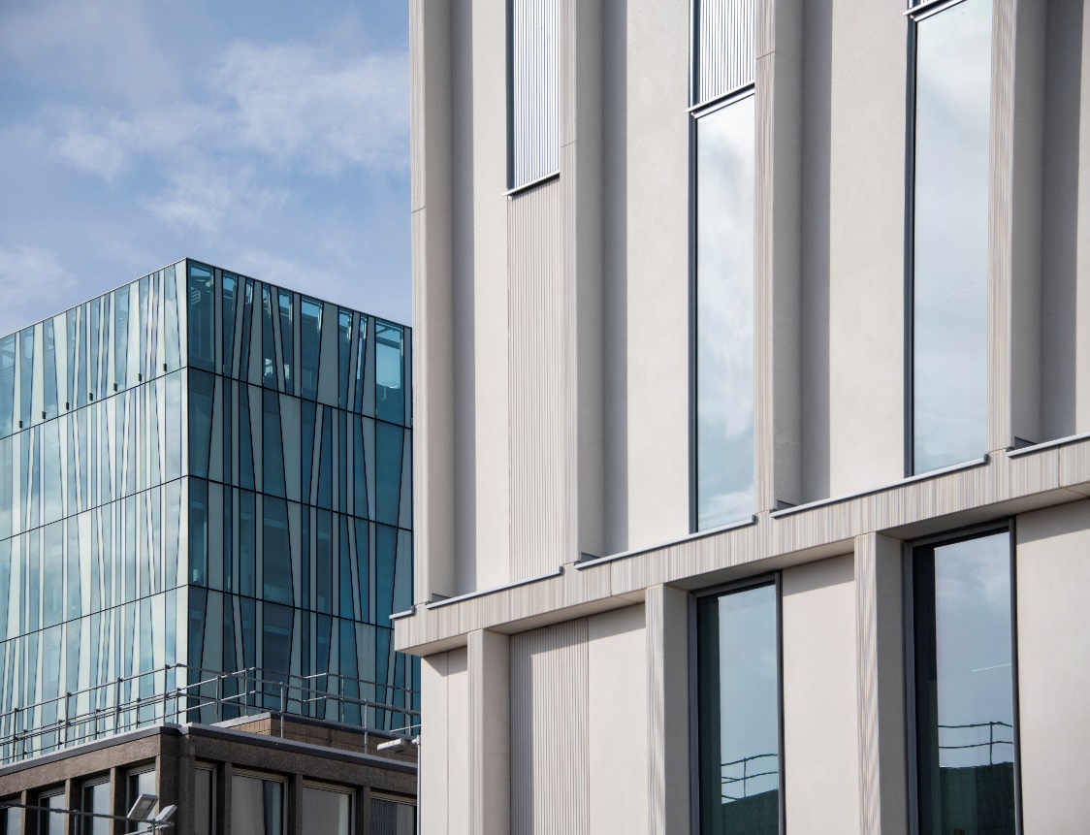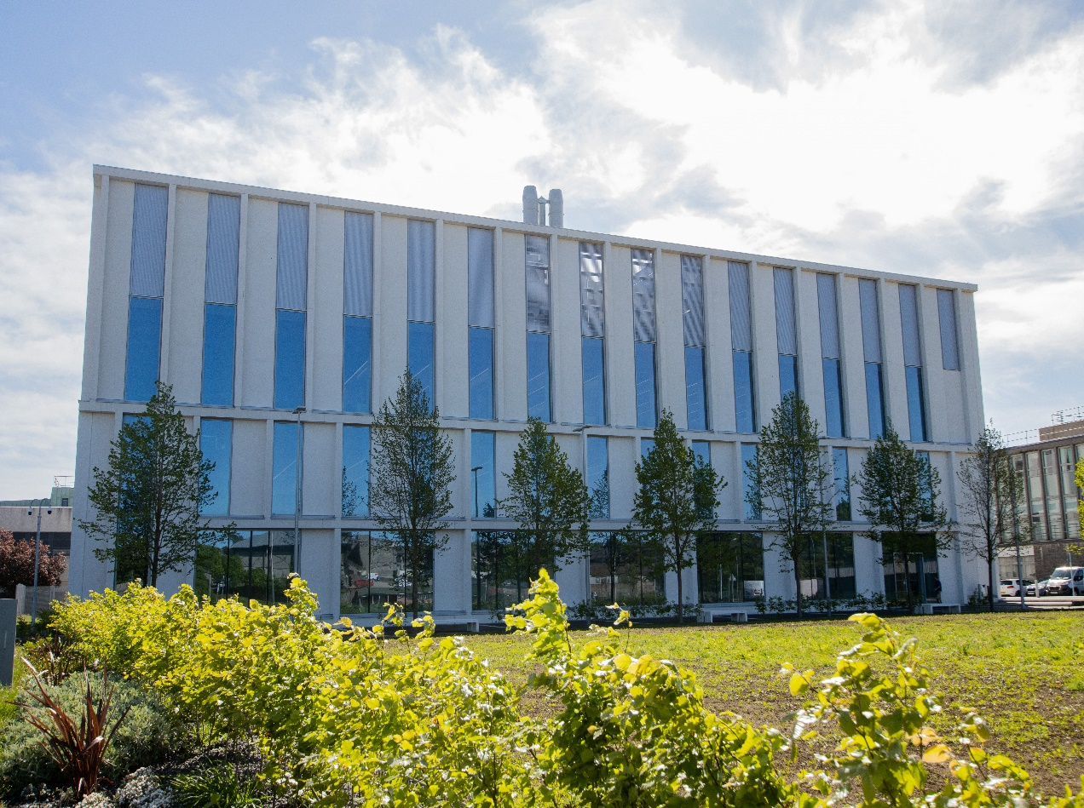

*Undergraduate Medical Sciences*

*School of Medicine, Medical Sciences & Nutrition*

**Contents**

* Course Summary (3)
* **Course Aims & Learning Outcomes**
* **Course Teaching Staff**(4)
* **Assessments & Examinations**(5)
* **Class Representatives**(6)
* **Problems with Coursework**
* **Course Reading List**(7)
* **Lecture Synopsis**(8)
* **Practical/Lab/Tutorial Work**(11)
* **University Policies** (12)
* **Academic Language & Skills support**(13)
* **Medical Sciences Common Grading Scale**(14)
* **Course Timetable MB3006: 2023-2024**(15)

Course Summary

The first part of the course deals with the basic biochemistry of genetic material, including an examination of DNA replication, including cell cycle, chromosome organisation, recombination and repair, and mobile genetic elements (transposons).

We progress into the core central dogma by dealing with both prokaryotic and eukaryotic mechanisms for the transcription of DNA into RNA and the subsequent synthesis of proteins encoded in mRNA. The focus then moves first to protein molecules, dealing with protein processing, targeting and turnover, and then to cell architecture and finally cell biological aspects of, membrane transduction, cell signalling and protein trafficking.

# 

Course Aims & Learning Outcomes

The overall general aims of the course are -

* To establish at foundation level a core knowledge of the molecular biology of the cell;
* To establish knowledge of how cellular processes, interact and inter-link to create a functional cell;
* To establish knowledge of how molecular interactions (e.g. protein-protein, nucleic acid-protein) contribute to and regulate cell activities and contribute to whole cell biology;
* To establish knowledge of how complex cell processes (e.g. cell division, transcription or translation) respond to, and are controlled by, the environment in which a cell is located;
* To provide knowledge of techniques that are commonly applied in investigating the molecular biology of the cell.

**Learning Outcomes:**

The course is built around a series of lectures, which provide a starting point for understanding. It is up to you to use this information as a basis for self-motivated learning and education.

The topics covered in the lectures build on your knowledge of nucleic acid biochemistry, protein biochemistry and molecular genetics introduced at more elementary levels in year 1 (SM1501: The Cell) and at year 2 (particularly BI20M3 Molecular Biology of the Gene and BI25M7 Energy for Life). Similar topics taught at level 3 either go into more detail and/or cover material not dealt with in earlier courses. For this reason, you will be expected to be familiar with knowledge and concepts presented to you during level 1 and 2 courses; use Level 1 and 2 material as preparation for the MB3006 lectures.

**Subject-Specific Learning Outcomes of the Course:**

At the end of the course students should be able to -

* Describe the main features of DNA structure and replication;
* Describe the main features of chromosomal organisation, recombination and repair;
* Describe the structure and propagation of mobile genetic elements (mobile DNA);
* Describe the main features of transcription, including post-transcriptional processing, and translation in both prokaryotes and eukaryotes;
* Describe various selected aspects of protein biochemistry including protein folding, turnover, targeting and trafficking within the cell;
* Describe some aspects of cell signalling in both prokaryotes and eukaryotes. This to include tyrosine kinases, G-proteins, Ras, nuclear receptors, steroids, 2-component systems in microorganisms;
* Describe the complex intracellular architecture of higher eukaryotic cells;

**Transferable Skills:**

Various transferable skills are fostered in the following elements of the course:

# 

Course Teaching Staff

Course Co-ordinator(s):

Prof Carol Munro ([c.a.munro@abdn.ac.uk](mailto:c.a.munro@abdn.ac.uk))

Other Staff:

Dr Daniel Berg (daniel.berg@abdn.ac.uk)

Dr Shin-ichiro Hiraga (**s.hiraga@abdn.ac.uk**)

Dr Riko Hatakeyama (**riko.hatakeyama@abdn.ac.uk**)

Dr Bin Hu (**bin.hu@abdn.ac.uk**)

Dr Takashi Kubota (t.kubota@abdn.ac.uk)

Dr Alexander Lorenz (**a.lorenz@abdn.ac.uk**)

Prof Iain McEwan ([iain.mcewan@abdn.ac.uk](mailto:iain.mcewan@abdn.ac.uk))

Dr Berndt Mueller ([b.mueller@abdn.ac.uk](mailto:b.mueller@abdn.ac.uk))

Prof Ian Stansfield ([i.stansfield@abdn.ac.uk](mailto:i.stansfield@abdn.ac.uk))

# 

Assessments

Students are expected to access and study **ALL** lectures, and online materials, participate in the online teaching events and to complete all exercises by the given deadlines.

The course assessment consists of 40% continuous assessment (based on your marks from in course essay and practical reports) and the remaining 60% is from an end of course final assessment to be completed in a 3 hour period (see information below). Your overall performance will be expressed as a grade awarded on the Common Grading Scale (CGS).

All work will be submitted through MyAberdeen.

***Continuous Assessment (40% of total)***

This will be made up of marks from -

**Coursework Value of Final Mark Date of Submission**

Essay Analysis Exercise 5% Thursday 28th September

Essay 1 15% Friday 13th October

Laboratory report 20% Tuesday 14th November

***Assignments must be handed in as specified above. Failure to do so will result in loss of marks and late submissions (without prior approval) will be penalised.***

***Open book Assessment (60% of total)***

Section A will consist of one essay style answer from a choice of questions based on the lecture material of the course.

Section B is a compulsory data-handling question, and you must answer all parts of this section.

Data handling questions; The data handling question in section B will be like the ones you will practice in the course workshops. There will also be data handling questions on the MyAberdeen Blackboard site to enable you to practice and get feedback through the provision of model answers.

**Course Grade Results:**

The results will be posted on the student portals early in the New Year once the exam board meeting has taken place. The criteria used in marking the open book assessment are given on the following page of the manual. Similar considerations apply to marking your other assessed written work.

The re-sit assessment will be based on a resit open book assessment (60%) that takes place in the summer exam period and the previous continuous assessment marks (40%) achieved during the course. If you are absent with good cause from all continuous assessment components of the course, you will be required to complete a re-sit assessment component at the end of the course based upon the material taught in the continuous assessment course components.

Class Representatives

We value students’ opinions in regard to enhancing the quality of teaching and its delivery; therefore, in conjunction with the Students’ Association we support the Class Representative system.

In the School of Medicine, Medical Sciences & Nutrition we operate a system of course representatives, who are elected from within each course. Any student registered within a course that wishes to represent a given group of students can stand for election as a class representative. You will be informed when the elections for class representative will take place.

What will it involve?

It will involve speaking to your fellow students about the course you represent. This can include any comments that they may have. You will attend a Staff-Student Liaison Committee and you should represent the views and concerns of the students within this meeting. As a representative, you will also be able to contribute to the agenda. You will then feedback to the students after this meeting with any actions that are being taken.

Training

Training for class representatives will be run by the Students Association. Training will take place within each half-session. For more information about the Class representative system visit [www.ausa.org.uk](http://www.ausa.org.uk) or email the VP Education & Employability [vped@abdn.ac.uk](mailto:vped@abdn.ac.uk) . Class representatives are also eligible to undertake the STAR (Students Taking Active Roles) Award with further information about this co-curricular award being available at: [www.abdn.ac.uk/careers](http://www.abdn.ac.uk/careers).

Problems with Coursework

If students have difficulties with any part of the course that they cannot cope with alone they should notify the course coordinator immediately. If the problem relates to the subject matter, general advice would be to contact the member of staff who is teaching that part of the course. Students with registered disabilities should contact the medical sciences office, ([medsci@abdn.ac.uk](mailto:medsci@abdn.ac.uk)) (based in the Polwarth Building, Foresterhill) to ensure that the appropriate facilities have been made available. Otherwise, you are strongly encouraged to contact any of the following as you see appropriate:

* Course student representatives
* Course co-ordinator
* Convenor of the Medical Sciences Staff/Student Liaison Committee (Professor Gordon McEwan)
* Personal Tutor
* Medical Sciences Disabilities Co-ordinator (Dr Derryck Shewan)

All staff are based at Foresterhill and we strongly encourage the use of email or telephone the Medical Sciences Office. You may have a wasted journey travelling to Foresterhill only to find staff unavailable.

If a course has been completed and students are no longer on campus (i.e. work from second half session during the summer vacation), coursework will be kept until the end of Fresher’s Week, during the new academic year. After that point, unclaimed student work will be securely destroyed.

# Course Reading List

Each student should own a personal copy of at least one book from this list; the course cannot be studied satisfactorily from lecture notes alone.

Lodish H et al.; Molecular Cell Biology

Macmillan Learning, 9th edition (2021) (older editions are also relevant)

ISBN 0716743663

Books strongly recommended for reference and for further reading; on selected aspects of the course; Students taking the Biochemistry 3rd year courses and intending to proceed to Honours should consider buying some of these books during the year. These books supplement the information given in the book listed above, and will provide the basis of your professional Library

Alberts et al., Molecular Biology of the Cell

Garland, 7th edition (2022)

ISBN 9780393884852

Berg, Tymoczko & Stryer, Biochemistry

Freeman, 9th edition (2019)

ISBN 9781319114657

Nelson, D.L. and Cox, M.M., Lehninger Principles of Biochemistry, Freeman, 8th edition (2021)

ISBN 9781319228002 (Older editions are also relevant)

Other relevant textbooks available in the library are -

Latchman, D., Gene Regulation: a eukaryotic perspective

Lindsay, D., A guide to Scientific Writing

Lecture Synopsis

The first part of the course deals with the basic biochemistry of genetic material, including an examination of DNA replication, including cell cycle, chromosome organisation, recombination and repair, and mobile genetic elements (transposons). We progress into the core central dogma by dealing with both prokaryotic and eukaryotic mechanisms for the transcription of DNA into RNA and the subsequent synthesis of proteins encoded in mRNA. The focus then moves first to protein molecules, dealing with protein processing, targeting and turnover, and then to cell biological aspects of protein trafficking, membrane transduction and cell signalling. The course concludes with a discussion of cell structure and cell death. Laboratory work, assignments and tutorials are designed to complement and extend the lecture topics. Additional learning opportunities are provided in the staged series of Workshops, which allow you the opportunity to actively employ your understanding of a topic in a workshop/small group learning environment.

**Subject - Nucleic Acids: DNA replication & Repair, Chromosome Organization**

**No. of lectures - 6**

**Lecturer – Dr Shin-ichiro Hiraga**

The aim of these lectures is to investigate how cells organize their DNA within the cell nucleus and replicate it during cell division to produce two new copies of the genome. Cellular processes to repair damaged DNA will also be covered.

* The mechanism of DNA replication will be discussed, covering the structure of the replication fork, how cells select sites of replication initiation, and how they control whether and when to replicate DNA
* The reaction mechanism catalysed by DNA polymerases causes difficulty in replicating the ends of linear DNA molecules. Various methods have evolved to solve this ‘end-replication problem’. The most common involves the use of an unusual reverse transcriptase, called telomerase
* We will discuss genome organization: introns, exons, satellites, repetitive DNA etc
* How is the huge amount of genomic DNA packaged to fit within the cell nucleus, whilst keeping specific sequences accessible for transcription? We will discuss the structure of the nucleosome and higher levels of chromatin organization and packaging
* DNA is often damaged under normal environmental conditions. How can cells repair their genome and what are the consequences if they cannot?

**Subject - Growth and the cell cycle**

**No. of lectures - 4**

**Lecturer –Dr A Lorenz (bacterial & eukaryotic cell cycle)**

The aim of these lectures is to examine the mechanisms that lead to the coordinated control of cell growth and cell division in bacteria and eukaryotes.

In bacteria the regulation of cell division in relation to growth rate will examined and will include discussion of overlapping cell cycles and the regulation of the initiation of DNA replication and cytokinesis by the fts genes. The eukaryotic cell cycle will be illustrated mainly using examples of yeasts and will discuss regulation of entry in S (DNA synthesis) and M (mitosis) by the cyclin dependent kinase(s) (cdk) and the control of cdk's by cyclin synthesis and by phosphorylation. Regulation of the cell cycle by cell size and environmental factors will be discussed and the loss of control over the cell cycle mentioned in terms of carcinogenesis.

**Subject - Transcription**

**No. of Lectures - 7**

**Lecturers – Prof C Munro (prokaryote transcription), Dr Takashi Kubota (eukaryote transcription)**

The aim of this series of lectures is to illustrate mechanisms by which prokaryotic and eukaryotic cells regulate gene expression primarily at the level of transcription. The basic principles of transcription will be described, emphasising the similarities and differences between the eukaryotic and prokaryotic systems, and highlighting the important events that contribute to the overall control of gene expression. The lectures on prokaryotic transcription regulation will also emphasize, using specific examples, the integration of gene expression with the metabolism of the cell.

*Introduction to transcription in prokaryotes*

* Subunit structure of RNA polymerase (RNAP) enzyme.
* Promoter architecture.
* Interaction of the RNAP with promoter sequences.
* Role of sigma factor(s) in control of gene expression, discussion of sporulation in *B. subtilis*.

*Regulated transcription: trans-acting factors*

* Positive and negative control of gene expression, discussion of the lac operon (lacI, CAP) and catabolite repression: allosteric regulation and phosphorylation.

*Regulated transcription: Two-component system*

* Regulation of gene expression in response to nitrogen starvation. The role of the nitrogen sensor protein, the allosterically regulated uridyl transferase enzyme, in the control of transcription of genes that encode proteins involved in nitrogen assimilation.

*Transcription termination*

* Intrinsic signals for termination
* Rho-dependent termination
* Anti-termination as a mechanism for regulating gene expression

*Eukaryotic transcription: cis-acting elements & trans-acting factors*

* Assembly of preinitiation complex.
* Upstream promoter elements and enhancers.
* Modular nature of transcription factors.
* Modulating gene expression.
* Inducible response elements: steroid hormone and heat shock.
* Mechanisms of activation and repression.
* Influence of chromatin structure on transcription initiation.
* Post-transcriptional processing.
* Addition of "caps and tails".
* RNA degradation.
* Splicing of RNA: formation of spliceosomes; mechanism of splicing; alternate splicing.

**Subject - Translation**

**No. of lectures - 5**

**Lecturer - Prof I Stansfield**

The aim of these lectures is to describe in detail the process of protein synthesis, whereby a messenger RNA is translated by the ribosome in the cytoplasmic compartment. The parallels and differences between eukaryote and prokaryote translation will be considered. As well as constituting a central component of the machinery of the cell, translation is also an important point at which control over gene expression is exerted at the post-transcriptional level in response to environmental and cell-cell signals; these control mechanisms will also be considered.

* Kozak's scanning hypothesis. Initiation of translation in prokaryotes vs. eukaryotes.
* Translation initiation factors. Key control points.
* Structural components of RNA that can affect translation and RNA degradation.
* Elongation; factors and mechanisms; the role of GTP; maintenance of the translational reading frame; the three-site model of elongation.
* Termination; factors and mechanisms; molecular mimicry hypothesis; post-termination events and the closed loop model of eukaryote translation.
* Functional RNAs in translation - tRNA and rRNA; ribosome structure and function - rRNA as a catalyst; ribosome biogenesis and rRNA processing; tRNAs - modification and charging; tRNA decoding, the genetic code and translational accuracy.

**Subject - Proteins: folding, processing, targeting and turnover**

**No. of lectures - 4**

**Lecturer - Prof I McEwan**

* These lectures will consider the folding of newly-synthesised proteins, including the formation of disulphide bonds, correct folding and stabilisation being essential for biological activity. The emphasis will be on mechanisms common to prokaryotes and eukaryotes, with some information specific to prokaryotes.
* Protein structure, with emphasis on the need for both stability and flexibility, so that the protein can undergo subtle conformational change and form larger functional assemblies.
* Folding pathways; chaperones.
* How the cell deals with unwanted or misfolded proteins; the ubiquitin system and the proteasome.
* Protein disulphide isomerases; protein folding and disulphide formation in the bacterial periplasm.

**Subject - Cell architecture**

**No. of Lectures - 3**

**Lecturer – Dr Daniel Berg**

The aim of these lectures is to illustrate the complex intracellular organisation of higher eukaryotic cells. We will consider the structure, biogenesis and brief function of organelles that are separate to the secretory pathway discussed previously that is the nucleus, mitochondrion, chloroplast and peroxisome. We will also discuss the cytoskeleton and its role in maintaining cell shape and cell motility

* Nuclear organisation: nucleolus, nuclear membrane and nuclear pore complex.
* Mitochondria and chloroplasts: overview of structures, consideration of evolutionary origin, organelle genome.
* Actin filaments – organisation of cytosol, myosin – molecular motor; functions in muscle and non-muscle cells.
* Microtubules and intermediate filaments, kinesin as a molecular motor, role in cilia and flagella movement.

**Subject - Membranes and signal transduction**

**No. of Lectures - 4**

**Lecturer - Dr B Mueller**

The aim of these lectures is to provide an outline of a variety of molecular signalling scenarios which living cells use to interact with their environment.

Higher eukaryotic signal transduction scenarios, membrane receptor molecules – G-protein coupled receptors, receptor tyrosine kinases and downstream events, nuclear receptors and steroids. 2-component systems in microorganisms; chemotaxis, trans-membrane transporters.

**Subject - Proteins – targeting and trafficking**

**No. of Lectures - 4**

**Lecturer – Dr Riko Hatakeyama**

The aim of this series of lectures is to illustrate how proteins are targeted to the correct cellular location to ensure the appropriate biological activity. Most lectures will be organized as follows:

* General principles: How are protein localizations coded? Can we predict the localization of a given protein?
* Membrane proteins: Some proteins are integrated into cellular membranes. How can they travel between different organelles?
* Soluble proteins: Many soluble proteins localize to the surface or the interior of specific organelles. How do they go where they should?
* Regulations: Proteins often change their location in response to environmental changes. How can this happen?

Practical/Lab/Tutorial Work

The course will comprise a formal lecture course (as indicated in the Lecture Synopses above), which will include a series of revision Workshops, two essay-type assessments, a computer simulation, and a practical class. All course work will be examined in an open book assessment. The essay analysis, essay and the practical report will form the continuous assessment element of the course.

Class Practical

The practical will give you the opportunity to apply the knowledge and understanding gained in the course thus far. It comprises an in-lab session, followed by the production of a written report (see separate Practical Manual).

“Responding to amino acid starvation: regulation of gene expression at the level of translation in baker’s yeast”

University Policies

Students are asked to make themselves familiar with the information on key education policies, available [here](https://www.abdn.ac.uk/staffnet/teaching/key-education-policies-for-students-11809.php). These policies are relevant to all students and will be useful to you throughout your studies.  They contain important information and address issues such as what to do if you are absent, how to raise an appeal or a complaint and how the University will calculate your degree outcome.

These University wide education policies should be read in conjunction with this programme and/or course handbook, in which School specific policies are detailed. These policies are effective immediately, for the 2023/24 academic year. Further information can be found on the [University’s Infohub webpage](https://www.abdn.ac.uk/students/) or by visiting the Infohub.

The information included in the institutional area for 2023-24 includes the following:

* Assessment
* Feedback
* Academic Integrity
* Absence
* Student Monitoring/ Class Certificates
* Late Submission of Work
* Student Discipline
* The co-curriculum
* Student Learning Service (SLS)
* Professional and Academic Development
* Graduate Attributes
* Email Use
* MyAberdeen
* Appeals and Complaints

Where to Find the Following Information:

C6/C7- University of Aberdeen Homepage > Students > Academic Life > Monitoring and Progress > Student Monitoriung (C6 & C7)

https://www.abdn.ac.uk/students/academic-life/student-monitoring.php#panel5179

Absences- To report absences you should use the absence reporting system tool on Student Hub. Once you have successfully completed and sent the absence form you will get an email that your absence request has been accepted. The link below can be used to log onto the Student Hub Website and from there you can record any absences you may have.

[Log In - Student Hub (ahttps://www.abdn.ac.uk/studenthub/loginbdn.ac.uk)](https://www.abdn.ac.uk/studenthub/login)

Submitting an Appeal- University of Aberdeen Homepage > Students > Academic Life > Appeals and Complaints

https://www.abdn.ac.uk/students/academic-life/appeals-complaints-3380.php#panel2109

Academic Language & Skills support

For students whose first language is not English, the Language Centre offers support with Academic Writing and Communication Skills.

Academic Writing

* Responding to a writing task: Focusing on the question
* Organising your writing: within & between paragraphs
* Using sources to support your writing (including writing in your own words, and

citing & referencing conventions)

* Using academic language
* Critical Thinking
* Proofreading & Editing

Academic Communication Skills

* Developing skills for effective communication in an academic context
* Promoting critical thinking and evaluation
* Giving opportunities to develop confidence in communicating in English
* Developing interactive competence: contributing and responding to seminar discussions
* Useful vocabulary and expressions for taking part in discussions

More information and how to book a place can be found here

Medical Sciences Common Grading Scale

|  |  |  |  |  |  |
| --- | --- | --- | --- | --- | --- |
| Grade | Grade Point | % Mark | Category | Honours Class | Description |
| A1 | 22 | 90-100 | Excellent | First | • Outstanding ability and critical thought • Evidence of extensive reading • Superior understanding •The best performance that can be expected from a student at this level |
|  |
| A2 | 21 | 85-89 |  |
|  |
| A3 | 20 | 80-84 |  |
|  |
| A4 | 19 | 75-79 |  |
|  |
| A5 | 18 | 70-74 |  |
|  |
| B1 | 17 | 67-69 | Very Good | Upper Second | • Able to argue logically and organise answers well  • Shows a thorough grasp of concepts  • Good use of examples to illustrate points and justify arguments  • Evidence of reading and wide appreciation of subject |  |
|  |
| B2 | 16 | 64-66 |  |
|  |
| B3 | 15 | 60-63 |  |
|  |
| C1 | 14 | 57-59 | Good | Lower Second | • Repetition of lecture notes without evidence of further appreciation of subject • Lacking illustrative examples and originality • Basic level of understanding |  |
|  |
| C2 | 13 | 54-56 |  |
|  |
| C3 | 12 | 50-53 |  |
|  |
| D1 | 11 | 47-49 | Pass | Third | • Limited ability to argue logically and organise answers • Failure to develop or illustrate points • The minimum level of performance required for a student to be awarded a pass |  |
|  |
| D2 | 10 | 44-46 |  |
|  |
| D3 | 9 | 40-43 |  |
|  |
| E1 | 8 | 37-39 | Fail | Fail | • Weak presentation • Tendency to irrelevance • Some attempt at an answer but seriously lacking in content and/or ability to organise thoughts |  |
|  |
| E2 | 7 | 34-36 |  |
|  |
| E3 | 6 | 30-33 |  |
|  |
| F1 | 5 | 26-29 | Clear Fail | Not used for Honours | • Contains major errors or misconceptions • Poor presentation |  |
|  |
| F2 | 4 | 21-25 |  |
|  |
| F3 | 3 | 16-20 |  |
|  |
| G1 | 2 | 11-15 | Clear Fail/Abysmal |  | • Token or no submission |  |
|  |
| G2 | 1 | 1-10 |  |
|  |
| G3 | 0 | 0 |  |
|  |

Course Timetable MB3006: 2023-2024

* Times are UK Time and show the timings of live sessions (either on campus or via MyAberdeen)
* Any changes to the timetable after start of term will be announced on MyAberdeen and by email.

Timetable Key:

|  |
| --- |
| Green = Recorded classes in MyAberdeen |
| Orange = Live classes delivered in person on campus |
| Blue = Live classes delivered as a live session in MyAberdeen/Collaborate |
| Yellow = Assessments |
| Grey = No scheduled classes for MB3006 on these days |

|  |  |  |  |  |  |
| --- | --- | --- | --- | --- | --- |
| Date | Time | Place | Subject | Session | Staff |
| Week 8 | | | | | |
| Mon 18 Sep | 15:00-16:00 | New Kings NK10 | Course Introduction | Lecture 1 | CM |
|  | MyAb | Writing Skills | Lecture 2 | HG |
| Tue 19 Sep | 09:00-11:00 | Kings College KCF7 | DNA Replication (1&2) chromosome structure replication | Lecture 3 &4 | SH |
| Wed 20 Sep |  |  |  |  |  |
| Thu 21 Sep |  |  |  |  |  |
| Fri 22 Sep | 14:00-16:00 | King's College KCG7 | DNA Replication (3) chromosome replication continued  Chromosome Organisation (1) packing | Lecture 5 &6 | SH |
| Week 9 | | | | | |
| Mon 25 Sep | 15:00-16:00 | New Kings NK10 | Chromosome Organisation (2) packing | Lecture 7 | SH |
| Tue 26 Sep | 09:00-10:00 | Fraser Nobel FN3 | Chromosome Organisation (3) domains | Lecture 8 | SH |
| 14:00-16:00 | Zoology ZG18 | *Workshop: Chromosome organisation* | Workshop | SH |
| Wed 27 Sep |  |  |  |  |  |
| Thu 28 Sep | 17:00 |  | Essay Analysis Test completion deadline  *(5% course marks)* |  |  |
| Fri 29 Sep | 14:00-15:00 | King's College KCG7 | Prokaryotic transcription (1) mechanisms | Lecture 9 | CM |
| 15:00-16:00 | King's College KCG7 | Prokaryotic transcription (2) mechanisms, sigma factors | Lecture 10 | CM |
| Week 10 | | | | | |
| Mon 2 Oct |  | MyAb | Prokaryotic transcription (3) lac and trp operons | Lecture 11 | CM |
|  | MyAb | Prokaryotic transcription (4) termination | Lecture 12 | CM |
| Tue 3 Oct | 10:00-12:00 | King's College Old Senate Room | *Workshop:* Transcription | Workshop | CM |
|  | 12:00-14:00 | King's College KCG7 | Cell cycle/growth (1 &2) - bacterial cell cycle | Lecture 13&14 | AL |
| Wed 4 Oct |  |  |  |  |  |
| Thu 5 Oct |  |  |  |  |  |
| Fri 6 Oct | 14:00-16:00 | King's College KCG7 | Cell cycle/growth (3 &4) yeast cell cycle and growth | Lecture 15 &16 | AL |
| Week 11 | | | | | |
| Mon 9 Oct | 15:00-16:00 | New Kings NK10 | Translation (1) initiation in eukaryotes | Lecture 17 | IS |
|  |  |  |  |  |  |
| Tue 10 Oct | 09:00-10:00 | Fraser Nobel FN3 | Translation (2) initiation in eukaryotes | Lecture 18 | IS |
| 14:00-16:00 | King's College KCG7 | *Workshop*: Cell Cycle | Workshop | AL |
| Wed 11 Oct |  |  | *Essay preparation* |  |  |
| Thu 12 Oct |  |  | *Essay preparation* |  |  |
| Fri 13 Oct | 14:00-16:00 | King's College KCG7 | Translation (3) elongation  Translation (4) termination | Lecture 19 & 20 | IS |
|  | 17:00 |  | Essay 1 Submission deadline  (15% course marks) |  |  |
| Week 12 | | | | | |
| Mon 16 Oct | 09:00-10:00 | Collaborate | Course organization Q & A session (optional) | Tutorial | CM |
| 14:00-17:00 | STH Lab 1.007 | *Practical Session 1* | Practical | BH/IS |
|  |  |  |  |  |
| Tue 17 Oct | 13:00-14:00 | New Kings NK10 | Translation (5) mRNA stability | Lecture 21 | IS |
|  | 14:00-17:00 | STH Lab 1.007 | *Practical Session 2* | Practical | BH/IS |
| Wed 18 Oct |  |  |  |  |  |
| Thu 19 Oct |  |  |  |  |  |
| Fri 20 Oct | 14:00-16:00 | Kings College KCF7 | Eukaryotic transcription (1) RNA polymerase activity  Eukaryotic transcription (2) transcriptional regulation | Lecture 22& 23 | TK |
| Week 13 | | | | | |
| Mon 23 Oct | 14:00-17:00 | STH Lab 1.007 | *Practical Session 3* | Practical | BH/IS |
| Tue 24 Oct | 13:00-14:00 | New Kings NK10 | Eukaryotic transcription (3) mRNA processing during transcription | Lecture 24 | TK |
|  | 14:00-17:00 | STH Lab 1.007 | *Practical Session 4* | Practical | BH/IS |
| Wed 25 Oct |  |  |  |  |  |
| Thu 26 Oct |  |  |  |  |  |
| Fri 27 Oct | 14:00-16:00 | King's College KCG7 | Protein Folding (1+2) folding, primary to final structure: chaperones and their function | Lectures 25,26 | IM |
| Week 14 | | | | | |
| Mon 30 Oct | 15:00-17:00 | Fraser Nobel FN2 | Protein Folding (3) disulphide bonds and proline isomerisation and Protein Folding (4) dealing with misfolded proteins | Lecture 27,28 | IM |
| Tue 31 Oct | 09:00-10:00 | King's College Old Senate Room | *Workshop*: Translation | Workshop | IS |
| 11:00-12:00 | King's College Old Senate Room | *Workshop*: Protein Folding | Workshop | IM |
|  | 14:00-16:00 | KING'S QUAD KQG5 Auditorium | Cell Architecture (1) cell organelles.  Cell Architecture (2) the cytoskeleton: cytoskeleton dynamics | Lecture 29 & 30 | DB |
| Wed 1 Nov |  |  |  |  |  |
| Thu 2 Nov |  |  |  |  |  |
| Fri 3 Nov | 14:00-15:00 | King's College KCG7 | Cell Architecture (3) the cytoskeleton: cytoskeleton dynamics | Lecture 31 | DB |
| Week 15 | | | | | |
| Mon 6 Nov | 09:00-10:00 | Collaborate | Q&A DATA analysis | Tutorial | CM |
| Tue 7 Nov | 10:00-13:00 | Edward Wright Comp F81 | Computer Simulation Practical Grp 1 | Computer Practical | BH/IS |
| 13:00-16:00 | Edward Wright Comp F81 | Computer Simulation Practical Grp 2 | Computer Practical | BH/IS |
| Wed 8 Nov |  |  |  |  |  |
| Thu 9 Nov |  |  |  |  |  |
| Fri 10 Nov | 15:00-16:00 | Zoology, ZOLAB G9 | *Workshop*: Eukaryotic Transcription | Workshop | TK |
|  | 16:00-17:00 | Zoology, ZOLAB G9 | *Workshop*: Cell architecture | Workshop | DB |
| Week 16 | | | | | |
| Mon 13 Nov | 14:00-16:00 | Fraser Noble FN3 | Membranes, signal transduction (1) components  Membranes, signal transduction (2) cell-cell interactions | Lecture 32 & 33 | BM |
| Tue 14 Nov | 09:00-10:00 | Fraser Nobel FN3 | Membranes, signal transduction (3) cell signalling | Lecture 34 | BM |
| 13:00-14:00 | New Kings NK10 | Membranes, signal transduction (4) cell signalling | Lecture 35 | BM |
| 17:00 |  | *Lab Report Submission Deadline*  (20% course marks) |  |  |
| Wed 15 Nov |  |  |  |  |  |
| Thu 16 Nov |  |  |  |  |  |
| Fri 17 Nov | 14:00-16:00 | King's College KCG7 | Protein Trafficking (1) general principles Protein Trafficking (2) membrane proteins | Lecture 36&37 | RH |
| Week 17 | | | | | |
| Mon 20 Nov | 09:00-10:00 | Auris Lecture Theatre | Structured revision session and exam preparation | REVISION | CM |
| 15:00-16:00 | New Kings NK10 | Protein Trafficking (3) soluble proteins | Lecture 38 | RH |
| Tue 21 Nov | 09:00-10:00 | Fraser Nobel FN3 | Protein Trafficking (4) regulations | Lecture 39 | RH |
| 14:00-15:00 | Zoology ZOLAB G9 | *Workshop*: Signal Transduction | Workshop | BM |
| 15:00-16:00 | Zoology ZOLAB G9 | *Workshop*: Protein Trafficking | Workshop | RH |
| Wed 22 Nov |  |  |  |  |  |
| Thu 23 Nov |  |  |  |  |  |
| Fri 24 Nov | 14:00-16:00 | Collaborate | *Workshop*: *course closing and feedback* | Tutorial | CM |
| Week 18 | | | | | |
| Mon 27 Nov |  |  | *REVISION* |  |  |
| Date and Time To be Announced | | | Final Course Assessment |  |  |

Staff

|  |
| --- |
| CM - Prof Carol Munro, Course Co-ordinator |
| DB - Dr Daniel Berg |
| HG - Prof Helen Galley |
| BH-Dr Bin Hu |
| RH- Dr Riko Hatakeyama |
| SH- Dr Shin-ichiro Hiraga |
| TK-Dr Takashi Kubota |
| AL - Dr Alexander Lorenz |
| IM - Prof Iain McEwan |
| BM - Prof Berndt Mueller |
| IS - Prof Ian Stansfield |