*DB3006-Principles of Developmental and Reproductive Biology*

*Course Handbook 2023-2024*

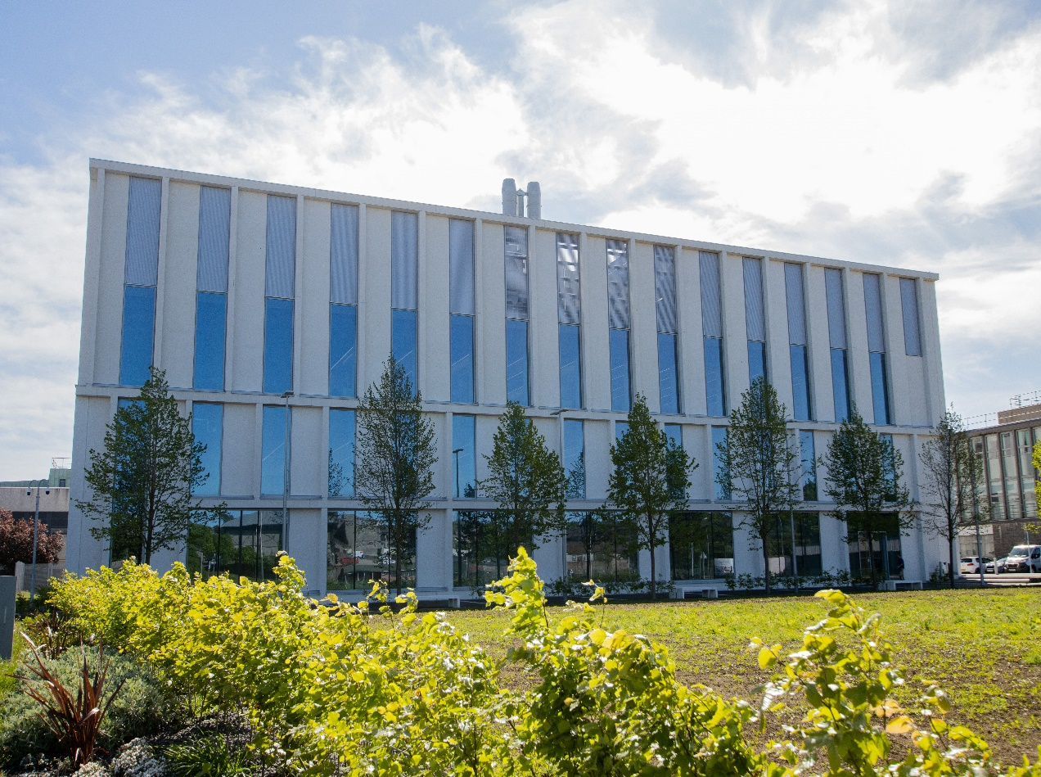

*Undergraduate Medical Sciences*

*School of Medicine, Medical Sciences & Nutrition*

**Contents**

* Course Summary –(3)
* **Course Aims & Learning Outcomes**
* **Course Teaching Staff**
* **Assessments & Examinations**–(4)
* **Class Representatives**
* **Problems with Coursework**–(5)
* **Course Reading List**
* **Lecture Synopsis**–(6)
* **Practical/Lab/Tutorial Work**–(7)
* **University Policies**
* **Academic Language & Skills support** –(8)
* **Medical Sciences Common Grading Scale**–(9)
* **Course Timetable DB3006: 2023-2024**–(10)
* Campus and Floor Maps

Course Summary

The course will cover questions of developmental biology, The life cycle: stages of development, cell-to-cell signalling in development, the concept of morphogens in development, the major model organisms (Drosophilia, C.elegans, zebrafish, Xenopus, chick, mouse), anatomical foundation of embryology, the physiological principles underlying embryonic development and the contribution of genetics to the understanding of the molecular processes regulating embryonic development.

The course will last for 5 weeks, consisting of lectures (with 2-5 per week), 2 multiple choice question assessments and 1 workshop session.

It is assessed by an open-book written examination (50%) and continuous assessment (50%).

Course Coordinator: Professor Neil Vargesson (ext. 7374) Email: [n.vargesson@abdn.ac.uk](mailto:n.vargesson@abdn.ac.uk)

Course Aims & Learning Outcomes

1. Provide a solid foundation in the principles of embryonic developmental biology and reproductive biology.

2. Describe the common features underlying developmental in different organisms.

3. Describe the techniques utilised in studying developmental biology.

4. Have an understanding of the different model organisms used to study development and their respective advantages and be able to describe why one would use one organism over another.

5. Explore how advances in developmental biology and reproductive biology impact on society.

Course Teaching Staff

Course Co-ordinator(s):

Professor Neil Vargesson (NV), (Course Coordinator) [n.vargesson@abdn.ac.uk](mailto:n.vargesson@abdn.ac.uk)

Other Staff:

Professor Martin Collinson (MC (m.collinson@abdn.ac.uk)

Dr Silvia Mazzotta ([silvia.mazzotta@abdn.ac.uk](mailto:silvia.mazzotta@abdn.ac.uk))

Professor Stefan Hoppler (s.p.hoppler@abdn.ac.uk)

Professor Jonathon Pettitt (JP),([**j.pettit@abdn.ac.uk**](mailto:j.pettit@abdn.ac.uk))

Professor Paul Fowler (PF),([**p.a.fowler@abdn.ac.uk**](mailto:p.a.fowler@abdn.ac.uk))

Professor Lynda Erskine (LE)

Assessments & Examinations

Students are expected to attend all lectures, laboratory classes, and tutorials, and to complete all class exercises by stated deadlines. The minimum performance acceptable is attendance at 75% of the lectures, seminars, practical classes, and presentation of all set course work, written and oral.

Assessment is derived from course work (50%) and a written open-book examination (50%). The continuous assessment (CA) component is based on one workshop, which contributes 20% of the total course mark and two timed MCQ tests that will be accessible via MyAberdeen, which each contribute 15% of the total course mark (please see MCQ instructions on the DB3006 Ultra website).

Written Open-Book Examination: 50% of the total assessment is based on an Essay Question aimed at testing knowledge of the course and integrating concepts. More information on this will be given during one of the Lectures. Students will have 3.5 hours to complete the Essay from the time the Essay Question is released (sometime in Week 18).

The Open book examination is held in November (week 18), with the re-sit examination in August.

Common grading scale (CGS) grade: The overall performance of the student is expressed as a grade awarded on the common spine marking scale.

# Class Representatives

We value students’ opinions in regard to enhancing the quality of teaching and its delivery; therefore, in conjunction with the Students’ Association we support the Class Representative system.

In the School of Medicine, Medical Sciences & Nutrition we operate a system of course representatives, who are elected from within each course. Any student registered within a course that wishes to represent a given group of students can stand for election as a class representative. You will be informed when the elections for class representative will take place.

What will it involve?

It will involve speaking to your fellow students about the course you represent. This can include any comments that they may have. You will attend a Staff-Student Liaison Committee and you should represent the views and concerns of the students within this meeting. As a representative, you will also be able to contribute to the agenda. You will then feedback to the students after this meeting with any actions that are being taken.

Training

Training for class representatives will be run by the Students Association. Training will take place within each half-session. For more information about the Class representative system visit [www.ausa.org.uk](http://www.ausa.org.uk) or email the VP Education & Employability [vped@abdn.ac.uk](mailto:vped@abdn.ac.uk) . Class representatives are also eligible to undertake the STAR (Students Taking Active Roles) Award with further information about this co-curricular award being available at: [www.abdn.ac.uk/careers](http://www.abdn.ac.uk/careers).

Problems with Coursework

If students have difficulties with any part of the course that they cannot cope with, alone they should notify the course coordinator immediately. If the problem relates to the subject matter general, advice would be to contact the member of staff who is teaching that part of the course. Students with registered disabilities should contact the medical sciences office, ([medsci@abdn.ac.uk](mailto:medsci@abdn.ac.uk)) (based in the Polwarth Building, Foresterhill) to ensure that the appropriate facilities have been made available. Otherwise, you are strongly encouraged to contact any of the following as you see appropriate:

* Course student representatives
* Course co-ordinator
* Convenor of the Medical Sciences Staff/Student Liaison Committee (Professor Gordon McEwan)
* Personal Tutor
* Medical Sciences Disabilities Co-ordinator (Dr Derryck Shewan)

All staff are based at Foresterhill and we strongly encourage the use of email or telephone the Medical Sciences Office. You may have a wasted journey travelling to Foresterhill only to find staff unavailable.

If a course has been completed and students are no longer on campus (i.e. work from second half session during the summer vacation), coursework will be kept until the end of Fresher’s Week, during the new academic year. After that point, unclaimed student work will be securely destroyed.

Course Reading List

Slack, J.M.W. Essential Developmental Biology, 3rd Edition (2012) Blackwells.

N.B. The course is based around/upon this book.

There are a range of titles available from the library focusing on developmental biology and embryology and reproductive biology, three examples are below. Whilst most of these are held in the Medical School library at Foresterhill, they can be delivered to Sir Duncan Rice Library for your convenience.

Gilbert, S. Developmental Biology, 10th Edition (2014) Sinaeur.

Johnson, M. H. & Everitt, B.J. Essential reproduction. (2000). Malden, Mass: Blackwell Science.

Wolpert, L. et al Principles of Development, 6th Edition (2019) Oxford.

Lecture Synopsis

Lecture 1: Introduction and Overview – Professor Neil Vargesson

Introduction to the course and its content, aims and goals.

Lecture 2: Common Features of Development I – Professor Neil Vargesson

Introduction to terminology; Gametogenesis and early development.

Lecture 3: Common Features of Development II –Professor Neil Vargesson

Morphogenetic processes. Cell death and proliferation.

Lecture 4: Experimental Embryology – Professor Neil Vargesson

Cell fate, cloning, acquisition of fate, commitment.

Lecture 5: Model Organisms – *C. elegans* – Professor Jonathan Pettit

Development, specification, analysis of cell fate, analysis of cell death.

Lecture 6: Model Organisms – Zebrafish – Professor Neil Vargesson

Development, specification, mutagenesis screens and imaging

Lecture 7: Human Reproduction – Professor Paul Fowler

Gonadal function, gametogenesis, fertilisation and sex determination

Lecture 8: Model Organisms – Chicken – Professor Neil Vargesson

Development, specification, organogenesis, limb development.

Lecture 9: Comparative Reproduction- Professor Paul Fowler

Anatomy and endocrinology of mammalian reproduction

Lecture 10: Model Organisms – Mouse – Professor Martin Collinson

Mammalian fertilisation, specification, development, transgenics, knockout mouse.

Lecture 11: Developmental Biology and Infertility – Prof Paul Fowler

Discussing issues relating to human fertility and infertility

Lecture 12: Model organisms – Drosophila – Professor Stefan Hoppler

Development, developmental genetics, homeotic genes.

Lecture 13: Model Organisms – Xenopus – Professor Stefan Hoppler

Oogenesis, maturation, specification, development, and inductive events.

Lecture 14: Developmental Biology and Stem Cells – Dr Silvia Mazzotta

Discussing issues relating to stem cells and their role in developmental biology and medicine

Lecture 15: Developmental Biology and Society – Professor Neil Vargesson

How research in developmental biology has helped us understand the origins of birth defects and prevention of birth defects as well as human disease e.g. folic acid supplements, cancer, regenerative medicine.

Practical/Lab/Tutorial Work

**Model Organisms Workshop – Professor Neil Vargesson**

Students in small groups (max of 3 per group) will look in-depth at a specific Model Organism and describe advantages, uses, and discoveries made and prepare a short presentation with the key points. It is the content of the presentation that will be assessed, not the presenter’s delivery.

Will hold a Tutorial to discuss this Workshop and to allocate groups and model organisms to present. Presentations will take place on 21st October in front of all students, plus Prof Vargesson and Prof Erskine.

The practical work required in this course may present difficulties to students with special educational needs. For such students, alternative arrangements will be made. Any student with special needs should make these known to the Course Co-ordinator when registering for the class, and should then also discuss their needs with the School Disabilities Co-ordinator, to ensure that they have the best possible outcome.

University Policies

Students are asked to make themselves familiar with the information on key education policies, available [here](https://www.abdn.ac.uk/staffnet/teaching/key-education-policies-for-students-11809.php). These policies are relevant to all students and will be useful to you throughout your studies.  They contain important information and address issues such as what to do if you are absent, how to raise an appeal or a complaint and how the University will calculate your degree outcome.

These University wide education policies should be read in conjunction with this programme and/or course handbook, in which School specific policies are detailed. These policies are effective immediately, for the 2023/24 academic year. Further information can be found on the [University’s Infohub webpage](https://www.abdn.ac.uk/students/) or by visiting the Infohub.

The information included in the institutional area for 2023-24 includes the following:

* Absence
* Appeals & Complaints
* Assessment
* Avoiding Plagiarism
* Communication
* Graduate Attributes
* MyAberdeen
* Student Learning Service (SLS)
* Student Monitoring/Class Certificates
* Student Discipline
* The Co-curriculum

Where to Find the Following Information:

C6/C7- University of Aberdeen Homepage > Students > Academic Life > Monitoring and Progress > Student Monitoriung (C6 & C7)

https://www.abdn.ac.uk/students/academic-life/student-monitoring.php#panel5179

Absences- To report absences you should use the absence reporting system tool on Student Hub. Once you have successfully completed and sent the absence form you will get an email that your absence request has been accepted. The link below can be used to log onto the Student Hub Website and from there you can record any absences you may have.

[Log In - Student Hub (ahttps://www.abdn.ac.uk/studenthub/loginbdn.ac.uk)](https://www.abdn.ac.uk/studenthub/login)

Submitting an Appeal- University of Aberdeen Homepage > Students > Academic Life > Appeals and Complaints

https://www.abdn.ac.uk/students/academic-life/appeals-complaints-3380.php#panel2109

Academic Language & Skills support

For students whose first language is not English, the Language Centre offers support with Academic Writing and Communication Skills.

Academic Writing

* Responding to a writing task: Focusing on the question
* Organising your writing: within & between paragraphs
* Using sources to support your writing (including writing in your own words, and

citing & referencing conventions)

* Using academic language
* Critical Thinking
* Proofreading & Editing

Academic Communication Skills

* Developing skills for effective communication in an academic context
* Promoting critical thinking and evaluation
* Giving opportunities to develop confidence in communicating in English
* Developing interactive competence: contributing and responding to seminar discussions
* Useful vocabulary and expressions for taking part in discussions

More information and how to book a place can be found here

Medical Sciences Common Grading Scale

|  |  |  |  |  |  |
| --- | --- | --- | --- | --- | --- |
| Grade | Grade Point | % Mark | Category | Honours Class | Description |
| A1 | 22 | 90-100 | Excellent | First | • Outstanding ability and critical thought • Evidence of extensive reading • Superior understanding •The best performance that can be expected from a student at this level |
|  |
| A2 | 21 | 85-89 |  |
|  |
| A3 | 20 | 80-84 |  |
|  |
| A4 | 19 | 75-79 |  |
|  |
| A5 | 18 | 70-74 |  |
|  |
| B1 | 17 | 67-69 | Very Good | Upper Second | • Able to argue logically and organise answers well  • Shows a thorough grasp of concepts  • Good use of examples to illustrate points and justify arguments  • Evidence of reading and wide appreciation of subject |  |
|  |
| B2 | 16 | 64-66 |  |
|  |
| B3 | 15 | 60-63 |  |
|  |
| C1 | 14 | 57-59 | Good | Lower Second | • Repetition of lecture notes without evidence of further appreciation of subject • Lacking illustrative examples and originality • Basic level of understanding |  |
|  |
| C2 | 13 | 54-56 |  |
|  |
| C3 | 12 | 50-53 |  |
|  |
| D1 | 11 | 47-49 | Pass | Third | • Limited ability to argue logically and organise answers • Failure to develop or illustrate points • The minimum level of performance required for a student to be awarded a pass |  |
|  |
| D2 | 10 | 44-46 |  |
|  |
| D3 | 9 | 40-43 |  |
|  |
| E1 | 8 | 37-39 | Fail | Fail | • Weak presentation • Tendency to irrelevance • Some attempt at an answer but seriously lacking in content and/or ability to organise thoughts |  |
|  |
| E2 | 7 | 34-36 |  |
|  |
| E3 | 6 | 30-33 |  |
|  |
| F1 | 5 | 26-29 | Clear Fail | Not used for Honours | • Contains major errors or misconceptions • Poor presentation |  |
|  |
| F2 | 4 | 21-25 |  |
|  |
| F3 | 3 | 16-20 |  |
|  |
| G1 | 2 | 11-15 | Clear Fail/Abysmal |  | • Token or no submission |  |
|  |
| G2 | 1 | 1-10 |  |
|  |
| G3 | 0 | 0 |  |
|  |

Course Timetable DB3006: 2023-2024

|  |  |  |  |  |  |
| --- | --- | --- | --- | --- | --- |
|  |  |  |  |  |  |
| Date | Time | Place | Subject | Session Type | Staff |
| Course Week 1 (University Week 8) | | | | | |
| Mon 18 Sept | 15:00-16:00 | ZB17 | Lecture 1.  Introduction | Lecture | NV |
| Mon 18 Sept | 16:00-17:00 | ZB17 | Lecture 2.  Common features of Development I | Lecture | NV |
| Tue 19 Sept | 15:00-16:00 | ZB17 | Lecture 3.  Common features of development II | Lecture | NV |
| Tues 19 Sept | 16:00-17:00 | ZB17 | Lecture 4.  Experimental Embryology | Lecture | NV |
| Fri 22 Sept | 14:00-15:00 | ZB17 | Lecture 5.  Model Organisms – C.elegans | Lecture | JP |
| Course Week 2 (University Week 9) | | | | | |
| Mon 25 Sept |  | Online | Safety Course I |  | GB |
| Mon 25 Sept | 16:00-17:00 | ZB17 | Lecture 6.  Model Organisms – Zebrafish | Lecture | NV |
| Weds 27 Sept | 11:00-12:00 | Zool LT | Safety Course II Test | Test | GB |
| Fri 29 Sept | 14:00-15:00 | ZB17 | Lecture 7.  Human Reproduction | Lecture | PAF |
| Course Week 3 (University Week 10) | | | | | |
| Mon 2 Oct | 09:00 | Online | MCQ Test I released.  Deadline 6 Oct 5pm. | Online Test |  |
| Mon 2 Oct | 15:00-16:00 | ZB17 | WORKSHOP overview and allocation of Presentation topics | Lecture | NV |
| Mon 2 Oct | 16:00-17:00 | ZB17 | Lecture 8.  Model Organisms – Chicken | Lecture | NV |
| Tues 3 Oct | 10:00-11:00 | ZB17 | Lecture 9.  Comparative reproduction | Lecture | PAF |
| Fri 6 Oct | 14:00-15:00 | ZB17 | Lecture 10.  Model Organisms - Mouse | Lecture | MC |
| Course Week 4 (University Week 11) | | | | | |
| Mon 9 Oct | 16:00-17:00 | ZB17 | Lecture 11.  Developmental Biology & Infertility | Lecture | PAF |
| Tues 10 Oct | 10:00-11:00 | ZB14 | Lecture 12.  Model Organisms – Drosophila | Lecture | SH |
| Tues 10 Oct | 11:00-12:00 | ZB14 | Lecture 13.  Model Organisms - Xenopus | Lecture | SH |
| Fri 13 Oct | 14:00-15:00 | ZB17 | Lecture 14.  Developmental Biology & Stem Cells | Lecture | SM |
| Course Week 5 (University Week 12) | | | | | |
| Mon 16 Oct | 09:00 | Online | MCQ Test II released.  Deadline 20 Oct 5pm. | Online Test |  |
| Mon 16 Oct | 16:00-17:00 | ZB17 | Lecture 15.  Developmental Biology and Society: Birth defects, Prenatal diagnosis, Regeneration | Lecture | NV |
| Fri 20 Oct | 14:00-17:00 | ZB17 | WORKSHOP – Presentations and FEEDBACK/EXAM PREP discussion | Workshop | NV/LE |

Staff

GB – Dr Guy Bewick

JMC – Professor Martin Collinson

LE – Professor Lynda Erskine

PAF – Professor Paul Fowler

SH – Professor Stefan Hoppler

SM – Dr Silvia Mazzotta

JP - Professor Jonathan Pettitt

NV – Professor Neil Vargesson (Course co-ordinator)

Rooms

ZB17, ZB14, Zool LT – Zoology Building

Campus Maps - Foresterhill



Polwarth Floor Plans

