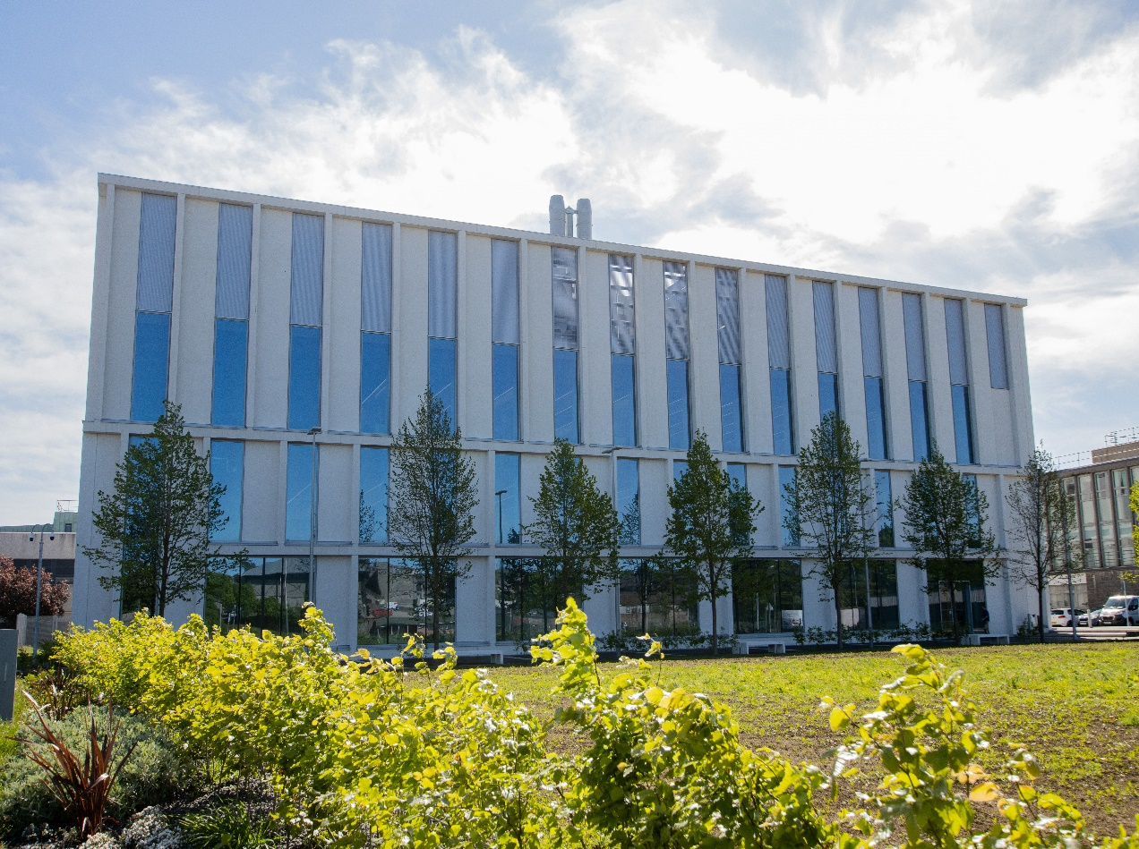

*AN3009- Architecture of Life*

*Course Handbook 2023-2024*

*Undergraduate Medical Sciences*

***School of Medicine, Medical Sciences & Nutrition***

Contents

* Course Summary
* Course Aims & Learning Outcomes
* Course Teaching Staff
* Assessments & Examinations
* Class Representatives
* Problems with Coursework
* Course Reading List
* Lecture/ Course Content Synopsis
* Tutorials, Practical Workbook and Other Coursework
* University Policies
* Academic Language & Skills support
* Medical Sciences Common Grading Scale
* Course Timetable AN3009: 2023-2024
* Campus and Floor Maps

Course Summary

This is a 15 credit Level 3 course which is provided in Semester 1: weeks 8-12

It has been designed to support the degree programme in BSc Biomedical Sciences (Anatomy) for which it is compulsory. However, students on other degree programs in the Biological Sciences and Medical Sciences may take this course.

This course involves the study of the relationship between structure and function in the organisation of body tissues. We will first describe the **four primary tissues** of the body: epithelium, connective, muscle and nerve. Using this basis, we will then investigate the anatomical organisation of other body structures including each aspect of the gastrointestinal system, specialised tissues including the skin, bone and cartilage and the respiratory and cardiovascular systems.

Course Aims and Learning Outcomes (Same as course catalogue)

**Aims**

To study the relationship between structure and function in the organisation of body tissues

**Learning Outcomes**

Students should have an understanding of tissue organisation in a variety of body locations and how these relate to function. They should be able to:

* Explain how cellular and extracellular components combine to form a cohesive structurally and functionally organised tissue.
* Describe and discuss a variety of tissue structural formats within the human body.
* Explain how variations to the structural formats of body surfaces, tubes and musculoskeletal structural components are modified from a basic format and the functional effects of such structural variations in normal and disease situations.
* Use the skills necessary to interpret microscopic slides through use of a virtual microscope
* Use the skills necessary to interpret histological images and use their findings to solve problems.
* Use the skills necessary to relate structural information and functional activity.
* Use the above to develop transferable skills, e.g. team work, presentation and communication skills.

Course Teaching Staff

Course Co-ordinator: Dr Bahgat Sami (BS) [bahgat.sami@abdn.ac.uk](mailto:d.j.chorn@abdn.ac.uk)

Other Staff:

Ms Hazel Fyfe (HF), [**h.fyfe@abdn.ac.uk**](mailto:h.fyfe@abdn.ac.uk)

Dr David Chorn (DC), [**d.j.chorn@abdn.ac.uk**](mailto:d.j.chorn@abdn.ac.uk)

Dr Flora Gröning (FG), [**f.groening@abdn.ac.uk**](mailto:f.groening@abdn.ac.uk)

Dr Okezi Ononeme (OO), [okezi.ononeme@abdn.ac.uk](mailto:okezi.ononeme@abdn.ac.uk)

Dr Shahida Shahana (SS), [**s.shahana@abdn.ac.uk**](mailto:s.shahana@abdn.ac.uk)

Assessment and Examinations

**Student Attendance**

Students are expected to attend all online lectures, demonstrations and tutorials, complete practical workbook sections and to meet deadlines of assessments and assignments provided. The minimum acceptable performance is attendance at 75% of the practical classes, and presentation of all set course work, written and oral.

This will be conducted by 4 in course assessments (ICA) spread evenly throughout the duration of the course. These will each equally contribute 25% to the total course mark (CM).

There will not be a degree examination in December 2022. A resit assessment will be held in July 2023.

# Types of Assessments

In course assessments 1 and 2 can include the following components:

1. Practical Tissue Identification.
2. Single Best Answer (SBA); Short Answer Questions (SAQ); Multiple Choice Questions (MCQ); True/False Questions (T-F) or Matching Answer Questions (MAQ).

In course assessment 3: (Poster Presentation)

In course assessment 4: (Selected Research Topic Essay) will be from a choice of histopathology topics to be provided.

# Deadlines for Assessments

|  |  |  |  |
| --- | --- | --- | --- |
| Type of Assessment | Date From: | Date to: | Mark |
| Online ICA-1 | 22/09/2023 (17:00) | 29/09/2023 (12:00) | 25% |
| Online ICA-2 | 29/10/2023 (17:00) | 067/10/2023 (12:00) | 25% |
| Online ICA-3 | 06/10/2023 (17:00) | 13/10/2023 (12:00) | 25% |
| ICA-4  (PowerPoint Presentation) | 18/09/2023 (17:00) | 16-17/10/2023 (9:00-12:00) | 25% |

Class Representatives

We value students’ opinions in regard to enhancing the quality of teaching and its delivery; therefore, in conjunction with the Students’ Association we support the Class Representative system.

In the School of Medicine, Medical Sciences & Nutrition we operate a system of course representatives, who are elected from within each course. Any student registered within a course that wishes to represent a given group of students can stand for election as a class representative. You will be informed when the elections for class representative will take place.

**What will it involve?**

It will involve speaking to your fellow students about the course you represent. This can include any comments that they may have. You will attend a Staff-Student Liaison Committee and you should represent the views and concerns of the students within this meeting. As a representative, you will also be able to contribute to the agenda. You will then feedback to the students after this meeting with any actions that are being taken.

**Training**

Training for class representatives will be run by the Students Association. Training will take place within each half-session. For more information about the Class representative system visit [www.ausa.org.uk](http://www.ausa.org.uk) or email the VP Education & Employability [vped@abdn.ac.uk](mailto:vped@abdn.ac.uk) . Class representatives are also eligible to undertake the STAR (Students Taking Active Roles) Award with further information about this co-curricular award being available at: [www.abdn.ac.uk/careers](http://www.abdn.ac.uk/careers).

Problems with Coursework

If students have difficulties with any part of the course that they cannot cope with, alone they should notify the course coordinator immediately. If the problem relates to the subject matter general, advice would be to contact the member of staff who is teaching that part of the course. Students with registered disabilities should contact the medical sciences office, ([medsci@abdn.ac.uk](mailto:medsci@abdn.ac.uk)) (based in the Polwarth Building, Foresterhill) to ensure that the appropriate facilities have been made available. Otherwise, you are strongly encouraged to contact any of the following as you see appropriate:

* Course student representatives
* Course co-ordinator
* Convenor of the Medical Sciences Staff/Student Liaison Committee (Professor Gordon McEwan)
* Personal Tutor
* Medical Sciences Disabilities Co-ordinator (Dr Derryck Shewan)

All staff are based at Foresterhill and we strongly encourage the use of email or telephone the Medical Sciences Office. You may have a wasted journey travelling to Foresterhill only to find staff unavailable.

If a course has been completed and students are no longer on campus (i.e. work from second half session during the summer vacation), coursework will be kept until the end of Fresher’s Week, during the new academic year. After that point, unclaimed student work will be securely destroyed.

Course Reading List

The recommended text for this course is:

**Histology at a Glance, by Michelle Peckham Wiley-Blackwell, ISBN 9781444333329**

Or, any other quality Histology text (or online, e.g., www.histology.leeds.ac.uk)

In addition, you will be expected to read around the subject matter presented in lectures and tutorials using the range of texts available in the Sir Duncan Rice Library at King’s College or the Medical library in the Polwarth Building at Foresterhill and other online resources.

Additionally, specific references may be provided by individual members of the teaching staff.

Course Schedule

## Week 8 (1)

Lectures

1. Course Introduction: Tissues 1&2 and Staining,
2. Tissues 1&2
3. Architecture of GIT, Oesophagus

Practical Workbook:

Practical 1: Microscopy, Tissues and Oesophagus

Tutorial 1

Tissues, Oesophagus and Poster instructions

**Online ICA-1**: Released online on MyAberdeen at 5pm 23/09 and the deadline is before 12 noon 30/09 (on Tissues, Oesophagus, Stomach, Small Intestine, and Pancreas)

## Week 9 (2)

Lectures

1. Epithelia and glands of the GIT
2. Stomach Histology of the Small intestine, Pancreas
3. Large intestine

Practical workbook:

Practical 2: Stomach, Small Intestine, Pancreas

Tutorial 2

Tissues, Oesophagus and Poster instructions

**Online ICA-2**: Released online on MyAberdeen at 5pm 30/09 and the deadline is before 12 noon 07/10 (on Large Intestine, Liver and Gall Bladder)

## Week 10 (3)

Lectures

Specialised Connective Tissue:

1. Specialised Connective Tissue: Bone & Cartilage
2. Liver, Gall Bladder
3. Cardiovascular System- Histology of the heart & blood vessels

Practical workbook:

Practical 3: Large Intestine, Liver, Gall Bladder

**Online ICA-3**: Released online on MyAberdeen at 5pm 07/10 and the deadline is before 12 noon 14/10 (on Bone & Cartilage, Cardiovascular System and Respiratory System)

## Week 11 (4)

Lectures

1. Respiratory System

Practical workbook:

Practical 4: Bone, Cartilage, Blood Vessels, Lung

Tutorial 3

Large Intestine, Liver, Respiratory and Cardiovascular Systems

## Week 12 (5)

**On-campus ICA-4 (Poster Presentation)**

Lecture/ Course Content Synopsis

All lectures will be recorded on Panopto and uploaded on MyAberdeen on the course site. They can be accessed at any time, asynchronously, but some will require compulsory online synchronous attendance. The times for these will be posted on the Course Timetable at the end of this course manual. (Online live attendance at all Tutorials, Question & Answer sessions is compulsory, and attendance will be monitored, as will submission of all coursework and in course assessments).

The lectures will be between about 10-30 minutes in length and provide an overview to the course content and the material set out in the practical workbook, in conjunction with which they should be used. They will all describe/ explain the normal histology and identification of the tissues and emphasise structure-function relationships.

Links to additional online learning material and resources to augment the lectures and the material in the practical workbook are provided in the practical workbook as appropriate.

### Welcome, Course Introduction, Cells/Tissues/Organs/Systems, tissue staining and viewing

Course administration, plan of course, how body is divided into tissues, Defining Characteristics of the Primary Tissues

How dyes enhance tissue contrast and visualisation under the microscope and assist tissue components in yielding up their secrets

### Tissue Types

Detailed overview of the 4 primary tissue types found in the body, including their distinguishing features and how these can be recognised under a microscope.

Tissue types 1: Epithelia and glands. The important tissue-lining cells at the interface between the tissue and its immediate surrounds. The relationship between epithelial structure and function is particularly emphasised in regard to substance secretion, location, architecture, arrangement, modes of secretion, locus of secretion. The smaller secretory glands residing within GIT walls are described and contrasted structurally and functionally with the specialised large GIT glands lying outside its walls.

: Connective Tissue. Classification, characterisation, and distinguishing features of general connective tissue types seen in the GIT and in other structures.

Tissue types 2: Muscle & Nerve. General features and properties of skeletal, cardiac, and smooth muscles. Types, muscular patterns, functions of the skeletal muscles. Motor unit & neuromuscular spindle. Other contractile cells. General features and properties of neurons and ganglia.

### Architecture of GIT, Oesophagus

You will use your knowledge of the primary tissues using the oesophagus as an example for understanding the general architecture of GIT tissue arrangement.

### Stomach

This lecture will help students reflect and build on Practical 2: How the tissues and cells of the stomach are specifically structured and arranged to enable it to fulfil its primary function – digestion.

### Small intestine

This lecture will help students reflect and build on Practical 2. How the tissues and cells

of the different parts of the small intestine are specifically structured and arranged to enable it to fulfil its primary function – absorption.

### Large intestine, Liver, Pancreas and Gallbladder

### This lecture will build on practical 3 and look at the architecture of these structures.

### The histological structure of the Pancreas, Liver and Gallbladder will be studied as specialised large GIT glands lying outside its walls in relation to their digestive, storage and endocrine functions.

### 7. Cardiovascular system - Heart and Blood vessels

A brief overview of the cardiovascular system including the heart and the different types of blood vessels will be given.

### 8. Specialised Connective Tissue - Bone and Cartilage

Architecture and types of bone and cartilage.

### 9. Respiratory System Histology

### Tissue organisation and arrangement in the respiratory system.

Tutorials, Practical Workbook and Other Coursework

**Tutorials 1 – 2**

* Introduction to Systems Histology and online resources.
* Distribution of virtual symposium topics, instructions, and preparation.
* Thinking in 3D.
* Approach to learning histology, question and answer sessions, quizzes, and in-course assessments.
* Highlighting of key points and difficulties in the week’s work. Revision and question answering.
* Aids for memory
* Use of MyAberdeen discussion board for additional question posting.

**Tutorial 4**

* Course evaluation and feedback.
* Questions from the week.
* Virtual symposium preparation and finalisation.

**Practical Workbook**

Diligent completion of all practicals in the Practical Workbook classes as well as all assigned coursework forms the key component of this course.

You will be supplied with a workbook for all practical classes at the commencement of the course. The workbook as well as all other details concerning the course will be posted to

the course site on MyAberdeen. Other coursework will be assigned at the appropriate times.

The relevant pages in the Practical workbook to be completed each week will be made known to you at the beginning of each week. The work required in this course may present difficulties to students with special educational or other special needs. Any student with special needs should make these known to the Course Co-ordinator when registering for the class and should also then discuss their needs with the School Disabilities Co-ordinator, to ensure that they have the best possible outcome.

Course Co-Ordinator Virtual Office Hours

## Please use the course website Discussion Board on MyAberdeen to post any queries relating to the course or course content. Or you can use the live Question & Answer sessions at the end of the week for this purpose. For any personal or private queries use the email address: [bahgat.sami@abdn.ac.uk](mailto:bahgat.sami@abdn.ac.uk) on Friday afternoons between 2-3pm only, unless otherwise very urgent.

University Policies

Students are asked to make themselves familiar with the information on key education policies, available [here](https://www.abdn.ac.uk/staffnet/teaching/key-education-policies-for-students-11809.php). These policies are relevant to all students and will be useful to you throughout your studies.  They contain important information and address issues such as what to do if you are absent, how to raise an appeal or a complaint and how the University will calculate your degree outcome.

These University wide education policies should be read in conjunction with this programme and/or course handbook, in which School specific policies are detailed. These policies are effective immediately, for the 2023/24 academic year. Further information can be found on the [University’s Infohub webpage](https://www.abdn.ac.uk/students/) or by visiting the Infohub.

The information included in the institutional area for 2023-24 includes the following:

* Assessment
* Feedback
* Academic Integrity
* Absence
* Student Monitoring/ Class Certificates
* Late Submission of Work
* Student Discipline
* The co-curriculum
* Student Learning Service (SLS)
* Professional and Academic Development
* Graduate Attributes
* Email Use
* MyAberdeen
* Appeals and Complaints

Where to Find the Following Information:

C6/C7- University of Aberdeen Homepage > Students > Academic Life > Monitoring and Progress > Student Monitoring (C6 & C7)

https://www.abdn.ac.uk/students/academic-life/student-monitoring.php#panel5179

Absences- To report absences you should use the absence reporting system tool on Student Hub. Once you have successfully completed and sent the absence form you will get an email that your absence request has been accepted. The link below can be used to log onto the Student Hub Website and from there you can record any absences you may have.

[Log In - Student Hub (ahttps://www.abdn.ac.uk/studenthub/loginbdn.ac.uk)](https://www.abdn.ac.uk/studenthub/login)

Submitting an Appeal- University of Aberdeen Homepage > Students > Academic Life > Appeals and Complaints

https://www.abdn.ac.uk/students/academic-life/appeals-complaints-3380.php#panel2109

Academic Language & Skills support

For students whose first language is not English, the Language Centre offers support with Academic Writing and Communication Skills.

Academic Writing

* Responding to a writing task: Focusing on the question
* Organising your writing: within & between paragraphs
* Using sources to support your writing (including writing in your own words, and

citing & referencing conventions)

* Using academic language
* Critical Thinking
* Proofreading & Editing

Academic Communication Skills

* Developing skills for effective communication in an academic context
* Promoting critical thinking and evaluation
* Giving opportunities to develop confidence in communicating in English
* Developing interactive competence: contributing and responding to seminar discussions
* Useful vocabulary and expressions for taking part in discussions

More information and how to book a place can be found here

Medical Sciences Common Grading Scale

|  |  |  |  |  |  |
| --- | --- | --- | --- | --- | --- |
| Grade | Grade Point | % Mark | Category | Honours Class | Description |
| A1 | 22 | 90-100 | Excellent | First | • Outstanding ability and critical thought • Evidence of extensive reading • Superior understanding •The best performance that can be expected from a student at this level |
|  |
| A2 | 21 | 85-89 |  |
|  |
| A3 | 20 | 80-84 |  |
|  |
| A4 | 19 | 75-79 |  |
|  |
| A5 | 18 | 70-74 |  |
|  |
| B1 | 17 | 67-69 | Very Good | Upper Second | • Able to argue logically and organise answers well  • Shows a thorough grasp of concepts  • Good use of examples to illustrate points and justify arguments  • Evidence of reading and wide appreciation of subject |  |
|  |
| B2 | 16 | 64-66 |  |
|  |
| B3 | 15 | 60-63 |  |
|  |
| C1 | 14 | 57-59 | Good | Lower Second | • Repetition of lecture notes without evidence of further appreciation of subject • Lacking illustrative examples and originality • Basic level of understanding |  |
|  |
| C2 | 13 | 54-56 |  |
|  |
| C3 | 12 | 50-53 |  |
|  |
| D1 | 11 | 47-49 | Pass | Third | • Limited ability to argue logically and organise answers • Failure to develop or illustrate points • The minimum level of performance required for a student to be awarded a pass |  |
|  |
| D2 | 10 | 44-46 |  |
|  |
| D3 | 9 | 40-43 |  |
|  |
| E1 | 8 | 37-39 | Fail | Fail | • Weak presentation • Tendency to irrelevance • Some attempt at an answer but seriously lacking in content and/or ability to organise thoughts |  |
|  |
| E2 | 7 | 34-36 |  |
|  |
| E3 | 6 | 30-33 |  |
|  |
| F1 | 5 | 26-29 | Clear Fail | Not used for Honours | • Contains major errors or misconceptions • Poor presentation |  |
|  |
| F2 | 4 | 21-25 |  |
|  |
| F3 | 3 | 16-20 |  |
|  |
| G1 | 2 | 11-15 | Clear Fail/Abysmal |  | • Token or no submission |  |
|  |
| G2 | 1 | 1-10 |  |
|  |
| G3 | 0 | 0 |  |
|  |

**Course Timetable AN3009: 2023-24**

|  |  |  |  |  |
| --- | --- | --- | --- | --- |
| **Date** | **Time** | **Subject** | **Session** | **Staff** |
| **Week 8** | | | | |
| **Mon 18 Sep** | **14:00-16:00** | **Course Introduction**  **Tissues and Staining**  **Architecture of GIT & Oesophagus** | **ZB18 (30)** | **DC/BS** |
| **Tues 19 Sep** | **10:00-13:00** | **Microscopy, Tissues, and Oesophagus** | **STH: FLEXI LAB_0.004** | **DC, DA** |
| Wed 20 Sep |  |  |  |  |
| Thurs 21 Sep |  |  |  |  |
| **Fri 22 Sep** | **15:00-16:00** | **Stomach** | **ZB18 (30)** | **DC** |
| **16:00-17:00** | **Small Intestine, Pancreas** | **ZB18 (30)** | **DC** |
| **Online ICA-1**: Released online on MyAberdeen at 5pm 22/09 and the deadline is before 12 noon 29/09 (on Tissues, Oesophagus, Stomach, Small Intestine, and Pancreas) | | | | |
|  | | | | |
| **Week 9** | | | | |
| **Mon 25 Sep** | **14:00-16:00** | **Tutorial (TBC)** | **ZB18 (30)** | **DC** |
| **Tues 26 Sep** | **10:00-13:00** | **Stomach, Small Intestine, Pancreas** | **STH: FLEXI LAB_1.007** | **DC, DA** |
| **14:00-16:00** | **Large Intestine** | **G08 (46)** | **DC** |
| Wed 27 Sep |  |  |  |  |
| Thurs 28 Sep |  |  |  |  |
| **Fri 29 Sep** | **14:00-16:00** | **Liver, Gall Bladder** | **ZB18 (30)** | **DC** |
| **16:00-17:00** | **Large Intestine, Liver, Gall Bladder**  **Tutorial (TBC)** | **ZB18 (30)** | **DC** |
| **Online ICA-2**: Released online on MyAberdeen at 5pm 30/09 and the deadline is before 12 noon 07/10 (on Large Intestine, Liver and Gall Bladder) | | | | |
|  | | | | |
| **Week 10** | | | | |
| **Mon 02 Oct** | **14:00-16:00** | **Tutorial (TBC)** | **ZB18 (30)** | **DC** |
| **Tues 03 Oct** | **10:00-13:00** | **Large Intestine, Liver, Gall Bladder** | **STH: FLEXI LAB_0.004** | **DC, DA** |
| **14:00-16:00** | **Specialised Connective Tissue: Bone & Cartilage** | **G08(46)** | **FG** |
| Wed 04 Oct |  |  |  |  |
| Thurs 05 Oct |  |  |  |  |
| **Fri 06 Oct** | **14:00-16:00** | **Cardiovascular System- Histology of the heart & blood vessels** | **ZB18 (30)** | **DC/OO** |
| **Online ICA-3**: Released online on MyAberdeen at 5pm 06/10 and the deadline is before 12 noon 13/10 (on Bone & Cartilage, Cardiovascular System and Respiratory System) | | | | |
|  | | | | |
| **Week 11** | | | | |
| **Mon 09 Oct** | **14:00-16:00** | **Respiratory System** | **ZB18 (30)** | **SS** |
| **Tues 10 Oct** | **10:00-13:00** | **Bone, Cartilage, Blood Vessels, Lung** | **STH: FLEXI LAB_1.007** | **DC, DA** |
| **14:00-16:00** | **Tutorial (TBC)** | **ZB14 (40)** |  |
| **Wed 11 Oct** |  |  |  |  |
| **Thurs 12 Oct** |  |  |  |  |
| **Fri 13 Oct** | **14:00-17:00** | **Tutorial about the presentation (TBC)** | **ZB18 (30)** | **DC/BS** |
|  | | | | |
| **Week 12** | | | | |
| **Mon 16 Oct** | **09:00-12:00** | **On-campus ICA-4 (Poster Presentation)** | **ZB17(30)** | **DC, BS** |
| **Tues 17 Oct** | **09:00-12:00** | **On-campus ICA-4 (Poster Presentation)** | **ZB14 (40)** | **DC, BS** |
| Wed 18 Oct |  |  |  |  |
| Thurs 19 Oct |  |  |  |  |
| Fri 20 Oct | 14:00-17:00 | OUTSIDE ACTIVITY / **Course evaluation and feedback.** | Online Tutorial | **DC, BS** |

**Venues:**

**ZB: Zoology Building** (Building No. 1 in Old Aberdeen Campus Map)

**G: Cruickshank** (Building No. 2 in Old Aberdeen Campus Map)

**STH: Science Teaching Hub** (Building No. 9 in Old Aberdeen Campus Map)

**Staff:**

Ms Hazel Fyfe (HF), [**h.fyfe@abdn.ac.uk**](mailto:h.fyfe@abdn.ac.uk)

Dr Bahgat Sami (BS) (Course Coordinator) (Anatomy), [**bahgat.sami@abdn.ac.uk**](mailto:d.j.chorn@abdn.ac.uk)

Dr David Chorn (DC), [**d.j.chorn@abdn.ac.uk**](mailto:d.j.chorn@abdn.ac.uk)

Dr Flora Gröning (FG), [**f.groening@abdn.ac.uk**](mailto:f.groening@abdn.ac.uk)

Dr Okezi Ononeme (OO), [okezi.ononeme@abdn.ac.uk](mailto:okezi.ononeme@abdn.ac.uk)

Dr Shahida Shahana (SS), [**s.shahana@abdn.ac.uk**](mailto:s.shahana@abdn.ac.uk)

**Ms Dhmyaa Alhalboosi, d.al-halboosi.21@abdn.ac.uk**

**Campus Maps – Old Aberdeen**

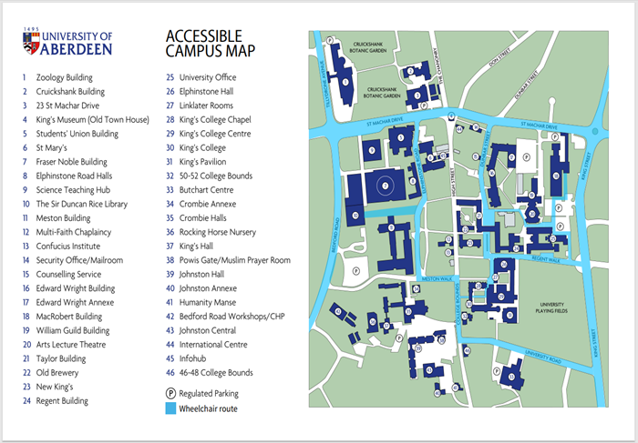

Campus Maps – Foresterhill



Polwarth Floor Plans

