Centre for Ministry Studies

Summer School 2015: 16th – 21st August
‘Participating in the Ministry of Christ’
Jesus invited his disciples, ‘Come to me, all you who are weary and burdened, and I will give you rest. Take my yoke upon you and learn from me, for I am gentle and humble in heart, and you will find rest for your souls. For my yoke is easy and my burden is light.’
You are warmly invited to come to a Summer School organised by the Centre for Ministry Studies at Aberdeen University in order to find a safe and stimulating space where ministries are refreshed and re centred on Jesus Christ.
During the week-long School we shall explore the implications of participating in Christ’s ministry and what it means practically to learn of him as we serve in the church today.
Each day will include a bible reflection, a main address, small group discussions, practical seminars and workshops as well as free time and other activities we shall share together.
The cost of the residential School is £520 which includes full board accommodation. £495 if booked by Friday 1st May.
The school will be led by: Canon Nick Cuthbert, Professor Tom Greggs, Very Rev John Miller,
Rev Peter Neilson, Rev Alison Wilkinson.

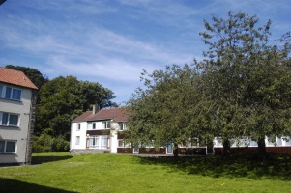
Accommodation will be full board in Crombie Hall on Kings Campus.
www.abdn.ac.uk/accommodation
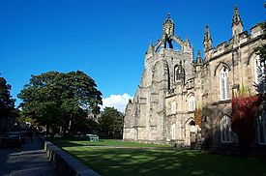
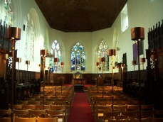
Classes will all be held on Campus with Worship in the Chapel www.abdn.ac.uk/chaplaincy/chapel

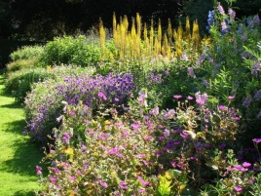
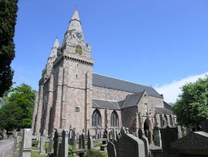
Visits will be to local relevant attractions,
www.stmachar.com
www.abdn.ac.uk/botanic-garden/
‘Participating in the Ministry of Christ’
16th – 21st August 2015 Draft Programme
SUNDAY
Afternoon: Arrivals
5.00pm: Registration
6.00pm: Tea
7.30pm: Welcome and Introductions: Interviews with main speakers
MONDAY ‘Down to earth glory: Among these people in this place?’
8.00am Breakfast
9.00am: Worship Rev Peter Neilson
9.30am: Bible Study: Ephesians 1 Prof Tom Greggs
10.15am: Coffee
10.45am: Small Group Conversations
11.30am: Main Session Very Rev John Miller
12.30pm: Lunch
1.30-3.30pm: Free Time
3.30pm: Workshop 1 Canon Nick Cuthbert
Reflecting on our calling: An opportunity to reflect on our calling, competencies and character in the here and now of ministry
5.00pm: Worship Rev Peter Neilson
5.30-6.30pm:Dinner
6.30pm: Free Time
8.00pm: Reflective Exercises in triplets
9.00pm: Free Time
TUESDAY ‘A seed must die: The Cross as Event and Experience’
8.00am Breakfast
9.00am: Worship Rev Peter Neilson
9.30am: Bible Study: Ephesians 2 Prof Tom Greggs
10.15am: Coffee
10.45am: Main Session Very Rev John Miller
11.45am: Small Group Conversations
12.30pm: Lunch
1.30-3.30pm: Free Time
3.30pm: Workshop 2 Canon Nick Cuthbert
Recognising the danger areas: A time to face the potentially destructive areas in our lives
5.00pm: Worship Rev Peter Neilson
5.30-6.30pm: Dinner
6.30pm: Free Time
8.00pm: Guided walk around Botanical Gardens
9.00pm: Free Time
WEDNESDAY ‘New Life Now: Living to the full’
8.00am Breakfast
9.00am: Worship Rev Peter Neilson
9.30am: Bible Study: Ephesians 3 Prof Tom Greggs
10.15am: Coffee
10.45am: Main Session Rev Alison Wilkinson
11.45am: Small Group Conversations
12.30pm: Lunch
1.30-3.30pm: Free Time
3.30pm: Workshop 3 Canon Nick Cuthbert
Re examining our use of time: Making sure our freedom does not lead to drivenness and burnout
5.00pm: Worship Rev Peter Neilson
5.30-6.30pm: Dinner
6.30pm: Free Time
8.00pm: Visit to St Machar Cathedral and Seaton Park
9.00pm: Free Time

THURSDAY ‘Absent yet Present: Ministries of the Ascended Lord’
8.00am Breakfast
9.00am: Worship Rev Peter Neilson
9.30am: Bible Study: Ephesians 4 Prof Tom Greggs
10.15am: Coffee
10.45am: Main Session Rev Alison Wilkinson
11.45am: Small Group Conversations
12.30pm: Lunch
1.30-3.30pm: Free Time
3.30pm: Workshop 4 Canon Nick Cuthbert
Renewing our spiritual life: Finding the place of rest in God that prepares us for the future
5.00pm: Worship Rev Peter Neilson
5.30-6.30pm: Dinner
6.30pm: Free Time
8.00pm: Prayer Evening: Ministry Circles
9.00pm: Free Time
FRIDAY ‘A Hope and a Home: Anticipating life to come’
8.00am Breakfast
9.00am: Worship Rev Peter Neilson
9.30am: Bible Study: Ephesians 5 Prof Tom Greggs
10.15am: Coffee
10.45am: Main Session Rev Alison Wilkinson
11.45am: Communion Rev Peter Neilson
12.30pm: Lunch
1.30PM: Departures

