**Weekly Divinity Newsletter: Undergraduate**

Greetings!

I hope that you are keeping well. Here is this week’s newsletter!

## **Congratulations!**

**Celebrations:**

**End of Year Book:**

As part of the celebrations of your studies and time here at the University of Aberdeen, I would like to put together a Divinity year book with your highlights, top tips and memories. I would be grateful if all final year students could send me your contributions. Your contribution could be from meeting in the Bobbin, top tips for first years, event highlights, pictures of a cat in King’s quad etc…!

Please send me your contribution by the **30th August 2020** ([s.newington@abdn.ac.uk](mailto:s.newington@abdn.ac.uk))

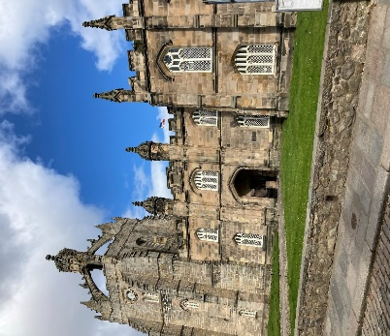 (King’s College: photograph by Amy Bender)

## **TRSS – Message from the Society:**

**TRSS News and updates:**

If you are interested in becoming a member or finding out more about TRSS and the events we organise, here is the link to our Facebook group: <https://www.facebook.com/groups/2272399396416039/>

If you do not have Facebook and are interested in joining TRSS, you can email us at:  [TRSSABDN@outlook.com](mailto:TRSSABDN@outlook.com)

## **Moving forward:**

**Course options 2020-2021:**

There are fantastic courses on offer for next academic session! Details for next academic year’s courses are available here: <https://www.abdn.ac.uk/sdhp/divinity-religious-studies/courses-20-21-1969.php>

Please do take a look, as there are some details about the courses as well as helpful links about each subject too.

**Summer Workshops:**

In preparation for the next academic year, there will be a range of optional online workshops. Details are as follows:

31st July 2020 @ 4pm: Looking at Primary Sources

7th August 2020 @ 4pm: Critical Analysis and Secondary Scholarship

14th August 2020 @ 4pm: Referencing

21st August 2020 @ 4pm: Top Tips for Academic Development – time management, orientation, academic skills support

28th August 2020 @ 4pm: Getting Involved – looking at CV development, funding opportunities and skills development

**How to join in:**

You can join this session either by clicking on the ONLINE DIVINITY Summer Workshops link located on the **Divinity, History and Philosophy myaberdeen site.**

1. Log into myaberdeen**;** instead of clicking on courses **– click on** **ORGANISATIONS** (located under the courses link – left toolbar facing) on **myaberdeen**.
2. Click on Divinity, History & Philosophy Student Information for Undergraduates.
3. Click on ONLINE DIVINITY Summer Workshops in the vertical toolbar (left facing)
4. Then click – Join session.

If you need a guest link, please do not hesitate to say!

## **Recent Events, Conferences and Workshops:**

The images of the killing of George Floyd sent a shockwave throughout the world. The protests that followed demand(ed) justice and proclaim that Black Lives Matter. Unfortunately, and painfully, nothing is new. Eric Garner, Michael Brown, Sheku Bayoh, Emmett Till, Travon Martin, – the list of black people who have died because of racism and police violence is long. On July 8th a webinar took place in order to listen to theologians and pastors who work for racial justice in the UK, USA and beyond. They specifically discussed: passive, active and systemic racism; current events and why they are happening; and pathways to overcome racism.

The webinar was organised by Mrs Lorraine Williams, PhD student in Christian Ethics, and Dr Léon van Ommen, Lecturer in Practical Theology.

Further details and a link to the webinar recording may be located here: <https://www.abdn.ac.uk/sdhp/news/14210/>

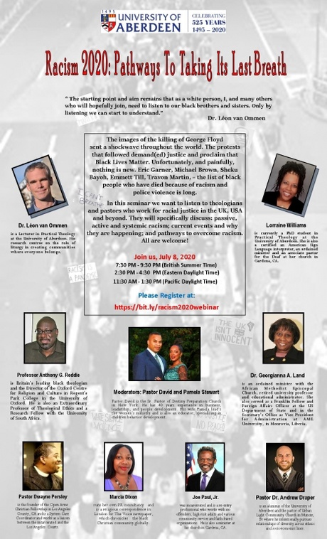

## **Summer Sun:**

Throughout the summer, I will post here some interesting online adventures! As ever, please do send in your suggestions too.

Here’s to a wonderful summer!

**Virtual Odyssey to Aksum**

The British Museum have offered a virtual online Odyssey to the city of Aksum, 6th century C.E. – taking us on a virtual journey though the trade routes, monasteries and markets.

Further details located here:

<https://blog.britishmuseum.org/historical-city-travel-guide-aksum-6th-century-ad/>

**Hadrian’s Wall:**

With thanks to Lorna Boyd too, for sharing some wonderful images from a recent trip to Vindolanda. Thank you too for the Latin inscription. Such an interesting place and here’s a link should you like to take a virtual tour of the site: <https://www.vindolanda.com/>

Calling all Latinists – feel free to translate the following inscription:

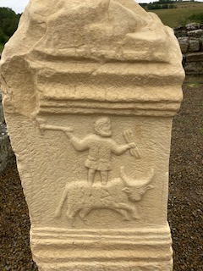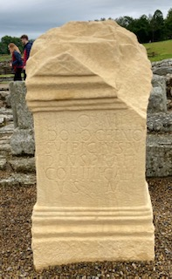(Photo by Lorna Boyd)

## **Support:**

There is a range of support on offer here at the Department of Divinity and University of Aberdeen:

Divinity Support and queries: Dr Sam Newington ([s.newington@abdn.ac.uk](mailto:s.newington@abdn.ac.uk))

Chaplaincy: <https://www.abdn.ac.uk/chaplaincy/>

Student Support: <https://www.abdn.ac.uk/students/>

Coronavirus FAQ: <https://www.abdn.ac.uk/staffnet/working-here/coronavirus/faqs-9773.php>

AUSA: <https://www.abdn.ac.uk/students/support/>

As ever should you have any queries or have any newsletter suggestions, please never hesitate to contact me.

Please to take care and stay safe.

All the very best,

Sam (Dr Newington)