Burning Fossil Fuels releases carbon dioxide.

Experiment. Products of combustion. Suitable for secondary age pupils.
We mentioned before that burning fossil fuels releases gases into the atmosphere. One of the major gases they release is carbon dioxide and we can do an experiment to prove this.
There are two versions of the experiment listed, depending on what equipment you have available to you. If you are unable to do this experiment yourself, there are videos of it being carried out on YouTube.
https://www.youtube.com/watch?v=px6-T_yVxmA
https://www.youtube.com/watch?v=8iCLrYDWiJ0
In this experiment, a solid hydrocarbon in the form of a candle (representing the hydrocarbons in coal, gas or oil) is burnt, and a pump is used to collect the gases that are produced during burning. These gases are then drawn by the pump over a piece of cobalt chloride paper and through limewater, with changes indicating the presence of water and carbon dioxide respectively. Once the experiment has been running for a few minutes the changes should be seen in the paper and the lime water, showing that the burning has produced water and carbon dioxide.
If students are not familiar with the cobalt chloride paper and limewater tests, either demonstrate these separately or allow students to try the tests themselves.
If the candle is a paraffin wax candle, the balanced chemical equation is:
C₂₅H₅₂ + 38 O₂ → 25 CO₂ + 26 H₂O
You can do a similar, but more simple experiment by lighting the candle and then covering it with a large, inverted jar.

Method
- Set up the apparatus as shown in the diagram below. The gas jar should be placed over the lit candle on a heatproof mat.
- When the candle goes out, put a lid on the gas jar.
- Test to see if the candle made water by adding a piece of blue cobalt chloride paper, test the sides of the jar. If it turns pink, water is present.
- Now test to see if carbon dioxide was produced. Pour a little limewater into the gas jar. Swill it around a little. If carbon dioxide is present, the limewater turns cloudy.
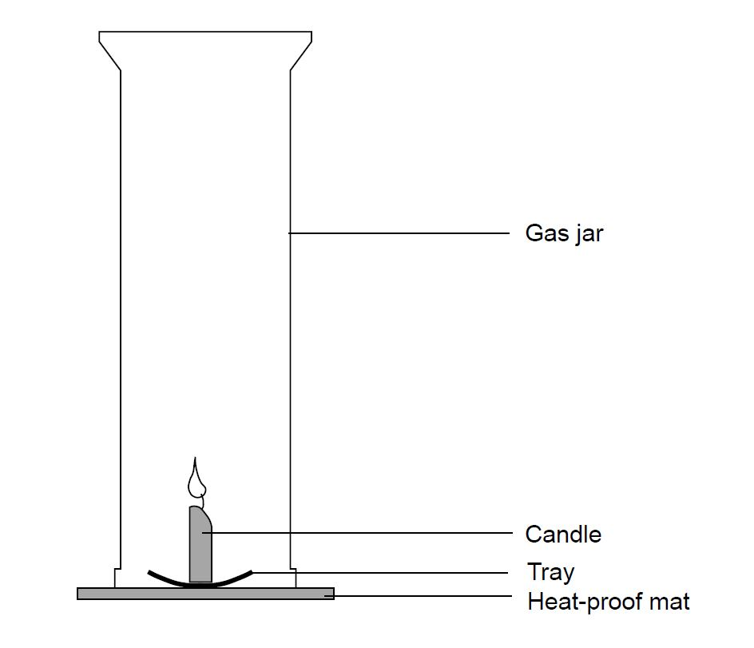
Discussion.
The candle represents fossil fuel as the wax of the candle is a hydrocarbon, just like petrol, coal, gas, or oil. Burning hydrocarbons produces carbon dioxide, which is released into our atmosphere, and is one of the key drivers of climate change.

