# Other craft ideas with autumn and winter natural resources.

Leaves, cones, acorns conkers and berries all land themselves really well to craft activities, and it’s also nice to tie these craft activities in to seasonal celebrations.

Here are some of our favourite ideas from the internet, but there are many others!

**[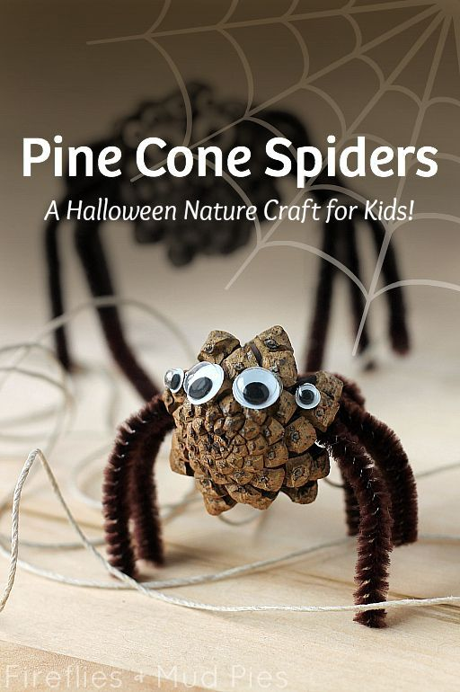](http://www.firefliesandmudpies.com/category/nature-crafts/)**

[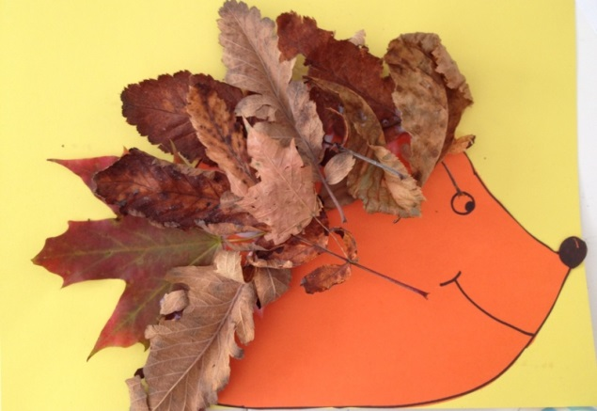](http://www.google.co.uk/url?sa=i&rct=j&q=&esrc=s&frm=1&source=images&cd=&cad=rja&uact=8&ved=0CAcQjRxqFQoTCKGy4b6L1scCFcmh2wodKLMCxA&url=http%3A%2F%2Fmykidcraft.com%2Fautumn-hedgehog%2Fautumn-fall-hedgehog-collage-preschool-im76827%2F&ei=_7vlVeG2AsnD7gao5oqgDA&psig=AFQjCNF8om5ktkzkSxJQxWVKkCVJh8cgGg&ust=1441205622071452)

[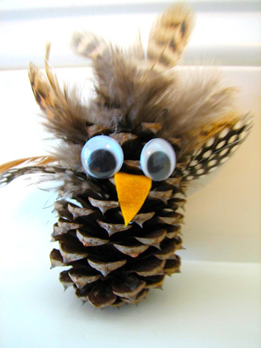](http://www.google.co.uk/url?sa=i&rct=j&q=&esrc=s&frm=1&source=images&cd=&cad=rja&uact=8&ved=0CAcQjRxqFQoTCKiIqtqE1scCFaoH2wodx4YAcg&url=http%3A%2F%2Fwww.crafthubs.com%2Fpine-cone-owl-craft%2F33929&ei=4bTlVeiTMaqP7AbHjYKQBw&psig=AFQjCNEKYuyWemdG9iSYjwKoKrV7bmA0WA&ust=1441203781984902)

**[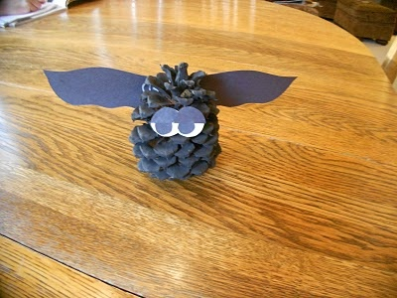](http://almostunschoolers.blogspot.com/2011/10/pine-cone-bats.html)**

[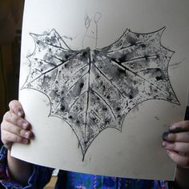](https://www.google.co.uk/url?sa=i&rct=j&q=&esrc=s&frm=1&source=images&cd=&cad=rja&uact=8&ved=0CAcQjRxqFQoTCJyBoKeH1scCFYSz2wodrHsN2Q&url=https%3A%2F%2Fwww.pinterest.com%2Fcfclassroom%2Fbats-crafts-projects-and-writing-ideas%2F&ei=m7flVdzHPITn7gas97XIDQ&psig=AFQjCNEak8-2bIZ9ZLaiZrdg7IyqnQOodQ&ust=1441204500164251)

[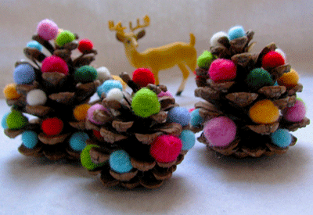](http://www.google.co.uk/url?sa=i&rct=j&q=&esrc=s&frm=1&source=images&cd=&cad=rja&uact=8&ved=0CAcQjRxqFQoTCOTZzsuH1scCFaWz2wodnHANXQ&url=http%3A%2F%2Fwww.lushome.com%2Feco-friendly-pine-cone-decorations-christmas-gifts%2F31399&ei=6LflVeTFD6Xn7gac4bXoBQ&psig=AFQjCNGybfhnlfxzOfpKGeKjcg7Ao9xiww&ust=1441204567460309)

[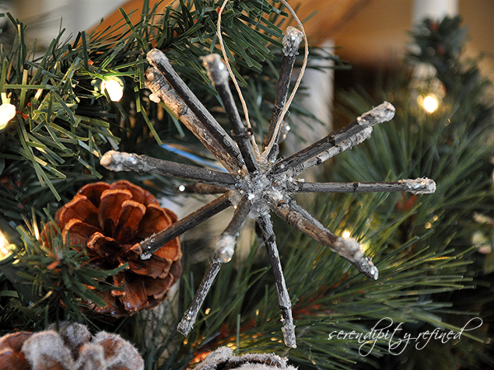](http://www.google.co.uk/url?sa=i&rct=j&q=&esrc=s&frm=1&source=images&cd=&cad=rja&uact=8&ved=0CAcQjRxqFQoTCOb8-7aK1scCFQWt2wod2D4OWA&url=http%3A%2F%2Fwww.serendipityrefined.com%2F2012%2F11%2Ftwig-ornaments-free-crafts-from-mother.html&ei=4rrlVeaDEIXa7gbY_bjABQ&psig=AFQjCNHJWaFxaXkSCNoRbb66Wd1W2YIq-w&ust=1441205338311265)

[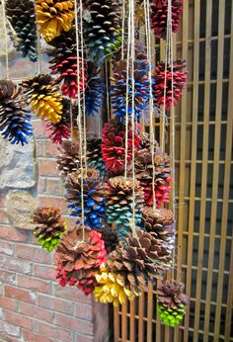](https://www.google.co.uk/url?sa=i&rct=j&q=&esrc=s&frm=1&source=images&cd=&cad=rja&uact=8&ved=0CAcQjRxqFQoTCOTfrO2K1scCFW052wodF2wAqg&url=https%3A%2F%2Fwww.pinterest.com%2Fexplore%2Fpine-cone-art%2F&ei=VLvlVeTlEu3y7AaX2IHQCg&psig=AFQjCNF2ZgwyvIcwThK-8vrp8ewGhH-_Qw&ust=1441205453077523)