Effect of greenhouse gases in our atmosphere.

Experiment 1 A tale of two thermometers.

What you will need:
- Two thermometers
- A large glass bowl, vase, or container.

Method.
- This works best in a sunny place.
- Let both thermometers acclimatise in the sun for a few minutes. The place one inside a glass container, and the other nearby in the open air. Record the temperature shown on both thermometers at the beginning. Record it (see example table below).
- Record the temperature shown on both thermometers every 5 to 10 minutes throughout the lesson.

Recording table
Time (minutes) | Temperature inside | Temperature outside
0
5
10
15

Discussion
After a while, the thermometer inside the glass container should show that it is warmer inside the container than outside. The glass container represents our atmosphere and shows how our atmosphere keeps heat from the sun in near earth and keeps the planet warmer than it would be without the atmosphere. THIS IS A GOOD THING! It has allowed life on earth to evolve in the way it has and keeps the temperature of the planet much more stable than it would be without the atmosphere. The greenhouse effect is natural and beneficial to life on earth as we know it. The problem is not carbon dioxide or other greenhouse gases in themselves, its when the balance of these gases change. When we burn fossil fuels, we are releasing carbon dioxide into the atmosphere and therefore changing the balance of the gases in the atmosphere.
Bubbles of ancient air trapped in polar ice caps can be analysed by scientists to let them understand how much carbon dioxide and other gases were in the air at different times throughout history. For hundreds of thousands of years, the amount of carbon in the atmosphere has fluctuated, and this can be shown in the graph (figure 1) below.
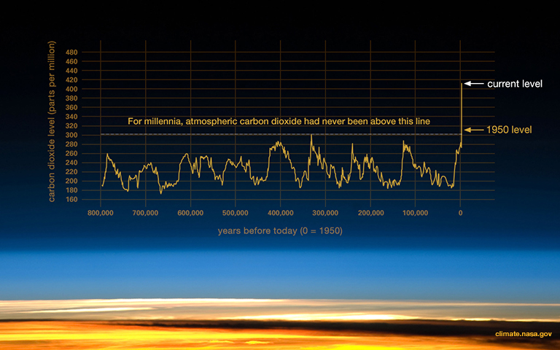
Figure 1. Atmospheric CO₂ levels fluctuations throughout history (Credit: NASA)
During ice ages the amount of carbon dioxide in the air was amount was about 200 parts per million (ppm). During the warmer periods in between ice ages, it was around 280 parts per million. Since the start of the industrial revolution, when we started burning a lot more fossil fuel, the amount of carbon dioxide has risen dramatically to unprecedented levels. In 2013 atmospheric CO₂ passed 400 ppm for the first time in recorded history.

Experiment 2. Effect of increased amount of CO2 in atmosphere.

What you will need
- Two 2l bottles half filled with water.
- Two thermometers in a bung to fit in the top of each bottle
- 2 lamps with identical wattage bulbs
- Alka seltzer

Method
- Set up the bottles so they are an equal distance away from their lamp.
- Add the alka seltzer to one bottle, then quickly put the bungs into the top of both bottles.
- Record the temperature shown on both thermometers.
- Record the temperature at 5 minute intervals throughout the lesson.

Recording table
Time | Temperature in bottle 1 (no additional CO2) | Temperature in bottle 2 (extra CO2)

Discussion
When the alka seltzer mixes with the water its fizzes and releases carbon dioxide, which can’t escape from the sealed bottle. This carbon dioxide acts in the same way as the extra carbon released from fossil fuels in our atmosphere. As both bottles are the same distance away from the lamps (representing the sun), they are both receiving the same amount of heat, but the one with extra carbon dioxide retains more of that heat energy, so the bottle warms up more.
This experiment is available to view on YouTube.
https://www.youtube.com/watch?v=kwtt51gvaJQ

Talking points.
The atmosphere is natural and essential to life on Earth. Carbon dioxide is natural and a certain amount of it always exists in the atmosphere and contributes to the earth’s natural temperature and climate. Human activities have released millions of tonnes of extra carbon dioxide into the environment which results in a stronger greenhouse effect, meaning less of the suns heat is released back into space and therefore the climate is heating up.

