
INTIMATION OF INTENTION TO SUBMIT A THESIS FOR A HIGHER DEGREE

Please note this form should be submitted to postgraduate@abdn.ac.uk one month in advance of your intended date of submission

Name: ID No:
School/Discipline: Degree:
Title of Thesis:

Supervisors:
Intended date of submission:

Have you submitted, or are you intending to submit, your thesis to another Higher Education Institution as well as to the University of Aberdeen: Yes No

Does your thesis contain confidential information: Yes No

If Yes, please state the name of the institution:

Please note that students are not permitted to submit their thesis for examination to two separate institutions unless there is a collaborative agreement between those institutions that requires it.

Please indicate if your supervisor(s) will see the final draft before submission: Yes No

Students are advised that they should present the final draft of their thesis to their supervisor before submission for comment. Where ‘no’ is indicated we will contact your supervisor to alert them.

PLEASE NOTE: Your address should be kept up to date through your student portal as we will use this to inform you of the outcome of your Viva.

For examination, a pdf copy of the thesis should be submitted to the Registry visa postgraduate@abdn.ac.uk

In person graduations will normally be held in June and late November. Application Forms to Graduate in person should be submitted by the beginning of April (for June) or the beginning of October (for November). The onus is on you to apply to graduate (see www.abdn.ac.uk/graduation for deadlines).

Please read attached info sheet for important information on thesis submission process

INFORMATION FOR RESEARCH STUDENTS ON THESIS SUBMISSION AND EXAMINATION

Important web-links
- Code of Practice for Research Students: https://www.abdn.ac.uk/staffnet/teaching/research-students-6125.php
- Library guide to presentation of thesis, and requirements for final submission: https://www.abdn.ac.uk/library/documents/guides/qggen009.pdf
- Information on graduation: https://www.abdn.ac.uk/graduation/
- Guidance on the submission of theses via Turnitin: https://www.abdn.ac.uk/pgrs/pgr-handbook/submission-of-theses-85.php

SuBMISSION OF thesis (prior to examination) VIA TURNITIN
From AY 2022/23 (September)all research degree theses submitted to Registry for examination will be uploaded by the Registry to Turnitin, prior to being sent to examiners, to ensure that no instances of Academic Misconduct have taken place. The similarity report will be reviewed to ensure any % match identified and the context of any matches within the topic and/or discipline ‘norms’ are acceptable and whether they infringe plagiarism standards. Please ensure you have read the guidance linked above.

For examination, a pdf copy of the thesis should be submitted to Registry via postgraduate@abdn.ac.uk

Things to remember during examination process
- Make sure your contact details, including term-time address, are kept up to-date. You can change your address through the Student Hub.
- Regularly check your University email address. Communication regarding your examination will be made through this email address.
- Submit Application to Graduate. Students are advised to apply early for graduation and not to wait for confirmation that thesis has been sustained. Applications to Graduate can be downloaded from Student Hub, on request to graduation@abdn.ac.uk or visiting the Infohub. Deadlines for applying to graduate can be found at the link given above. A late fee is applicable for submissions after the deadlines.

IT Account
Your computer account will be closed after completion of your degree, i.e when the thesis has been sustained and minor corrections completed. This will be the date when the Registry sends the letter confirming completion and eligibility to graduate. Students are granted Associate Student status, which will remain in place for a period of three months or 2 weeks prior to graduation, whichever is shorter. Your ID card, IT account and email will remain active for this period. Your email account will remain active for 30 days following the cessation of the Associate Student Status. Please ensure that you have any emails you require to keep or files saved on a University computer saved elsewhere.

DELAYS IN SCHEDULING VIVA
Examiners are asked that the viva be scheduled within two months of submission of the thesis to the Registry. However, delays in scheduling the viva can happen, depending on availability. If there is a delay in scheduling the viva, the Internal Examiner, or Moderator if appointed, has responsibility for making the viva arrangements. He or she will keep you informed of any delays.

VIVA BY TELE-CONFERENCE OR VIDEO CONFERENCE
Holding a viva by video or teleconference is not the ideal situation, but if you are unable to return to Aberdeen for the viva it may be permissible, and this should be arranged with the Internal Examiner/Moderator.

THESIS EXAMINATION PROCESS

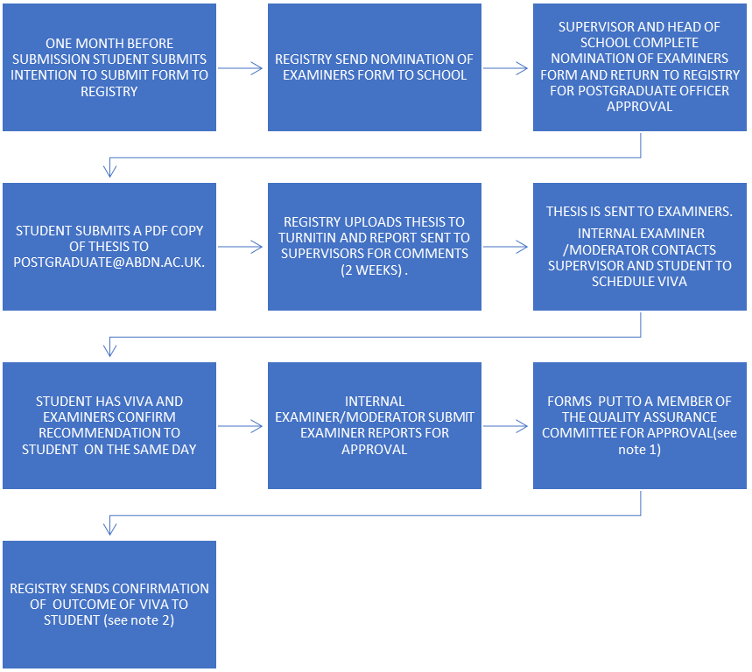

NEXT STEPS

IF STUDENT HAS MINOR CORRECTIONS:
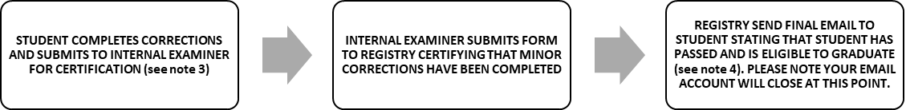

IF STUDENT HAS TO RESUBMIT THESIS FOR EXAMINATION:
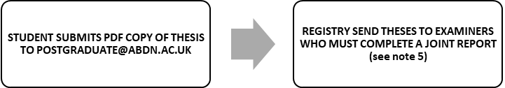

ONCE THESIS IS SUSTAINED AND ANY CORRECTIONS HAVE BEEN COMPLETED:


Notes
1. After the viva, students will be informed of the outcome by their Examiners. This is a recommendation and requires approval from a Quality Assurance Committee Officer on behalf of Senate. QAC Officers are appointed by Senate and have the authority to over-rule the decision of the Examiners, or request further information. The approval of a member of the Quality Assurance Committee is normally obtained within 2-3 weeks of receipt of reports from the Examiners, although this will be delayed when the University is closed for public holidays, i.e. over the Christmas break.
2. Following QAC approval, the Registry will issue confirmation of the outcome of the viva within 2-3 days. If there are corrections to be made to the thesis, the time for completing these will start from the date the letter is sent from the Registry.
3. If there are two External Examiners, one will be designated to certify the corrections. In this situation, students should submit corrections to the Internal Moderator, who cannot certify the corrections but who will liaise with the appropriate External.
4. The Registry will send confirmation that minor corrections have been passed as soon as possible after receipt of form certifying the corrections have been completed. This will normally be within 2-3 days of receipt of form.
5. In the case of resubmission, the same Examiners will be required to examine the thesis so the nomination process will not need to be gone through again. There is not normally a viva for a resubmission, unless the Examiners specifically request it and approval is given. Thus for a resubmission, the Examiners are required to complete a joint report, normally within two months of submission of the thesis to the Registry.

