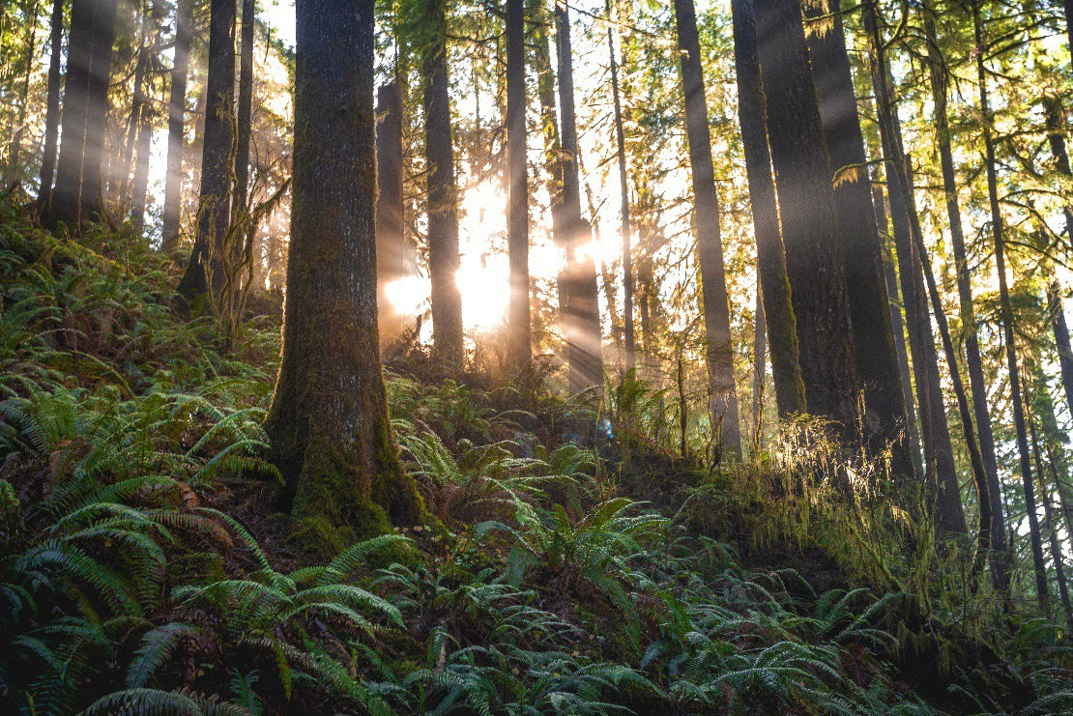 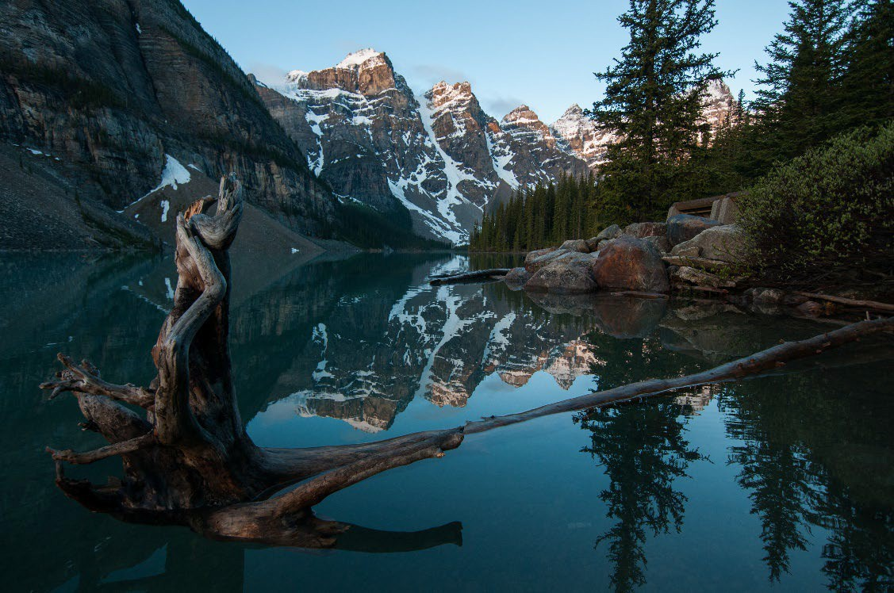

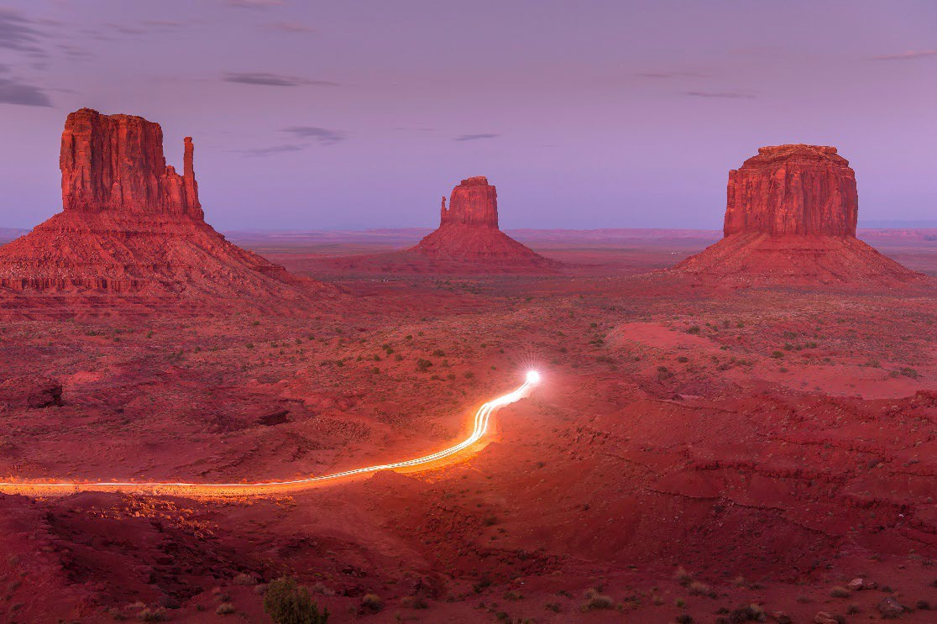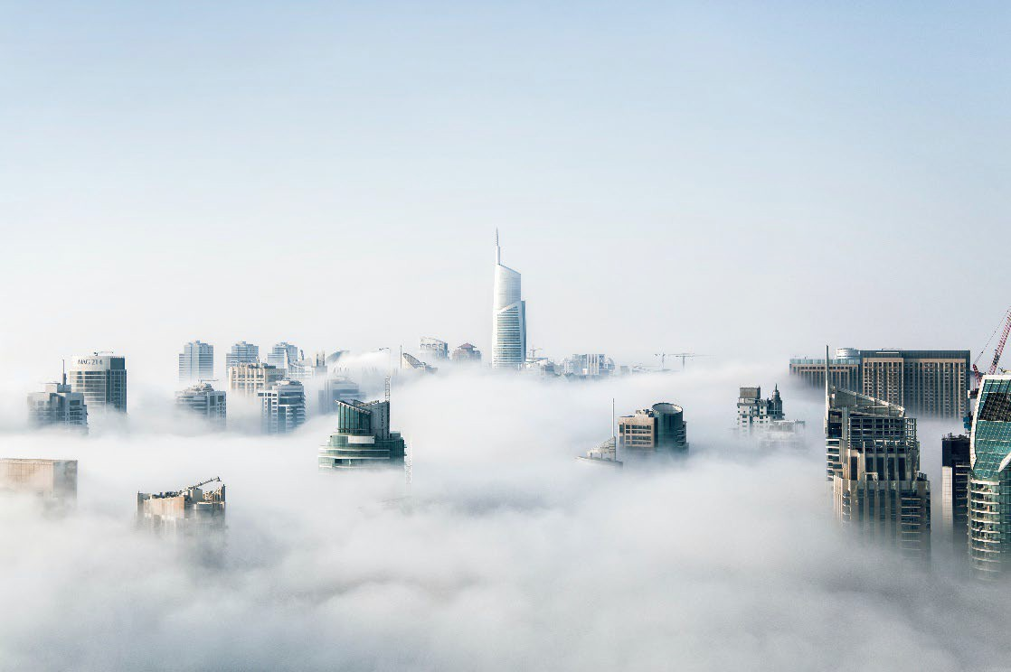

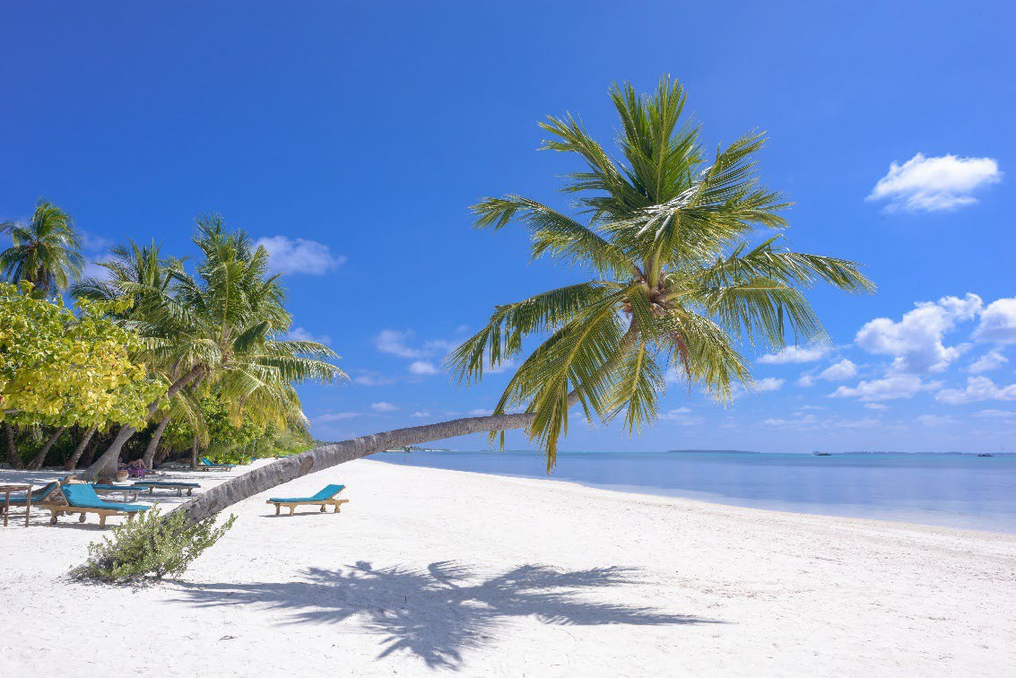 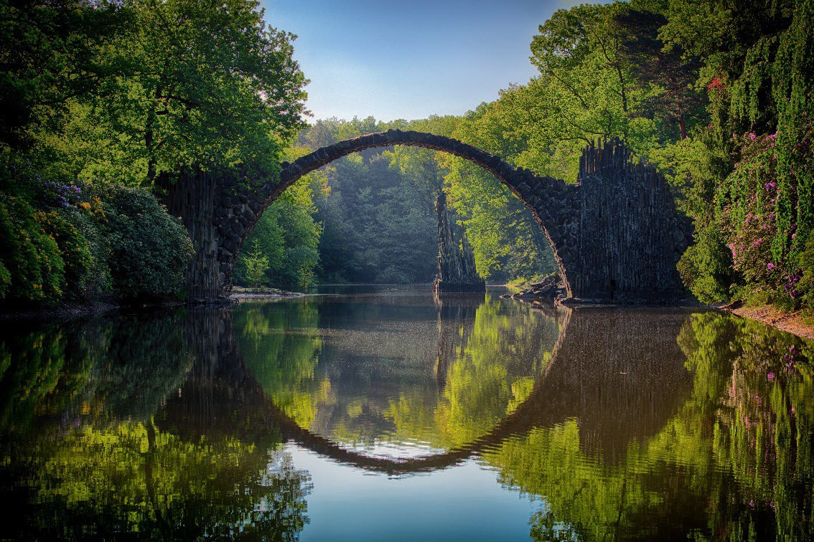

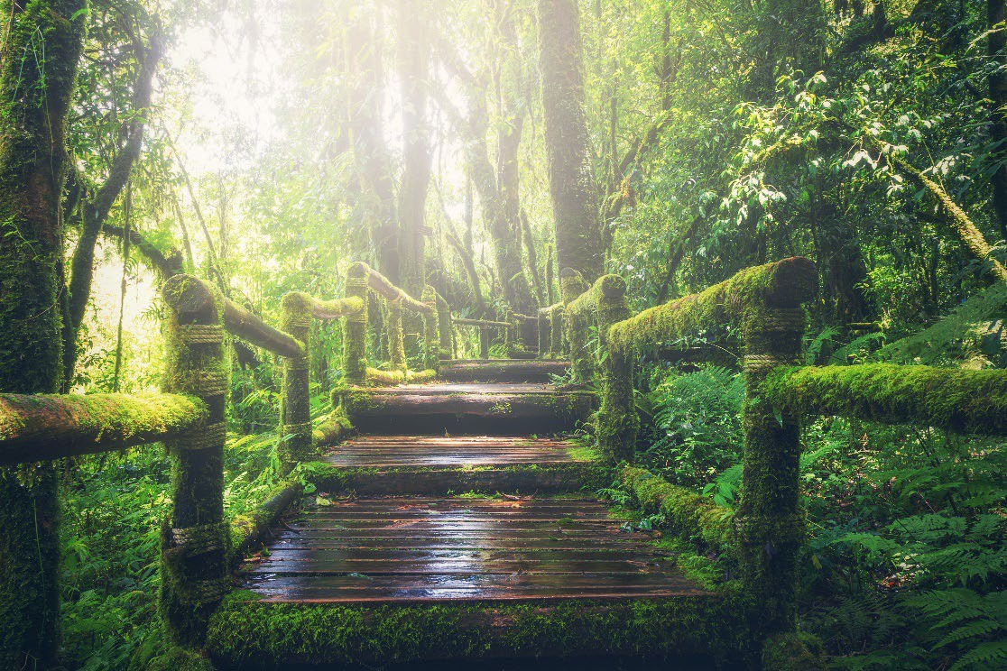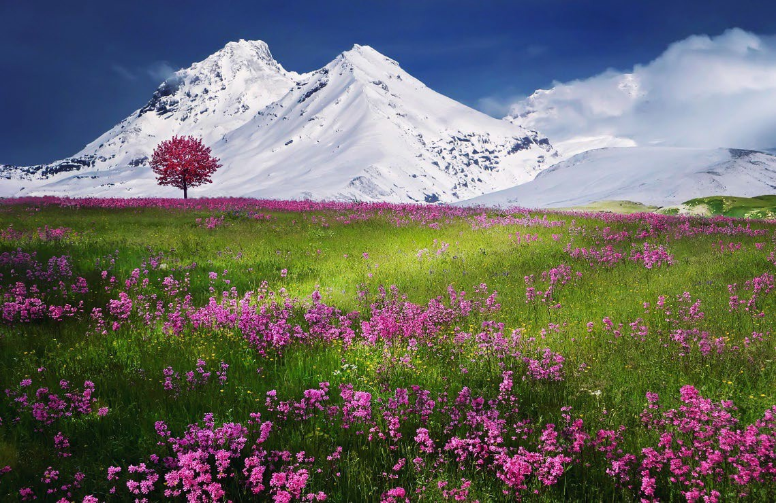

# Photo credits:

Photo by Ken Cheung: <https://www.pexels.com/photo/brown-rock-formation-7459424/> Photo by Aleksandar Pasaric: <https://www.pexels.com/photo/view-of-cityscape-325185/>

Photo by Jacob Colvin: <https://www.pexels.com/photo/scenic-photo-of-forest-with-sunlight-1757363/>

Photo by Ezra Comeau: <https://www.pexels.com/photo/landscape-photography-of-mountain-and-body-of-water-2387418/> Photo by Asad Photo Maldives: <https://www.pexels.com/photo/photo-of-coconut-trees-on-seashore-1591373/>

Photo by Martin Damboldt: <https://www.pexels.com/photo/gray-bridge-and-trees-814499/>

Photo by Pixabay: <https://www.pexels.com/photo/adventure-beautiful-boardwalk-bridge-235734/> Photo by Pixabay: <https://www.pexels.com/photo/landscape-nature-night-relaxation-36478/>

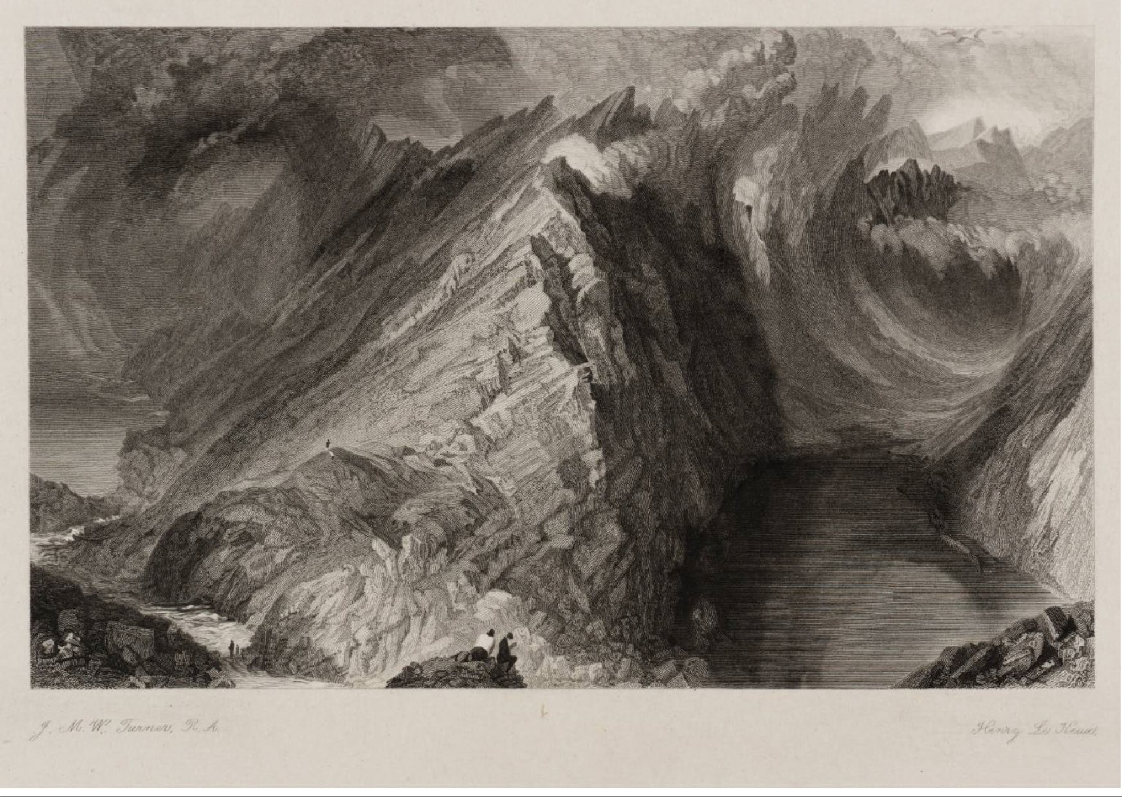

To:



No marvel thus the Monarch spoke; For rarely human eye has known

Just before this passage, Robert the Bruce arrived and was amazed.

Rent = ripped

Rude bosom = empty front

Sable = black Abyss = deep hole

Genial = kindly

Copse = small group of trees

Aught = anything

Hue = colour

A scene so stern as that dread lake,

With its dark ledge of barren stone.

Seems that primeval earthquake’s sway Hath rent a strange and shatter’d way

Through the rude bosom of the hill, And that each naked precipice,

Sable ravine, and dark abyss, Tells of the outrage still.

The wildest glen, but this, can show Some touch of Nature’s genial glow; On high Benmore green mosses grow, And heath-bells bud in deep Glencoe,

And copse on Cruchan-Ben; But here,–above, around, below,

On mountain or in glen,

Nor tree, nor shrub, nor plant, nor flower, Nor aught of vegetative power,

The weary eye may ken.

For all is rocks at random thrown,

Black waves, bare crags, and banks of stone, As if were here denied

The summer sun, the spring’s sweet dew, That clothe with many a varied hue

The bleakest mountain-side.

1. What does the king see in front of 2. Look at the second sentence. It looks him? like something happened in ancient
   1. Rolling hills leading down to a times. What was it?

river 3. How is this place different from

* 1. Bare mountains and a lake Benmore, Glencoe, and Cruchan-Ben?
  2. A dense forest 4. What colour words are used? What
  3. Mountains covered in fir trees impression do they give of this place?

5. What feeling words are used? Why?



Just before this passage, Robert the Bruce arrived and was amazed.

Rent = ripped Rude bosom = empty front Sable = black

Abyss = deep hole Genial = kindly

Copse = small group of trees

Aught = anything

Hue = colour

Scott’s poem:

No marvel thus the Monarch spoke;

For rarely human eye has known A scene so stern as that dread lake,

With its dark ledge of barren stone.

Seems that primeval earthquake’s sway Hath rent a strange and shatter’d way

Through the rude bosom of the hill, And that each naked precipice,

Sable ravine, and dark abyss, Tells of the outrage still.

The wildest glen, but this, can show Some touch of Nature’s genial glow; On high Benmore green mosses grow, And heath-bells bud in deep Glencoe,

And copse on Cruchan-Ben; But here,–above, around, below,

On mountain or in glen,

Nor tree, nor shrub, nor plant, nor flower, Nor aught of vegetative power,

The weary eye may ken. For all is rocks at random thrown,

Black waves, bare crags, and banks of stone, As if were here denied

The summer sun, the spring’s sweet dew, That clothe with many a varied hue

The bleakest mountain-side.

Modernised version:

It’s not surprising that the king was amazed Because not many have seen

A place as unwelcoming as that bleak lake, With its dark ledge of stone.

It is like an earthquake from ancient times Had ripped a hole

Through the empty front of the hill, And each plant-less drop,

Black valley, and dark hole,

Still show the effect of this quake.

Every wild place, other than this one, Has some signs of gentle nature, There is green moss on Benmore, And small flowers grow in Glencoe,

And trees grow on Cruchan-Ben; But here,–above, around, below,

On mountain or in glen, No trees, shrubs, plants, flowers, Nor any signs of them growing,

Can be seen by your tired eye.

All there is are rocks scattered at random, Everything is dark and bare,

As if […]

The summer and spring

That cover with beautiful colours

The bleakest mountain side [never come here]



Seems that primeval earthquake’s sway Hath rent a strange and shatter’d way Through the rude bosom of the hill, And that each naked precipice,

Sable ravine, and dark abyss, Tells of the outrage still.

* Find two examples of effective word choice. Explain why the word choice is effective.
* Is the sentence short or long? What effect does the sentence length have?
* How is the natural world described in this passage?
* Put the passage into your own words.





The wildest glen, but this, can show Some touch of Nature’s genial glow; On high Benmore green mosses grow, And heath-bells bud in deep Glencoe,

And copse on Cruchan-Ben; But here,–above, around, below,

On mountain or in glen,

Nor tree, nor shrub, nor plant, nor flower, Nor aught of vegetative power,

The weary eye may ken.

* Find two examples of effective word choice. Explain why the word choice is effective.
* Is the sentence short or long? What effect does the sentence length have?
* How is the natural world described in this passage?
* Put the passage into your own words.





For all is rocks at random thrown,

Black waves, bare crags, and banks of stone, As if were here denied

The summer sun, the spring’s sweet dew, That clothe with many a varied hue

The bleakest mountain-side.

* Find two examples of effective word choice. Explain why the word choice is effective.
* Is the sentence short or long? What effect does the sentence length have?
* How is the natural world described in this passage?
* Put the passage into your own words.



Just before this passage, Robert the Bruce arrived and was amazed.

Rent = ripped Rude bosom = empty front Sable = black

Abyss = deep hole Genial = kindly

Copse = small group of trees

Aught = anything

Hue = colour

Scott’s poem:

No marvel thus the Monarch spoke;

For rarely human eye has known A scene so stern as that dread lake,

With its dark ledge of barren stone.

Seems that primeval earthquake’s sway Hath rent a strange and shatter’d way

Through the rude bosom of the hill, And that each naked precipice,

Sable ravine, and dark abyss, Tells of the outrage still.

The wildest glen, but this, can show Some touch of Nature’s genial glow; On high Benmore green mosses grow, And heath-bells bud in deep Glencoe,

And copse on Cruchan-Ben; But here,–above, around, below,

On mountain or in glen,

Nor tree, nor shrub, nor plant, nor flower, Nor aught of vegetative power,

The weary eye may ken. For all is rocks at random thrown,

Black waves, bare crags, and banks of stone, As if were here denied

The summer sun, the spring’s sweet dew, That clothe with many a varied hue

The bleakest mountain-side.

Modernised version:

It’s not surprising that the king was amazed Because not many have seen

A place as unwelcoming as that bleak lake, With its dark ledge of stone.

It is like an earthquake from ancient times Had ripped a hole

Through the empty front of the hill, And each plant-less drop,

Black valley, and dark hole,

Still show the effect of this quake.

Every wild place, other than this one, Has some signs of gentle nature, There is green moss on Benmore, And small flowers grow in Glencoe,

And trees grow on Cruchan-Ben; But here,–above, around, below,

On mountain or in glen, No trees, shrubs, plants, flowers, Nor any signs of them growing,

Can be seen by your tired eye.

All there is are rocks scattered at random, Everything is dark and bare,

As if […]

The summer and spring

That cover with beautiful colours

The bleakest mountain side [never come here]

Feelings are expressed through word choice and imagery. Some possible feeling words, which suggest that the place is unpleasant yet impressive, are highlighted in blue.

Colour words [yellow] emphasise the lack of colour and bleakness.

The landscape is described as bleak and bare. Nothing lives there and there are no colours. This gives the impression that the landscape is wild, impressive, and unwelcoming.

Just before this passage, Robert the Bruce arrived and was amazed.

Rent = ripped Rude bosom = empty front Sable = black

Abyss = deep hole Genial = kindly

Copse = small group of trees

Aught = anything

Hue = colour

Scott’s poem:

No marvel thus the Monarch spoke;

For rarely human eye has known A scene so stern as that dread lake,

With its dark ledge of barren stone.

Seems that primeval earthquake’s sway Hath rent a strange and shatter’d way

Through the rude bosom of the hill, And that each naked precipice,

Sable ravine, and dark abyss, Tells of the outrage still.

The wildest glen, but this, can show Some touch of Nature’s genial glow; On high Benmore green mosses grow, And heath-bells bud in deep Glencoe,

And copse on Cruchan-Ben; But here,–above, around, below,

On mountain or in glen,

Nor tree, nor shrub, nor plant, nor flower, Nor aught of vegetative power,

The weary eye may ken. For all is rocks at random thrown,

Black waves, bare crags, and banks of stone, As if were here denied

The summer sun, the spring’s sweet dew, That clothe with many a varied hue

The bleakest mountain-side.

Modernised version:

It’s not surprising that the king was amazed Because not many have seen

A place as unwelcoming as that bleak lake, With its dark ledge of stone.

It is like an earthquake from ancient times Had ripped a hole

Through the empty front of the hill, And each plant-less drop,

Black valley, and dark hole,

Still show the effect of this quake.

Every wild place, other than this one, Has some signs of gentle nature, There is green moss on Benmore, And small flowers grow in Glencoe,

And trees grow on Cruchan-Ben; But here,–above, around, below,

On mountain or in glen, No trees, shrubs, plants, flowers, Nor any signs of them growing,

Can be seen by your tired eye.

All there is are rocks scattered at random, Everything is dark and bare,

As if […]

The summer and spring

That cover with beautiful colours

The bleakest mountain side [never come here]

The sublime is expressed through imagery: the landscape is large, bleak, and imposing. Although it is unpleasant, it is impressive. The personification of the landscape, which has been outraged by the

earthquake, is almost religious. The word choice of ‘primeval’ to suggest the age of the landscape, untouched by human hands, also expresses this idea. The sublime is also expressed through contrast to the beautiful ('the spring’s sweet dew' versus the ‘bleakest mountain-side.’)