**Athena Swan Bronze renewal application form for departments**

**Applicant information**

|  |  |
| --- | --- |
| Name of institution | University of Aberdeen |
| Name of department | School of Law |
| Date of current application | 31st January 2024 |
| Level of previous award | Bronze |
| Date of previous award | March 2017 |
| Contact name | Anne-Michelle Slater |
| Contact email | [a.m.slater@abdn.ac.uk](mailto:a.m.slater@abdn.ac.uk) |
| Contact telephone | 01224 272427 |

|  |  |
| --- | --- |
| **Section** | **Words used** |
| An overview of the department and its approach to gender equality | 2,550 |
| An evaluation of the department’s progress and issues | 2,952 |
| Future action plan* |  |
| Appendix 1: Culture survey data* |  |
| Appendix 2: Data tables* |  |
| Appendix 3: Glossary* |  |
| **Overall word count** | 5,502 |

*These sections and appendices should not contain any commentary contributing to the overall word limit

**Overall word limit: 5500 words**

Table of Contents

**Applicant information** 1

Section 1: An overview of the department and its approach to gender equality 5

1. Letter of endorsement from the head of the department 5

2. Description of the department and its context 7

3. Athena Swan self-assessment process 12

SAT and EDIC Membership 13

Section 2: An evaluation of the department’s progress and issues 16

1. Evaluating progress against the previous action plan 16

Overview of progress achieved 16

RAG rating the action plan 16

Reflection on actions rated RED 17

Reflection on actions rated AMBER 17

2. Key priorities for future action 31

Teaching and Learning 31

Staff Recruitment 31

Current staff and culture 32

Pandemic 33

Key priority 1: Addressing culture and communication. 33

Key priority 2: Addressing concerns about workload 34

Key priority 3: Promotion 34

Key Priority 4: PGR support and development 35

Section 3: Future action plan 36

Appendix 1 – Culture Survey 55

Appendix 1 – Culture Survey 56

Appendix 2 – Data sets 61

1. Students at Foundation, UG, PGT and PGR level 61

2. Student Admissions data 64

3. Degree attainment and/or completion rates for students at foundation, UG, PGT and PGR level 66

4. Academic staff overview 68

5. Academic staff by grade and contract function 70

6. Academic staff by grade and contract type 73

7. Professional, technical and operational (PTO) staff by job family 76

8. PTO staff by contract type 77

9. Applications, shortlist and appointments made in recruitment to academic posts 78

10. Applications, shortlist and appointments made in recruitment to PTO posts 79

11. Applications and success rates for academic promotion 80

12. Applications and success rates for PTO progression 81

**Appendix 3: Glossary** 82

# Section 1: An overview of the department and its approach to gender equality

Recommended word count: 2500 words

## Letter of endorsement from the head of the department

Blue text on a black background - UoA Logo **School of Law
King’s College
Aberdeen
AB24 3FX
Scotland, UK

Tel: +44 (0) 1224 27 4620
Web: www.abdn.ac.uk/law
**

**31 January 2024**

**Athena SWAN Assessment Panel**

**Dear Colleagues,**

As Head of the School of Law of the University of Aberdeen, I am delighted to offer my strong support for our application for renewal of an Athena SWAN Bronze award.

Since becoming Head of School in 2017 I have ensured that gender equality is a priority. I have felt enabled to do this by the institutional prioritisation of Equality, Diversity and Inclusion in the University’s 2040 vision. The principles of the Athena Swan Charter are now embedded in our day-to-day running, in our long-term plans, and in our allocation of resources.

The key priority of the Law School since the bronze award in 2017 has been the ongoing development of an inclusive school culture that develops and enhances gender equality. To achieve this, the AS SAT has been integrated within a more recently created EDI committee, which provides an intersectional lens.

Important achievements and milestones include:

• the introduction of an induction for new staff by the EDI and AS leads.

• Female colleagues are strongly represented in leadership roles

• Appointments: Principles of gender equality embedded in our recruitment practices,

• Promotions: Over the last four promotion rounds: 6 female colleagues promoted to Personal Chairs and 8 females to senior lecturer.

I am personally committed to the AS principles and formally signed up to them on behalf of the School in March 2022. Promotion is a matter in which I take a personal interest, mentoring and advising colleagues who are going through the process. I was a member of the SAT 2017-2020, but the integration of the EDIC with the SAT resulted in a reconfiguring of membership and the Senior Academic Line Manager is now a SAT member. Other members of the Law School Executive team on the EDIC are the Director of Research, the EDI lead and the School Administration Manager, with the EDIC lead reporting to the School Executive on EDI issues.

The work of the SAT has been prioritised through allocating administrative resource from 2018. AS and EDI work have been given significant workload recognition,[1] and I have drawn attention to individual contributions to the school’s gender equality achievements in progression and promotion applications.

I consider it to be important, both for our academic community and for our students, to celebrate the successes of female members of staff and to provide strong signs that women have a place in senior roles. The EDI Committee’s series of interviews with notable women alumna under its Aberdeen Women in Law (AWIL) Conversation Series also helps to inspire current and future students.

The principal challenges faced over the period of my headship have related to the maintenance of a life-work balance, caused by increasing student numbers, and the challenges imposed by Covid. The school, however, has been successful in attracting investment in new staff, leading to improvements in staff student ratio and reductions in workload. As the sector faces a potentially challenging period due to projected drops in student numbers and revenue, we will have to remain vigilant about potential impacts upon advancement and workload.

By addressing these key challenges, and by continuing to build on the progress we have already made, we expect early submission of a silver application. I confirm that the information presented in the application (including qualitative and quantitative data) is an honest, accurate and true representation of our School.

Yours sincerely,

Greg Gordon's signature - blue on white background 

Prof. Greg W. Gordon

Head of School

Registered Scottish Charity No SC013683 

## Description of the department and its context

**History and Background**

The University of Aberdeen (UoA) was founded in 1495, and Law has a rich heritage that can be traced back to the University’s foundation. The Law School, one of 12, comprises a diverse and international community. In alignment with the UoA Strategic Plan, Aberdeen 2040 (Abe2040), UoA is committed to creating an inclusive and supportive environment where all staff and students feel welcome and valued. The School achieved Athena SWAN (AS) Bronze in 2017.

**Physical Environment**

The Law School (School) is located within the Taylor Building (Taylor), an accessible building equipped with ramps, stairs and lift access. Free sanitary products are available locally and in other areas across campus. Gender-neutral toilets are planned as part of ongoing refurbishment to Taylor.

Taylor accommodates academic and Professional Services (PS) staff, teaching rooms and a Library. There is a staff room, where tea/coffee is provided and staff network. Regular Social events include receptions, lunches, and a regular cake club. All academic staff have their own offices.

PGR students have shared offices with a social space/kitchen to encourage socialising. Postgraduate Researchers (PGR) network with academic staff at research seminars and Research Centre events.

In 2021, following consultation to which the School contributed, UoA introduced a working from home (WFH) policy, to support all staff with the option of flexible and hybrid working. All requests by current staff to WFH have been approved and implemented (6W, 1 M).

Practices developed in the School to keep connected with staff during the pandemic WFH period (March 2020 – September 2021) have now been embedded as good practice, for example online monthly staff meetings and hybrid research seminars. Most of the teaching is on campus, and therefore, a balance is being established between in person and virtual interactions between staff and students.

**Research**

The School is research-intensive with varied research areas grouped into 5 Centres, with support for organic research clusters emerging to enable liminal spaces for developments across existing areas of expertise. The REF 2021 submission consisted of 24 M: 19 W, with an outcome for the unit of assessment of 32/69 (GPA) / 26/69 (power). This can be compared with REF 2014: 35/67 (GPA) 27/67 (power) (12M/ 6 W) reported in the previous Bronze application.

The Research Committee (RC) developed a research strategy adopted in March 2023 which embeds regard to Equality, Diversity and Inclusion (EDI) issues in all research-related decisions. All Teaching and Research staff are eligible to apply research leave one teaching term on rotation of approximately 3 years with issues EDI as key consideration for a successful application. Additional leave can be applied for at School and level and through an Institutional (UoA) scheme. The current UoA research leave application round (closed January 2024) particularly invited applications from underrepresented groups, those with protected characteristics and/or at early career stages. It also notes that in considering applications, allowance will be made for those who have taken a career break or family-related leave or are returning from long absence.

The Director of Research provides 1:1 meetings with colleagues to support them in making research related decisions that balance their research goals with other commitments. All probationary lecturers are assigned to provide guidance on career development. There are plans to widen this mentoring program to all teaching and research staff.

The School organises bi-annual Research Away Days which provide colleagues with an opportunity to make suggestions and provide feedback on the School’s strategic goals relating to Research. A *Research Environment and Culture Survey* was conducted in 2023, the results of which were presented in the January 2024 Research Away Day, where colleagues had the opportunity to engage with the findings and workshop solutions.

RC regulated the process of the appointment of directors of the 5 LAW research centres in accordance with the EDI values to increase transparency and foster inclusivity in these key roles within the School. Co-directors are now appointed for a three-year term, renewable once. Each Centre has had a women director or co-director over the last five years.

In 2021, RC introduced in its membership an ECR representative, who was elected by the ECR community for a mandate of 3 years. The first ECR representative was a woman. The ECR group has been active in organising research retreats, reading groups, and ECR Coffee and Research Exchange events.

**Education**

The Law School teaches a range of Scots and English law LLB programmes (Scots Law LLB accredited by the Law Society of Scotland) and MA Legal Studies. An International and Comparative LLB is recruiting for September 2024. At PGT level there are 20+ LLM programmes, the Diploma in Professional Legal Practice (DPLP), and research degrees (LLM and PhD). LLM International Commercial Law Programme is delivered at AFG College with the University of Aberdeen (Qatar). The School portfolio also includes 3 online PGT programmes and stand-alone online courses. It recently added the Solicitors Qualifying Exam (SQE1) to its online portfolio, broadening our professional offering. An articulation agreement with NESColl, enables entrance to LLB programmes, following HND in Legal Studies. From March 2020 to May 2022, the School delivered blended learning - primarily online lectures and classes - alongside small group on-campus teaching in 2021 and 2022. Teaching returned to on campus classes from September 2022.

**Leadership and Management Structure**

The School’s key strategic management forum is the School Executive Committee (SEC). It is comprised of the Directors/leads of key School committees, with HoS as a Chair. It includes SAM, Directors of Research (DoR) and Education (DoE), Leads of EDIC, SAT, the Coordinator for International Partnerships, and Senior Academic Line Managers (SALM) with all Academic Line Managers (ALM). It currently has 7W and 5M. It has a remit to plan for the development and strategic direction of the School, in line with institutional objectives, of which Inclusivity is a major theme (Abe2040). Communication and transparency are a key focus in School management, and dissemination of discussions and decisions at the SEC are shared at school meetings. Operational decisions, for example, workload allocations and day-to-day management is undertaken by the lead academic line manager in consultation with the ALMs.

*Graph I. - School Reporting Structure Organogram*

**Staff and Student profile 2021-22 (FTE and % W)**

**Undergraduate**

Law 1106 (63% W)

Legal Studies 47 (72% W)

**Postgraduate taught (LLM and DPLP) (including p/t)**

269 (60%W)

**PhD (including writing up)**

54 (50% W)

**Academic Staff (including p/t)** Teaching and Research 48 (56%W)

Teaching and Scholarship 72 (54%W)

Research only 3 (67% W)

**Professional Services**

Open-ended 13 (85%W)

No staff p/t or on fixed term contacts

## Athena Swan self-assessment process

**Feedback on Bronze Award**

The SAT has reflected on the Bronze Award feedback. This highlighted key transition points for women: promotion rates, percentage of professors, and lack of support for unsuccessful promotion applications. The Actions taken to address these areas and implement the approved Action Plan are reflected in the RAG rated bronze action plan. These actions have enhanced perceptions about gender equality in the School. In the 2022 survey, 89% of staff reported awareness of AS process in the school. Furthermore, 77% W (20) and 94% M (15) positively responded that leadership actively supported gender equality. 77% W (20) and 88% M (14) also positively regarded the school as committed to achieving gender balance in leadership positions. However, only 38% W (10) considered that EDI work was recognised when workload was allocated, compared to 12 M (75%). In terms of positively responding that EDI work is recognised for promotion / progression applications, this resulted in 9 W (35%) and 11 M (69%). These findings regarding perceptions of EDI work are addressed in the Action Plan and align with positive changes undertaken at the institutional level (UoA).

**Reporting Structure**

The AS Self-Assessment Team now operates as a subset of EDIC rather than as a separate entity, which has enhanced its ability to identify and address intersectional issues. Strategic oversight is provided by EDIC lead being a member of SEC and the SAT Co-Lead. The SAT reports to EDIC, EDIC reports to the SEC (Graph 1).

**Key contextual changes and developments**

Since LAW’s Bronze application was submitted in 2016 and awarded in 2017, the University has seen significant changes led by a new Senior Management Team. Prof. George Boyne was appointed Principal and Vice-Chancellor in August 2018. Prof. Karl Leydecker was appointed Senior Vice Principal in March 2019, with responsibility for ensuring delivery of School plans and budgets. In 2021 UoA appointed a new University Secretary and Chief Operating Officer, Tracey Slaven, who is responsible for governance and provides strategic direction to Professional Services across the University.

In 2020, UoA launched its Strategic Plan, Aberdeen 2040 (A2040), based on the mission statement – referring to the stated purpose of the University’s 15th century founders – “Open to all and dedicated to the pursuit of truth in the service of others”. A2040 is organized around the four core themes of Inclusive, Interdisciplinary, International, and Sustainable, each of which includes up to six commitments. Inclusive commitments include:

* Care for the wellbeing, health, and safety of our diverse community, supporting and developing our people to achieve their full potential.
* Encourage widening access to study.
* Secure the highest standards of equality, diversity and inclusion, achieving accreditation across multiple strands and characteristics.
* Eliminate pay gaps across all protected characteristics.

Fulfilling strategic goals and commitments on EDI is led by the University’s Equality, Diversity, and Inclusion committee, chaired by the Vice Principal for Education, Prof. Ruth Taylor. The committee published its Gender Pay Gap report in 2020 and launched its Antiracism Strategy in 2022. Staff Equality Networks have been established to provide safe spaces to discuss equality, diversity, and inclusion: there are networks for LGBTQ+, Women’s Development, Parents and Carers, Menopause, Race Equality, and Disability. UoA has convened a new strategy group to address Gender Based Violence and Sexual Harassment with a member of LAW staff contributing expertise and input to this group. UoA and has introduced new policies, procedures, and reporting tools to address these issues and support victims. LAW engages fully with these structures and initiatives.

LAW had a change of HoS in 2017, when Anne-Michelle Slater stepped down and Professor Greg Gordon was appointed HoS and is now in his second term of office. The key positions of Director of Education and Director of Research are held by female professors (both appointed through an open and competitive process). During this period there has been an overall increase in staff numbers with some staff turnover, resulting in an increase in female staff at all grades, including at professorial level. Student numbers fluctuated in different categories but have not changed significantly in terms of overall headcount or gender balance. (Table 1-6 / Appendix 2).

### SAT and EDIC Membership

An overarching LAW Equality, Diversity, and Inclusion Committee (EDIC) was created in 2020 in line with the UoA’s strategic direction outlined above. Currently, 7 SAT members are also on EDIC (47%). Members are appointed annually by the HoS in consultation with ALMs, aiming to ensure representation of the staff profile for career track, contract type, and gender (Table 1). Student members were previously co-opted, but a process of advertisement and application is now in place. The annual review of EDIC/ SAT membership should maintain balance and representation **(AP 1.1)** but aim to ensure that while experience is retained the work is not disproportionally undertaken by W or Early Career Researchers (ECR). Achieving and retaining this balance has provide challenging and continues as an Action in the FAP

*Table 1.2 – SAT Composition*

The 2023/24SAT comprises 12 women and 3 men: 5 women academics 2 women PS. 80% women, 20% men, 47% academics, 33% PS, all F/T. It also includes 3 women students (20%).

|  |  |  |
| --- | --- | --- |
| **SAT role** | **University role** | **Inter-sectional connection with SAT** |
| SAT Lead | Professor | EDIC |
| EDIC Lead  SAT | Lecturer | EDIC/ SEC |
| Lead ALM | Professor | SEC |
| HR Partner | Central University Services | HR |
| SAT Member | Lecturer | ECG (probation) |
| Committee Clerk | School Administration | EDIC |
| SAM | School Administration | SEC, Research Committee, Education Committee & Staff Student Liaison |
| EDIC Vice | Lecturer | ECG |
| Director of Research | Professor | Research Committee/ SEC |
| Student Representative | PGT Student | Staff Student Liaison Committee |
| Student Representative | PGR Student | Legal Research Society |
| Student Representative | DPLP | Staff Student Liaison Committee |
| SAT Member | Lecturer | EDIC |
| PG Administrator | School Administration | PCT & PGR Policy Committees |
| Senior Equality, Diversity, and Inclusion Partner | Central University Services | EDI forum |

**Table 1.3 Summary of SAT membership (staff) – EDIC also includes three students**

|  |  |  |
| --- | --- | --- |
| **Characteristic** | **Current EDIC staff representation** | **School Staff Benchmark – as at end of July 2023** |
| Sex | Female 75%  Male 25% | Female 48%  Male 52% |
| Ethnicity | BMEO 17%  White 83% | BMEO 21%  White 76%  Not known 3% |
| Grade | Grade 3-5 – 17%  Grade 7 – 58%  Grade 9 – 25% | Grade 3-5 – 12%  Grade 6 – 9%  Grade 7 – 33%  Grade 8 – 21%  Grade 9 – 24% |
| PS / Academic | Academic – 58%  PS – 42% | Academic – 84%  PS – 16% |

*Table I.4 – List of SAT Subgroups*

|  |  |  |  |
| --- | --- | --- | --- |
|  | Sub-group | Task | Formed |
| 1. | Induction Handbook | Create and review | October 2019 |
| 2. | Policy review | Review institutional and school policy | September 2019 |
| 3. | Data Review | Review survey and other data | November 2019 |
| 4. | PS Group | Review data to develop actions | Autumn 2019 |
| 5. | Student Reps Group | Identify UG, PGT and PGR issues | July 2020 |
| 6. | EDIC | Organise events | December 2020 |
|  | EDIC | Covid-19 survey and actions | Feb 2021 |
| 7. | Application review Group (Silver application) | Review application following internal and external feedback | March 2022-Septmber 2022 |
| 9. | Action Plan RAG Rating | Review plan and RAG rating | March 2022 |
| 10. | PGR Induction | PGR induction and updates | March 2022 |
| 11. | Future SAT | Review SAT operation and facilitate amalgamation with EDIC | May 2022 |
| 12 | Application Review Group (Bronze resubmission) | Review Advance HE feedback | March 2023 |

**Table 1.5 Consultation with Staff and collection of data**

|  |  |  |
| --- | --- | --- |
|  |  | % of School demographic |
| University Staff survey (2022) | Male – 13  Female – 24  Prefer Not to Say – 4 (these are not reported on as they are under the 5 threshold) | 29% |
| School Covid-19 survey (2021) | 45  53% W  47%M | 37% |
| Athena Swan Culture Survey (2022) | 26 women  16 men  Prefer not to say 3 | 33% |

Table 1.6 Views gathered in Focus Groups

|  |  |
| --- | --- |
| **Period** | **Type** |
| **2020/21** | PGR feedback at an online meeting hosted by PG PS staff with PGR students during WFH period meeting: 16/41 (39%) PGR students) |
| **2021/22** | PGR in person focus group 8/39 (21%) |
| **2023/24** | Staff Focus group 12/75 (16%% of FTE Academic and PS). |
| **2017-2024** | Regular feedback from student representatives (UG/ PGT/ PGR) on SAT |

Over the next 5 years, the School will deliver and maintain gender equality activity through EDIC. Quarterly EDIC meetings with an AS focus will report on the implementation, review and updating of the Action Plan. The SAT will meet bi-monthly to identify specific steps to implement the Action Plan and the Priority Areas. EDIC will be dedicated to operationalising the AS values on an everyday basis by setting out subgroups with assigned tasks and overseeing powers. The Action Plan will be a live document that is updated and evaluated at these meetings and carried forward into all committees and other LAW activities.

Table 1.7 Future Plans

|  |
| --- |
| **Future Plans**  Action 1.1 – Annual appointment to EDIC and SAT to ensure EDI balance and representation of staff, plus fair workload distribution  Action 1.2 – Annual advertisement and appointment of student reps UG/PGT/ PGR  Action 1.3 - Identification of SAT subgroup leads to oversee implementation of Action Plan and clear reporting structure within EDIC  Action 1.4 - Quarterly EDIC meetings dedicated to AS  Action 1.5 - SAT leads to oversee annual evaluation of the implementation of the Action Plan, with individual tasks allocated to subgroups |

# Section 2: An evaluation of the department’s progress and issues

Recommended word count: 3000 words

## Evaluating progress against the previous action plan

Please provide a critical evaluation of your most recent action plan and any other actions you have initiated since your award.

### Overview of progress achieved

Since submitting a successful Bronze AS application in 2016, LAW has established an Equality, Diversity, and Inclusion Committee (EDIC) with the Athena SWAN Self-Assessment Team (SAT) as a subgroup to implement the Action Plan and oversee EDI **(AP.1.1)**. Responsibility is taken by HoS, SAM, and EDI Lead and SAT co lead, with specific actions devolved to other members of staff in leadership roles.

LAW submitted an unsuccessful AS Silver application in December 2022. EDIC and the SAT reflected on the feedback and decided to apply for a Bronze resubmission as a next stage before applying again for Silver.

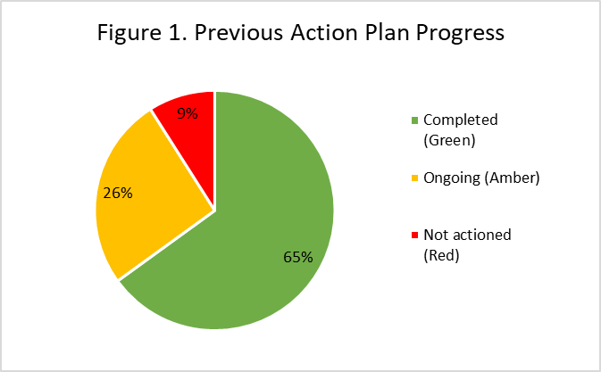LAW has made strong progress on the majority of actions: 65% complete, 26% ongoing, 9% not actioned effectively (see Fig.1.).

The impactful changes and actions include the EDI lead being a member of the School Executive. EDI considerations are agenda items in all committee and school meetings. Subgroups of EDIC review and report on the Actions and updates/ amendments to the Actions **(AP1.5).**

The principles of AS are well understood. EDI/ AS forms part of all new staff induction **(AP4.1).** EDI and AS are standing items on all school meetings. An annual AS Newsletter was produced 2019-2021. EDI/ AS updates are now a regular section in the LAW School newsletter.

It is evident from the Institutional Survey that LAW staff consider EDI a prominent and visible aspect of the school environment and leadership**.** 100%% of LAW staff said they were aware of the University’s EDI policy (Figure 7). The 2022 LAW cultural survey indicates that of the staff, 77% (20W) and 94% (15M) (Figure 2) positively view LAW leadership as actively supporting gender equality.

### RAG rating the action plan

As part of the self-assessment process for this submission, the action plan was RAG rated using the following ratings:

* Green – action is complete and, where applicable, met the desired outcome; for example, actions 1.1, 1.2, 1.5 have been rated as green as the EDIC / AS meetings have been regularly held and Teams site set up. 65% of Actions have been rated as GREEN: complete.
* Amber – the action is yet to be completed and there has been a delay in implementing the action in line with the original timescale. Actions have also been rated as amber where the action has occurred, the success measure has not been achieved – for example, action 1.3 is amber as attempts to achieve greater gender balance on our EDIC has not been achieved, action 3.2 is amber as while staff recruitment data is now more regularly reviewed, the data suggests women remain less likely to apply to senior grades. 26 % of Actions rated as AMBER: yet to be completed. These have mostly been carried through into the Future Action Plan (FAP)
* Red rating denotes actions which were ‘not started’, will never be started, or that have been stopped after critical review. For examples, action 3.7 on establishment of a central database on outreach activities was not taken forward because of issues with workload restrictions and the changing nature of outreach during the COVID 19 pandemic. 9% of Actions rated as RED.

The AS SAT found that some success criteria outlined in the previous AS plan were not consistent throughout and often set further action rather than providing targets for evaluation; this has been addressed in the future action plan. Moreover, several actions were challenged, especially by the emerging Covid-19 pandemic, and were superseded. The main barriers to implementation were assessed as being related to overall embedded cultural practice (for example less women applying to senior grades) and communication of institutional and LAW school policy (e.g. UoA family friendly hours and LAW school workload model developments). These have all been addressed in the Future Action Plan (FAP).

### Reflection on actions rated RED

*PGR students to be facilitated in mentoring PGR students*

During the pandemic weekly online keeping in touch sessions enabled informal mentoring between students. Students and staff were supportive of PhD students’ health and wellbeing. There were also limited opportunities for career and other development. Post pandemic the workload pressures and staff changes meant that a peer mentoring scheme was not established, It remains a priority and will be taken forward (**FAP 4.1)**

*Data on Outreach activities to be collected to assess impact on workload and identify any gender inequality issues.*

This was not undertaken, mainly due to workload restrictions and the changing nature of outreach during the COVID 19 pandemic. A central data base for UoA is in the process of being established and will address gender inequality regarding the allocation of outreach activities and how it is dealt with as part of workload.

### Reflection on actions rated AMBER

*Regular review of SAT/ EDIC membership*

SAT and EDIC membership was reviewed annually as part of the workload allocation. IT has proved challenging to achieve a balance on the committee that reflects the current staff make up. Other considerations were research leave, experience in EDI/ AS, including those who expressed an interest and overall workload considerations*.* There was also a desire to have an experience SAT for the re-application process. It therefore was rated as AMBER. (**FAP.5.1)**

*Annual recruitment of student representatives*

Students were originally co-opted onto the SAT. It was difficult to identify students during covid after previous reps had graduated. Athena SWAN and EDIC are referred to in all the student induction processes each year (and in January for PGT). The opportunity to act as an EDIC representative is advertised. It is recognised that this is a more equitable and open process than previously, however, no undergraduates came forward in 2023-24, therefore this Action is rated as Amber **(FAP. 5.1**).

*Promotion*

There have been improvements in the overall understanding of the promotions process and the annual review affords a structured opportunity to discuss career progression. The area of promotions continues to be an area of concern, particularly for women. This Action was rated as AMBER, it is a priority area for future Actions, **(FAP 3.1-3.5)** including encouragement for mentoring post probation **(FAP3.1)**

*Workload / Reduce work activities*

Workload, understanding the workload model and concerns about fair allocation of workload are an ongoing issue. Some progress has been made, but the impact and repercussions of the pandemic plus the increased opportunities to take research leave result in this overall being rated as AMBER. Data analysis make this a critical ongoing issue and therefore has been identified as a priority area. **(FAP 2.1-2.5)**

Actions have resulted in some improvement in other areas rated as AMBER but will continue to be monitored and reinforced in terms of ensuring gender equality in the LAW annual programme of *external research seminar speakers* **(FAP5.5).** Improvement in the take up of *unconscious bias training* will also be an ongoing Action **(FAP.5.6)** The recruitment material has been reviewed to address gender bias and enhanced in relation to EDI however less women apply to senior grades resulting in ongoing gender inequality in LAW senior positions **(FAP 5. 4)**

| **Item** | **Planned Action** | **Rationale** | **Key Outputs & Milestones** | **Timeframe Start** | **Timeframe End or Revisit** | **Person Responsible** | **Actual Progress** |
| --- | --- | --- | --- | --- | --- | --- | --- |
| **1.** | **Actions pertaining to SAT** | | | | | | |
| 1.1 | Form overarching Equality Diversity and Inclusion Committee and to include AS SAT as a subset of EDIC | Effectively address intersectional issues alongside gender equality | Formation of EDCI | Spring 2020 | Autumn 2020 | HoS/ EDIC Chair | Regular Law EDIC meetings with a clerk, a Teams site, minutes and actions. |
| 1.2 | Quarterly meetings of EDIC dedicated to AS | Address LAW gender equality issues and implementation of AS Bronze Action Plan | Regular SAT meetings with minutes and Actions | Autumn 2020 | Annual review | EDIC Chair and SAT Co-leads | Annual diarising of EDIC and SAT |
| 1.3 | Regular review of EDIC/ SAT membership | EDIC and SAT make up represent LAW population for effective implementation of Bronze Action Plan  EDIC / SAT work does not fall disproportionally on w or ECR | Annual review of membership | Spring 2017 | Annual review | HoS/ Lead ALM | Current EDIC/ SAT higher % W, PTO and Grade 7 academic staff than LAW profile. |
| 1.4 | Annual recruitment of student reps | EDIC and SAT include ongoing representation from whole student body for effective implementation of student focused gender equality issues. | Student reps from UG/PGT and PGR members of EDIC/ SAT | Autumn 2022 | Annual process | EDIC Chair/ SAT co-lead | Current EDIC/ SAT has no UG representative. I of 2 PG reps a recent UG LAW student |
| 1.5 | SAT subgroups established annually to oversee implementation of gender equality activities and Bronze Action Plan | Effective review and implementation of Bronze Action Plan | Subgroups identified and established | Autumn 2017 | Annual review | EDIC chair/ SAT co-lead | Subgroups report progress to EDIC at quarterly SAT meetings |
| 1.6 | SAT leads to undertake annual evaluation of progress against actions | Effective review and implementation of Bronze Action Plan | Annual RAG rating of Action Plan | Autumn 2017 | Annual review and report | EDIC Chair/ SAT co-lead | EDIC reports on implementation of Bronze Action Plan to LAW SEC |
| 2 | **Actions pertaining to students** | | | | | | |
| 2.1 | Increase and regularize PGR training. | PGR focus group identified that students recognised a need for all PGR students to be provided with training to enhance research and employability skills | A training programme developed for years 1-3 of LAW doctoral programmes | Autumn 2018 | Annual review | HoS/ PGR Lead | Annual training programme established for level 1, 2 and 3 PGR students. Attendance is mandatory and the content and delivery reviewed annually. |
| 2.2 | PGR students facilitated in mentoring other PGR students | PGR focus group identified that students can effectively provide mentorship for each other. This occurs informally but would be enhanced by a formal mentoring scheme and ensure inclusivity. | Identify and advertise UoA opportunities to mentor and be mentored. | Autumn 2018 | Annual review | PGR Lead | Peer to peer mentoring scheme lapsed during COVID-19 pandemic and not reestablished |
| 2.3 | Working group to review need for women only PGR scholarship | 2016 Bronze application noted that PGR population below HESA norm of 51% | Formation of working group (including PGR students) to identify quantitative and qualitative data on PGR recruitment and experience to identify whether gender equality in PGR population would be enhanced by a women only PGR scholarship | Summer 2018 | Summer 2019 | PG Coordinator | Focus group formed and reported that PGR population reverted to and has maintained in line with HESA norm of 51% and concluded that a women only scholarship not required. |
| 2.4 | Gender issues being raised in course feedback forms. | 2016 Bronze application identified through student focus group of lack of capacity to report / feedback on gender issues, | Process for raising gender issues established by UoA. All course feedback forms include an appropriate question on EDI issues | 2017 | Reviewed annually | DoE | EDI question now accounted for in all course coordinator reports, discussed at SSLC and actions identified and reported centrally |
| 3. | **Actions pertaining to data collection and analysis to inform gender equality actions** | | | | | | |
| 3.1 | Gender data on research students | 2016 Bronze application noted that PGR population below HESA norm of 51% | Formation of working group ( including PGR students) to identify quantitative and qualitative data on PGR recruitment and experience to identify barriers to W PGR recruitment | Summer 2020 | Autumn 2020 | PG coordinator | Working group report on good practice for balanced gender recruitment, including marketing materials, highlighting expertise of staff for supervision and video clips of successful women PhDs graduates.  Headcount for postgraduate research remains at about 50% having dropped in 2019/20, in line with HESA data norm of 51%.  Recruitment of Women PhDs applicants has risen to 40% over the period, and on application are more like to be offered a place. |
| 3.2 | Address gender bias in recruitment | Monitor and enhance recruitment material to reduce gender bias in the LAW recruitment process | Include reference to UoA and School’s EDI commitments  E Recruitment software utilised centrally and data collected and analysed | 2017 | Review recruitment materials at each recruitment round | HoS / HR Partner | Data suggests that women are less likely to apply to senior grades (table 21), application to offer is fairly similar by gender except at senior grades – however numbers are small. |
| 3.3 | Develop database of gender regarding external research applications and awards | To identify any gender patterns or bias | Identify and review data on external funding applications | 2020 | Review annually | DoR | Database established and reviewed at Research Committee annually  Review period 2020-2023 more W apply for research awards and more W successfully receive research funding |
| 3.4 | Allocations to committee and research centre roles | To identify any gender patterns or bias, including in appointment to Committee chairs. | Process of allocation of roles reflects LAW’s gender balance, facilitates an equitable allocation of workload and enables career progression | 2017 | Review annually | HoS/ Lead ALM/ EDIC chair | Achievement of consistent gender balance in committees, including of committee chairs in line with gender balance in School. |
| 3.5 | REF submission | Research staff (T&R) of all genders have equal opportunity to submit to REF 2020  2016 Bronze Application identified that 58% of M submitted to REF 2014. | REF policy changed and all T&R staff required to be submitted to REF 2021 | 2017 | Reviewed annually | DoR | All T&R staff supported in REF submission. In 2021 (19W/ 24M) |
| 3.6 | Research seminar speakers | 2016 Bronze application identified that 78% of research seminar speakers were male | Redress gender balance for research seminar speakers | 2017 | Review annually | DoR | Gender actively balance addressed 2017-18;2018-19 but inequality developed 2020-21 onwards.  2021/22: 2W, 4M 2021/22; 5W, 8M, 2023/24: 5W, 5M |
| 3.7 | Outreach activities | 2016 Bronze application recognsied that data collection by gender was not undertaken by LAW and this impacted equality issues on workload allocation | Partner with UoA central services to collect outreach activities data | 2020 | Review annually | HoS/ HR partner | Impacted by COVID 19 pandemic and not taken forward for workload reasons |
| **4.** | **Staff experience** | | | | | | |
| 4.1 | Induction Handbook /Induction processes | 2016 Bronze application data showed that 21% of staff did not find induction helpful. Induction a key stage in disseminating EDI and gender equality policies and practices | Induction working group to review induction handbook and induction practices | 2018 | Review annually | SAM / HR Partner | Annually reviewed induction handbook  All new staff appointed on an open ended contract receive a phased induction including a dedicated session on LAW EDI/ AS principles policies and procedures |
| 4.2 | Staff Training | 2016 Bronze application revealed staff concerns about undertaking training due to teaching and administrative duties coupled with rapid uptake of available courses | Discussion about Staff training part of ALM check list for annual review.  Training opportunities advertised internally and on MS Teams and in Newsletter | 2017 | Review annually | ALMs | Institutional survey showed that 100% of staff had undertaken training, learning or development paid for by the UoA in the past 12 months |
| 4.3 | Unconscious Bias Training | 10/142 ( 7%) staff has undertaken Unconscious bias training at the time of the Bronze 2016 application | Wider availability of Unconscious bias training opportunities by the centre. | 2017 | Review update annually | ALMs / HR partner | By 2023 49/ 151 staff had undertaken unconscious bias training (32%) |
| 4.4 | Mentoring post probation | 2016 Bronze application Survey data revealed low uptake of the mentoring scheme within LAW both as mentor and mentee. | UoA Mentoring scheme relaunched 2016 and 2023  ALM to encourage mentoring (mentor and mentee) | 2017 | Review uptake annually | ALMs/ HR partner | 1 M and 2 W engaged in mentoring scheme in 2022-2023 this is typical of annual uptake in LAW |
| 4.5 | Workload | Active engagement of staff in workload model process and outcomes as 2016 Bronze application showed that 54% of LAW staff did not think the workload model of benefit | Workload model discussed annually at LAW school meetings and refined with input from staff  ALMs engage with staff on annual workload modelling exercise | 2017 | Annual review | HoS/ SAM/ ALMs | 2022: 46%(W) and 56% agreed or strongly agreed that workloads in my department are fairly allocated |
| 4.6 | Early Career Group reestablished | Ongoing support for ECR by ensuring maintenance of Early Career Group. | Re establish ECG with chair and clerk | 2016 | Review annually | HoS/ SAM | ECG re-established 2016 and maintained and refreshed with new co-chairs appointed in 2020 and 2023in the context of a changing ECR population. |
| 4.7 | Promotions | 2016 Bronze application 44% of staff unsure of the promotions process and 20% did not understand the process  Future culture survey reveal that majority of staff understand the promotion process and that it is usefully discussed at annual review | ALMs to utilise annual review check list and discuss progression and promotion at annual review | 2017 | Review annually | HoS/ ALMs/ HR partner | 2022: 45% agreed or strongly agreed that career progression usefully discussed at Annual Review (42% W / 56% M – figure 5)  2022: 47% agreed or strongly agreed that they had a good understanding of the promotion process (46% W / 50% M – figure 5) |
| 5.1 | Parental leave | 2016 Bronze application showed that Staff survey reveals that 29% of staff believed that parental leave would negatively effect career progression  Reinforce to staff from induction onwards that maternity/paternity/parental leave is a right for parents | Induction process to highlight parental leave policies and to be part of ALM meetings and annual review as appropriate in individual cases | 2017 | Review annually | HoS/ ALMs/ HR Partner | ALMs/ HR partners promote parental leave policies and rights at induction, annual review and ALM meetings. Staff directed towards the Parent and Carers Network |
| 5.2 | Family Friendly Hours | Bronze application 2016 Staff survey/focus group indicated that not all staff are aware that family-friendly hours practice occurs | EDIC to review and publicise UoA meeting, email and family friendly hours policy annually | 2023 | Review annually | HoS/ SAM/ EDIC | 2022: 38% W (10) / 69% M (11) (Figure 3) of staff agreed or strongly agreed that the timing of meetings takes into account those with caring responsibilities |
| 5.3 | Timing of Research Seminars | Focus groups identified that at time of 2016 Bronze application not all staff could attend seminars at 4pm on Friday and 6pm on Thursday | Explore with staff suitable days and times for research seminars | 2017 | Review annually | DoR | Post COVID 19 all research seminars are hybrid online and in person. Any held outside of family friendly hours are recorded. |
| 5.4 | Care costs part of school funding applications for research and teaching activities (e.g. conferences etc) | 2016 Bronze application included that Staff focus group indicated that care costs prohibit attendance at conference and training | Care funding incorporated into research application process and staff encouraged to apply | 2019 | Annual review | DoR/ DoE | Embedded as a policy for all LAW research and teaching related internal funding applications |
| **6.** | **Additional Actions added to address the impact on students and staff of Covid-19** | | | | | | |
| 6.1 | Redesign teaching delivery | Reduce workload by delivering all programmes but reducing courses within programmes by 25%  Design all courses to be team taught to facilitate resilience | Audit of teaching expertise across staff | April 2020 | May 2022 | HoS/ DoR | Maintained manageable teaching workload for all staff during the COVID 19 pandemic |
| 6.2 | Online meetings | Twice weekly online meetings of all staff March 2020 to September 2021.  Weekly meetings 2021 to 2022 | Diarising Online meetings for all staff | March 2020 | September 2022 | HoS/ SAM | To facilitate connectively across staff when working from home |
| 6.3 | Reduce work activities | Reduce workload across all staff activities | Utilised the Light Touch Annual Review  Introduced and promoted the  Workload reduction toolkit to all staff | Summer 2020 | Review annually | HoS/ SAM/ ALM | Maintain manageable workload for all staff while delivering online teaching and support for students.  My current workload is manageable (Figure 6), 54% W (14) and 81% M (13) |
| 6.4 | Student learning and welfare support | Introduction of online and tools and meetings to support students to continue learning during the COVID 19 pandemic | Introduction of weekly live online ‘ keeping in touch sessions for PGT and PGR students | April 2020 | May 2022 | DoE | Appropriate measures and processes developed and implemented to enable successful completion of learning outcomes |
| 6.5 | Amendments to research leave | Inability for research projects to be undertaken as planned during the pandemic and the need for a redesign of teaching resulted in some staff with planned research leave postponing it. | School policy decision to allow postponement of research leave | September 2020 | January 2022 | HoS/ DoR | New School and Institutional research leave policy which recognised impact of COVID 19 on research projects and research leave with more staff eligible for an increased variety of research leave  Data shows that all research leave over the September 2020 to May 2022 has now been taken.  2022: My department has taken action to mitigate the adverse gendered impact of COVID-19 pandemic on staff (Figure 3) 54% (14W) and 56% 9M. |
| 6.6 | Online learning | To ensure staff and student health and wellbeing a balance of online and on campus teaching developed | Effective hybrid teaching delivery | September 2021 | Review annually | DoE | Effective hybrid teaching delivery.  Exceptional cases continue to be considered for either staff or students to undertake online teaching and learning. |

## Key priorities for future action

*Please describe the department’s key issues relating to gender equality and explain the key priorities for action.*

### Teaching and Learning

EDI is embedded in teaching and learning in LAW, with Education, PGT, and PGR Committees taking responsibility for, e.g., anonymous marking and balanced PGT/PGR Representation on SSLC. Student reps are also appointed annually to EDIC (**AP.1.4).** UGAdmission selectors and PGT Theme leaders take responsibility for, e.g., ensuring gender balance at on campus and virtual open days and PG information sessions**.** EDIC hosts an annual programme of events and leads for LAW on UoA strategic initiatives such as decolonising the curriculum.

EDI training is required for all members of staff, including PGR teaching assistants (**AP.4.2**). All new staff undertake unconscious bias training **(AP.4.3)** and the need to mitigate this phenomenon is widely understood and accepted. Take up has been limited by existing members of staff. Issues with accessing the online training have been identified as a barrier to completion of the online training. ALMs will advise all staff to take the training at the annual review **(FAP 5.1).** In course evaluation forms students are asked “If any aspect of the course caused you difficulties in relation to your gender, sex, sexual orientation, transgender status, race, religion/belief, disability, age or caring responsibilities” and “If any aspect of the course handled issues related to these characteristics particularly well”. Staff are required to respond to comments in annual course reports which are discussed at LAW SSLC and actions reported in Programme Reviews **(AP2.4)**.

It is a sector norm that more women apply and are admitted to law programmes at UK Law Schools. LAW at UoA matches this trend (2017-21 average 65% of LLB population W) and higher for MA Legal Studies (72%) (Table 1-2). For PGT the average is 60% W between 2017-21 (Table 3-4). While a higher proportion of UG students are women, this drops to PGT and to PGR (Figure 8), although for PGR over the same period, it is 52% W (Table 5). There is a lower proportion of female applicants at PGR, yet a higher offer rate and slightly higher registration rate. PGR training **(AP.2.1)** has been formalised and developed into a LAW annual programme for Years 1-3. PGR teaching fellow and assistant posts are advertised as open to all eligible PGRs. Those appointed are provided with training from UoA CAD prior to teaching and supervised by relevant course coordinators. Degree attainment data shows improvement in the award of good undergraduate degrees; from 55% W and 66% M in 2017/18 to 66% W and 63% M in 2021/22.

Figure 8 Student pipeline demonstrates the cross over in the gender balance from 66%W at undergraduate to 28% W at professorial level. At PGR it is 50% W/M. The Action Plan therefore addresses training, mentoring, networking, targeted opportunities, and removal of barriers for PGR women with the aim of rebalancing this gender **(FAP. 4.1-4.5**). This gender pattern is not unique to LAW at UoA, as some disparity is a sector norm across universities and the legal profession. It is a stark figure, illustrative of the real-world norm and therefore requires ongoing targeted action in relation to other areas key areas including recruitment **(FAP. 5.3)** and internal promotion **(FAP 3.1-3.5)**

### Staff Recruitment

In the Bronze application, the requirement to improve recruitment materials and selection processes was acknowledged. This has taken place alongside changes in HR policy and procedure. Successful actions include:

* Job advertisements prominently display the AS logo, feature a statement stating the School’s commitment to EDI, and include a statement encouraging members of under-represented groups and ECRs to apply **(AP.3.2)**.
* HoS encourages informal calls ahead of applications; these conversations have been reported by successful candidates as pivotal in their decision to apply.
* Online interviews are offered to those unable to attend in person. Efforts are made to ensure that online candidates are not disadvantaged by not offering additional opportunities (e.g., informal meetings) to in-person candidates.
* Members of selection committees are required to take recruitment-specific EDI and unconscious bias training **(AP.4.3).**
* Selection committees must ‘give due regard to an appropriate gender, race and age balance’ and always include at least one M and at least one W.

For academic vacancies there continue to be many more M than W applicants **(APP.2.7; Table 21),** especially at grades 7-9. However, shortlisting across all years sees more W than M relative gender parity in shortlisting at grades 5 or 6 (applicants: 48%W, 52%M; 43%W, 40%M were shortlisted) and at grades 7 or 8 (applicants: 37%W, 63%M; 21%W / 19% M were shortlisted; women were more successful at interview). More W have been appointed overall. However, at most senior grades, women are less likely to apply and to be shortlisted, although numbers are small, suggesting more needs to be done for recruitment to senior grades (FAP. 3.3).

### Current staff and culture

Most academic staff are employed on Open-Ended Teaching & Research (T&R) contracts. In 2021-22 this comprised 21W (44%) and 27M (56%) (Table 16). There is progress in terms of the promotion pipeline since 2016 with 7W (54%) and 5M at Grade 8 and 4W (25%) and 12M at Grade 9 (Figure 12), but still demonstrating gender disparity at professorial level.

On the Teaching & Scholarship track there is 33W (46%) and 39M in 2021-2022 (Figure 11). Of the staff on open ended contracts this includes 3 W and 5M. The remainder of the teaching staff are part time teaching fellows and assistants including members of the legal profession who tutor on the Diploma in Legal and Professional Practice (DPLP)on a part time basis.

All policies and procedures have improved in line with the action plan. Everyone has an annual review and career progression/ promotion is a formal part of discussion **(AP.4.7)**. 100% W / 88%M found their review useful, as found in the Institutional Staff Survey (Figure 7). However, the AS culture survey suggested that staff were less positive about feedback on their career development (42%W / 56%M).

There have been improvements in promotion and application rates by women (Table 23). Since 2019, there has been W: 100% success rate at Grade 7, 60 % at Grade 8 and 80 % at Grade 9. Understanding of the promotions process, however, could be improved (46% W / 50% M) and 42% W / 44% M reported finding the promotions process transparent. Currently HoS and ALMs discuss promotions with staff who are at a suitable stage to apply for promotion, however it is recognised that more positive actions should be taken (**FAP. 3.0)**

Every probationary member of staff is assigned a mentor, and a broader mentoring scheme and mentor training are available to all staff **(AP.4.4).** The mentoring scheme was relaunched in 2023, but to date there is limited utilisation of the scheme (2023: 2W, 1: M) **(FAP: 3.1)** take up of this.There are new HR policies around parental leave, flexible working, and homeworking **(AP.5.1, 5.2)**. Staff are encouraged to apply to the family-friendly fund for help with childcare at events **(AP.5.4).**

There have been significant changes to the workload model to address concerns about fairness **(AP.4.5)**. ALMs discuss workload with staff and the models are accessible to improve transparency. Workload continues to cause dissatisfaction. In the Culture Survey (2022) in response to ‘Workloads in my department are allocated fairly’ showed gender disparity. 54% W / 81% M find their workload manageable; 46% W / 81% M have useful discussions regarding workload at their annual review – Figure 6; the institutional survey showed that 58% W / 70% M find their workload too much. **(FAP.2.1-5)**

Reports of bullying and harassment is relatively low, however, there is a gender difference with women more likely to have experienced and / or witnessed bullying and harassment in the last 12 months (8% W/0%M experienced, 12%W / 6%M witnessed). Awareness of how to report is high with little gender difference (73%W / 75%M) although could be improved. Confidence in management tackling bullying and harassment shows a gender difference (42% W / 69%M). **(FAP1.3)**

### Pandemic

During the pandemic LAW actively supported homeworking.Staff could take home equipment and additional equipment was purchased. We reduced workload by pausing some committees and decreasing meetings. Staff welfare was monitored by ALMs; HoS and SAM convened weekly online fora to reduce isolation. Workload allocation considered caring responsibilities, and expectations for probation and Annual Review were adjusted.

Post-pandemic, flexible working continues to be supported in line with the University’s Homeworking policy. From the LAW Professional Services staff, 6 out of 11 (5W) have formal homeworking arrangements for some of the week. Academic staff must be on campus for teaching and meetings, which have largely returned to in-person, but otherwise are able to work flexibly by agreement with their ALM.

### Key priority 1: Addressing culture and communication.

As a result of the first 2017 Bronze AS application and award, awareness, culture and communication about gender equality and addressing EDI issues has developed and is now integral to School and UoA operations and strategy. LAW has made clear efforts to enhance communication, including about EDI issues **(AP.1.6).** A dedicated EDIC notice board in TAYLOR highlights events and contacts. LGBTQ+ welcome postcards are displayed around the school as are breast feeding welcome signs. All new staff receive induction and probationers are appointed with a mentor throughout the 3-year probation period to assist with answering questions and providing of general guidance and advice **(AP.4.1).**

Findings from the 2023 staff Focus Group drew attention to the gap between the existence of policies at UoA and School level and actual work in practice. Points were made that information on the website may be difficult to locate, particularly if issues relate to sensitive or confidential maters, there may be a reluctance to ask other staff members for help in finding the information or policy. Dissemination of policies, understanding of how to find out relevant information and ensuring effective implementation were all highlighted by the focus group. The data revealed two key areas and therefore LAW should overtly develop a culture and communication strategy on mental health and wellbeing support and a no tolerance policy on bullying and harassment as a key priority area.

A clear strategy and shift to a positive culture in which women are confident in seeking support for mental health and wellbeing would benefit the workplace. It could reduce absence from work and enhance retention of staff at all levels. It could also contribute positively to career progression for women, including promotion and retention of women at senior levels **(FAP.1.3)**.

There is good awareness about policies and information on mental health and wellbeing. The culture survey showed that 73% (19W) and 81% (13) knew where to seek information for in mental health and / or wellbeing at work. However, only 46% (12 W) and 56%(9M) felt confident asking for mental health and / or wellbeing support at work**.**

The culture survey indicates low incidence of bullying and harassment that 8% (2W) and 0 M had experienced bullying or harassment in the last 12 months. 12% (3W) and 6% (1M) had witnessed bullying or harassment over the same period. Staff know how to report bullying and harassment with positive responses from women (73% 19W) and 75% (12M). However, this number reduced in terms of considering that LAW was active in tackling bullying and/or harassment (42% 11W and 69% 11M). It drops further regarding positive views on satisfaction as to how bullying and harassment is dealt with (35% 9W and 63% 10 M). (**FAP 1.4)**

Although the numbers of women who reported bullying and harassment was low, women are concerned about the active tackling of bullying and how it is dealt with. A clear anti-bullying culture and an open and supportive environment would also ensure retention, particularly of women who have expressed concerns about this. The LAW focus group highlighted the limited awareness of the UoA policies on bullying and harassment. A range of ideas and initiatives were suggested which have contributed to the Acton Plan (**FAP. 1-1-1,5)**

### Key priority 2: Addressing concerns about workload

The 2022 Institutional survey revealed that staff are concerned about workload with over 75% of staff (76% W and 77% M) reporting they frequently work more than their contracted hours and 58% W, and 70% saying they struggle to cope. Only 46% consider they have a good work-life balance. Although the culture survey reveals that in terms of work life balance 85% (22W) and 81% M consider that workloads are allocated fairly **(AP4.5)** This is an improvement from the 2016 and 2021 surveys which did not show improvement in the perception of workloads being allocated fairly (from 54% to 46%(12W) **(AP4.5).** The culture survey, however, also indicated that only 46% W (12) considered that their workload was usefully discussed at annual review.

Notwithstanding the improvements in the perceptions of fairness, a 2023 staff focus group highlighted the need for transparency around workload decisions and that there should be a holistic approach to the totality of workload, both for individuals and for the school. The time requirements and pressures of new teaching or administrative roles need to be acknowledged along with flexibility and responsiveness to changing personal circumstances, particularly around wellbeing. It is important to note that ongoing high workload – particularly when combined with caring responsibilities – can have an impact on women’s career development **(FAP. 2.3)**. A LAW Focus Group response included reference to some people not feeling comfortable about discussing or admitting to struggling with workload, particularly if they also have caring responsibilities or their care role has changed to become more demanding and time consuming. We recognize the need to reduce workload and to address staff concerns about work life balance **(FAP2.5).** If high workloads are, or are seen to be, barriers to career progression, particularly for W, it is essential that this is addressed. **(FAP. 2.2)**.

### Key priority 3: Promotion

Issues around promotions continues to be an area of concern, particularly for women. Understanding of the promotions process could be improved (46% W / 50% M). UoA has implemented a new promotions process and criteria in 2023 and this revised system will take time to be fully understood by all involved. At this submission date there had been no outcomes from the new promotions process. It was designed to be more streamlined and transparent. Concerns about transparency under the old system were highlighted in the culture survey (42% W / 44% M reported finding the promotions process transparent).

Currently HoS and ALMs discuss promotions with staff who are at a suitable stage to apply for promotion, however it is recognised that more positive actions should be taken (**FAP. 3.0)** A setting out of a clear pipeline of progression from probation to professor setting out key requirements at each stage and providing role models and examples is required **(FAP 3.2).** Formal and informal guidance, mentoring and networking (**FAP 3.1).** The gender imbalance at Grade 9 requires to be tackled (28% W Figure 8) **(FAP.3.3**) as does women applying to senior roles **(FAP3.3).** Clarity on promotion, combined with ongoing continued success for women in the promotion process will contribute to retention and positively contribute to addressing the gender balance at Grade 9.

### Key Priority 4: PGR support and development

The 2016 Bronze Action Plan included actions identified relating to PGR students in terms of support and development. These were addressed in terms of training and teaching opportunities for all PGR students **(AP 2.1-2.2).** The pandemic, however, particularly impacted on PRG students due to the nature of their individual study and isolation. The majority of PGR population are international students and LAW encouraged and supported PGR students formally and informally. The PG coordinator received an AUSA award for her imaginative and proactive support for students over the pandemic period**.** Most of the PGR students who were studying for a PhD during the pandemic have now completed their studies. But the 2022 PGR Focus group emphasized the persistence of an online culture for supervisions and research seminars and a desire for increased focus on in person development opportunities for PGR students. This information can be combined with the data on gender balance from undergraduate to PGR and onwards to an academic career. Figure 8 Student pipeline demonstrates the cross over in the gender balance from 66%W at undergraduate to 28% W at professorial level. There is gender parity at PGR level. Targeted development for PGR women is therefore recognised as a key priority area in which targeted positive action can address on going gender inequality **(FAP 4.1-5).**

**The 4 key priorities areas of:**

* culture / communication,
* workload,
* promotion / progression
* support for PGR women

have a range of actions and timelines set out in the Future Action Plan. A final section of the FAP deals with effective monitoring and implementation of the FAP.

# Section 3: Future action plan

| **Objective** | | **Action Details** | **Responsibility** | **Time Frame** | **Success Criteria** |
| --- | --- | --- | --- | --- | --- |
| Priority Area 1: Communication and Culture | | | | | |
| 1.1 | Enhance inclusive and accepting environment | Increase number of staff engaging with central wellbeing events | Wellbeing Team/Wellbeing representatives/ EDI Committee/ Clerk | 2024-2025 including reference to wellbeing events in EDI Digest (see below) | 50% of staff engaged with at least one central wellbeing event in the period 2025-2029.  (no more than 10% discrepancy between men and women) by 2029  Increased confidence asking for support and increased feeling of being supported for mental health and wellbeing and reduced gender disparity (Baseline = 46% F / 56% M and 58% F / 81% M) |
| 2025-2026 advertise through posters and screens (see specific action point on communication plan below) |
| 2026-2027 collaborate on bespoke event for the Law School |
| 2027-2028 conduct short survey to gauge progress on engagement with central wellbeing events |
| Building on the success of our informal celebration of International Women’s Day – commit to holding two events / year that highlight gender specific issues. | EDIC | Hosting one event in 2024-2025.  Hosting two events in 2025-2026 increasing to 3 events in 2026-2027 | 50% of staff engaged with at least one EDI event by 2027.  (no more than 10% discrepancy between men and women) by 2029. |
| Introduce EDI Digest (a short one-page briefing on available resources and upcoming events) | EDIC | EDI digest to launch in 2024 -2025. Moving from annual to bi-annual publication from 2025-2027. Review whether to move to EDI digest/term in 2027. | Bi-annual publication by 2027 with 70%+ of staff indicating that the digest is useful in future surveys.  (no more than 10% discrepancy between men and women) by 2029 |
| Annual briefing for all staff on A/S and EDI | AS Lead/EDI Lead/Clerk | Planning from 2024-2025  Annual briefing from 2025-2026 onwards. | 70+% of staff are satisfied with their understanding of EDI and AS after briefings.  (no more than 10% discrepancy between men and women) by 2029 |
| Induction for new staff on AS and EDI | AS Lead/EDI Lead/ SAM | Planning from 2024-2025  Induction on EDI/AS for all new staff from: 2025-2026 | 70+% of new staff feel satisfied with their understanding of AS and EDI by 2027 after induction.  (no more than 10% discrepancy between men and women) by 2029 |
| Increase awareness of menopause and its impact on working life | EDI Lead/Menopause Network Rep | Approach Menopause network in academic year 2024-2025 | EDI member represented on the Menopause Network by start of academic year 2026 at the latest. |
| Develop imaginative and effective internal communication plan regarding EDI including health and wellbeing. | SAM/ EDIC/ Wellbeing Team/Wellbeing representatives/ Senior EDI partner | 2024-2025: collating resources from School and central level to use for communications/ developing budget for marketing/communication resources  2025-2026: working with Graphic Design Team lead to develop posters and visualisations.  2026-2027: roll out communications plan for health and wellbeing  2027-2028: review communication plan | 50% of staff satisfied that EDI policies and events are effectively communicated by 2028  60+% of staff satisfied that EDI policies and events are effectively communicated by 2029.  (no more than 10% discrepancy between men and women) by 2029 |
| Increase use of social media to raise awareness of EDI among student including on health, wellbeing and reporting tools. | SAM/ EDIC/ Senior EDI partner/ Wellbeing Team/Wellbeing representatives/ | Building on the above communication plan; work with Graphic Design Team in 2025-2026 to develop visualisations for social media.  2026-2027 (onwards): roll out social media campaign  2027-2028 (onwards): review campaign | 50% of students are satisfied that EDI policies and events are effectively communicated by 2028  60+% of students are satisfied that EDI policies and events are effectively communicated by 2029.  (no more than 10% discrepancy between men and women) by 2029 |
| Review and improve gender representation in research events. | DoR/RSS Lead/Research Centre Leads/ Clerk | Autumn 2024 - 2025 – collaborate with research centre leads to develop a system for monitoring gender representation in research events. | Gender representation in research events has improved by 2027-2028. |
| Autumn 2025 – Research leads report to EDIC and EDIC to review gender representation in research events and annually thereafter |
| 1.2 | Increase Engagement with Athena Swan / EDI / staff surveys | Increasing engagement with staff surveys by allocating time during law staff meetings aiming at 80% engagement | SAM | Allocating time during law staff meetings from beginning of academic year 2024-2025 | 50% engagement in 2024-2025  60% engagement in 2025-2026  70% engagement in 2026-2027  70+% engagement by 2029.  (no more than 10% discrepancy between men and women) by 2029 |
| Increase engagement among students by allocating time during induction week to fill in surveys. | Program Coordinators/ Deputy SAM and School Administrator / President of Legal Research Society | Liaise with relevant persons 2025-2026 (and annually thereafter) | 30% engagement in 2024-2025  40% engagement in 2025-2026  50% engagement in 2026-2027  50+% engagement by 2029.  (no more than 10% discrepancy between men and women) by 2029 |
| Liaise with students on surveys and the issue of engagement at Law School Meeting | Law School Meeting Chair and Clerk | Liaise with relevant persons 2025-2026 (and annually thereafter)  Time allocated to surveys during induction week for 2026-2027 cohort | 30% engagement in 2024-2025  40% engagement in 2025-2026  50% engagement in 2026-2027  50+% engagement by 2029.  (no more than 10% discrepancy between men and women) by 2029 |
| 1.3 | Increase the % of W feeling confident in seeking mental health support at work.  (see also 1.1, 1.4) | Promotion of the mental health first aiders and wellbeing resources in the school, including adding their mental health first aid role to email signatures and utilising postcards displaying the information on office doors and desks.  Engage the Institutional Wellbeing team to arrange Wellbeing events, pop up stalls, and workshops. | Lead ALM/ HoS/ ALMs/ SAM/ Existing Mental Health First Aiders | 2025-2026: create action plan for promoting mental health first aiders and wellbeing resources (including allocating time in law staff meeting and EDI bulletin). | % of staff aware of mental health first aiders increase:  50% awareness in 2025-2026  70% engagement in 2026-2027  70+% engagement by 2029.  Baseline: Confidence asking for support 46% F / 56% M and feeling of being supported for mental health and wellbeing 58% F / 81% M)  (no more than 10% discrepancy between men and women) by 2029 |
| Increase number of staff taking mental health training in the law school | Lead ALM/ HoS/ ALMs/ SAM/ Existing Mental Health First Aiders | Liaise with Lead ALM to identify appropriate training opportunities (including assessing impact on workload). Begin by piloting ½ day (hybrid) mental health first aid training. | Ratio of 1:6 mental health first aiders by 2029. A 25% increase women’s confidence in seeking mental health support at work by 2029.  Equal number of men and women taking up mental health training by 2029. |
| Senior ALM to have taken ½ day (hybrid) mental health first aid training by 2027. |
| Senior personal tutor to have taken ½ day (hybrid) mental health first aid training by 2027. |
| Review pilot scheme and extend (if appropriate) to ALMs by 2029 or reconsider training opportunities. |
| 1.4 | Increase engagement and awareness with EDI policies and anti-bullying and harassment reporting tools. | ALM training on EDI and anti-bullying and harassment reporting tools | Senior ALM/ EDI lead / Senior EDI partner | 2024-2026: plan training activities with Senior ALM, EDI lead and Senior EDI partner | Majority of ALMs understand how the tools work and are able to explain the tools to their LMs by 2027.  Increased confidence that ‘Department management is active in tackling bullying and / or harassment’ and reduce gender disparity (Baseline 42% F / 69% M) |
| 2025-2026: EDI training |
| 2026-2027: ALMs integrate training into their management work |
| Increase uptake in anti-bullying and unconscious bias training for all staff as current data shows that the majority of staff have not undertaken unconscious bias training (7% uptake in 2022) | Senior ALM/EDI Lead/HR/SMA | 2024 – anti-bullying and unconscious bias training highlighted by ALMs/PSLMs. | By 2026 50+% of Law Staff have undertaken unconscious bias training.  By 2027 the school adds unconscious bias training as compulsory for new staff.  Equal number of men and women taking up mental health training by 2029 |
| 2025 – ALMs/PSLMs to include training in staff annual review goals |
| 2026 – 50+% Staff have undertaken anti-bullying and unconscious bias training |
| 2027 – the school makes anti-bullying and unconscious bias training compulsory for new starts |
| 2028 – 60+% Staff have undertaken anti-bullying and unconscious bias |
| Staff handbook to have information on EDI policies and reporting tool | SAM/EDI Lead/Clerk | September 2024 | 70+% are familiar with handbook and refer to it regularly in the next culture survey |
| Priority Area 2: Workload | | | | | |
| 2.1 | Improve transparency and ensure fairness in workload allocation | Development of an anonymised reporting system for workload allocation (w/ aggregated information) | Senior ALM/ALMs/SAM | August/September 2024 (and annually thereafter) | 90% of academic staff report satisfaction with their understanding of workload by 2027  Discrepancy between genders to be no greater than 10% by 2025 and thereafter |
| Workload model including key dates and personnel shared with staff annually | Workload model designed in 2023/24 and shared from March 2024 with annual refinement therafter if needed. |
| Opportunities provided for feedback on workload allocation | Staff invited to comment on workload model on a bi-annual basis from 2024/2025 (to include review of citizenship – see below 2.3) |
| Work with institutional “Workload implementation group” to implement institutional best practice | 2026 onwards |
| 2.2 | Improve transparency and ensure fairness in PS workload allocation | Annual away day to discuss workload concerns for professional services | PSLM/HR | Time allocated from June 2024 onwards | 90% of PS report satisfaction with their understanding of workload by 2027 |
| Provide a matrix to professional services staff to give information about career interests and knowledge | Matrix developed in 2024  Matrix shared from June 2024 onwards |
| Targeted survey for professional services | Survey developed in 2024-2025  Survey shared from June 2025 |
| 2.3 | Effectively address workload issues | Internal LLM On Campus Review to streamline and enhance the LLM programmes with a view to reducing duplicated workload | LLM Review Lead/ HoS/ Theme Coordinators | 2024-2025: conduct review of LLM  August 2024: Finalise action plan.  2024-2025: Approval by QAC  2025-2026: Implement action plan | 60% of women and men respond that “their workload is manageable” and that “they are not frequently working more than their contracted hours” by 2026.  70% of women and men respond that “their workload is manageable” and that “they are not frequently working more than their contracted hours” by 2028.  80+% of women and men respond that “their workload is manageable” and that “they are not frequently working more than their contracted hours” by 2029.  (no more than 10% discrepancy between men and women) |
| Administrative tasks to be streamlined with a view to reducing duplication and improving efficiency in delivery | SAM/Lead ALM | 2024-2025: consultation (and annually thereafter)  2025-2026: implementation | 60% of women and men respond that “their workload is manageable” and that “they are not frequently working more than their contracted hours” by 2026.  70% of women and men respond that “their workload is manageable” and that “they are not frequently working more than their contracted hours” by 2028.  80+% of women and men respond that “their workload is manageable” and that “they are not frequently working more than their contracted hours” by 2029. |
| LLM Online Review to streamline and enhance delivery of programmes with a view to reducing duplicated workload/ courses | LLM Online Review Lead/HoS/ Theme Coordinator/DoE | 2024-2025: conduct review of LLM  August 2024: Finalise action plan.  2024-2025: Approval of programme and courses efficiencies by Quality Assurance Committee  2025-2026: Implement action plan |
| Institutional Teaching Review to include critical assessment of efficiency in delivery of undergraduate programmes with a view to reduction in overall teaching and assessment burden | SAM/ Lead ALM/ Director of Education/HoS | Review to be conducted in 2026/7 |
| Include citizenship as a distinct workload category. | SAM/Lead ALM | 2024-2025 (and annually thereafter): 100 hours allocated on workload for citizenship and inclusion of illustrative activities that qualify as citizenship. | % staff report that they are able to complete research predominantly during contracted hours. |
| Review of assessment burden. Review conducted annually and proposals for revised assessments sent to Quality Assurance Committee | SAM/ Lead ALM/ Director of Education | Annually from May 2024 | By 2026 – 10% reduction in assessment burden for staff |
| 2.4 | Improve staff satisfaction with work/life balance in Law | Implement inclusive meeting guidance which complements UoA good practice guidance. | SAM/ALM/Clerk/DoE/DoR | 2024 onwards  2026 – review of progress to date.  2028 – review of progress to date | 50% of staff satisfied that timings of meetings takes into account those with caring responsibilities by 2026  60% of staff satisfied that timings of meetings takes into account those with caring responsibilities by 2028  70+% of staff satisfied that timings of meetings takes into account those with caring responsibilities by 2029.  (no more than 10% discrepancy between men and women)  (Baseline 38% F / 69% M)  ----------------  50% of staff satisfied that inclusive meeting guidelines are followed by 2026.  60% of staff satisfied that inclusive meeting guidelines are followed by 2028.  70% of staff satisfied that inclusive meeting guidelines are followed by 2029.  (no more than 10% discrepancy between men and women) |
| LMs encourage all staff to take full leave entitlement | PSLMs/ALMs | 2024-2025 onwards | 10% annual increase in uptake of annual leave from 2025 |
| Develop a better understanding of the causes of staff working unsociable hours, including analysis relating to gender and grade | SAM/Lead ALM/EDI Lead | EDI survey on work-life balance to be conducted 2024-2025 (and annually thereafter)  Analysis of aggregated data from workload model (being implemented in 2024, see 2.1)  and cross-reference to EDI survey data.  2025-2026: collect qualitative data to complement survey and workload data, with a view to identifying actions to benefit colleagues with caring responsibilities and those with protected characteristics.  2025-2026: development of action plan to inform workload for 2026-2027 | 50% of staff do not report working more than their contracted hours by 2027.  60% of staff do not report working more than their contracted hours by 2029.  (no more than 10% discrepancy between men and women) by 2029  ---------------  60% of staff are satisfied with their work/life balance by 2027.  70% of staff are satisfied with their work/life balance by 2029.  (no more than 10% discrepancy between men and women) by 2029  (Baseline – I have good worklife balance 46% F / 46% M) |
| Priority Area 3: Promotions and Progression | | | | | |
| 3.1 | Enhance understanding of career progression and promotion | ALMs to discuss career progression (for each career stage) at Annual Review (including training, workload, promotion, and mentoring) to ensure accuracy and consistency regarding expectations for progression and possible opportunities to achieve them | ALMs / PSLMs | 2024-2025 (onwards): Guidance to be provided to ALMs | By 2025, AS survey indicates that majority of women agreed or strongly agreed that progression was explained to them clearly at annual review or probation review.  By 2027, at least 70% reporting agreement or strong agreement.    By 2027, discrepancy between different genders’ reporting of satisfaction with discussion of promotion at annual review or probation review to be no greater than 10%.  (Baseline: I have a good understanding of the promotions process… 46% F / 50% M) |
| 2025-2026 (onwards): annual reflection and peer review session by ALMs to review guidance |
| 2025 (onwards): session on promotions and career progression at one law staff meeting per year. |
| 3.2 | Develop a clear path from probation to promotion and senior roles for women | Develop and launch leadership sessions for women in law which draws on available good practice and expertise at institutional and national level. | HoS/ALMs / Senior EDI Partner | One hybrid session to be held in year 2025-2026.  Two hybrid sessions to be held a year per from 2025 onwards. | 2026 data indicates that 65% of women below Grade 9 are confident in their understanding of promotion processes and their own promotion prospects, as well as how they can enhance them. Figure to improve to 75% by 2027.  (Baseline: I have a good understanding of the promotions process… 46% F / 50% M / Decisions about promotion are made fairly – 31% F / 56% M)) |
| Bespoke training sessions for Law School staff informed by experience of recent rounds of promotion to be organised on an annual basis. Panels to be gender inclusive with a view to providing diverse role models to staff, and to include a wide range of experiences such as successful applicants and members of past promotion panels. |
| 3.3 | Address gender imbalance at Grade 9 | Encourage/mentor female staff to work towards promotion to Grade 9 and the necessary opportunities to meet the promotions criteria, including through actions identified in 3.2 above. | HoS / ALMs | 2025 promotion round and annually, and at any future recruitment. | Women to make up at least 40% of Grade 9 by 2027. |
| Targeted recruitment of women for LAW professorial posts   1. advertising materials state that applications welcomed from women 2. Use of recruitment agency to identify and support women in professorial applications. 3. Informal approaches to potential women candidates by HoS |
| 3.4 | Raise awareness, facilitate and encourage take up of post-probation mentoring in LAW. | In parallel with line management, Law School to support structured uptake of available mentoring opportunities, including institutional mentoring and Law School research mentoring, and to encourage post-probation mentoring by providing adequate workload allocation for mentors, and encouraging staff to act as mentors and to receive mentoring. | ALMs and PSLMs | 2024-2025: develop action plan on integrating mentoring into workload and disseminating information on mentoring opportunities (including through law staff meetings)  2025 (workload cycle): ALMs encourage LMs to take up mentoring positions  Annually thereafter. | By 2026, 60% of post-probation staff have designated mentor or act as a designated mentor. 75% by 2028. |
| 3.5 | Raise awareness and encourage membership Women’s Development Network (WDN) | Connect, network, and receive support from female staff at all grades, career paths and backgrounds. | ALMs/EDIC Lead | 2024-2025 (onwards): information on WDN to be included in EDI bulletin (at least once / year). ALMs to raise awareness of WDN among LMs. | By 2026 50% of staff aware of WDN    By 2028 75% of staff aware of WDN |
| Priority Area 4: PGR Environment | | | | | |
| 4.1 | Establish Peer to peer mentoring for LAW PhD students to help them adjust to expectations and context of postgraduate research | Mentoring scheme for LAW PhD students established with new PGRs encouraged to sign up and senior PGRs invited to volunteer as mentors | PGR coordinator/ School Administrator for PGR | 2024-2025: recruit mentors from senior PGRs and ECRs within the law school.  2025- training opportunities for mentors  2025-2026: invite sign-ups to scheme | Autumn 2026 30% uptake of scheme    Autumn 2027 50% uptake of scheme    Autumn 2028 70% + uptake of scheme  2028 PGR survey indicates 70% + awareness and take up of mentoring opportunities (particularly among distance learning PGRs)  (no more than 10% discrepancy between men and women) by 2029 |
| Monitor gender balance in uptake and devise actions to ensure equal benefit of scheme to avoid disproportionately |
| Ensure mentors are provided with adequate information and support to be effective at supporting their peers. |
| Ensure mentoring scheme is inclusive of and effecting in supporting distance learning PGRs |
| 4.2 | Establish Aberdeen bi-annual LAW PGR conference to facilitate skills development for women | Support and facilitate LAW PGR students in developing all skills for conference planning, organisation and delivery of a bi-annual PGR conference. The selection of papers, presentations and other roles in the PGR conference should demonstrate gender equality    Ensure distance PGR students are included in the planning and facilitation of the conference | Legal research Society/PGR coordinator | Summer 2025 – annual event and by Summer 2027 – bi- annual event | Bi-annual PGR conference held by 2028 with gender equality in presentations and session chairs with PGR survey indicating 80%+ satisfaction and confidence that the conference boosted their skill set |
| 4.3 | Focused career development support for women PGR students | Career events for PGR students including careers in and beyond academia and a dedicated panel or invited speaker event of women, open to all | PGR coordinator/  Careers service | In AY 2024/25 annually | Future PGR survey indicates awareness and take up of career guidance and opportunities by PGR women |
| 4.4 | Ensure equal access to research funding among PGR students | Establish system to review funding allocation on annual basis, with data disaggregated to reflect protected characteristics. | PGR Coordinator / PGR administrator | 2024-2025: establish system  2025-2026: review funding allocation on annual basis and implement action plan to increase gender parity as necessary. | Future PGR survey indicates 70% + awareness and take up of funding to attend conferences by women. |
| PGR Funding applications for conferences extended to include care costs. | PGR coordinator/School Administrator | February 2025 |
| Amend funding application form to include care costs as coverable. | PGR coordinator/School Administrator | September 2024 |
| PhD supervisors to advise students of the availability of funding. | PGR coordinator/Individual supervisors | September 2024 |
| 4.5 | Promote and Integrate PGR students into the School’s Research Environment (Research Centres, Groups, Clusters, etc.) | PGR students are informed of the school’s Research Centres and encouraged to join up to two centres. | PGR Coordinator/PGR Supervisors/Research Centre Leads | 2024/2025: information/invitation included in induction Informal | 70+% of PGRs are satisfied of available opportunities to present their work at Research Centre and School events.  (no more than 10% discrepancy between men and women) by 2029 |
| Research Centres to invite PGRs to share their research | Research Centre Leads | 2024-2025: one PGR presentations per term for each centre. Review for gender representation (on annual basis – as above) |
| 2025-2026: moving to two PGR presentations per term for each centre. Review for gender representation (on annual basis – as above) |
| Involve PGR students in the administration of the Research Centres to facilitate research leadership skills | Research Centre Leads | 2024/2025 - Research Students participate in moderating and organising centre events. Review for gender representation (on annual basis – as above) |
| 2026/2027 - Research Centres add a PGR student to their leadership Team to help facilitate engagement and dialogue. Review for gender representation (on annual basis – as above) |
| Ensuring that the PGR email list is consistently reviewed and updated, ensuring all internal research information is send to Outlook Calendars directly. | School Administrator for PG | Review at start of each term from 2024-2025 | 70+% PGs satisfied with communication by 2029.    (no more than 10% discrepancy between men and women) by 2029 |
| Actively promote informal research groups to PGRs and invite them to discuss their research (e.g. ECR writing workshop, Law and Political Economy reading group) | PGR Coordinator/PGR supervisors/ Group Coordinators | 2024/2025 - PGR Coordinator ensures all supervisors are aware of the schools' networks. | 2028 survey indicates 70+% of PGRs have joined/participated/benefited from the school's research groups.  (no more than 10% discrepancy between men and women) by 2029 |
| 2025/2026 - PGR supervisors actively encourage their students to join various research groups within the school |
| 2027/2028 - All PGRs are aware of the law research groups and actively participate. |
| 4.6 | Raise awareness and encourage membership of Women’s Development Network | Opportunity to connect, network and receive support from other women PGRs and women staff at all levels, career paths and ethnic groups at UoA | EDIC Lead/PGR Coordinator/PGR Supervisors | Autumn 2024 - include information about WDN as part of the PGR induction. | 2026 PGR survey indicates awareness and membership of WDN + 60 % W  2028 - 70+% of women PGRs indicate awareness and membership WDN in future survey |
| Autumn 2026 – All PGR supervisor aware of WDN and actively encourage their students to join. |
| 4.7 | Ensure a safe working environment for all PGRs | Develop a better understanding and identify any potential barriers in the use of shared office spaces as well as potential safety concerns. | PGR coordinator/ PGR Administrator/EDIC Lead/Student support services | 2024-2025: supervisors to raise awareness of reporting tools and additional university resources  2024-2026: supervisors to discuss barriers with supervisees.  2026-2029: create and implement action plan as necessary. | At least 70+% feel safe on campus.  (no more than 10% discrepancy between men and women) by 2029 |
| Priority Area 5: Action Plan Implementation | | | | | |
| 5.1 | Effective implementation of gender equality actions and AS Bronze Action Plan | SAT meets quarterly to review and report on implementation progress. | EDIC/ SAT Lead | February 2025 and quarterly | At least 80 % Actions achieved at time of next AS application. |
| SAT reports to EDIC and EDIC reports to SEC | EDIC/ SAT Lead | February 2025 and quarterly |
| Create a GANTT chart for the full action plan to assist SAT in keeping track of objectives and action timeframes. | SAT Lead/Clerk | January 2025 GANTT chart for full action plan |
| Start of each term until 2028 – GANTT chart for each year's actions |
| 5.2 | Improve representation on EDIC and SAT to better reflect gender, ethnicity and grade of LAW staff and students | Regular review of EDIC/ SAT membership, including student reps | HoS/EDI Lead/SAT Lead | Summer 2024 and annually | EDIC and SAT reflect gender, ethnicity and grade of LAW staff and students  (Baseline: 80% F in 2023/24 SAT and 75% F EDIC) |
| Ensure equal gender *participation* in EDIC and SAT. | EDI Lead | September 2024 (onwards): EDI Lead to take attendance at EDI meetings and report to Lead ALM at the end of academic year. |
| 5.3 | Collect data from staff to ensure effective evaluation of actions | Two main AS surveys to be created and distributed during the timeline of the award with questions around the action points | EDI Lead/SAT Lead/Clerk | First survey middle of academic year 2026/2027  Second survey end of academic year 2027/2028 | Both surveys distributed timely with 80%+ uptake and engagement |
| 5.4 | Effectively evaluate the action plan regularly | Create a RAG rating methodology for monitoring progress on an annual basis | EDI Lead/SAT Lead/Clerk | June 2025 – RAG rating created and approved by SAT, HoS, and Senior EDI Partner | At least 80 % Actions achieved at time of next AS application. |
| 5.5 | Monitor and Support Action Owners in implementing the action plan | Create a dynamic, accessible check system for each lead to monitor progress on their assigned objectives making it easier for each action owner to understand their responsibilities under the action plan. | EDIC/EDI Lead/SAT Lead | 2024/2025 each action owner provided with their own individualised task list to be completed for the academic year. List to be revised at start of each academic year and progress to be reviewed.  End of 2025 review progress | By 2029 80% of actions green, 25% amber and 5% red |
| 5.6 | Ensure continuity of responsibility for actions | To ensure that where there is a change in position that the new person occupying that position has been briefed on their responsibilities under this action plan by the outgoing action owner or another responsible party. | HoS/Lead ALM/SAM/ALMs | 2024/2025 action owners informed of their duty that to brief successors on their progresses to date and ongoing responsibilities.  AS Lead reviews on an annual basis that action owners are aware of their duties. | 80+% of incoming actions owners are satisfied that they had a useful handover at end of award period |

# Appendix 1 – Culture Survey

# Appendix 1 – Culture Survey

#### Figure 1 - Culture Survey: Belonging and Inclusion questions

A graph of people with numbers and text

Belonging and Inclusion

#### Figure 2 - Culture Survey: Gender Equality questions

A graph of people with text

Gender Equality

#### Figure 3 - Culture Survey: Work life Balance questions

A graph of work life balance

Worklife Balance

#### Figure 4 - Culture Survey: Bullying and harassment questions

A graph of people with numbers and text

Bullying and harassment


#### Figure 5 - Culture Survey: Career Development questions

**A graph on Career Development satisfaction

**

#### Figure 6 - Culture Survey: Wellbeing questions

**A graph of Wellbeing satisfaction

**

#### Figure 7 – Institutional Staff Survey – Law School results

Institutional Staff survey data with questions and percentage M/F answers. 

part two of staff survey data.

# Appendix 2 – Data sets

## Students at Foundation, UG, PGT and PGR level

|  |  |  |  |  |  |  |  |  |  |  |  |  |  |  |  |  |  |  |  |  |  |  |  |  |  |  |  |  |  |  |  |  |
| --- | --- | --- | --- | --- | --- | --- | --- | --- | --- | --- | --- | --- | --- | --- | --- | --- | --- | --- | --- | --- | --- | --- | --- | --- | --- | --- | --- | --- | --- | --- | --- | --- |
| Table 1: Undergraduate headcount by year | | | | | | | | | | | | | | 1 |  |  |  |  |  |  |  |  |  |  |  |  |  |  |  |  |  |  |
|  | **2017/18** | | | | **2018/19** | | | | **2019/20** | | | | **2020/21** | | | | **2021/22** | | | |  |  |  |  |  |  |  |  |  |  |  |  |
|  | **F** | **M** | **Total** | **%F** | **F** | **M** | **Total** | **%F** | **F** | **M** | **Total** | **%F** | **F** | **M** | **Total** | **%F** | **F** | **M** | **Total** | **%F** |  |  |  |  |  |  |  |  |  |  |  |  |
| **Part-time** | 11 | 4 | 15 | 73% | 6 | 3.5 | 9.5 | 63% | 5 | 4 | 9 | 56% | 3 | 1 | 4 | 75% | 2 | 2 | 4 | 50% |  |  |  |  |  |  |  |  |  |  |  |  |
| **Full-time** | 532 | 261 | 792 | 67% | 552 | 280 | 832 | 66% | 591 | 323 | 914 | 65% | 601 | 340 | 941 | 64% | 730 | 372 | 1103 | 66% |  |  |  |  |  |  |  |  |  |  |  |  |
|  |  |  |  |  |  |  |  |  |  |  |  |  |  |  |  |  |  |  |  |  |  |  |  |  |  |  |  |  |  |  |  |  |
| Table 2: Undergraduate full and part time combined | | | | | | | | | | | | | | |  |  |  |  |  |  |  |  |  |  |  |  |  |  |  |  |  |  |
| **Discipline** | **2017/18** | | | | **2018/19** | | | | **2019/20** | | | | **2020/21** | | | | **2021/22** | | | |  |  |  |  |  |  |  |  |  |  |  |  |
| **F** | **M** | **Total** | **%F** | **F** | **M** | **Total** | **%F** | **F** | **M** | **Total** | **%F** | **F** | **M** | **Total** | **%F** | **F** | **M** | **Total** | **%F** |  |  |  |  |  |  |  |  |  |  |  |  |
| **Law** | 515 | 257 | 772 | **67%** | 532 | 272 | 804 | **66%** | 570 | 316 | 886 | **64%** | 575 | 328 | 902 | **64%** | 698 | 360 | 1106 | **63%** |  |  |  |  |  |  |  |  |  |  |  |  |
| **Legal Studies** | 27.5 | 7.5 | 35 | **79%** | 26 | 11.5 | 37.5 | **69%** | 27 | 11 | 38 | **71%** | 30 | 14 | 43 | **69%** | 34 | 13 | 47 | **72%** |  |  |  |  |  |  |  |  |  |  |  |  |

#### Figure 7 – Undergraduate headcount by year

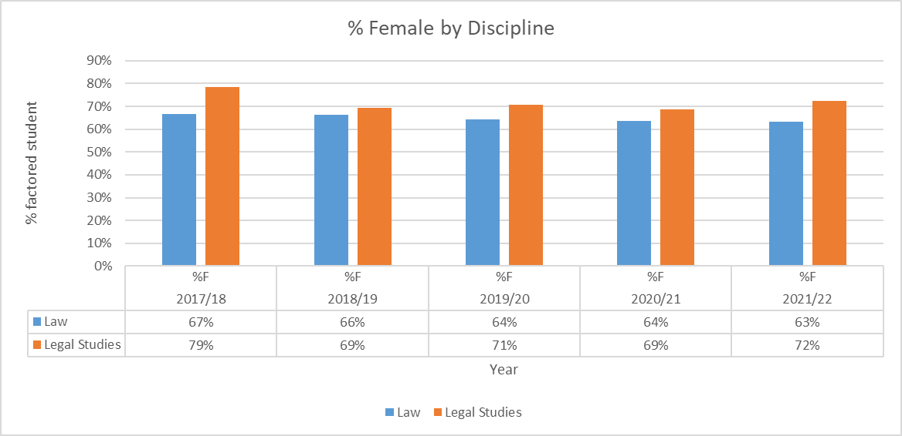

|  |  |  |  |  |  |  |  |  |  |  |  |  |  |  |  |  |  |  |  |  |  |  |  |  |  |  |  |  |  |  |  |  |
| --- | --- | --- | --- | --- | --- | --- | --- | --- | --- | --- | --- | --- | --- | --- | --- | --- | --- | --- | --- | --- | --- | --- | --- | --- | --- | --- | --- | --- | --- | --- | --- | --- |
| Table 3: Postgraduate Taught – Headcount by year | | | | | | | | | | | | | |  |  |  |  |  |  |  |  |  |  |  |  |  |  |  |  |  |  |  |
|  | **2017/18** | | | | **2018/19** | | | | **2019/20** | | | | **2020/21** | | | | **2021/22** | | | |  |  |  |  |  |  |  |  |  |  |  |  |
|  | **F** | **M** | **Total** | **%F** | **F** | **M** | **Total** | **%F** | **F** | **M** | **Total** | **%F** | **F** | **M** | **Total** | **%F** | **F** | **M** | **Total** | **%F** |  |  |  |  |  |  |  |  |  |  |  |  |
| **Part-time** | 10 | 15 | 25 | 40% | 15 | 18 | 33 | 45% | 13 | 10 | 23 | 57% | 8 | 12 | 20 | 40% | 8 | 11 | 19 | 42% |  |  |  |  |  |  |  |  |  |  |  |  |
| **Full-time** | 139 | 85 | 224 | 62% | 165 | 90 | 255 | 65% | 175 | 109 | 284 | 62% | 153 | 92 | 245 | 62% | 154 | 96 | 250 | 62% |  |  |  |  |  |  |  |  |  |  |  |  |
|  |  |  |  |  |  |  |  |  |  |  |  |  |  |  |  |  |  |  |  |  |  |  |  |  |  |  |  |  |  |  |  |  |
|  |  |  |  |  |  |  |  |  |  |  |  |  |  |  |  |  |  |  |  |  |  |  |  |  |  |  |  |  |  |  |  |  |
| Table 4: Postgraduate Taught - Full and part time combined | | | | | | | | | | | | | | |  |  |  |  |  |  |  |  |  |  |  |  |  |  |  |  |  |  |
| **Discipline** | **2017/18** | | | | **2018/19** | | | | **2019/20** | | | | **2020/21** | | | | **2021/22** | | | |  |  |  |  |  |  |  |  |  |  |  |  |
| **F** | **M** | **Total** | **%F** | **F** | **M** | **Total** | **%F** | **F** | **M** | **Total** | **%F** | **F** | **M** | **Total** | **%F** | **F** | **M** | **Total** | **%F** |  |  |  |  |  |  |  |  |  |  |  |  |
| **Law** | 149 | 100 | 249 | **60%** | 180 | 108 | 288 | **63%** | 188 | 119 | 307 | **61%** | 161 | 104 | 265 | **61%** | 162 | 107 | 269 | **60%** |  |  |  |  |  |  |  |  |  |  |  |  |

|  |  |  |  |  |  |  |  |  |  |  |  |  |  |  |  |  |  |  |  |  |  |  |  |  |  |  |  |  |  |  |  |  |
| --- | --- | --- | --- | --- | --- | --- | --- | --- | --- | --- | --- | --- | --- | --- | --- | --- | --- | --- | --- | --- | --- | --- | --- | --- | --- | --- | --- | --- | --- | --- | --- | --- |
| Table 5: Postgraduate Research - Headcount by year | | | | | | | | | | | | | |  |  |  |  |  |  |  |  |  |  |  |  |  |  |  |  |  |  |  |
|  | **2017/18** | | | | **2018/19** | | | | **2019/20** | | | | **2020/21** | | | | **2021/22** | | | |  |  |  |  |  |  |  |  |  |  |  |  |
|  | **W** | **M** | **Total** | **%W** | **W** | **M** | **Total** | **%W** | **W** | **M** | **Total** | **%W** | **W** | **M** | **Total** | **%W** | **W** | **M** | **Total** | **%W** |  |  |  |  |  |  |  |  |  |  |  |  |
| **Part-time** | 0 | 3 | 3 | 0% | 0 | 2 | 2 | 0% | 1 | 1 | 2 | 50% | 2 | 0 | 2 | 100% | 1 | 0 | 1 | 100% |  |  |  |  |  |  |  |  |  |  |  |  |
| **Writing Up** | 15 | 14 | 29 | 52% | 14 | 9 | 23 | 61% | 12 | 4 | 16 | 75% | 13 | 11 | 24 | 54% | 12 | 13 | 25 | 48% |  |  |  |  |  |  |  |  |  |  |  |  |
| **Full-time** | 19 | 13 | 32 | 59% | 17 | 14 | 31 | 55% | 12 | 20 | 32 | 38% | 16 | 19 | 35 | 46% | 14 | 14 | 28 | 50% |  |  |  |  |  |  |  |  |  |  |  |  |
|  |  |  |  |  |  |  |  |  |  |  |  |  |  |  |  |  |  |  |  |  |  |  |  |  |  |  |  |  |  |  |  |  |
|  |  |  |  |  |  |  |  |  |  |  |  |  |  |  |  |  |  |  |  |  |  |  |  |  |  |  |  |  |  |  |  |  |
| Table 6: Postgraduate Research - Full and part time combined | | | | | | | | | | | | | | |  |  |  |  |  |  |  |  |  |  |  |  |  |  |  |  |  |  |
| **Discipline** | **2017/18** | | | | **2018/19** | | | | **2019/20** | | | | **2020/21** | | | | **2021/22** | | | |  |  |  |  |  |  |  |  |  |  |  |  |
| **W** | **M** | **Total** | **%W** | **W** | **M** | **Total** | **%W** | **W** | **M** | **Total** | **%W** | **W** | **M** | **Total** | **%W** | **W** | **M** | **Total** | **%W** |  |  |  |  |  |  |  |  |  |  |  |  |
| **Law** | 34 | 30 | 64 | **53%** | 31 | 25 | 56 | **55%** | 25 | 25 | 50 | **50%** | 31 | 30 | 61 | **51%** | 27 | 27 | 54 | **50%** |  |  |  |  |  |  |  |  |  |  |  |  |

#### Figure 8 – Student pipeline

A graph of a student-academic pipeline 



## Student Admissions data

#### Table 7: Undergraduate Admissions - Law

|  |  |  |  |  |  |  |
| --- | --- | --- | --- | --- | --- | --- |
| **Year** | **Sex** | **Apps** | **Apps (%F)** | **Offers: Applications** | **Registered : Offers** | **Registered: Applications** |
| 2017/18 | Female | 925 | 67% | 85% | 21% | 18% |
| Male | 449 | 80% | 19% | 15% |
| 2018/19 | Female | 849.67 | 64% | 87% | 25% | 22% |
| Male | 479.67 | 85% | 25% | 21% |
| 2019/20 | Female | 1058.37 | 64% | 76% | 25% | 19% |
| Male | 601.02 | 79% | 25% | 20% |
| 2020/21 | Female | 1016.7 | 67% | 73% | 24% | 17% |
| Male | 512.03 | 73% | 31% | 22% |
| 2021/22 | Female | 1355 | 70% | 82% | 24% | 20% |
| Male | 588.5 | 82% | 21% | 17% |

#### Table 8: Undergraduate Admissions – Legal Studies

|  |  |  |  |  |  |  |
| --- | --- | --- | --- | --- | --- | --- |
| **Year** | **Sex** | **Apps (%F)** | | **Offers: Applications** | **Registered : Offers** | **Registered: Applications** |
| 2017/18 | Female | 94.5 | 74% | 74% | 18% | 13% |
| Male | 33.5 | 79% | 15% | 12% |
| 2018/19 | Female | 72.5 | 71% | 76% | 19% | 14% |
| Male | 29.5 | 81% | 35% | 29% |
| 2019/20 | Female | 70 | 71% | 58% | 17% | 10% |
| Male | 28 | 52% | 24% | 13% |
| 2020/21 | Female | 73.5 | 73% | 57% | 26% | 15% |
| Male | 27.5 | 71% | 23% | 16% |
| 2021/22 | Female | 78 | 76% | 40% | 58% | 23% |
| Male | 24.5 | 88% | 16% | 14% |

#### Table 9: Postgraduate Taught Admissions - Law

|  |  |  |  |  |  |  |
| --- | --- | --- | --- | --- | --- | --- |
| **Year** | **Sex** | **Apps** | **Apps (%F)** | **Offers: Applications** | **Registered : Offers** | **Registered: Applications** |
| 2017/18 | Female | 626 | 53% | 79% | 27% | 21% |
| Male | 563 | 71% | 22% | 16% |
| 2018/19 | Female | 726 | 53% | 79% | 29% | 23% |
| Male | 649 | 71% | 24% | 17% |
| 2019/20 | Female | 809 | 55% | 79% | 25% | 20% |
| Male | 672 | 71% | 22% | 16% |
| 2020/21 | Female | 820 | 52% | 76% | 22% | 16% |
| Male | 743 | 73% | 21% | 16% |
| 2021/22 | Female | 904 | 51% | 74% | 22% | 16% |
| Male | 865 | 70% | 17% | 12% |

#### Table 10: Postgraduate Research Admissions - Law

|  |  |  |  |  |  |  |
| --- | --- | --- | --- | --- | --- | --- |
| **Year** | **Sex** | **Apps** | **Apps (%F)** | **Offers: Applications** | **Registered : Offers** | **Registered: Applications** |
| 2016/17 | Female | 71 | 34% | 24% | 53% | 13% |
| Male | 136 | 12% | 25% | 3% |
| 2017/18 | Female | 45 | 38% | 24% | 64% | 16% |
| Male | 72 | 15% | 64% | 10% |
| 2018/19 | Female | 44 | 32% | 18% | 25% | 5% |
| Male | 93 | 20% | 42% | 9% |
| 2019/20 | Female | 51 | 40% | 39% | 30% | 12% |
| Male | 78 | 21% | 44% | 9% |
| 2020/21 | Female | 60 | 41% | 30% | 56% | 17% |
| Male | 88 | 18% | 38% | 7% |
| 2021/22 | Female | 34 | 40% | 26% | 33% | 9% |
| Male | 50 | 18% | 33% | 6% |

## Degree attainment and/or completion rates for students at foundation, UG, PGT and PGR level

#### Table 11: Undergraduate degree attainment - Law

|  |  |  |  |  |  |  |  |
| --- | --- | --- | --- | --- | --- | --- | --- |
| **Year** | **Gender** | **First Class** | **2 (i) Class** | **2 (ii) Class** | **3rd Class** | **Non-honours** | **% Good Honours** |
| 2017/18 | Female | 22 | 59 | 2 | 0 | 65 | 55% |
| Male | 16 | 28 | 4 | 0 | 19 | 66% |
| 2018/19 | Female | 42 | 57 | 3 | 1 | 58 | 61% |
| Male | 11 | 33 | 3 | 0 | 24 | 62% |
| 2019/20 | Female | 48 | 70 | 2 | 0 | 44 | 72% |
| Male | 27 | 37 | 1 | 0 | 26 | 70% |
| 2020/21 | Female | 45 | 43 | 2 | 0 | 29 | 74% |
| Male | 25 | 19 | 0 | 0 | 19 | 70% |
| 2021/22 | Female | 51 | 68 | 9 | 0 | 52 | 66% |
| Male | 25 | 26 | 4 | 0 | 26 | 63% |

#### Table 12: Undergraduate degree attainment – Legal

|  |  |  |  |  |  |  |  |
| --- | --- | --- | --- | --- | --- | --- | --- |
| **Year** | **Gender** | **First Class** | **2 (i) Class** | **2 (ii) Class** | **3rd Class** | **Non-honours** | **% Good Honours** |
| 2017/18 | Female | 1.0 | 3.5 | 1.0 |  |  | 82% |
| Male | 0.5 | 0.5 | 0.0 |  |  | 100% |
| 2018/19 | Female | 0.5 | 0.5 | 0.5 |  |  | 67% |
| Male | 0.0 | 1.5 | 0.0 |  |  | 100% |
| 2019/20 | Female | 4 | 2 | 0 |  |  | 100% |
| Male | 1 | 1 | 0 |  |  | 100% |
| 2020/21 | Female | 3 | 2 | 0 |  |  | 100% |
| Male | 1 | 1 | 0 |  |  | 100% |
| 2021/22 | Female | 2 | 4 | 0 |  |  | 100% |
| Male | 1 | 2 | 1 |  |  | 86% |

#### Table 13: Postgraduate Taught degree attainment

|  |  |  |  |  |  |
| --- | --- | --- | --- | --- | --- |
| **Year** | **Gender** | **Commendation** | **Distinction** | **Pass** | **Distinction %** |
| 2017/18 | Female | 49 | 48 | 33 | 37% |
| Male | 45 | 16 | 32 | 17% |
| 2018/19 | Female | 72 | 35 | 23 | 27% |
| Male | 34 | 16 | 19 | 23% |
| 2019/20 | Female | 69 | 36 | 29 | 27% |
| Male | 41 | 20 | 26 | 23% |
| 2020/21 | Female | 63 | 80 | 28 | 47% |
| Male | 48 | 36 | 21 | 34% |
| 2021/22 | Female | 51 | 54 | 10 | 47% |
| Male | 33 | 23 | 12 | 34% |

#### Table 14: Postgraduate Research degree attainment

|  |  |  |
| --- | --- | --- |
| **Year** | **Gender** | **Completed** |
| 2017/18 | Female | 5 |
| Male | 12 |
| 2018/19 | Female | 9 |
| Male | 8 |
| 2019/20 | Female | 3 |
| Male | 1 |
| 2020/21 | Female | 6 |
| Male | 5 |
| 2021/22 | Female | 4 |
| Male | 6 |

## Academic staff overview

#### Table 15 – Academic staff by grade

|  |  |  |  |  |  |  |
| --- | --- | --- | --- | --- | --- | --- |
| **Grade** | **Year** | **Female Number** | **Female %>** | **Male Number** | **Male**  **%>** | **Total** |
| **Grade 5** | 2017-18 | 8 | 62% | 5 | 38% | 13 |
| 2018-19 | 8 | 67% | 4 | 33% | 12 |
| 2019-20 | 4 | 67% | 2 | 33% | 6 |
| 2020-21 | 10 | 77% | 3 | 23% | 13 |
| 2021-22 | 1 | 25% | 3 | 75% | 4 |
| **Grade 6** | 2017-18 | 20 | 36% | 36 | 64% | 56 |
| 2018-19 | 21 | 40% | 31 | 60% | 52 |
| 2019-20 | 20 | 39% | 31 | 61% | 51 |
| 2020-21 | 24 | 44% | 31 | 56% | 55 |
| 2021-22 | 31 | 49% | 32 | 51% | 63 |
| **Grade 7** | 2017-18 | 11 | 61% | 7 | 39% | 18 |
| 2018-19 | 9 | 56% | 7 | 44% | 16 |
| 2019-20 | 10 | 48% | 11 | 52% | 21 |
| 2020-21 | 9 | 43% | 12 | 57% | 21 |
| 2021-22 | 11 | 48% | 12 | 52% | 23 |
| **Grade 8** | 2017-18 | 7 | 37% | 12 | 63% | 19 |
| 2018-19 | 8 | 42% | 11 | 58% | 19 |
| 2019-20 | 9 | 45% | 11 | 55% | 20 |
| 2020-21 | 8 | 50% | 8 | 50% | 16 |
| 2021-22 | 7 | 44% | 9 | 56% | 16 |
| **Grade 9** | 2017-18 | 2 | 20% | 8 | 80% | 10 |
| 2018-19 | 3 | 23% | 10 | 77% | 13 |
| 2019-20 | 3 | 20% | 12 | 80% | 15 |
| 2020-21 | 1 | 8% | 12 | 92% | 13 |
| 2021-22 | 5 | 28% | 13 | 72% | 18 |

#### Figure 8 – Academic staff by grade

A graph of academic staff by grade



## Academic staff by grade and contract function

#### Table 16 – Academic staff by grade and contract function

|  |  |  |  |  |  |  |
| --- | --- | --- | --- | --- | --- | --- |
|  |  | **Female Number** | **Female %>** | **Female Number** | **Female %>** | **Total** |
| **Research-only (Headcount)** | 2017-18 | 2 | 50% | 2 | 50% | 4 |
| 2018-19 | 3 | 75% | 1 | 25% | 4 |
| 2019-20 | 2 | 67% | 1 | 33% | 3 |
| 2020-21 | 5 | 83% | 1 | 17% | 6 |
| 2021-22 | 1 | 33% | 2 | 67% | 3 |
| **Teaching & Scholarship (Headcount)** | 2017-18 | 27 | 37% | 46 | 63% | 73 |
| 2018-19 | 27 | 40% | 40 | 60% | 67 |
| 2019-20 | 24 | 39% | 38 | 61% | 62 |
| 2020-21 | 30 | 42% | 41 | 58% | 71 |
| 2021-22 | 33 | 46% | 39 | 54% | 72 |
| **Teaching & Research (Headcount)** | 2017-18 | 19 | 49% | 20 | 51% | 39 |
| 2018-19 | 19 | 46% | 22 | 54% | 41 |
| 2019-20 | 20 | 43% | 27 | 57% | 47 |
| 2020-21 | 17 | 43% | 23 | 58% | 40 |
| 2021-22 | 21 | 44% | 27 | 56% | 48 |

#### Figure 9 – Academic staff by career track

A graph of academic staff by career track



#### Figure 10 – Academic staff by career track and grade – Research onlyA graph of academic staff by career track and grade - Research contracts only

#### Figure 11 – Academic staff by career track and grade – Teaching and Scholarship

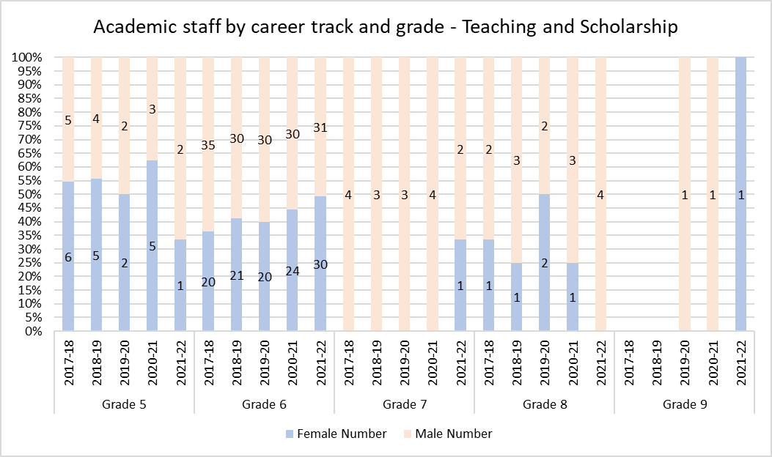

#### Figure 12 – Academic staff by career track and grade – Teaching and Research

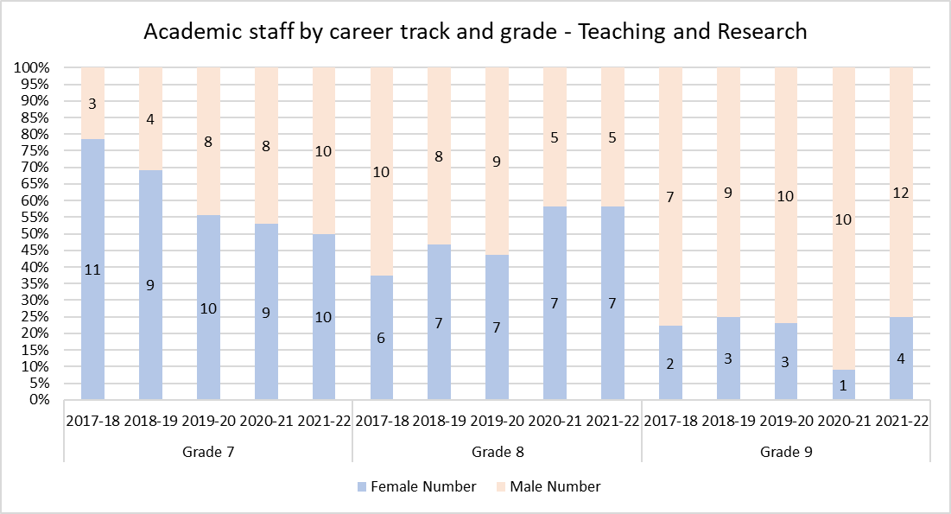

## Academic staff by grade and contract type

#### Table 17 – Academic staff by grade and contract type

|  |  |  |  |  |  |  |
| --- | --- | --- | --- | --- | --- | --- |
|  |  | **Female Number** | **Female %>** | **Female Number** | **Female %>** | **Total** |
| **Open-ended (Headcount)** | 2017-18 | 18 | 44% | 23 | 56% | 41 |
| 2018-19 | 19 | 44% | 24 | 56% | 43 |
| 2019-20 | 20 | 41% | 29 | 59% | 49 |
| 2020-21 | 18 | 42% | 25 | 58% | 43 |
| 2021-22 | 23 | 45% | 28 | 55% | 51 |
| **Funding-limited (Headcount)** | 2017-18 | 2 | 67% | 1 | 33% | 3 |
| 2018-19 | 2 | 100% |  | 0% | 2 |
| 2019-20 | 2 | 100% |  | 0% | 2 |
| 2020-21 | 1 | 100% |  | 0% | 1 |
| 2021-22 | 1 | 50% | 1 | 50% | 2 |
| **Fixed Term (Headcount)** | 2017-18 |  |  |  |  |  |
| 2018-19 |  |  |  |  |  |
| 2019-20 |  |  |  |  |  |
| 2020-21 | 1 | 50% | 1 | 50% | 2 |
| 2021-22 | 1 | 100% |  | 0% | 1 |
| **GMH (Headcount)** | 2017-18 | 28 | 39% | 44 | 61% | 72 |
| 2018-19 | 28 | 42% | 39 | 58% | 67 |
| 2019-20 | 24 | 39% | 37 | 61% | 61 |
| 2020-21 | 32 | 45% | 39 | 55% | 71 |
| 2021-22 | 30 | 43% | 39 | 57% | 69 |

#### Figure 13 – Academic staff by contract type

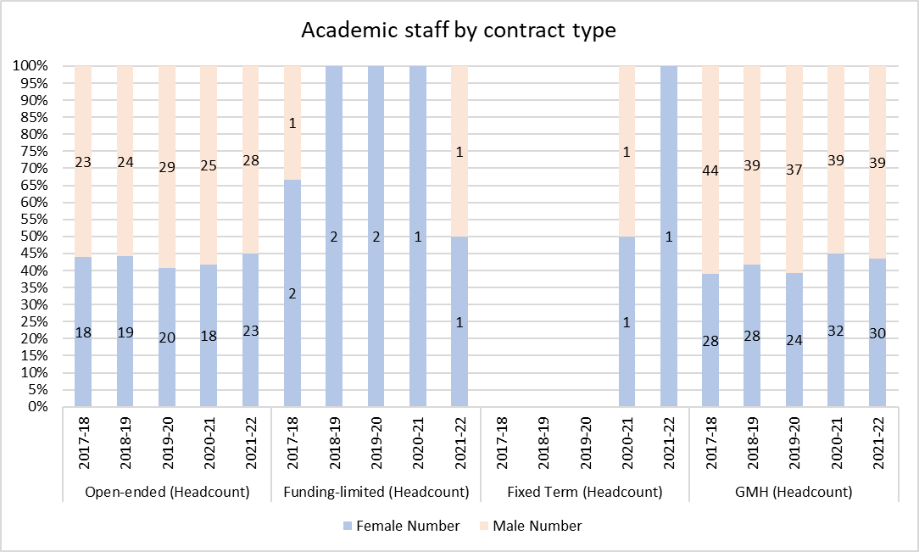

#### Figure 14 – Academic staff by contract type and grade – open ended contracts

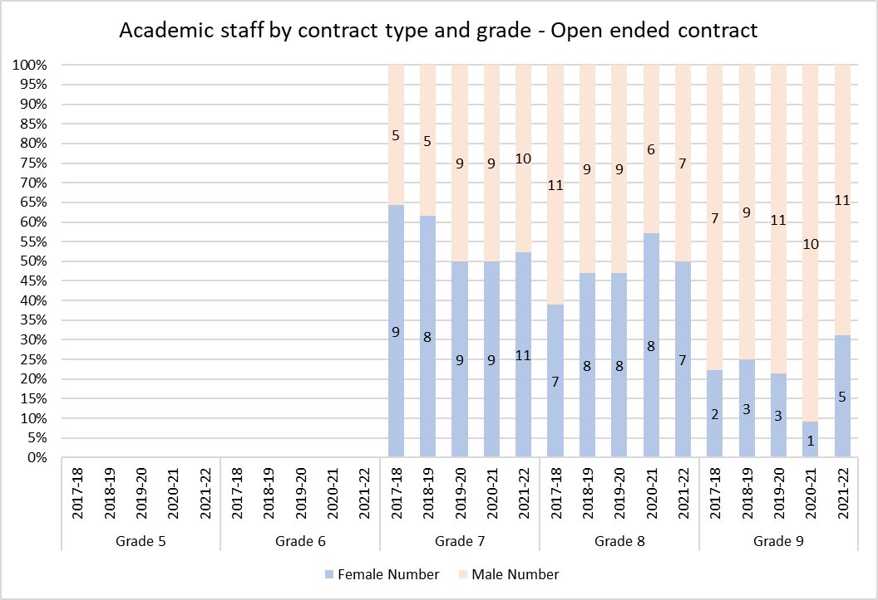

#### Figure 15 – Academic staff by contract type and grade – GMH

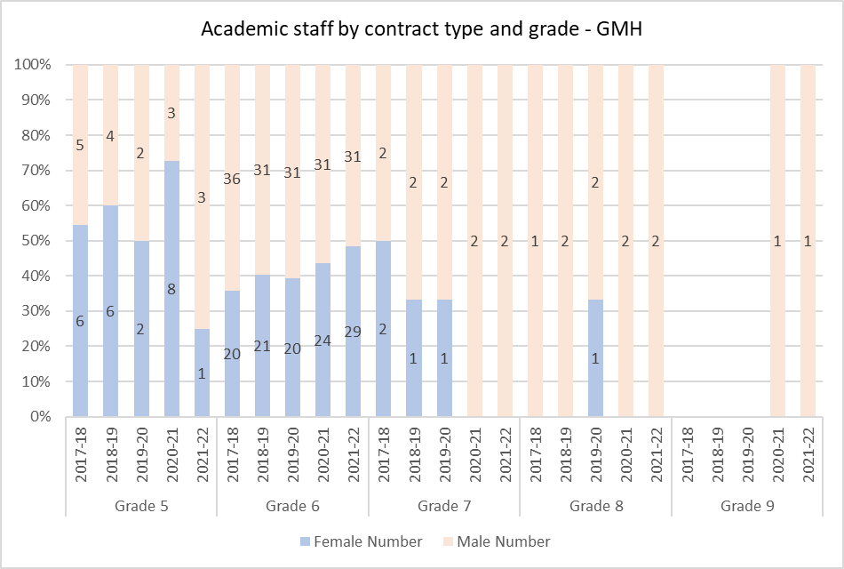

Breakdown by grade for funding limited and fixed term contract staff not provided due to small numbers. Aggregated numbers for funding limited and fixed term are provided in figure 13.

## Professional, technical and operational (PTO) staff by job family

#### Table 18 – Professional, technical and operational staff

|  |  |  |  |  |  |  |
| --- | --- | --- | --- | --- | --- | --- |
| **Grade** | **Year** | **Female Number** | **Female %>** | **Male Number** | **Male %>** | **Total** |
| **Grades 2 - 4** | 2017-18 | 5 | 100% |  | 0% | 5 |
| 2018-19 | 4 | 80% | 1 | 20% | 5 |
| 2019-20 | 7 | 88% | 1 | 13% | 8 |
| 2020-21 | 7 | 88% | 1 | 13% | 8 |
| 2021-22 | 9 | 82% | 2 | 18% | 11 |
| **Grades 5 - 7** | 2017-18 | 3 | 100% |  |  |  |
| 2018-19 | 3 | 100% |  |  |  |
| 2019-20 | 3 | 100% |  |  |  |
| 2020-21 | 3 | 100% |  |  |  |
| 2021-22 | 3 | 100% |  |  |  |
| **Grades 8 - 9** | 2017-18 |  |  |  |  |  |
| 2018-19 |  |  |  |  |  |
| 2019-20 |  |  |  |  |  |
| 2020-21 |  |  |  |  |  |
| 2021-22 |  |  |  |  |  |

#### Figure 16 – Academic staff by contract type and grade – GMH

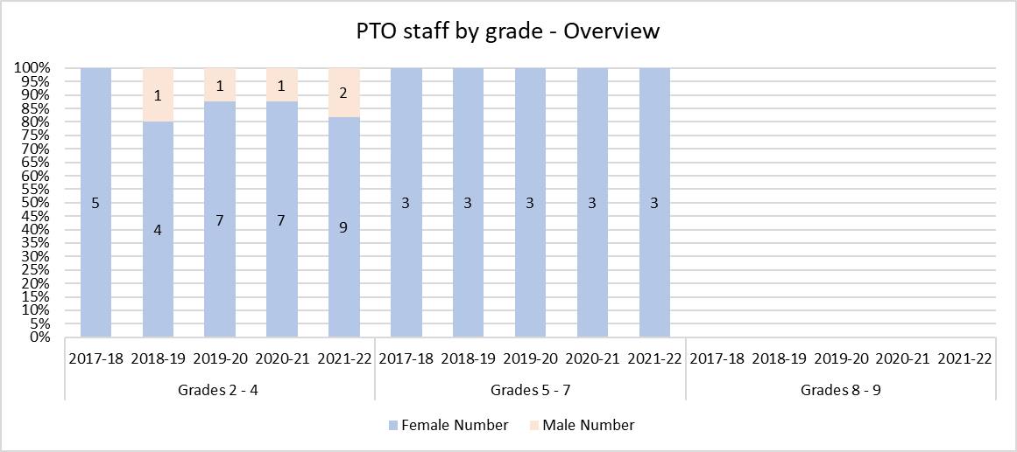

All PTO staff in the School of Law are professional support. There are no technical staff in the School.

#### Table 19 – PTO staff by job family

|  |  |  |  |  |  |  |
| --- | --- | --- | --- | --- | --- | --- |
|  |  | **Female** | | **Male** | |  |
|  |  | **Number** | **%>** | **Number** | **%>** | **Total** |
| **Professional Support** | 2017-18 | 8 | 100% |  | 0% | 8 |
| 2018-19 | 7 | 88% | 1 | 13% | 8 |
| 2019-20 | 10 | 91% | 1 | 9% | 11 |
| 2020-21 | 10 | 91% | 1 | 9% | 11 |
| 2021-22 | 12 | 86% | 2 | 14% | 14 |

## PTO staff by contract type

Most PTO staff are on open-ended contracts. There have been no staff on fixed term contracts during the period.

#### Table 20 – PTO staff by contract type

|  |  |  |  |  |  |  |
| --- | --- | --- | --- | --- | --- | --- |
|  |  | **Female** | | **Male** | |  |
|  |  | **Number** | **%>** | **Number** | **%>** | **Total** |
| **Open-ended (Headcount)** | 2017-18 | 7 | 100% |  | 0% | 7 |
| 2018-19 | 6 | 100% |  | 0% | 6 |
| 2019-20 | 9 | 90% | 1 | 10% | 10 |
| 2020-21 | 9 | 90% | 1 | 10% | 10 |
| 2021-22 | 11 | 85% | 2 | 15% | 13 |
| **Funding-limited (Headcount)** | 2017-18 |  |  |  |  |  |
| 2018-19 |  |  | 1 | 100% | 1 |
| 2019-20 |  |  |  |  |  |
| 2020-21 |  |  |  |  |  |
| 2021-22 |  |  |  |  |  |
| **GMH (Headcount)** | 2017-18 | 1 | 100% |  |  | 1 |
| 2018-19 | 1 | 100% |  |  | 1 |
| 2019-20 | 1 | 100% |  |  | 1 |
| 2020-21 | 1 | 100% |  |  | 1 |
| 2021-22 | 1 | 100% |  |  | 1 |

## Applications, shortlist and appointments made in recruitment to academic posts

#### Table 21 – Academic recruitment

|  |  |  |  |  |  |  |  |  |  |  |  |  |  |  |  |  |  |
| --- | --- | --- | --- | --- | --- | --- | --- | --- | --- | --- | --- | --- | --- | --- | --- | --- | --- |
| **Recruitment to academic posts** | | | | | | | | | | | | | | | | | |
| **Year** | **Grade** | **Applications** | | **Shortlisted** | | **Offers** | | **Hired** | | **Proportion of applications** | | **Proportion of applications shortlisted** | | **Proportion of those shortlisted made offers** | | **Proportion of applicants hired** | |
| **F** | **M** | **F** | **M** | **F** | **M** | **F** | **M** | **F** | **M** | **F** | **M** | **F** | **M** | **F** | **M** |
| **2017-18** | Grades 5 - 6 |  |  |  |  |  |  |  |  |  |  |  |  |  |  |  |  |
| Grades 7 - 8 | 42 | 64 | 7 | 11 | 4 | 4 | 4 | 4 | 40% | 60% | 17% | 17% | 57% | 36% | 10% | 6% |
| Grade 9 |  |  |  |  |  |  |  |  |  |  |  |  |  |  |  |  |
| **2018-19** | Grades 5 - 6 |  |  |  |  |  |  |  |  |  |  |  |  |  |  |  |  |
| Grades 7 - 8 | 68 | 98 | 13 | 26 | 3 | 6 | 2 | 4 | 41% | 59% | 19% | 27% | 23% | 23% | 3% | 4% |
| Grade 9 |  |  |  |  |  |  |  |  |  |  |  |  |  |  |  |  |
| **2019-20** | Grades 5 - 6 |  |  |  |  |  |  |  |  |  |  |  |  |  |  |  |  |
| Grades 7 - 8 | 25 | 64 | 2 | 6 | 2 | 3 | 2 | 2 | 28% | 72% | 8% | 9% | 100% | 50% | 8% | 3% |
| Grade 9 | 5 | 14 | 0 | 4 | 0 | 1 | 0 | 1 | 26% | 74% | 0% | 29% | 0% | 25% | 0% | 7% |
| **2020-21** | Grades 5 - 6 | 10 | 9 | 3 | 3 | 2 | 3 | 2 | 3 | 53% | 47% | 30% | 33% | 67% | 100% | 20% | 33% |
| Grades 7 - 8 | 36 | 68 | 9 | 12 | 6 | 4 | 6 | 4 | 35% | 65% | 25% | 18% | 67% | 33% | 17% | 6% |
| Grade 9 |  |  |  |  |  |  |  |  |  |  |  |  |  |  |  |  |
| **2021-22** | Grades 5 - 6 | 1 | 3 | 1 | 3 | 0 | 3 | 0 | 3 | 25% | 75% | 100% | 100% | 0% | 100% | 0% | 100% |
| Grades 7 - 8 | 52 | 85 | 20 | 20 | 10 | 3 | 10 | 3 | 38% | 62% | 38% | 24% | 50% | 15% | 19% | 4% |
| Grade 9 | 0 | 0 | 0 | 0 |  |  |  |  |  |  |  |  |  |  |  |  |
| **2022-23** | Grades 5 - 6 | 12 | 13 | 6 | 4 | 4 | 2 | 4 | 2 | 48% | 52% | 50% | 31% | 67% | 50% | 33% | 15% |
| Grades 7 - 8 | 29 | 45 | 1 | 5 | 1 | 1 | 1 | 0 | 39% | 61% | 3% | 11% | 100% | 20% | 3% | 0% |
| Grade 9 | 2 | 11 | 0 | 1 | 0 | 1 | 0 | 1 | 15% | 85% | 0% | 9% | 0% | 100% | 0% | 9% |
| **All Years** | Grades 5 - 6 | 23 | 25 | 10 | 10 | 6 | 8 | 6 | 8 | 48% | 52% | 43% | 40% | 60% | 80% | 26% | 32% |
| Grades 7 - 8 | 252 | 424 | 52 | 80 | 26 | 21 | 25 | 17 | 37% | 63% | 21% | 19% | 50% | 26% | 10% | 4% |
| Grade 9 | 7 | 25 | 0 | 5 | 0 | 2 | 0 | 2 | 22% | 78% | 0% | 20% | 0% | 40% | 0% | 8% |

## Applications, shortlist and appointments made in recruitment to PTO posts

#### Table 22 – PTO recruitment

|  |  |  |  |  |  |  |  |  |  |  |  |  |  |  |  |  |  |
| --- | --- | --- | --- | --- | --- | --- | --- | --- | --- | --- | --- | --- | --- | --- | --- | --- | --- |
| **Recruitment to PTO posts** | | | | | | | | | | | | | | | | | |
| **Year** | **Grade** | **Applications** | | **Shortlisted** | | **Offers** | | **Hired** | | **Proportion of applications shortlisted** | | **Proportion of applications shortlisted** | | **Proportion of those shortlisted made offers** | | **Proportion of applicants hired** | |
| **F** | **M** | **F** | **M** | **F** | **M** | **F** | **M** | **F** | **M** | **F** | **M** | **F** | **M** | **F** | **M** |
| **2017-18** | Grades 3 - 4 | 53 | 30 | 10 | 7 | 2 | 1 | 1 | 1 | 64% | 36% | 19% | 23% | 20% | 14% | 2% | 3% |
| Grades 5 - 6 |  |  |  |  |  |  |  |  |  |  |  |  |  |  |  |  |
| Grade 7+ |  |  |  |  |  |  |  |  |  |  |  |  |  |  |  |  |
| **2018-19** | Grades 3 - 4 | 64 | 31 | 17 | 7 | 2 | 1 | 1 | 1 | 67% | 33% | 27% | 23% | 12% | 14% | 2% | 3% |
| Grades 5 - 6 |  |  |  |  |  |  |  |  |  |  |  |  |  |  |  |  |
| Grade 7+ |  |  |  |  |  |  |  |  |  |  |  |  |  |  |  |  |
| **2019-20** | Grades 3 - 4 | 56 | 13 | 10 | 1 | 2 | 0 | 2 | 0 | 81% | 19% | 18% | 8% | 20% | 0% | 4% | 0% |
| Grades 5 - 6 |  |  |  |  |  |  |  |  |  |  |  |  |  |  |  |  |
| Grade 7+ |  |  |  |  |  |  |  |  |  |  |  |  |  |  |  |  |
| **2020-21** | Grades 3 - 4 | 25 | 10 | 7 | 2 | 1 | 1 | 1 | 1 | 71% | 29% | 28% | 20% | 14% | 50% | 4% | 10% |
| Grades 5 - 6 |  |  |  |  |  |  |  |  |  |  |  |  |  |  |  |  |
| Grade 7+ |  |  |  |  |  |  |  |  |  |  |  |  |  |  |  |  |
| **2021-22** | Grades 3 - 4 | 43 | 14 | 14 | 2 | 3 | 0 | 1 | 0 | 75% | 25% | 33% | 14% | 21% | 0% | 2% | 0% |
| Grades 5 - 6 | 31 | 6 | 6 | 0 | 3 | 0 | 1 | 0 | 84% | 16% | 19% | 0% | 50% | 0% | 3% | 0% |
| Grade 7+ |  |  |  |  |  |  |  |  |  |  |  |  |  |  |  |  |
| **2022-23** | Grades 3 - 4 | 8 | 10 | 1 | 0 | 1 | 0 | 1 | 0 | 44% | 56% | 13% | 0% | 100% | 0% | 13% | 0% |
| Grades 5 - 6 | 26 | 7 | 4 | 1 | 1 | 0 | 1 | 0 | 79% | 21% | 15% | 14% | 25% | 0% | 4% | 0% |
| Grade 7+ | 14 | 8 | 5 | 1 | 2 | 0 | 2 | 0 | 64% | 36% | 36% | 13% | 40% | 0% | 14% | 0% |
| **All Years** | Grades 3 - 4 | 249 | 108 | 59 | 19 | 11 | 3 | 7 | 3 | 70% | 30% | 24% | 18% | 19% | 16% | 3% | 3% |
| Grades 5 - 6 | 57 | 13 | 10 | 1 | 4 | 0 | 2 | 0 | 81% | 19% | 18% | 8% | 40% | 0% | 4% | 0% |
| Grade 7+ | 14 | 8 | 5 | 1 | 2 | 0 | 2 | 0 | 64% | 36% | 36% | 13% | 40% | 0% | 14% | 0% |

## Applications and success rates for academic promotion

#### Table 23 – application and success rates for academic promotions

|  |  |  |  |  |  |  |  |  |  |  |  |
| --- | --- | --- | --- | --- | --- | --- | --- | --- | --- | --- | --- |
| **Year** | **Grade applied for** | **Headcounts\*** | | **Applied** | | **Application rate (%)** | | **Successful** | | **Success rate (%)** | |
| **Female** | **Male** | **Female** | **Male** | **Female** | **Male** | **Female** | **Male** | **Female** | **Male** |
| 2015/16 | 7 | 22 | 34 | 0 | 0 | 0% | 0% | 0 | 0 | - | - |
| 8 | 8 | 11 | 3 | 4 | 38% | 36% | 0 | 1 | 0% | 25% |
| 9 | 6 | 12 | 1 | 1 | 17% | 8% | 1 | 1 | 100% | 100% |
| 2016/17 | 7 | 19 | 34 | 3 | 5 | 16% | 15% | 3 | 3 | 100% | 60% |
| 8 | 12 | 9 | 0 | 0 | 0% | 0% | 0 | 0 | - | - |
| 9 | 5 | 11 | 2 | 3 | 40% | 27% | 1 | 0 | 50% | 0% |
| 2017/18 | 7 | 20 | 36 | 0 | 0 | 0% | 0% | 0 | 0 | - | - |
| 8 | 11 | 7 | 1 | 3 | 9% | 43% | 1 | 1 | 100% | 33% |
| 9 | 7 | 12 | 1 | 3 | 14% | 25% | 0 | 3 | 0% | 100% |
| 2018/19 | 7 | 21 | 31 | 0 | 0 | 0% | 0% | 0 | 0 | - | - |
| 8 | 9 | 7 | 3 | 1 | 33% | 14% | 2 | 0 | 67% | 0% |
| 9 | 8 | 11 | 0 | 3 | 0% | 27% | 0 | 3 | - | 100% |
| 2019/20 | 7 | 20 | 31 | 0 | 0 | 0% | 0% | 0 | 0 | - | - |
| 8 | 10 | 11 | 2 | 0 | 20% | 0% | 2 | 0 | 100% | - |
| 9 | 9 | 11 | 3 | 1 | 33% | 9% | 3 | 1 | 100% | 100% |
| 2020/21 | 7 | 24 | 31 | 0 | 0 | 0% | 0% | 0 | 0 | - | - |
| 8 | 9 | 12 | 1 | 0 | 11% | 0% | 1 | 0 | 100% | - |
| 9 | 8 | 8 | 3 | 1 | 38% | 13% | 3 | 1 | 100% | 100% |
| 2021/22 | 7 | 31 | 32 | 0 | 0 | 0% | 0% | 0 | 0 | - | - |
| 8 | 9 | 12 | 1 | 0 | 11% | 0% | 1 | 0 | 100% | - |
| 9 | 7 | 9 | 3 | 1 | 43% | 11% | 3 | 1 | 100% | 100% |
| All years | 7 | 126 | 197 | 3 | 5 | 2% | 3% | 3 | 3 | 100% | 60% |
| 8 | 59 | 57 | 10 | 8 | 17% | 14% | 6 | 2 | 60% | 25% |
| 9 | 43 | 65 | 10 | 12 | 23% | 18% | 8 | 9 | 80% | 75% |

## Applications and success rates for PTO progression

2018/19 one unsuccessful female application to grade 6 for a PSS

2017/18 no PSS staff

2019/20 no PSS staff

2016/17 no PSS staff

**Appendix 3: Glossary**

Please provide a glossary of abbreviations and acronyms used in the application.

Abe2040: Aberdeen 2040: University of Aberdeen Strategic Plan

ALM: Academic Line Manager

AS: Athena SWAN

DPLP: Diploma in Professional and Legal Practice

EDIC: Equality and Diversity and inclusion committee

FTE: Full time equivalent staff

GPA: **grade point average** calculated for the REF. GPA is calculated by multiplying its percentage of 4* research by 4, its percentage of 3* research by 3, its percentage of 2* research by 2 and its percentage of 1* research by 1; those figures are added together and then divided by 100 to give a score between 0 and 4.”

HoS: Head of School

LAW: Law School

M: men

NESColl: North East Scotland Further Education College

RAG rating: Red, Amber, Green rating process

REF: Research Excellence Framework

RC: Research Committee

Research power calculated for the REF: reflects both the GPA and the total number of FTE staff submitted to the REF.

PGR: Postgraduate Research

PGT: Postgraduate Taught

PS: Professional Services

PSLM: Professional Services Line Manager

REF: Research excellence framework

SAT: AS self-assessment team

SEC: School Executive Committee

SAM: School Administration Manger

Taylor: Taylor Building, location for the School of Law

UG: Undergraduate

W: women

WFH: work from home

UoA: University of Aberdeen

1. The EDI lead and AS lead each receive an allocation of 80 hours per annum; the Deputy EDI lead receives 40 hours, while all AS SAT team members receive 20 hours.