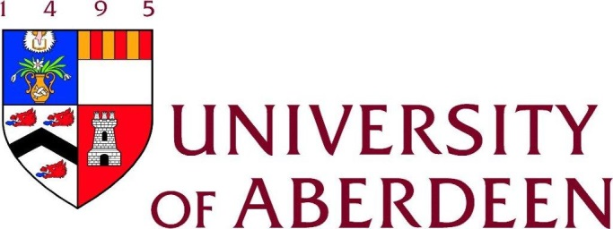

MINI SYMPOSIUM

Tuesday 9th June 2015
Level 7
Institute of Medical Sciences

CUTTING-EDGE TECHNOLOGIES

12.30 pm Finger buffet

1.05 pm Introduction and Welcome
Professor Gordon Brown

Chair – Dr Lynne Hocking

1.15 pm Confetti Mice
Dr Saskia Ellenbroek, University Medical Center Utrecht

2.00 pm In vivo Imaging
Professor Paul Garside, University of Glasgow

2.45 pm Coffee break

Chair – Dr Heather Wilson

3.15 pm In Cell NMR
Dr Volker Dötsch, University of Frankfurt

4.00 pm CRISPR-Cas9 system
Dr William Skarnes, The Wellcome Trust Sanger Institute

4.45 pm Sum up and closing comments
Professor Miep Helfrich

5.00 pm Reception
IMS Atrium

For catering purposes, please register your attendance with Fiona Ashby (f.ashby@abdn.ac.uk)

