**BSc Geology & Mineralogy**

**Reunion: class of 1978-79**



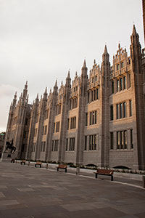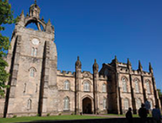

**13 July 2019**

**The Boat Inn, Aboyne**

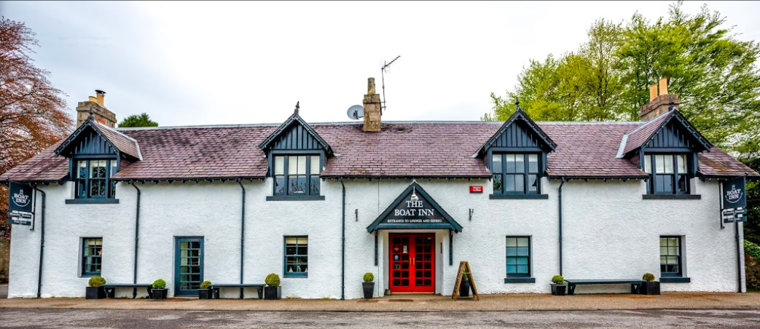



*www.theboatinnaboyne.co.uk*

**Charleston Road, Aboyne, AB34 5EL,**

**Tel +44 (0) 1339 886137 E enquiries@theboatinnaboyne.co.uk**

**Programme**

**19:00 Drinks**

**19:45 Group photo**

**20:00 Supper**

*With Music from the 1970’s*

**- - -**

**Starters**

**Soup of the Day**

with Granary Bread and butter

(V)(GF available)

**Menzies Juniper Smoked Venison,**

Apple and Celeriac Slaw (GF)

**Vegan Mushroom and Roast Garlic Pate,** Watercress Salad, Scottish Oatcakes

**- - -**

**Wines**

Chile Pinto De Vista, Sauvignon Blanc

Chile Punta De Vista, Merlot

**- - -**

**Mains**

**Beef and Haggis Pie**

with seasonal vegetables and herb mash

**Breaded Fish and Chips**

with either salad, mushy peas or garden peas

**Boat Inn Chicken OR Vegetable Tikka Curry,** Saffron and Cardamom Rice, Kachumber (GF)

**Pan Fried Salmon,**

Salsa Verdi and Citrus Bulgar

**Lemon and Thyme Risotto,**

Asparagus Spears, Preserved Lemon and Green Olive Salsa (GF, Ve available)

**- - -**

**Deserts**

**Boat Inn Sticky Toffee Pudding**

with Hot Fudge Sauce and Ice Cream

**Vanilla Ice Cream and Hot Fudge Sauce**

(GF available)

**Chocolate and Bean Curd Mousse,**

Pistachio and Raspberry (Ve) (GF)

**After Dinner**

Coffee or a dram

**Heads & Tails**

For the charity Prostate Cancer UK



**Our thanks for this evening go to**

* Lynn and the Chef’s Team at The Boat Inn

**Special thanks go to**

* Retired lecturers Bill Ashcroft, Clive Rice and Alan Crane
* Woody who travelled from Calgary, Canada
* David who travelled from Perth, Australia
* Neil who travelled from Nairobi, Kenya
* Gordon who travelled from Assen, The Netherlands
* Bruce and Alex who travelled from Stavanger, Norway
* Yourselves who have travelled from all parts of the UK

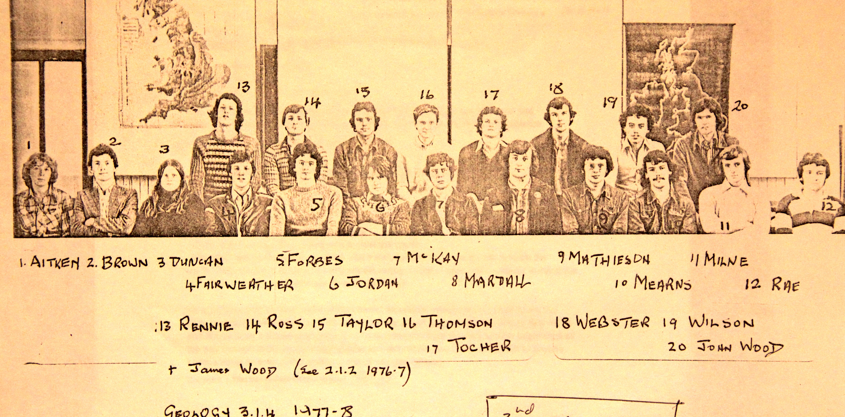

**Year 3 Class photo 1977-78 James Wood was absent**

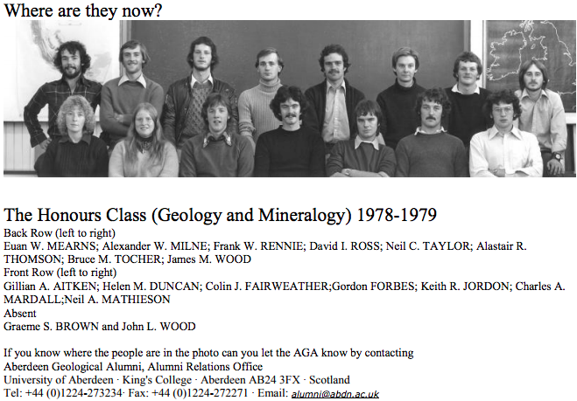

**Year 4 Class photo 1978-79 Graeme Brown & John Wood were absent**