** We’re going on an OUTDOOR 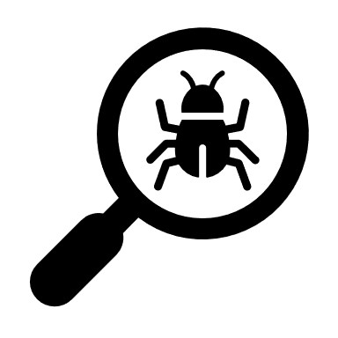 BUG hunt!**

**You might want to take:**

 A magnifying glass

 A camera to snap any bugs you find.

 A notebook and pencil to draw your critters and to write down colours, measurements and behaviour.

 A snack if you are going on a long expedition!

Use your EYES to find and observe any insects.

You may want to pick some bugs up but please be careful not to hurt any mini beasts during your hunt …

and remember that some insects can sting!



 **Bug Hunt Checklist**

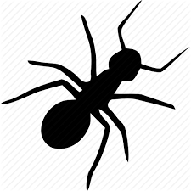

wasp 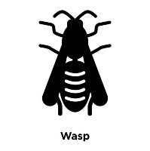

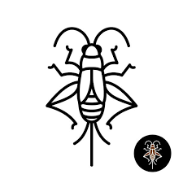

grasshopper



aphid

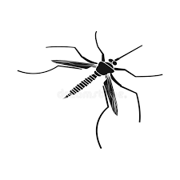

midge



butterfly

ladybird

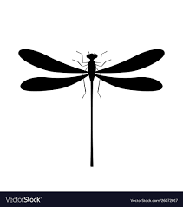

dragonfly

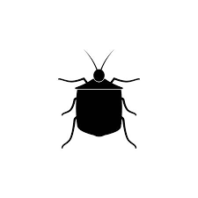

beetle

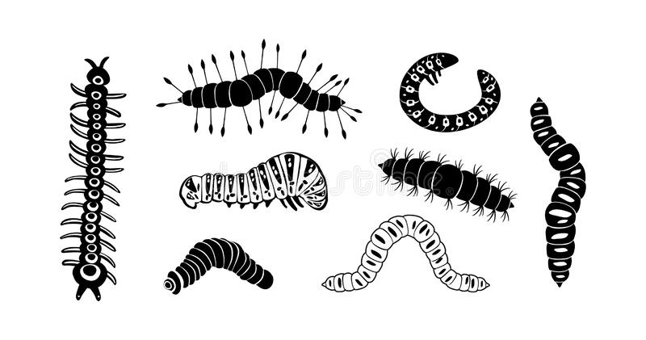

caterpillar



bee

TIPS

Look under rocks and stones.

 Look around plants, shrubs and flowers.

 Look at what birds are eating!

FACT There are 5,000 different species of ladybird in the world. Find out more about insects at [NATIONAL INSECT WEEK 2020](https://www.nationalinsectweek.co.uk/)

BUG ID Found a bug you can’t identify? [ASK AN EXPERT](https://www.nationalinsectweek.co.uk/ask-expert)

