** We’re going on an INDOOR 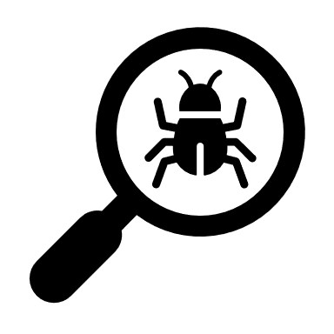 BUG hunt!**

**You might want to take:**

 A magnifying glass

 A camera to snap any bugs you find.

 A notebook and pencil to draw your critters and to write down colours, measurements and behaviour.

 A snack if you are going on a long expedition!

Use your EYES to find and observe any insects.

You may want to pick some bugs up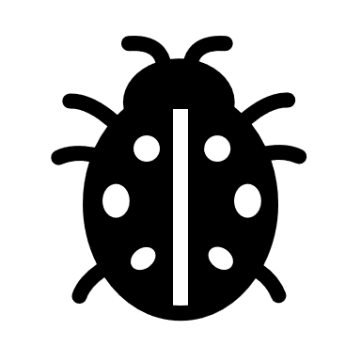 but please be careful not to hurt any mini beasts during your hunt …

and remember that some insects can sting!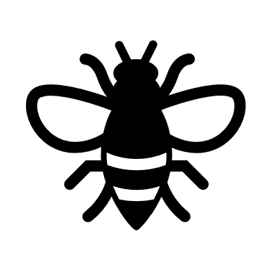



 **Bug Hunt Checklist**

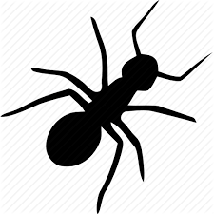

fly 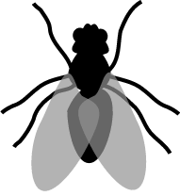

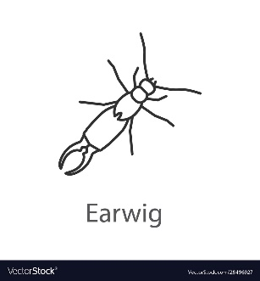

earwig

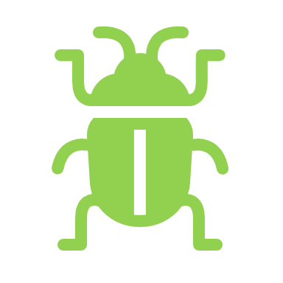

aphid



ant

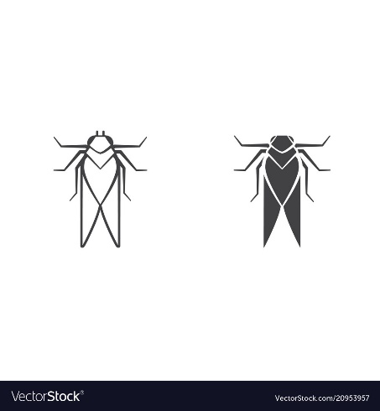

moth

ladybird

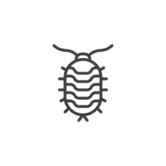

woodlice

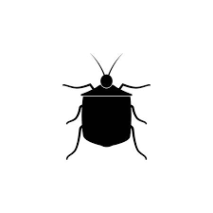

beetle

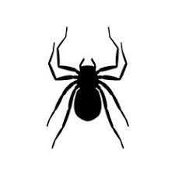

spider

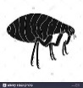

flea

TIPS

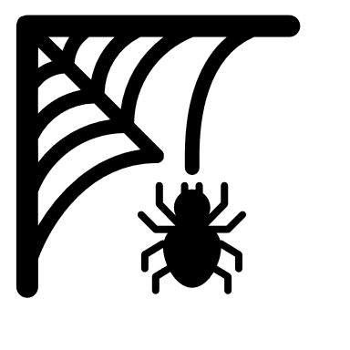 Look in cold, dark corners.

 Look at your house plants.

 Look on your pets!

FACT Woodlice and spiders are not classed as insects? Find out more about insects at [NATIONAL INSECT WEEK 2020](https://www.nationalinsectweek.co.uk/)

BUG ID Found a bug you can’t identify? [ASK AN EXPERT](https://www.nationalinsectweek.co.uk/ask-expert)

