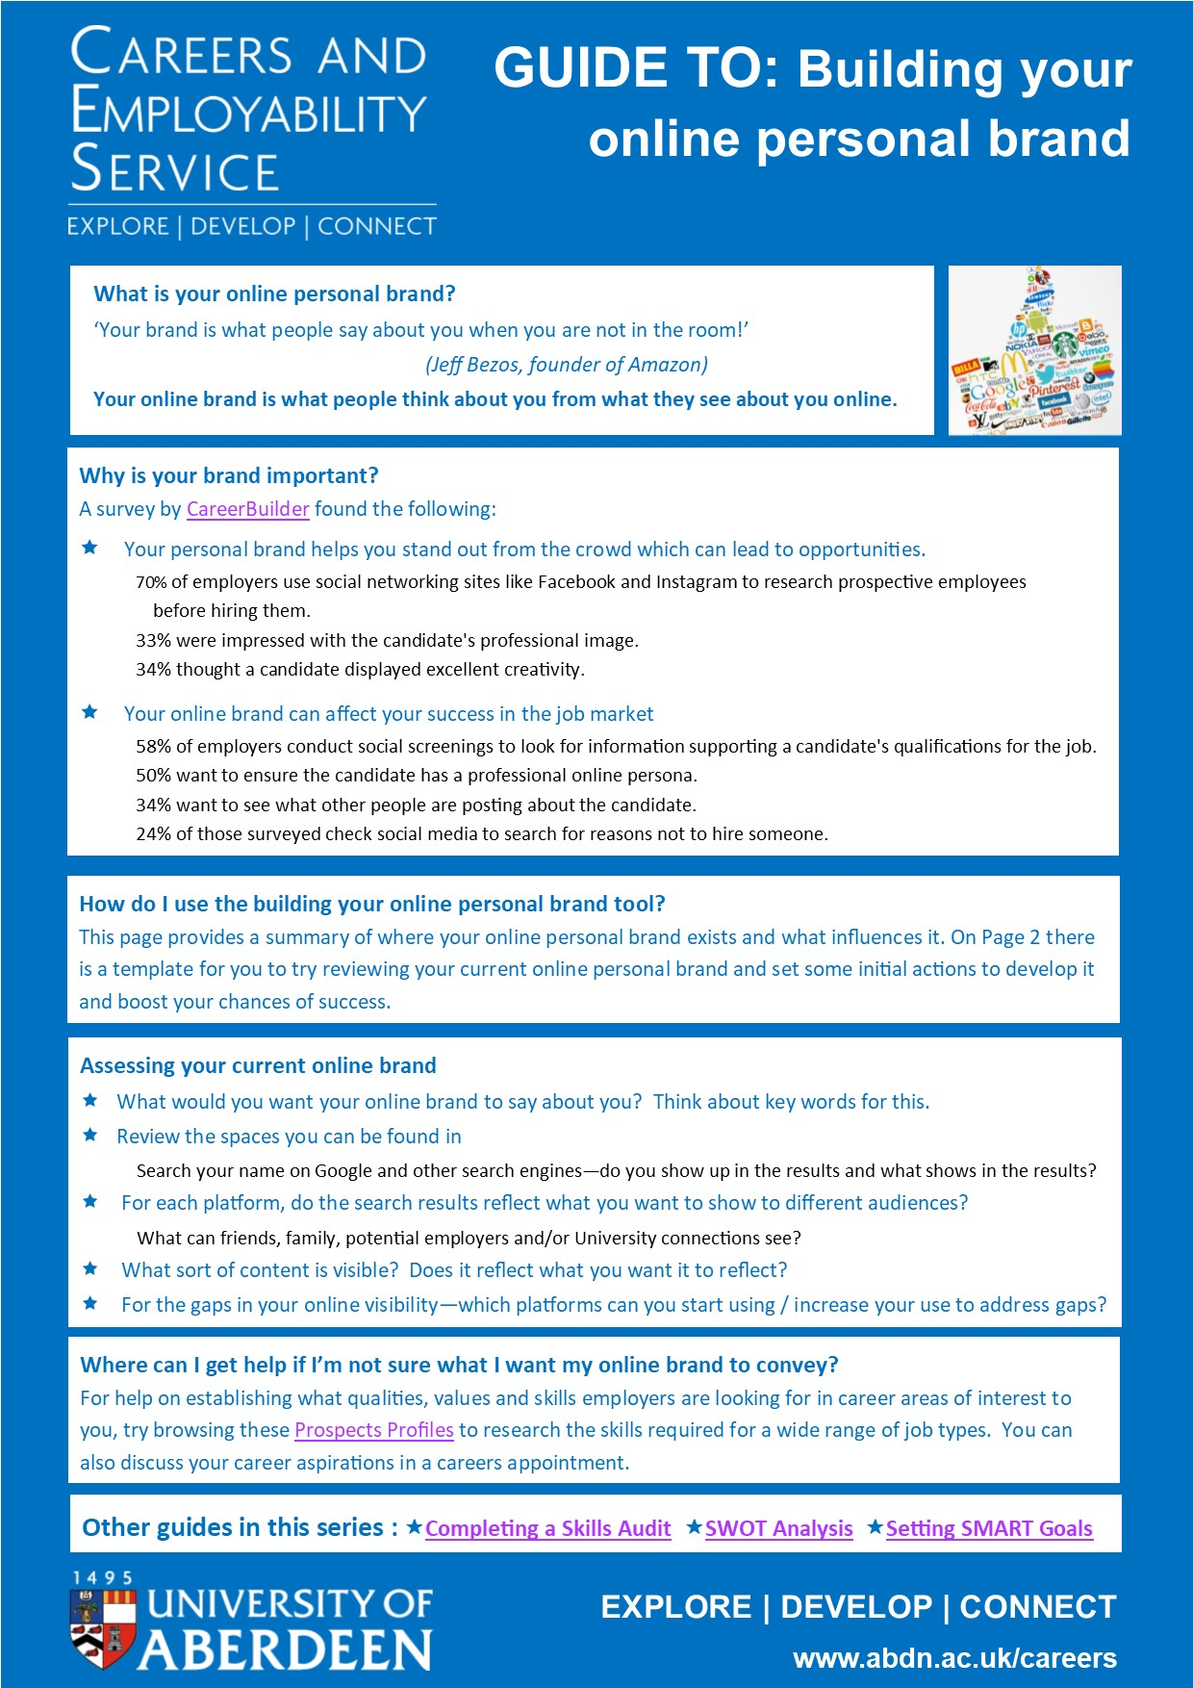
TO COMPLETE:
Brand review and plan
STEP 1: What do you want people to think about you based on your online profile?:
Write some key words you would hope people who view you online will associate with you:
Click or tap here to enter text.

STEP 2: What will people searching for you online find to inform their view of you?
1) Do you appear in the first page of search results on a major search engine? Yes ☐ No ☐

2) Which of the following types of content appears in the first few results pages?
Social Media Account(s) ☐ LinkedIn Account ☐ Personal Website(s) ☐ Blog(s) ☐ Vlog(s) ☐ Images ☐
3) How happy are you about the content which appears about you?
It’s all great and relates to my key words ☐ Some content needs adjusted (out of date/inappropriate) ☐
Note any immediate adjustments you need to make:
Click or tap here to enter text.

STEP 3: Which of the following platform types are you currently visible on?
Social connections: Facebook ☐ Twitter ☐ Other ☐ Click or tap here to enter text.

Professional connections: LinkedIn ☐  Other ☐ Click or tap here to enter text.

Visual creative content focus: Instagram ☐ YouTube ☐ TikTok ☐ Pinterest ☐ 
Other ☐ Click or tap here to enter text.

STEP 4: How are each of your key words from step 1 shown in your online results

Key word: | Clearly demonstrated | Could be visible | Not visible/Contradicts | Actions could take:
EG: Creative | Videos (YouTube)  Evidence of creative work (LinkedIn links) | Text describing how you’ve been creative in your activities (Facebook) | Poor visual use of customised sections of platforms (LinkedIn profile background) | Review all platforms to check all show high quality creativity
Click or tap here to enter text. | Click or tap here to enter text. | Click or tap here to enter text. | Click or tap here to enter text. | Click or tap here to enter text.
Click or tap here to enter text. | Click or tap here to enter text. | Click or tap here to enter text. | Click or tap here to enter text. | Click or tap here to enter text.
Click or tap here to enter text. | Click or tap here to enter text. | Click or tap here to enter text. | Click or tap here to enter text. | Click or tap here to enter text.

What do I do once I have reviewed my online brand?
Use the notes you have made and actions you have identified to assist you to make a plan for developing your online brand. The SMART Goal Setting tool gives you a format to follow for setting goals.

Other guides in this series : Completing a Skills Audit SWOT Analysis Setting SMART Goals

