PG Residential Reading Weekend at the Burn, 22-24 March 2024
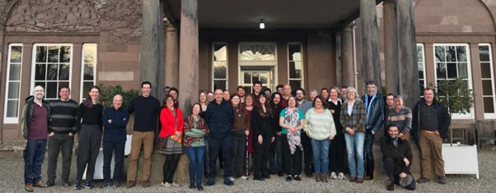

Scholarly debate, enhanced by blue skies, breath-taking walks around a wooded estate, delicious food, and conviviality over a glass of whisky – what more could one ask for in a weekend? Forty postgraduate students and faculty of the University of Aberdeen’s School of Divinity, History, Philosophy, and Art History (DHPA) enjoyed such a weekend retreat together at The Burn near Brechin, Scotland from 22-24 March 2024.

This annual reading weekend, sponsored by DHPA, is optional and helps to differentiate the University of Aberdeen from other university postgraduate programmes. Students who were able to join found it to be an excellent way to engage with others, many of whom they had only met in a classroom or on a collaborate screen. The participants are enrolled in postgraduate taught or postgraduate research programmes. These are a mix of on-campus, hybrid courses, as well as the fully online master’s courses in Scottish Heritage or PhDs from a distance.

The agenda and weekend activities, coordinated by Dr Bradford Bow, was rich in content, yet relaxing. Composed of short presentations (‘papers’) by students and accompanying group dialogue, the format brought new topics to the fore among participants and enabled support to each researcher with challenging questions and suggestions. Topics included Observations on nineteenth-century social, economic, and religious changes from the diaries of a NE tenant farmer, 1826-76; Scottish identity through eighteenth- and nineteenth-century visual art; concepts of Federalism in 1880-1920 Poland and Russia; disability in Old Norse literature; the Scots in the Crusades; and Scots in the New Model Army.
Favourite Quote from a PhD candidate’s presentation:
“Historiography… I discovered I didn’t really like it…”

(As a student of history, wow, did he have some explaining to do...)

Informational sessions led by faculty supported those who were transitioning to a postgraduate or taught environment, or even to a PhD, publishing, or the world of academia. The Burn’s bursar, David Turner, delivered a fascinating presentation on The Burn’s history–his last as he is retiring this month after 12 incredible years.

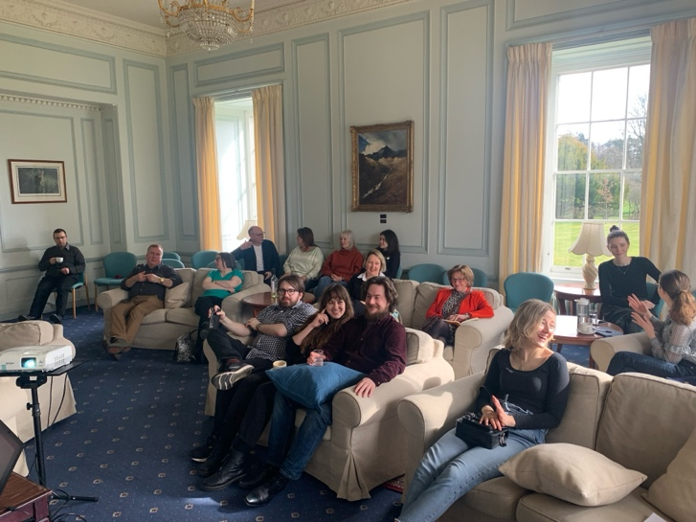
But ‘all work and no play make Jack a dull boy’. So fresh air and exercise, frequent breaks, drinks in the library coupled with only the best of Burns’ poetry, and a game or two of snooker were all on tap. Perhaps the highlight was the ever-so-special evening musical performance and sing-a-long by Professor Robert Frost and Professor Karin Friedrich. And apparently the fun didn’t stop when students left the Burn, with reports of ‘car karaoke’ and plans for the next Burn’s musical playlist.

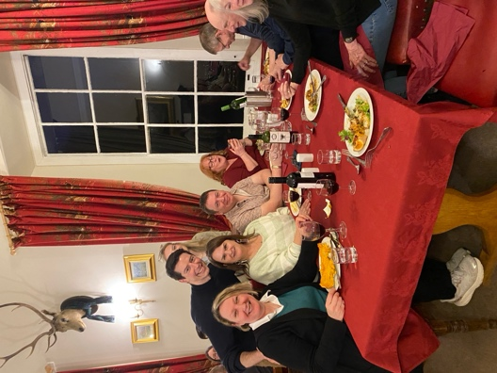
Food was plentiful, hearty, and delicious, and the Burn aptly catered to all diets, from Friday evening curry night to Saturday’s vegetarian tart and lasagne, to the full Scottish breakfasts each morning.

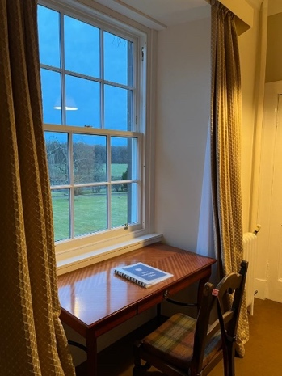
Students stayed in single or double rooms throughout The Burn’s main house and stables. Clean, brightly lit from full length windows with views to the surrounding estate, and communal bathroom facilities that still afforded high levels of privacy, meant that we could achieve an excellent night’s rest.

What emerged throughout the weekend was not just new ideas and conviviality, but a real sense of community among the diverse groups attending the DHPA’s courses. Ages ranged from 25 to almost 70. Participants represented many nationalities and travelled in from all over the UK, Europe, and North America. Research interests varied significantly between centuries and thematic areas as well as potential use of the degree for careers versus purely personal fulfilment.
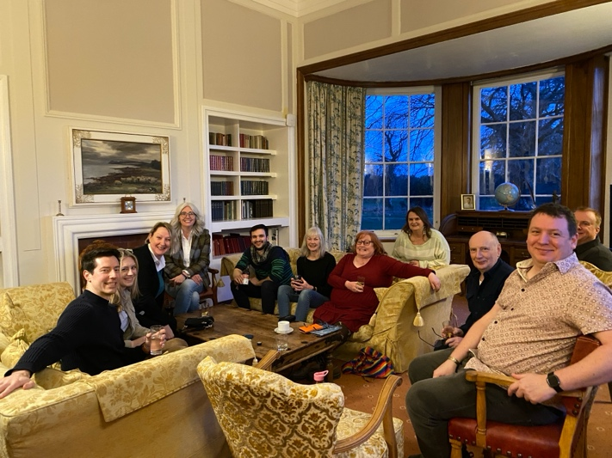
The participants in the MLitt Scottish Heritage – formerly only known to each other online – bonded and brainstormed ideas on how to stay more regularly engaged and share ongoing research topics. One idea was to host a reading weekend again in the autumn. Faculty of the DHPA were incredibly supportive in seeking new ways to sustain students’ interests in higher levels of engagement with each other and the school, including more frequent reading weekends. By the end of the short weekend, the sense of community was palpable.
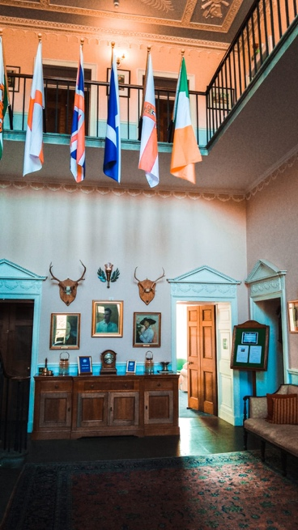
Programme
Friday, 22 March 2024
16.00 Pick up at Laurencekirk and Montrose train stations/check-in
18.00 David Turner, Bursar of The Burn, ‘Welcome and Introduction’
19.00 Dinner
20.00 Heidi Mehrkens and Karin Friedrich, ‘Making the Transition: UG to PGT, PGT to PGR’
21.15 Networking & Social Time
Saturday, 23 March 2024
09.00 Breakfast
10.00 PG Papers I (Chair: Alanna MacTavish)
Neil Harper, ‘The McWillie Diaries: Insights from the diaries of a NE tenant farmer, 1826-76’
Dr Donna Betts, ‘The Complex, Intersecting Layers of Scottish Identity as Expressed in Three Phases of Painting Spanning the 17th - 19th Centuries’
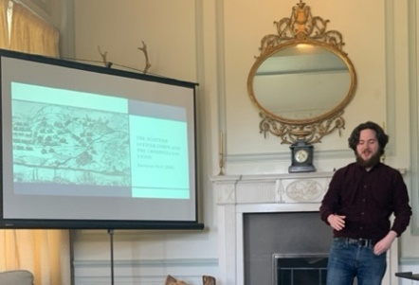
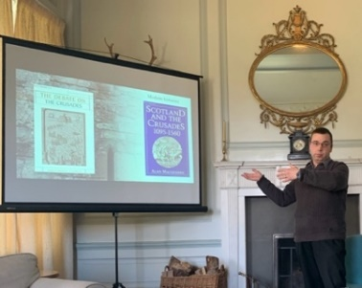
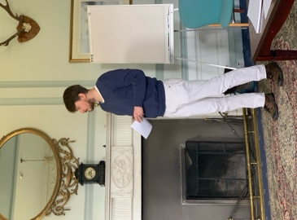
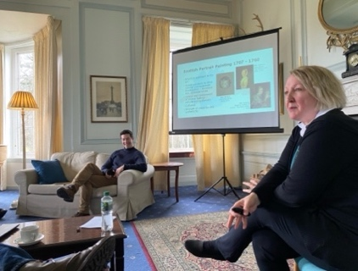
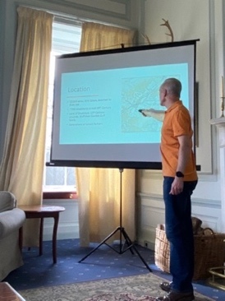
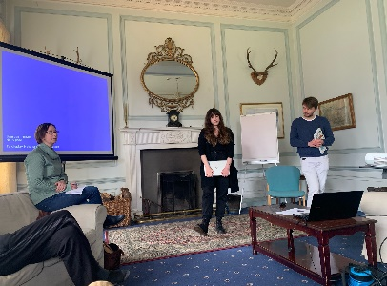
11.30 Coffee break
We appreciate our student presenters:
Top row: Neil Harper, Dr. Donna Betts, Marcel Garboś
Bottom row: Erin Benton, Arpad Kuffler, and Cameron Flint

12.00 BA Postdoctoral and PG papers II (Chair: Heidi Mehrkens)
Paper 1: Marcel Garboś, ‘Brotherhood Beyond the Borderlands: The “Great Russian nation” in the Polish Federalist Imagination, 1880s-1920s’
Paper 2: Erin Benton, ‘But the boy was boneless…’: Disability and Embodied Narratives in Old Norse Literature'
13.00 Lunch
14.00 Walk around the Estate
15.00 Robert Frost and Pawel Grabowski, ‘Pointers for Working in Archives’
15.45 Bill Naphy, ‘How to rework your thesis as a monograph and develop a book proposal’
16.45 PG papers III (Chair: Aly Macdonald)
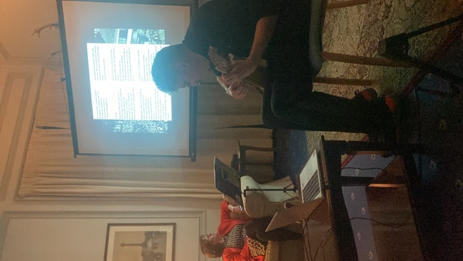
Arpad Kuffler, ‘Souldiers to the Syrian war': Pre-modern Histories of Scotland and the Crusades, 1527 – 1715’
Cameron Flint, ‘Scots in Strange Places: Scottish Involvement in the New Model Army’
19.00 Dinner
20.00 Live Music: History in Song led by Robert Frost and Karin Friedrich

Sunday, 24 March 2024
09.00 Breakfast
10.15 Laura Mair and Anna Lively, ‘How to navigate postdoc applications and life’
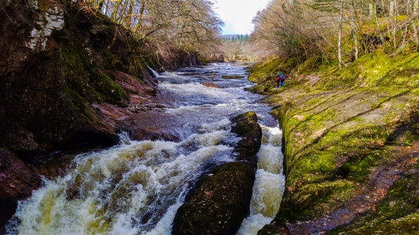
12:00 Depart The Burn and transport to train stations
Programme (https://theburn.co.uk/academic-retreats/)
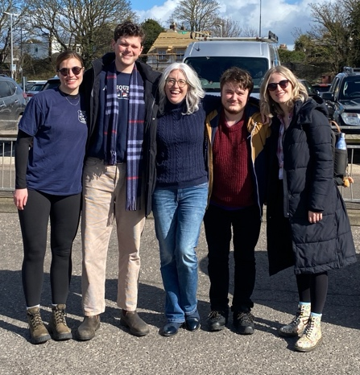
Participant List 2024
Students | Course/Programme
Benton, Erin | PhD
Betts, Donna | MLitt Scottish Heritage
Bonner, Megan | MLitt Medieval and Early Modern Studies
DeMarco, Avery | PhD
Dobie, Amanda | MLitt Scottish Heritage
Ferenczy, John | MLitt Medieval And Early Modern Studies
Flint, Cameron | PhD
Gray, Vicky | MLitt Scottish Heritage
Grabowski, Pawel | PhD
Hamilton, Alastair | MLitt Scottish Heritage
Harper, Neil | MLitt Scottish Heritage
Ivanecky, Jakub | MLitt Medieval and Early Modern Studies
Kelly, Susan | MLitt Scottish Heritage
Kilmartin, Cari | MLitt Modern History
Kuffler, Arpad | PhD
Llewellyn, Richard | MLitt Scottish Heritage
Lourenco, Miles | MLitt Viking & Nordic Studies
MacTavish, Alanna | MLitt Scottish Heritage
Meiklejohn, Kirsteen | MLitt Scottish Heritage
Moreau, Elizabeth | MLitt Scottish Heritage
Napier, Graeme | MLitt Scottish Heritage
Ndwandwe, Sabelo | PhD
Robertson, Gordon | MLitt Scottish Heritage
Robertson, Hannah | MLitt Scottish Heritage
Strong, Genevieve | PhD
Van Els, Lynn | MLitt Modern History
Vassev, Kaloyan | MLitt Modern History
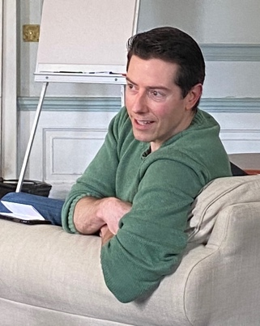
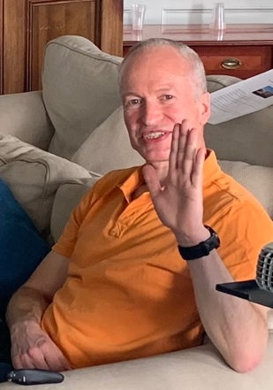
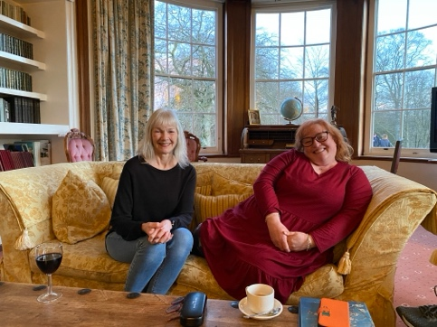
Armstrong, Jackson | DHPA Faculty
Bow, Brad | DHPA Faculty
Friedrich, Karin | DHPA Faculty
Frost, Robert | DHPA Faculty
Garbos, Marcel | DHPA Faculty
Lively, Anna | DHPA Faculty
Naphy, Bill | DHPA Faculty
Macdonald, Aly | DHPA Faculty
Mair, Laura | DHPA Faculty
Mehrkens, Heidi | DHPA Faculty
Walsh, Owen | DHPA Faculty

